Group Members:

Annze Villena #100372699

Sameer Muhammad #100373026

Assignment 3 : Project Report

INFO 1113 S10

Instructor: Dr. Abhijit Sen

October 25,2018

Sameer Muhammad

Website : <https://sites.google.com/view/main-app-project-sameer/home>

Git Hub: <https://github.com/sameerm799>

Annze Villena

Website: <https://sites.google.com/view/annze-villena/home>

Git Hub: <https://github.com/anzv>

Table of Contents

Introduction…………………………………………………………………..3

Project Functions………………………………………………………..4-8

Use Case Diagram…………………………………………………....9-10

Use Case Description………………………………………………11-17

Conclusion…………………………………………………………………..18

**Introduction**

In this report we will describe each function of our application by using a Use Case Diagram and Use Case Descriptions.

Our application is based on productivity. The application is designed to display two different applications on the screen to allow user to multitask between applications. The user will no longer have to continually switch between multiple apps. In a situation where a user needs to finish a power point presentation on their phone but is having to keep switching back and forth on their notes and their presentation slide…. Well this application is built for that. Allowing the user to display both the power point and their notes without finking back and forth through the apps. With this application the user is not limited to just one application on a massive display screen. As technology advances evolving in screen resolutions it is possible to have a mobile device display more than one application at a time. The user can control how much each application will take up the space of their screen. The application also allows landscape view.

**Project Functions – of the application**

There are four main functions in this application, that the actor(user) can control.

1.Selecting applications

2. Size Selection

3.Change Application

4.Settings.

Here are examples of what the function would look like on their mobile devices.

1. Select Application

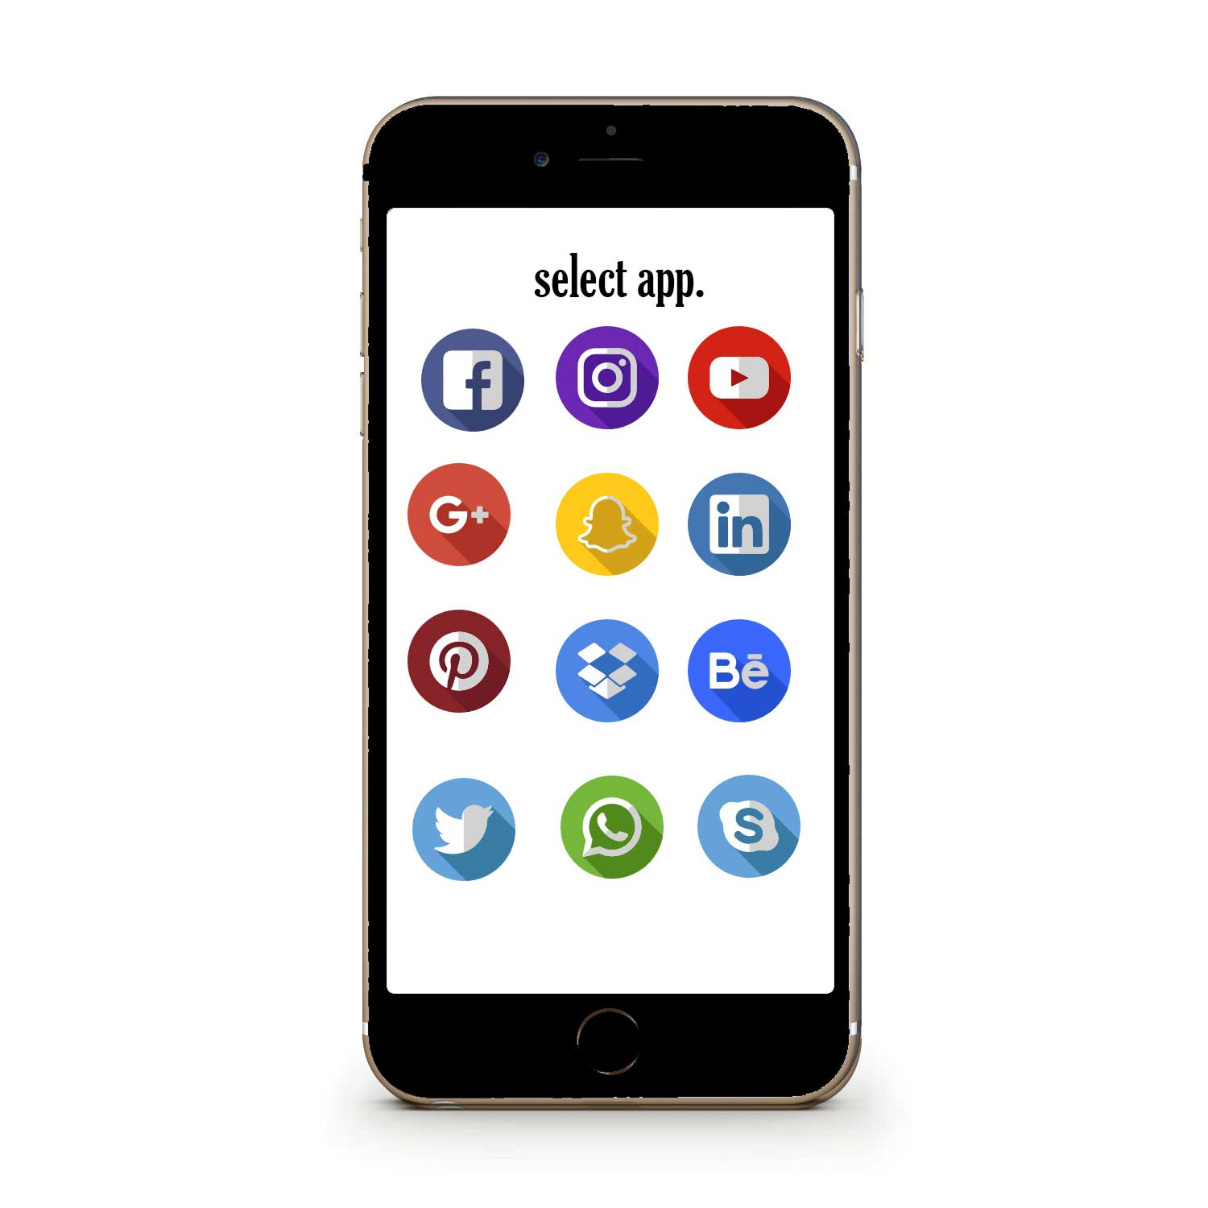

1. Size Selection

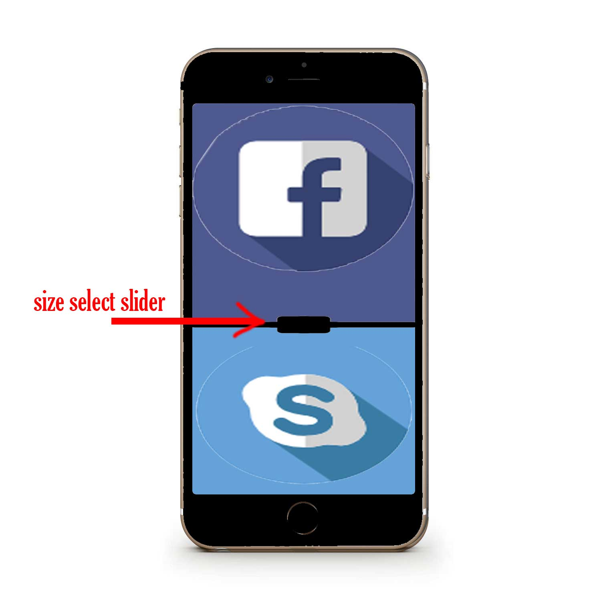

1. Change Application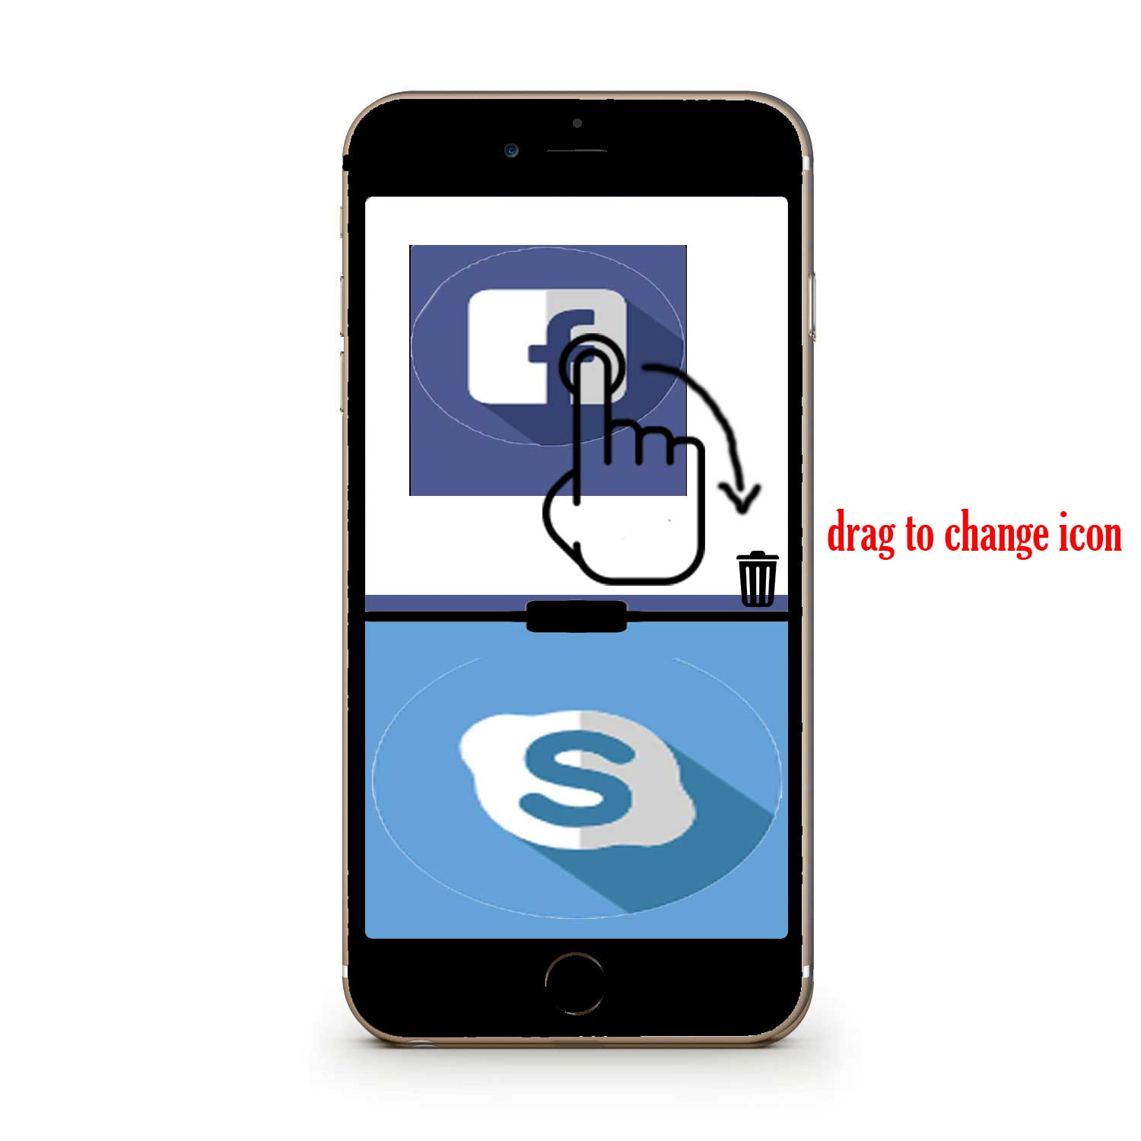
2. Settings

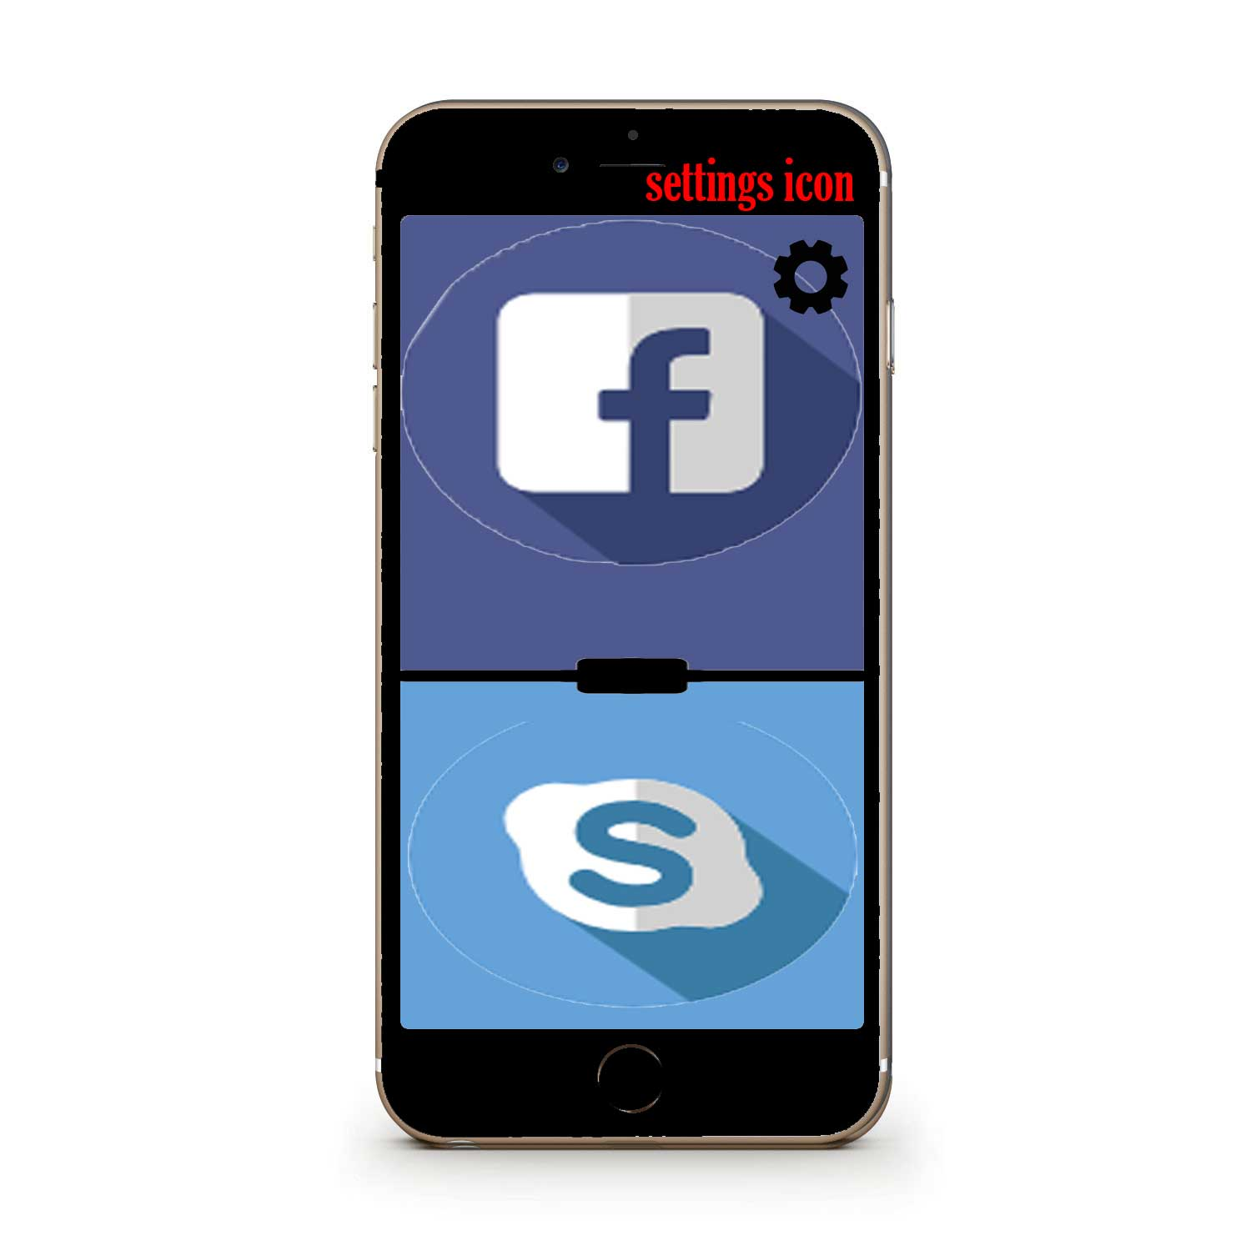

**Use Case Diagram**

This Use Case Diagram was made in collaboration of Annze and Sameer. We as a group had the time in class to configure the main functions together. This way it was more efficient to work off one Use Case Diagram instead of downloading two and trying to rearrange two different diagrams into one.

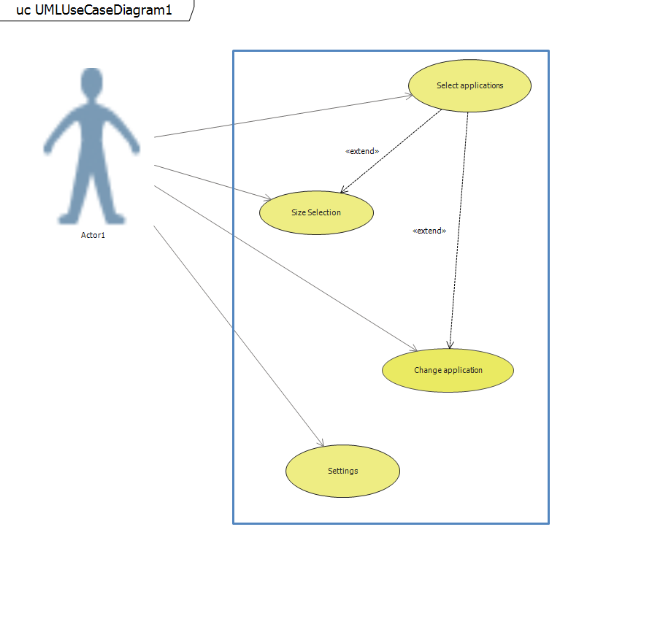

As you can see in this Diagram. The actor is the User of the application. As mentioned earlier there are 4 main functions the user has control of. The functions are in an oval titled with the function name. And an arrow is pointed from the actor(user) to the functions indicating that the actor(user) is in able to control, select applications, size selection, change application, and settings. There are also arrows that connect two functions together. These are extended arrows. For example, Select Application is also extended to the function Size Selection because once the actor(user) goes on to the function select Application they will then have the option to size selection. Instead of having these two functions separate from each other they are linked together. Same goes for Select Application and Change application. Upon Selecting an application, the function is also extended to the function change application meaning that change application can be done when after an application has been selected but the actor(user) has changed their mind and wants a different application.

**Use Case Description**

**Use Case By: Annze Villena**

**Reviewed by: Sameer Muhammad (edits in italics)**

|  |
| --- |
| Use Case Title: Select Application |
| Primary Actor: User |
| Level: Sea Level (user goal) |
| Stakeholders: User |
| Precondition: Application must be downloaded, Recommended device screen larger than 1136x640 |
| Minimal Grantee: Application crashes, restart application and selection. |
| Success Grantee: Applications selected and displays on screen properly. |
| Trigger: User Selects the actual application *(multi-display application)* from their device. |
| Main Success Scenario:  1.Screen Displays all available applications the user has on their device.  2. The user will select one application on their device *(Examples of applications: Facebook, Google Docs, Notes)*  3. The user will select a second application on their device that is not identical to the first. *(Example: if Facebook is selected. A different application like Twitter can be selected. No two of the same application)*  4. The user can unselect an application if they miss clicked or did not want to have that application be in use.  5.The user clicks confirm once they have chosen their two application  6. The user can then go to “Select Size” of application “Change Application” or “Settings” |
| Extension:  1.a. The desired application may not appear on their screen.  1.a.1. The user may have to close the application and restart the application again.  1.a.2. The user can simply choose a different application than the original one desired.  2.a. The application selected may not be supported by the application its self  2.a.1. The user will have to pick a different application.  3.a. The second application selected may not be supported  3.a. The user will have to pick a second different application.  5.a. The submit button may not be processed through  5.a.1 The user may have to re-click the confirm button  5.a.2 The user may have to restart their application and reselect their applications to confirm their selection. |

**Use Case By: Annze Villena**

**Reviewed by: Sameer Muhammad (edits in italics)**

|  |
| --- |
| Use Case Title: Size Selection |
| Primary Actor: User |
| Level: Sea Level(user goal) |
| StakeHolders: User |
| Precondition: Application must be downloaded, Recommended device screen larger than 1136x640, Applications must have been already selected |
| Minimal Grantee: Application crashes, must restart application and reselect applications that was being used. |
| Success Grantee: The application sizing is desired by the user |
| Trigger: Application must have been already selected and submitted. |
| Main Success Scenario:   1. User can control the display selection of the applications on their screen. 2. User slides up or down to select the proportion of how much each app takes up the device screen. 3. The user can turn their screen on landscape view to have applications side by side. 4. The user can slide left or right to adjust how much of the application displays in landscape view.   5. The user can go to “Change Application” or “Settings” |
| Extensions:  2.a. There is a limited slide of how small an application can be on the screen.  2.a.1. The user will be able to go only as far as the limit.  3.a If device’s auto rotation is locked the user my not be able to trigger landscape view  3.a.1. The user must turn off lock rotation on their device to have their applications on landscape view.  4.a. There is a limited slide of how small an application can be on their screen in landscape view.  4.a.1. The user will only be able to go as far as the application limit |

**Use Case by: Sameer Muhammad**

**Reviewed by: Annze Villena (edits in italics)**

|  |
| --- |
| Use Case Title: Change Application |
| Primary Actor: User |
| Level: Sea Level (user goal) |
| Stakeholders: User |
| Precondition: Application must be downloaded, Recommended device screen larger than 1136x640 |
| Minimal Guarantee: The application crashes, restart is required |
| Success Guarantee: Desired change of applications is made. |
| Trigger: User holds down the application they wish to remove, and slides it off the screen, application will display a grayed area with a plus sign to add new application. |
| Main Success Scenario:   1. User holds down the application they wish to switch out. 2. User drags the application out of its *device screen. (example: swiping to the left or right ect.)* 3. The user now selects a new application *and confirms application selection.* (*examples of applications that a user my choose*: *Twitter, Facebook, Google Docs, ect)* 4. The new application takes up the space of the old one. 5. The user now has a new application and a different one they had from the start displayed. |
| Extensions:  1a. The change application function is not available      1a1. User closes the multi-display application  1b. Desired application to change to is not available      1b1. User restarts the multi-display application      1b2. User chooses a different application to display      1b3. User tries desired application at a different time  2a. Desired application change causes display application to crash      2a1. User opens display application again. Tries to change desired           application to display |

**Use Case by: Sameer Muhammad**

**Reviewed by: Annze Villena (edits in italics)**

|  |
| --- |
| Use Case Title: Settings |
| Primary Actor: User |
| Level: Sea Level (user goal) |
| Stakeholders: User |
| Precondition: Application must be downloaded, Recommended device screen larger than 1136x640 |
| Minimal Guarantee: User is not able to access all the features of settings, restart is  required or update is required. |
| Success Guarantee: User has access to all the features that settings has to provide for the multi-display application. |
| Trigger: User Selects the actual application (our project) from their device. Then selects the settings icon. |
| Main Success Scenario:   1. User selects the application 2. The settings icon is clicked on 3. The user can modify the settings to their desire 4. The user has access to modifications such as: volume control for each application, dark mode or light mode, brightness control, select which apps should be used. |
| Extensions:  1a. The settings function is not available      1a1. The user restarts the application or there is an update required  1b. A function within the settings is not available.      1b1. The user must modify the screen for an option to appear again or restart the application |

**Conclusion**

To conclude. Our project application, is designed to be used for any type of user. Our Use Case Diagram only consist of 4 main functions, whereas other applications may have complex and too many functions for anyone to understand. Upon having self-explanatory functions. We were able to break it down into even more simpler yet detailed descriptions of our Use Case Functions.

Difficulties faced as a group was breaking down each function. Although we as the creator perceive these functions to be simple enough to be understood there may be users who are completely new to the functions and my not know where to start. We are the creators of this application, but we are also the user, we both have different goals and objectives we would like to accomplish with this application and the goals we set are connected to the desires of the users in the application.

We believe as a group by first analyzing our functions and making a use case diagram allowed us to better understand and construct an application that is fully functioning and targets all the objectives and possible risk to solve these situations. Leading forward we know what we must to do to create a fully functional application and how to deal with the challenges faced that arrive.