Assignment 2

Annze Villena
Course: INFO 1113 S10
Student #: 100372699
Website: https://sites.google.com/view/annze-villena/home

Setting up Git
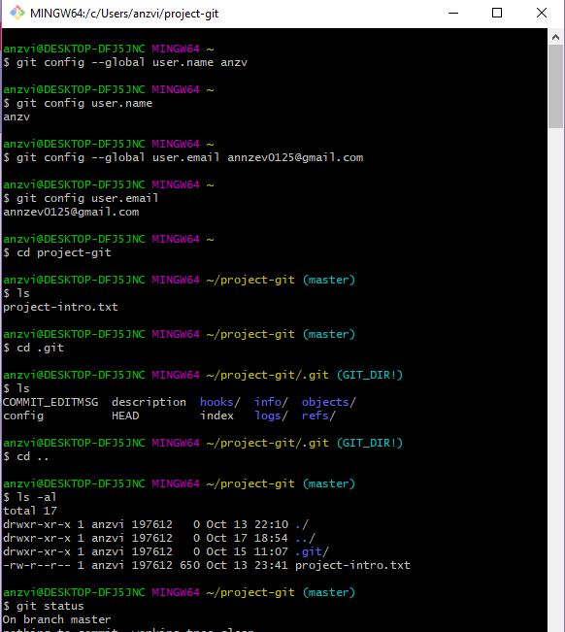
User Identification:
$ git config --global user.name
$ git config –global user.email

with the following commands I was able to make a user and email that was identified in my desktop to show who was making the changes.
$ git config user.name
$ git config user.email

shows who’s user and email Is being used by displaying it on the next line and I have entered the commands correctly so it displays my user name and email: anzv & annzev125@gmail.com

I had already made a working directory in my file called project-git for I had just commanded git to just go to that corresponding folder.

Next typing
$ git init
Initialized a .git repository in the folder of project-git
This is an invisible folder that holds the contents of the directories when commanded to display them with
$ ls
Shows all the files in the project-git/.git repository

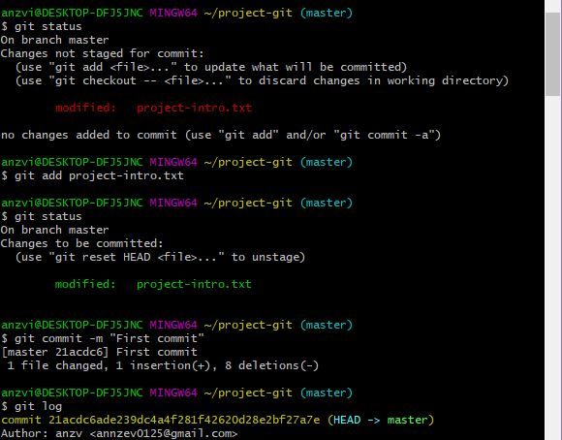
Staging > Committing :
Already had making a text file called Project-introduction.txt
I was then able to display the status of the file to be staged.
$ git status
Showed the file in red which means it has been modified and can be staged
$ git add project-intro.txt
Stages the file Typing in
$ git status
Again, then shows that the file is green and has been staged and can be then committed.
$ git commit -m “first commit”
Commits the file and shows what modifications has been made.

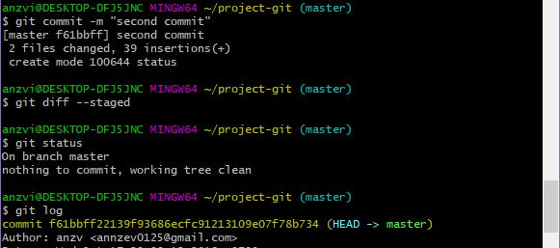
Modifying the file again by adding information such as my name and partner name and course info.
By first staging the file then commanding
$ git commit -m “second commit”
$ git log shows all the files committed
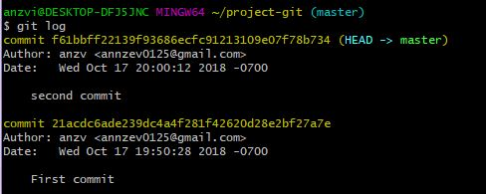

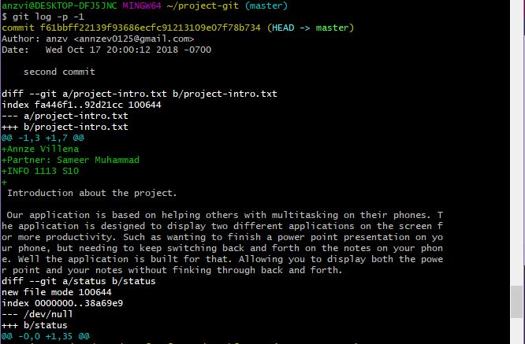
$ git log -p -1
Shows what kind of changes has been made in the file and shows it in green
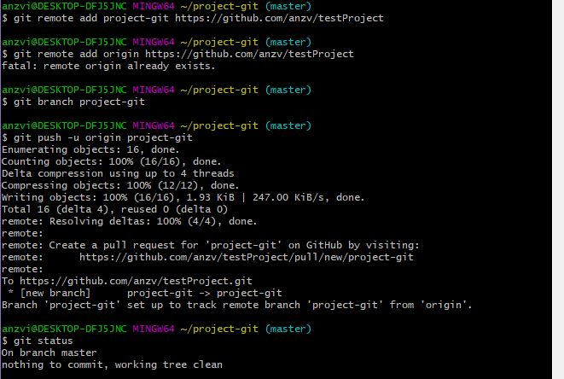
Pushing repository to GITHUB:
$ git remote add project-git https://github.com/anzv/testProject/pull/new/project-git

$ git branch project-git
Adds the branch called project-git to Github which contains all the files for the project-git directory

$ git push -u origin project-git
Pushes the branch online and shows all the detail of the file

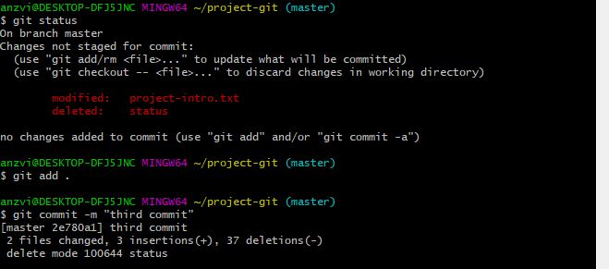
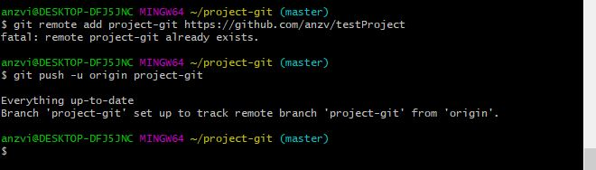
Re-modifying the file and staging and committing then pushing once again to GitHub.

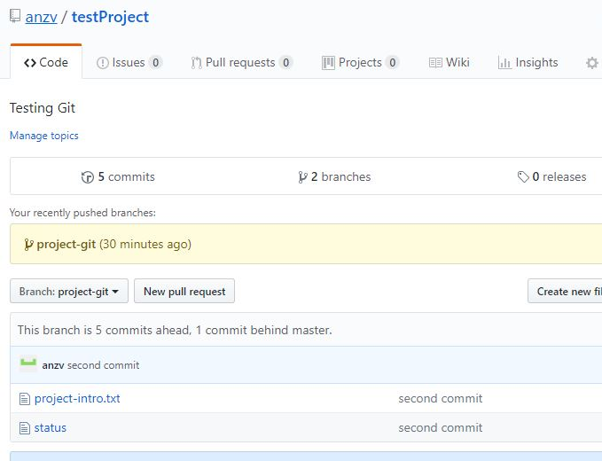

Git commands
$ git config –global user.name | Sets the user of who is the one making changes
$ git config –global user.name | Sets the users email being used
$ git config –list | Shows all the settings of the computer
$ ls | Displays the items is the current directory
$ ls -al | Shows all the sub directories
$ git init | Initializes a git repository
$ cd | Path to a folder
$ cd .. | Leaves the current folder to go to previous
$ git status | Shows the status of the files
$ git add | Adds the following file to the staging area
$ git commit -m | Commits a file
$ -m | Means a comments for the commit
$ git log | Shows the logs of the committed files
$ git log –stat | Shows the log and descriptive status of the committed files
$ git diff | Shows what changes has been made in the file
$ git log -p -1 | Shows all the current and previous files that have been committed
$ git remote add <remote> <remote url> | Tells git which file and where to push to
$ git branch <file> | Makes a new branch
$git remote add origin <branch> | Which remote origin branch to push
$git push –u origin <branch> | Pushes the branches and its files to the remote url
$ start . | Opens the folder of the current directory
$ mkdir | Makes a new directory
$ rmdir | Removes / deletes a directory
$ exit | To log off of git bash / close the program

References

Youtube channel:
The Net Ninja
Tutorial on how to use Git hub.
https://www.youtube.com/watch?v=3RjQznt-8kE&list=PL4cUxeGkcC9goXbgTDQ0n_4TBzOO0ocPR

Git Basics:
https://git-scm.com/book/en/v2/Getting-Started-Git-Basics

