**River Architect Tutorial**

**Step 0. Download RiverArchitect**

1. Create a folder “RiverArchitect” where you want.
2. Go to <https://github.com/RiverArchitect>
   1. Click “program” and “Code > Download Zip”
   2. Go back and click “SampleData_RosgenC4” and “Code > Download Zip”
3. Go to “Download” folder and unzip the downloaded files.
4. Put “Program” and “SampleData_RosgenC4” in “RiverArchitect” folder that you made in 1.
5. Now you are ready to explore RiverArchitect!

**Step 1. Create new condition and Analyze Flows**

1. Start RiverArchitect by running Start_River_Architect.bat

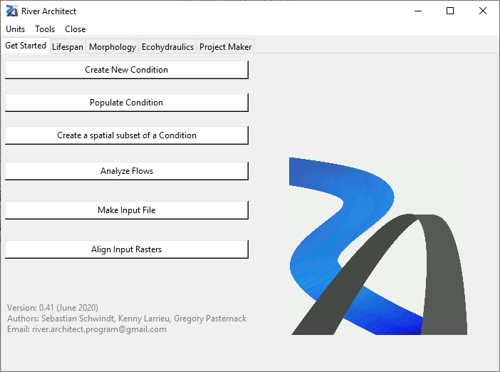

1. In “Get Started” tab - <https://riverarchitect.github.io/RA_wiki/Signposts#getstarted>, Click “Create New Condition”
   1. Select u, h, DEM, Grain size raster as below
      * The folders and files are located at: “RiverArchitect\SampleData_RosgenC4\01_Conditions”

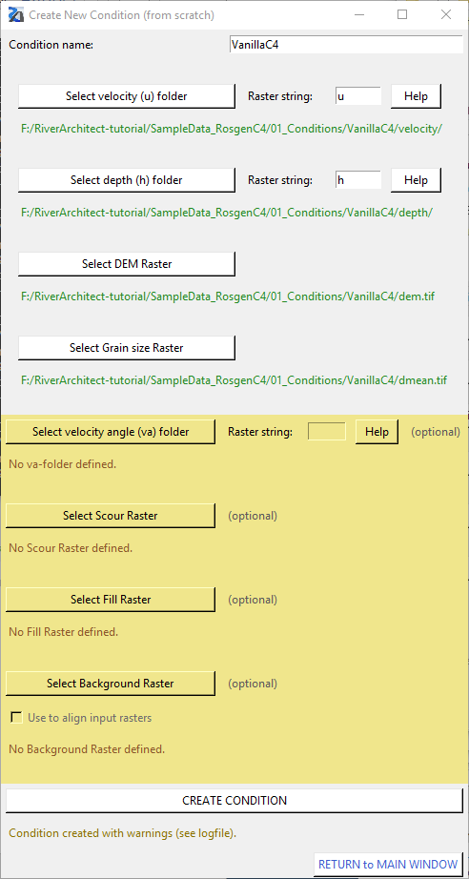

1. Click “Return to Main window”
   1. Then these INFO windows will pop up:

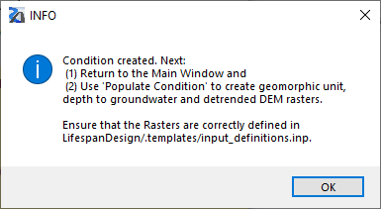

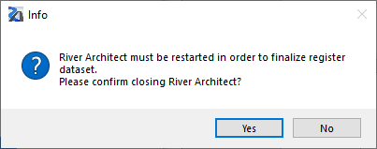

* 1. Restart River Architect

1. In 1), select “VanillaC4” and click “Analyze”.

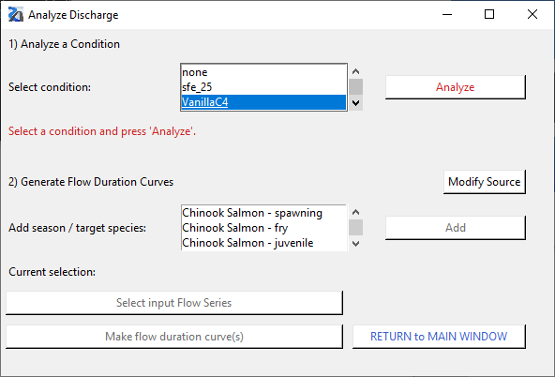

1. Then an excel sheet would pop up – manually type in Return periods and save the file.

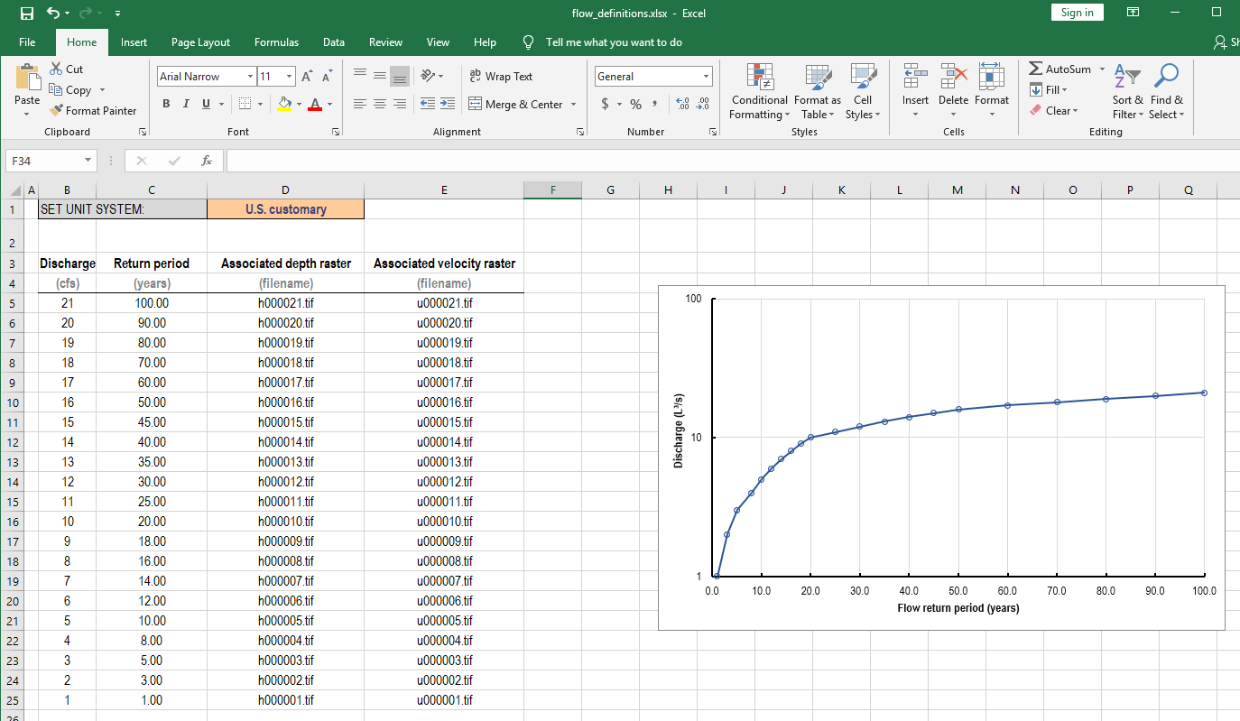

1. Now go back to River Architect. In 2), select one of the season/target species and click “Add”- in this tutorial, select Chinook Salmon - spawning

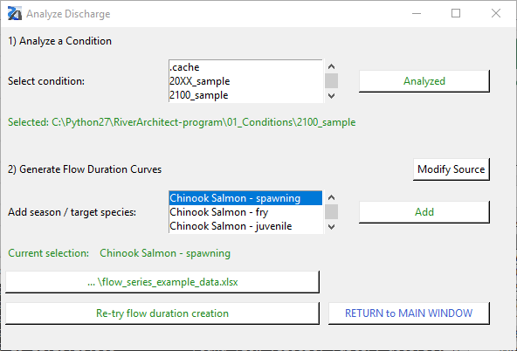

1. Click “Select input Flow Series” and navigate to the flow series file and select it. In this tutorial, choose “RiverArchitect\SampleData_RosgenC4\00_Flows\Flow_series_RosgenC4.xlsx”
   1. Click “Make flow duration curve”. Then the result excel file will pop up.

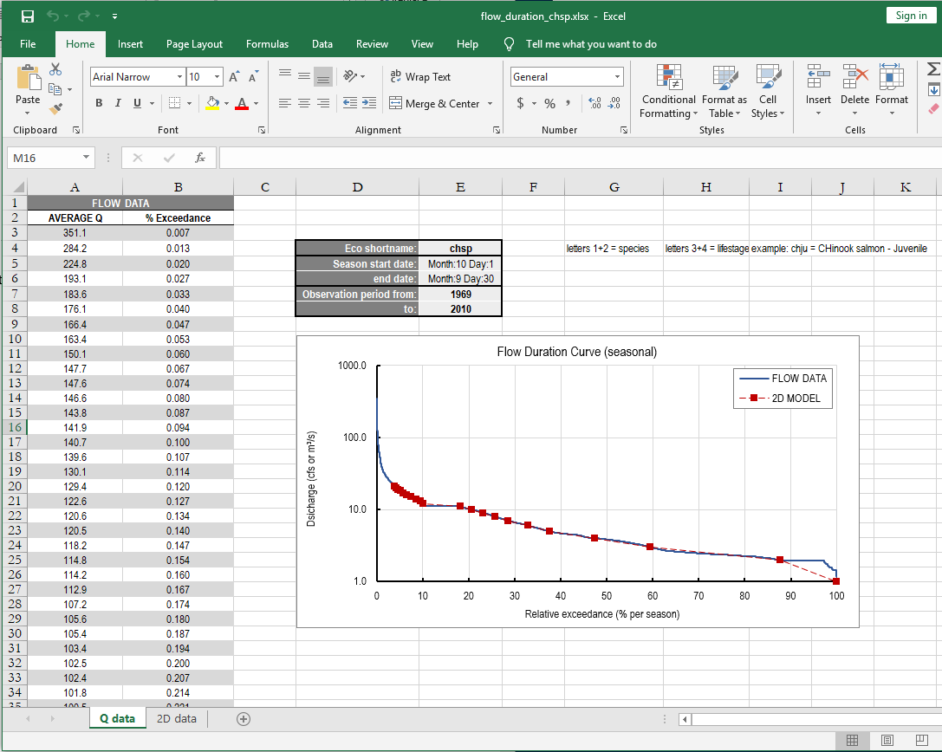

* 1. Click “Return to Main Window”

**Step 2. Create new condition and Analyze Flows**

1. Go to “Ecohydraulics” tab
   1. Change the unit if needed

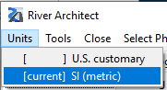

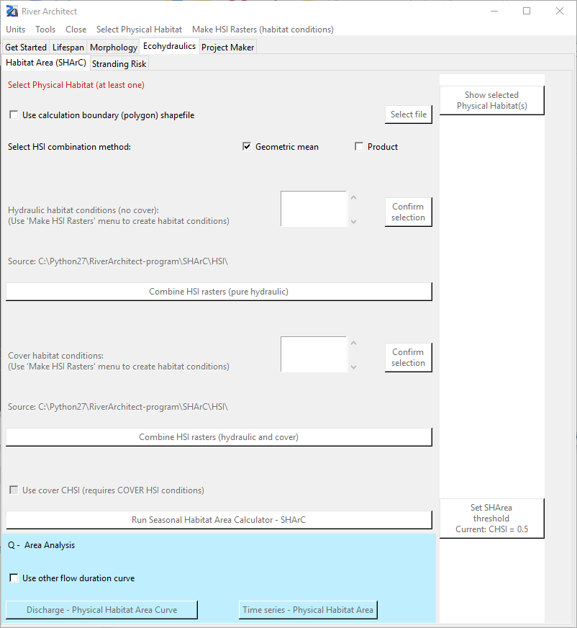

1. From the manu bar, click “Select Physical Habitat” and select the fish species – In this tutorial, select “Chinook salmon – spawning”
   1. You can check the selected physical habitats by clicking “Show selected Physical Habitat(s)”.
      * If you want to remove your selections, go to “Select Physical Habitat” and click “CLEAR ALL”.
2. From the manu bar, click “Make HIS Rasters (habitat conditions” and click “Flow depth – flow velocity HSIs”
3. Click “” and “Select”

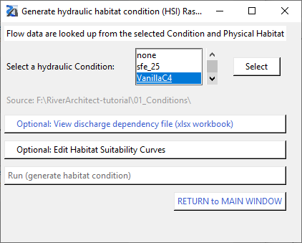

1. After the process has finished, you can check the dependency file by clicking “View discharge dependency file (xlsx workbook)” - this file is SHArC\SHArea\VanillaC4_sharea_chsp.xlsx
   1. You can change the habitat suitability curve by clicking “Edit Habitat Suitability Curves”.
   2. The default curve is at “RiverArchitect\.site_packages\templates\Fish.xlsx”

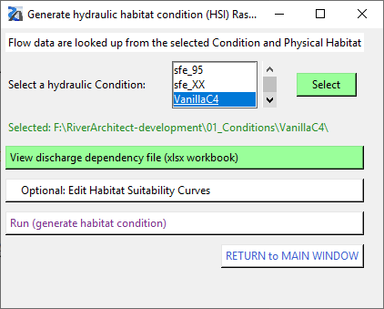

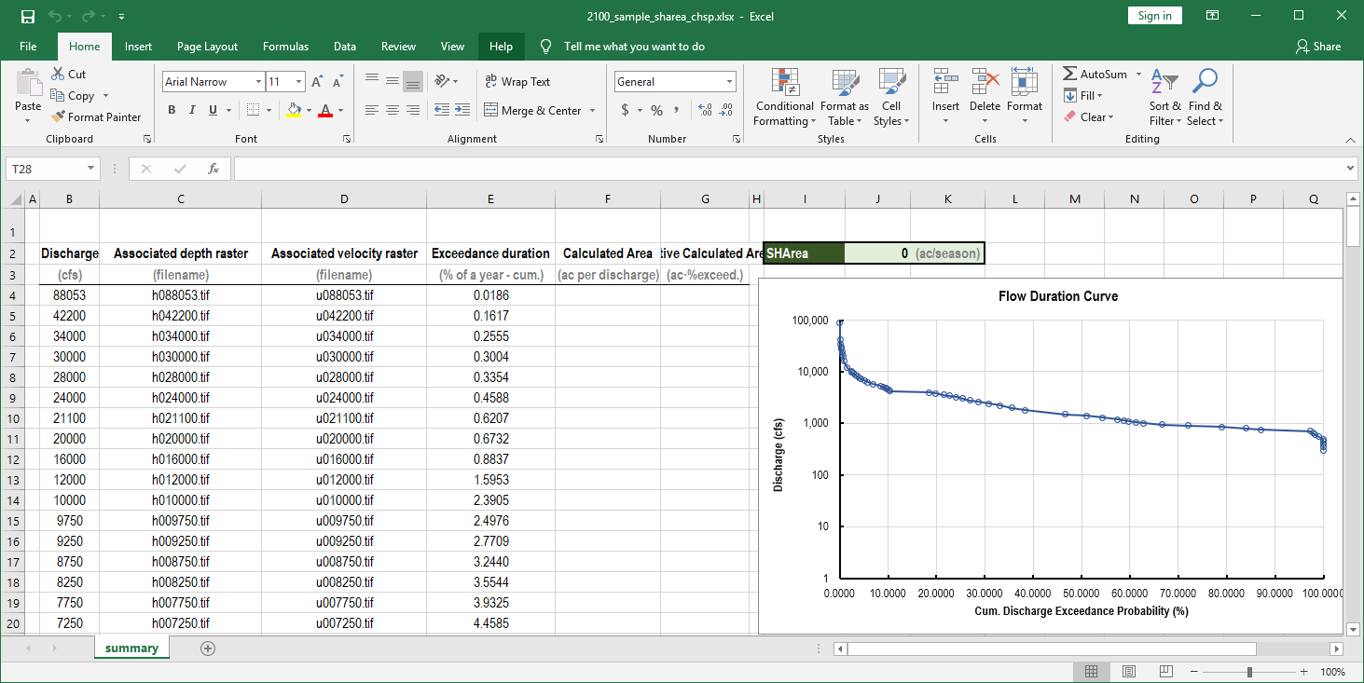

1. Click “Run (generate habitat condition)”
2. Click “Return to Main Window”
3. Now, a new condition, “VanillaC4” for Hydraulic/Cover habitat conditions is generated.

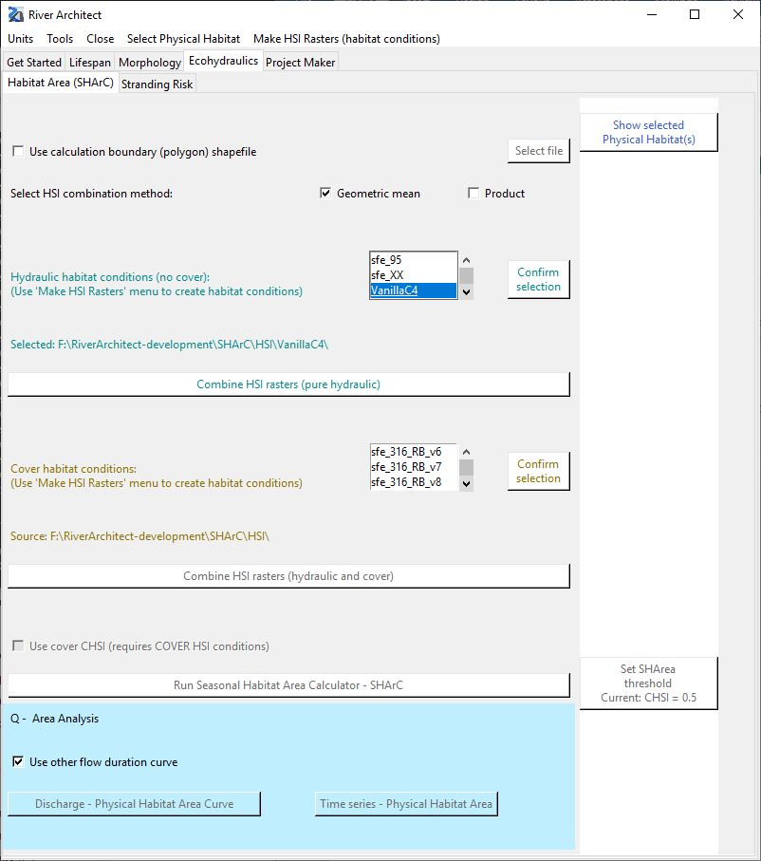

1. Select “VanillaC4” condition for both hydraulic and cover habitat conditions and click “Confirm selection”
2. Click “Combine HSI rasters (pure hydraulic)”
3. Click “Run Seasonal Habitat Area Calculator – SHArC”
   1. Adjust the threshold for cHSI
4. Check the result cHSI at “RiverArchitect/SHArC/SHArea/Rasters_VanillaC4”

**Step 3. Post-processing for ecoseries analysis**

1. Now, we are going to plot Habitat area vs. flow for a given flowseries.
2. Create a folder named “VanillaC4” in “RiverArchitect\SHArC\SHArea” and put “VanillaC4_sharea_chsp.xlsx” and “VanillaC4_sharea_chsp_cov.xlsx”
3. Create a folder named “VanillaC4” in “RiverArchitect\00_Flows”
4. Copy “RiverArchitect\SampleData_RosgenC4\00_Flows\flow_series_RosgenC4.xlsx” and paste it in “RiverArchitect\00_Flows\VanillaC4”
   1. Rename “flow_series_RosgenC4.xlsx” to “flow_series_VanillaC4.xlsx”
5. Open “RiverArchitect\Tools\ecoseries_SHArea.py” and set:
   1. case_name = “VanillaC4”
   2. fish_periods = [“chsp”]
      * the first to strings describe the species
        1. ch = chinook Salmon
        2. ra = Rainbow / Steelhead Trout
      * the last to strings describe the period
        1. sp = spawning
        2. fr = fry
        3. ju = juvenile
        4. ad = adult
   3. timeseries_path: path to flowseries
   4. figure_path: directory that you want to store the result figures
      * For this example, the figures are stored in “RiverArchitect\SHArC\SHArea\VanillaC4”
   5. interptype: the type of interpolation
   6. scale_to_one: 1 if you want to set the upper limit of y = 1 in sequence plot
6. The result figures are as follows:
   1. Habitat area vs bankfull discharge
      * X and y axis are normalized by
        1. X: bankfull discharge
        2. Y: bankfull area

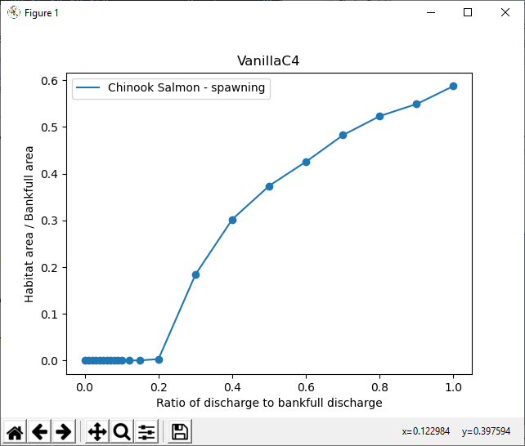

* 1. Flowseries

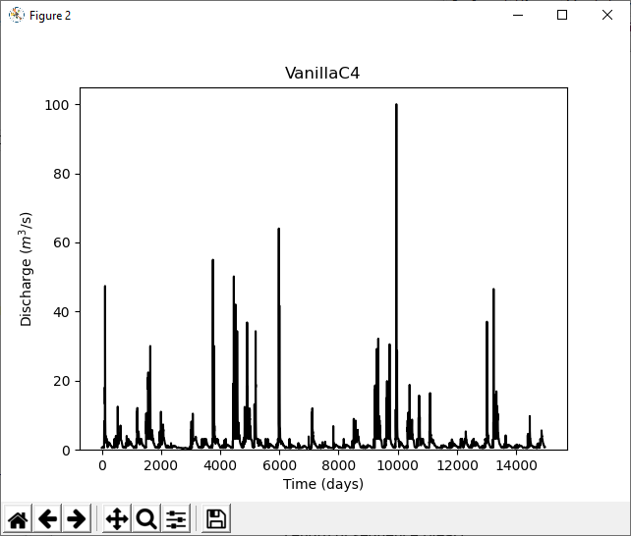

* 1. Habitat area timeseries

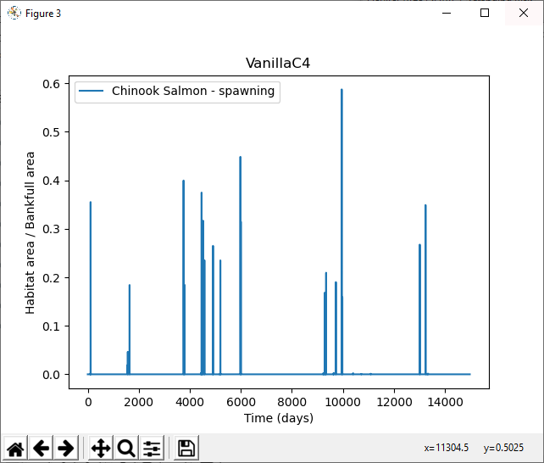

* 1. Sequence-averaged habitat area

