**River Architect Tutorial**

Prepared by Anzy Lee

**Run TUFLOW [Optional]**

1. We will work with “SampleData_RosgenC4” folder to generate input dataset. Go into “Sample Data_RosgenC4” folder. If you have TUFLOW installed in your computer, you can generate the sample dataset from the scratch using “tuflow_run.py”.
   1. You can specify the flow discharges and cell size.
2. After running “tuflow_run.py”, you can rearrange the velocity and depth raster files into the file structure for River Architect using “RA_input.py”. For example, this code will generate the folder “VanillaC4” in 01_Conditions, containing the folders and files as below:

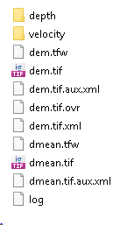 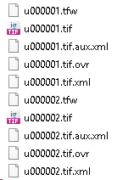

**Create a condition**

1. Now, start River Architect by double-clicking “Start_River_Architect.bat” then you will see the window as below:

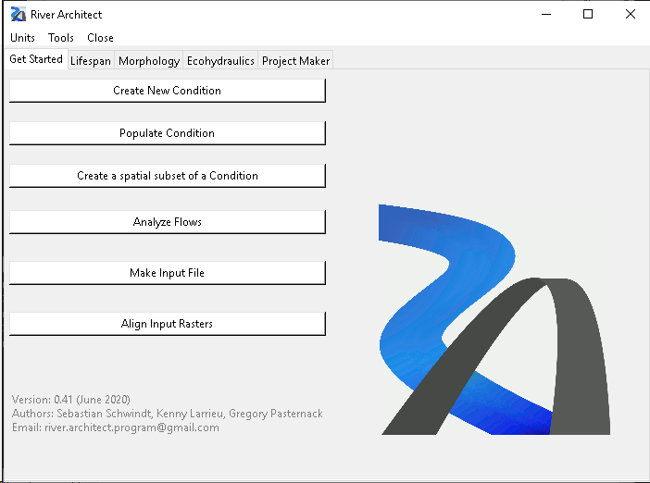

1. In “Get Started” tab - <https://riverarchitect.github.io/RA_wiki/Signposts#getstarted>, Click “Create New Condition”
   1. Select u, h, DEM, Grain size raster as below: be aware that you need to select the velocity and depth folder in “SampleData_RosgenC4/01_Conditions/VanillaC4”.
      1. Condition name: VanillaC4
      2. Velocity folder: SampleData_RosgenC4/01_Conditions/VanillaC4/velocity
         1. Raster string: u
      3. Depth folder: SampleData_RosgenC4/01_Conditions/VanillaC4/depth
         1. Raster string: h
      4. DEM Raster: SampleData_RosgenC4/01_Conditions/VanillaC4/dem.tif
      5. Grain size Raster: SampleData_RosgenC4/01_Conditions/VanillaC4/dmean.tif

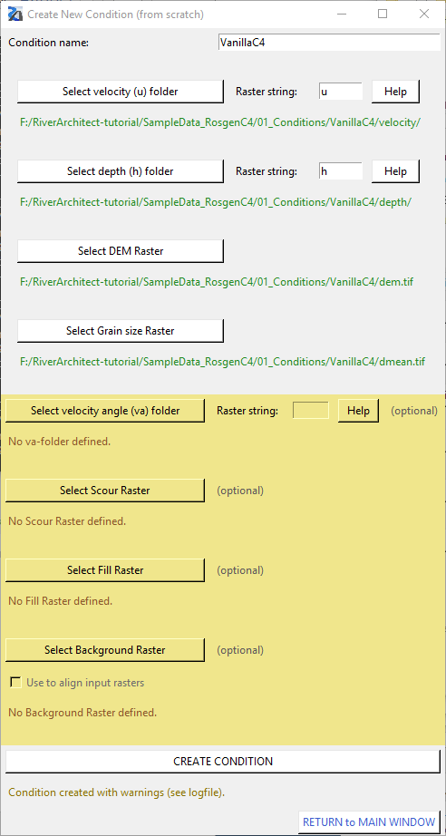

1. Click “Return to Main window”
2. Restart River Architect.

**Analyze Flows**

1. Click “Analyze Flows”.



1. In “1) Analyze a Condition” section, select “VanillaC4”and click “analyze”
   1. Then an excel sheet named “flow_definitions.csv” would pop up – manually type in Return periods and save the file. Close the excel sheet.

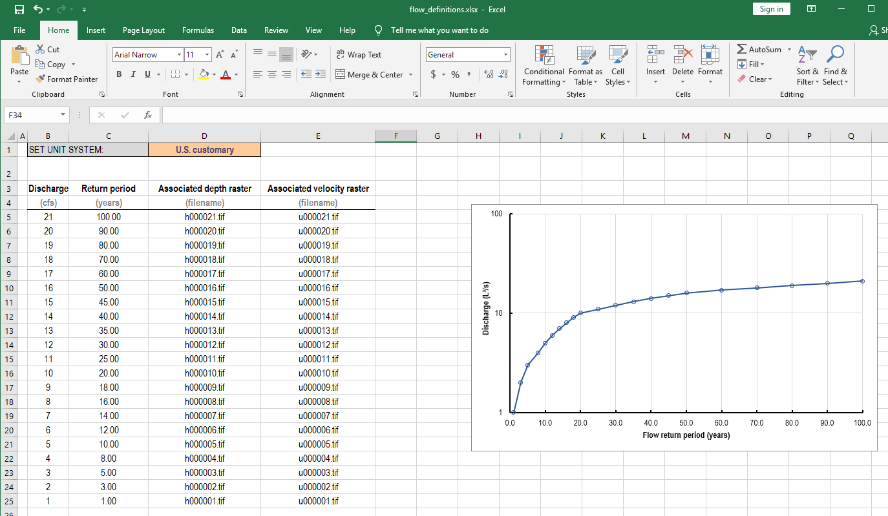

1. In “2) Generate Flow Duration Curves” section, select season/targe species and click “Add”. For this tutorial, we will only add “Chinook Salmon – spawning”
2. Click “Select input Flow Series”. Choose “SampleData_RosgenC4/00_Flows /flow_series_RosgenC4.xlsx”
3. Click “Make flow duration curve”. Then the result excel file named “flow_duration_chsp.xlsx” will pop up: this gives you the relative exceedance for simulated discharges. Close the excel sheet.

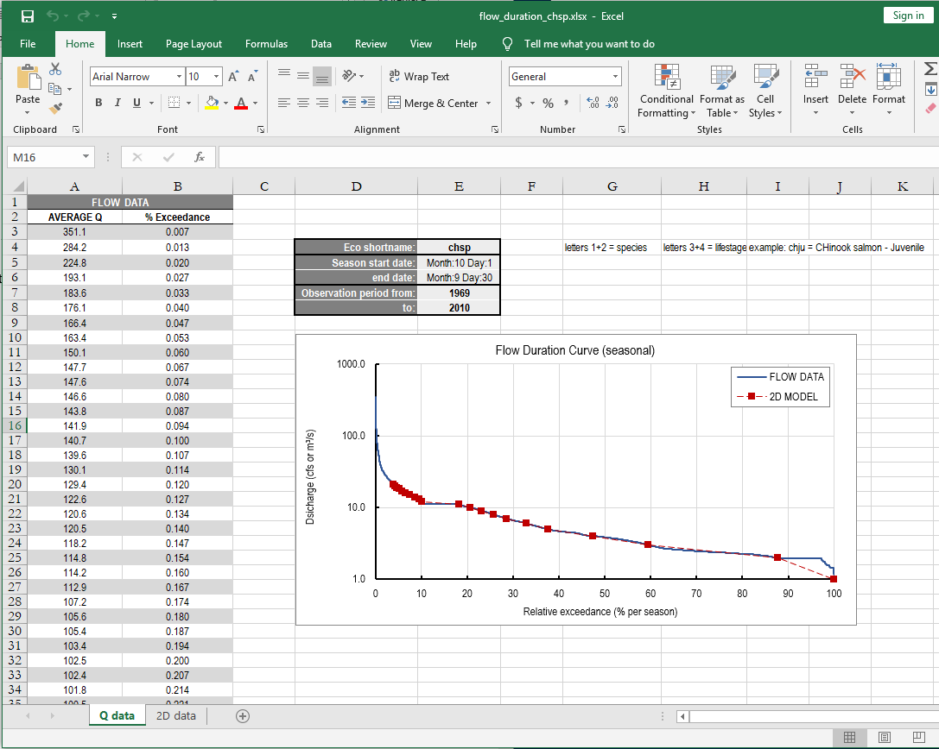

1. Click “Return to Main Window”

**Ecohydrualics**

1. Go to “Ecohydraulics” tab and change the unit if needed

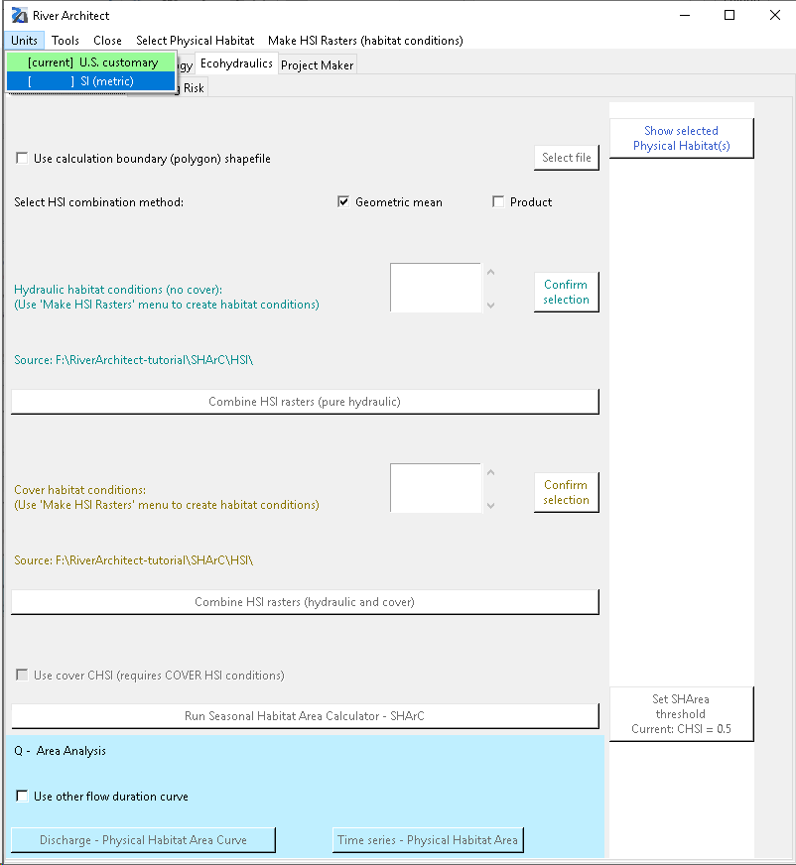

1. From the manu bar, click “Select Physical Habitat” and select the fish species – In this tutorial, select “Chinook salmon – spawning”

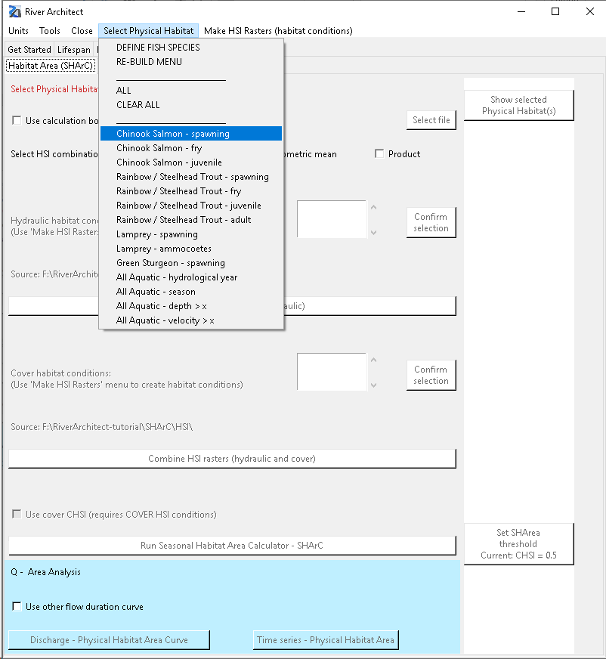

* 1. You can check the selected physical habitats by clicking “Show selected Physical Habitat(s)”.
  2. If you want to remove your selections, go to “Select Physical Habitat” and click “CLEAR ALL”.

1. From the manu bar, click “Make HIS Rasters (habitat conditions” and click “Flow depth – flow velocity HSIs”
   1. Click “VanillaC4” and “Select”

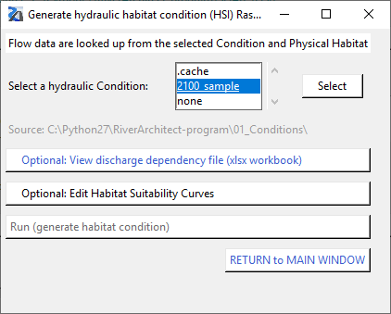

1. Click “View discharge dependency file (xlsx workbook)” will pop up. Review the plot. This file is SHArC\SHArea\2100_sample_sharea_chsp.xlsx. Close the window.

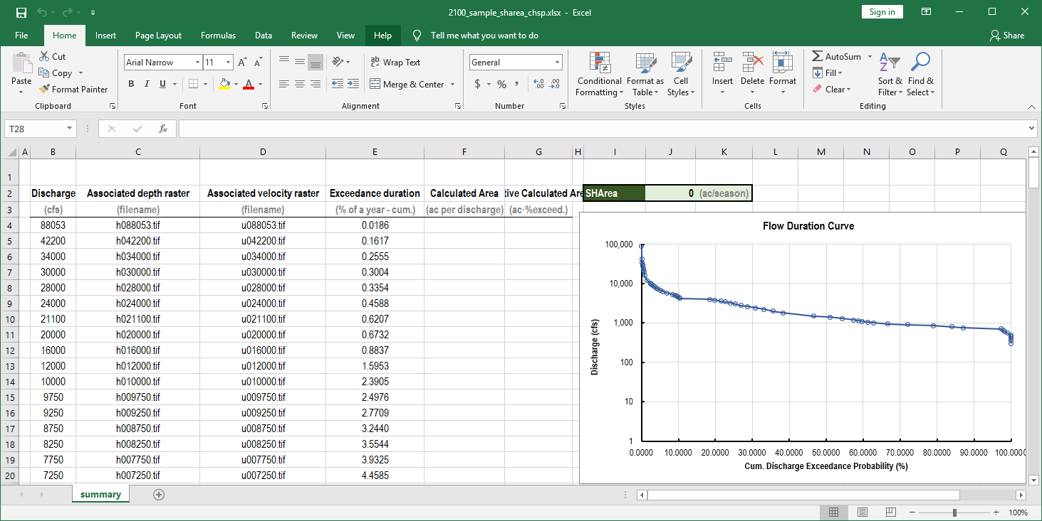

1. Click “Run (generate habitat condition)”
2. Click “Return to Main Window”
3. Now, a new condition, “2100_sample” for Hydraulic/Cover habitat conditions is generated.

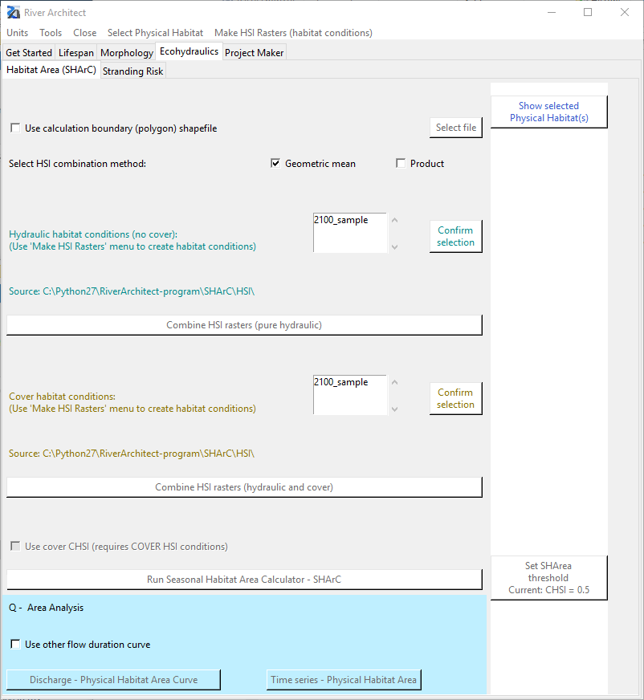

1. Select 2100_sample condition for both hydraulic and cover habitat conditions and click “Confirm selection”
2. Click “Combine HIS rasters (pure hydraulic)”



1. Click “Run Seasonal Habitat Area Calculator – SHArC”



1. Check the result file: SHArC\SHArea\2100_sample_sharea_chsp.xlsx
2. Repeat 3. ~ 23. for InphaseC4 and OutphaseC4 cases.

**HSI and CHSI**

**SHArea Curves**

**Adding more species**

1. First, you need to create flow duration curve for the species you are interested in. Go to “Get Started” tap and click “Analyze Flows”
2. Select season/target species and click “Add”. Multiple selection is available.
3. Click “Make flow duration curve(s)”