**River Architect**

1. With 2100_sample dataset
   1. Run RiverArchitect
      * C:\Python27\RiverArchitect\program\Start_River_Architect.bat

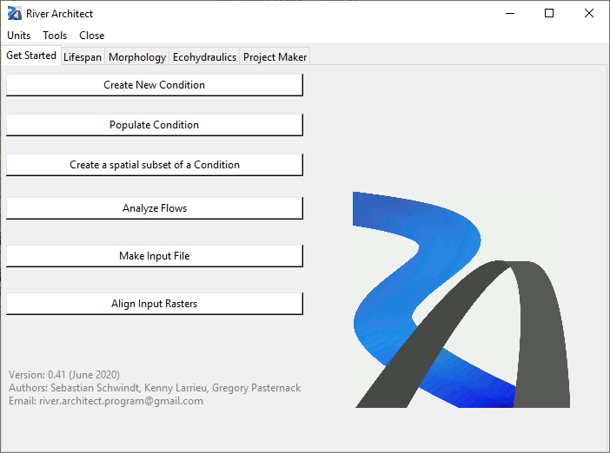

* 1. In “Get Started” tab - <https://riverarchitect.github.io/RA_wiki/Signposts#getstarted>, Click “Create New Condition”
     + Select u, h, DEM, Grain size raster as below

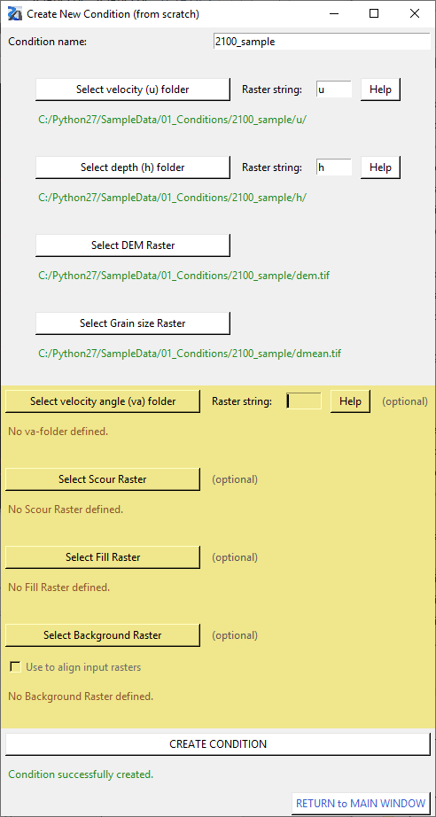

* 1. Click “Return to Main window”
  2. Then this INFO window will pop up:

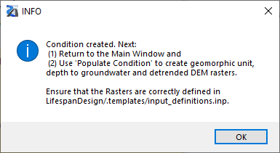

* 1. Restart River Architect

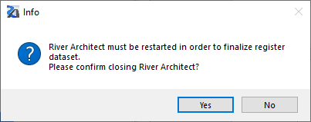

* 1. In 1), select 2100_sample and click “Analyze Discharge” and select 2100_sample and analyze.

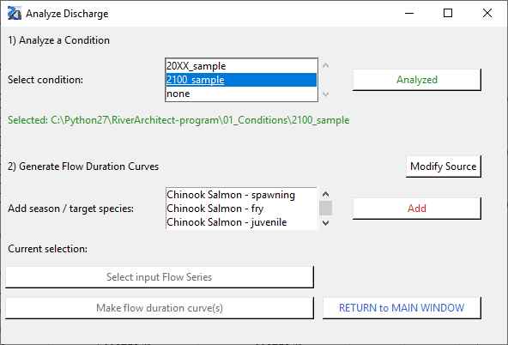

* 1. Then an excel sheet would pop up – manually type in Return periods and save the file.

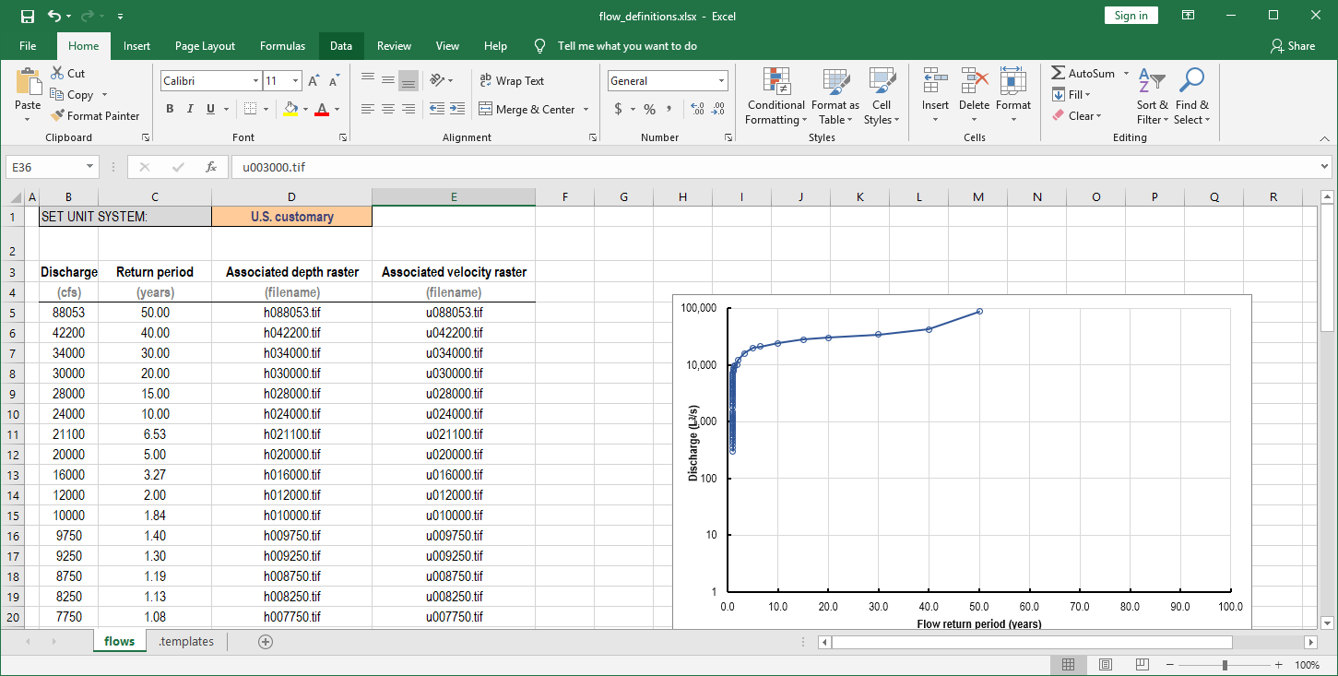

* 1. In 2), select one of the season/target species and click “Add”- in this tutorial, select Chinook Salmon - spawning
  2. Select flow series from C:\Python27\RiverArchitect-program\00_Flows\InputFlowSeries

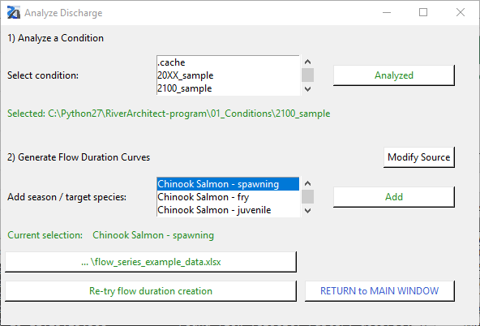

* 1. Click “Make flow duration curve”. Then the result excel file will pop up.

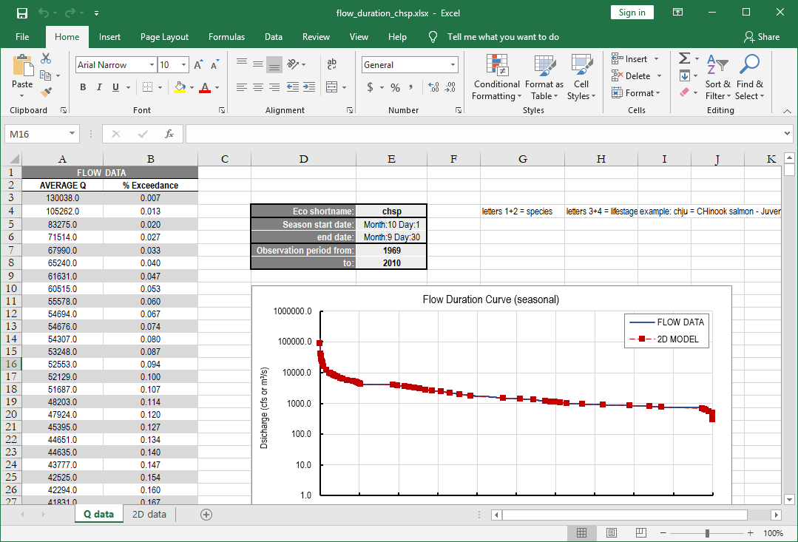

* 1. Click “Return to Main Window”
  2. Go to “Ecohydraulics” tab

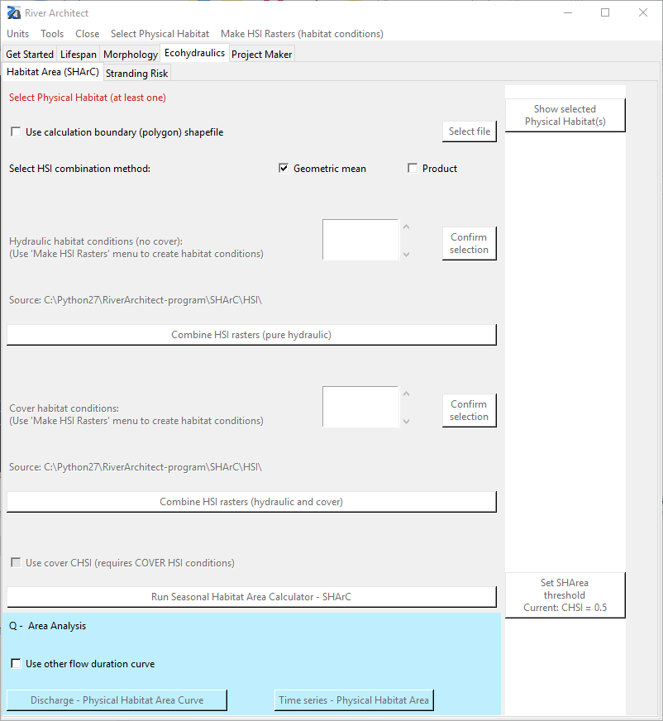

* 1. From the manu bar, click “Select Physical Habitat” and select the fish species – In this tutorial, select “Chinook salmon – spawning”
  2. You can check the selected physical habitats by clicking “Show selected Physical Habitat(s)”.
     + If you want to remove your selections, go to “Select Physical Habitat” and click “CLEAR ALL”.
  3. From the manu bar, click “Make HIS Rasters (habitat conditions” and click “Flow depth – flow velocity HSIs”
  4. Click “2100_sample” and “Select”

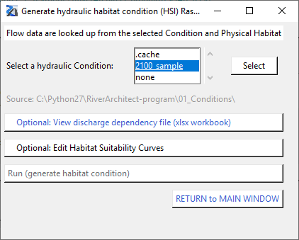

* 1. After the process has finished, you can check the dependency file by clicking “View discharge dependency file (xlsx workbook)” - this file is SHArC\SHArea\2100_sample_sharea_chsp.xlsx

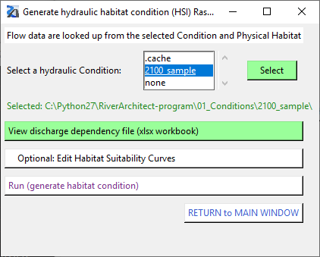

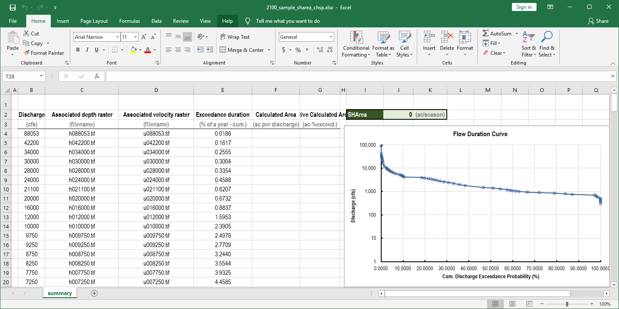

* 1. Click “Run (generate habitat condition)”
  2. Click “Return to Main Window”
  3. A new condition, “2100_sample” for Hydraulic/Cover habitat conditions is generated.

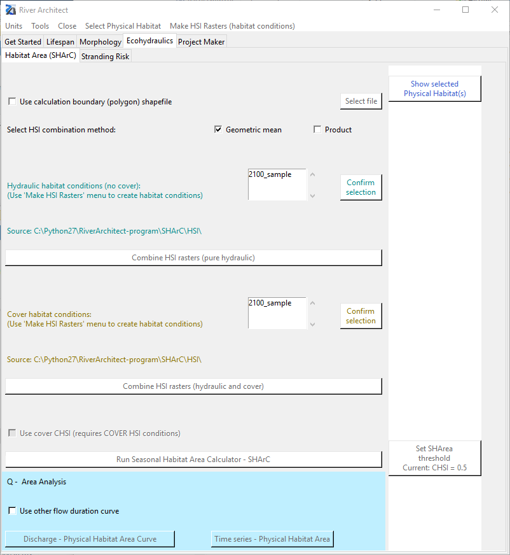

* 1. Select 2100_sample condition for both hydraulic and cover habitat conditions and click “Confirm selection”
  2. Click “Combine HIS rasters (pure hydraulic)”
  3. Click “Run Seasonal Habitat Area Calculator – SHArC”
  4. Check the result file: SHArC\SHArea\2100_sample_sharea_chsp.xlsx Now, the columns for “Calculated Area” and “Active Calculated Area” are filled.

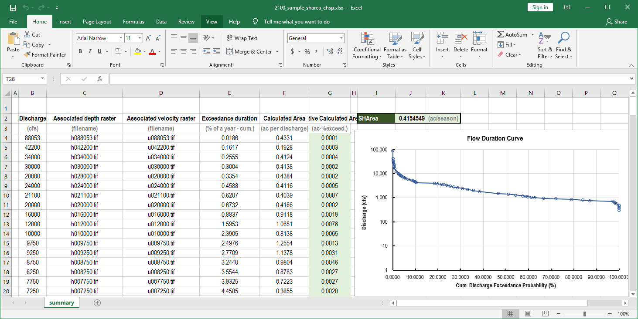

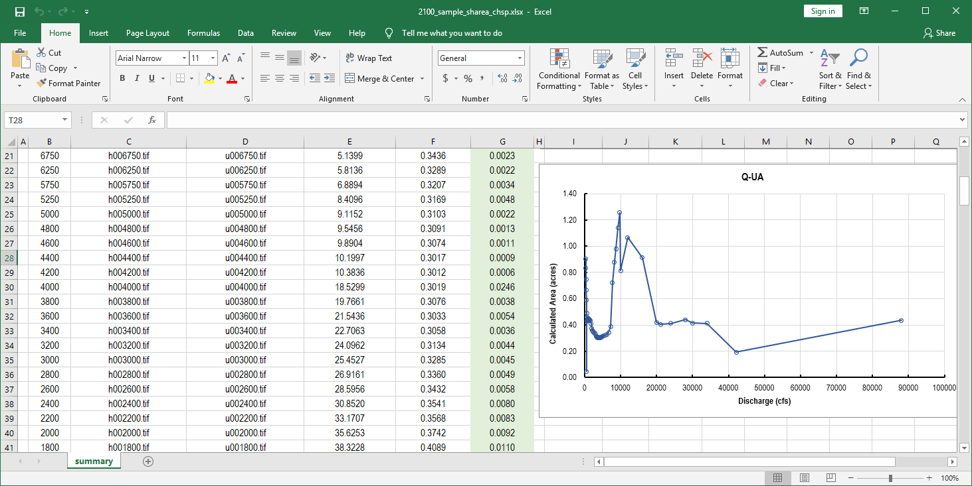

* 1. Click “Discharge – Physical Habitat Area Curve”
  2. Check the result file: SHArC\SHArea\ 2100_sample_QvsA_chsp_stats.xlsx

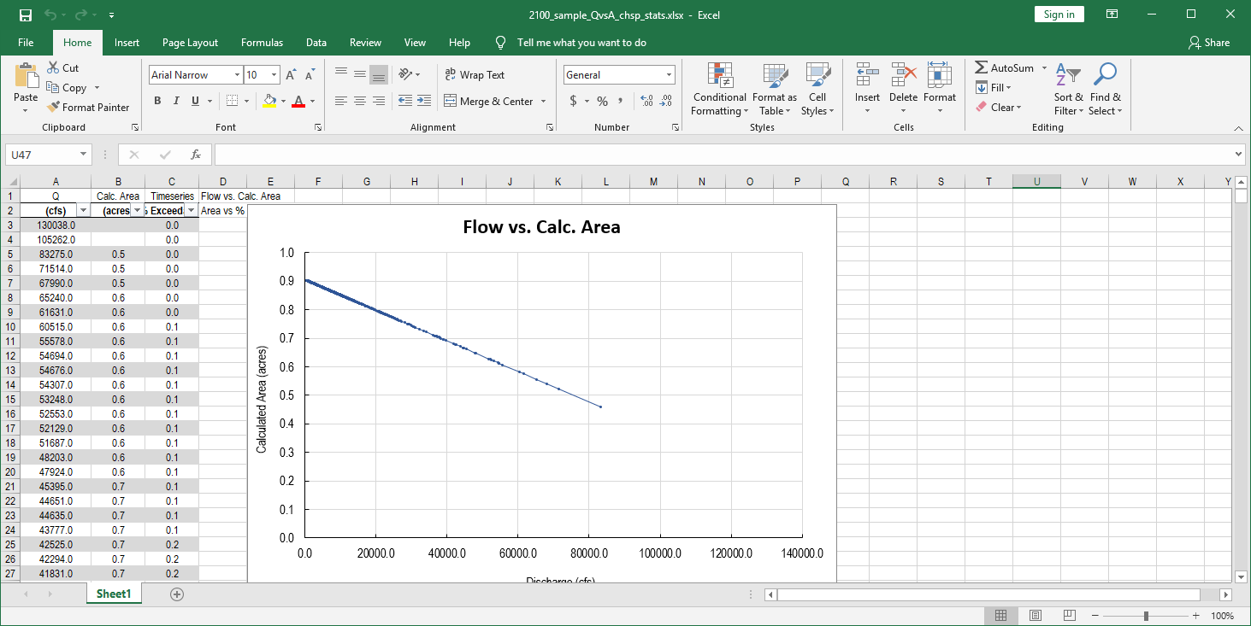

* 1. Click “”
  2. Select the flow series (e.g. InputFlowSeries: flow_series_example_data.xlsx)

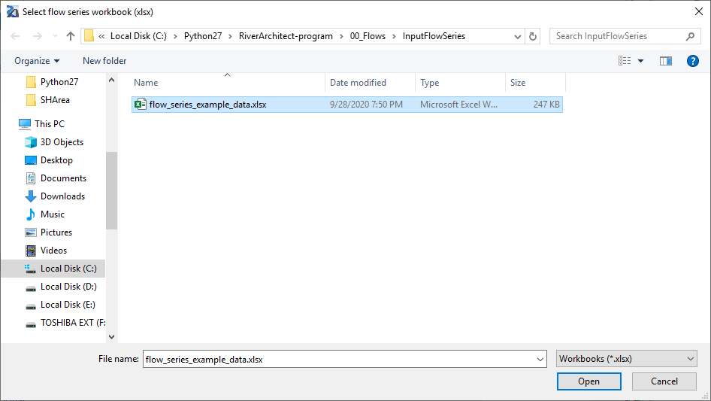

* 1. Check the result file: SHArC\SHArea\ 2100_sample_QvsA_chsp_time.xlsx

Result:

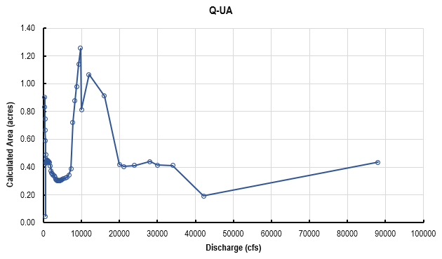

Expected:

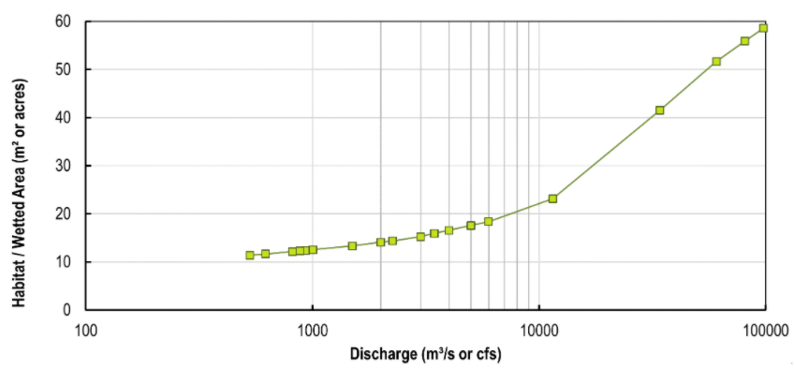

u042200.tif

Min: 0

Max: 11.77

Mean: 7.229

Std: 2.605

u088053.tif

Min: 0

Max: 5.5

Mean: 0.67

Std: 1.3

h042200.tif

Min: 0

Max: 22.03

Mean: 10.68

Std: 5.85

h088053.tif

Min: 0

Max: 6.83

Mean: 0.86

Std: 1.6