**1. Correlation Heatmap of the CWUR Dataset**

**Comprehension:**

* The World Rank is strongly correlated with Publications and Influence. High-ranking universities are often associated with better research outputs and more citations.
* Score has a negative correlation with Year, that over time, universities have been doing things differently or new metrics affecting rankings.

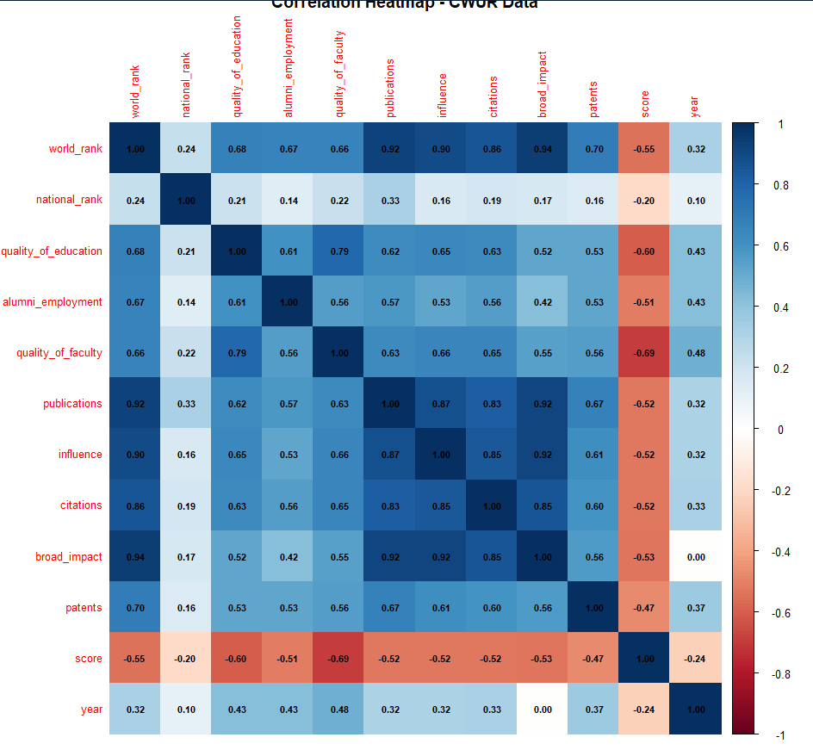

* **Key Findings**:
  + **Publications and Impact:** Strong relationship with 0.92-Universities with higher publication tend to have higher impact.
  + **o World Rank and Publications:** Strong correlation (0.92) — More publications tend to imply higher ranking in the world.
  + **Score and Year:** Slightly negative correlation with a coefficient of -0.55, hence ranking in later years might not be the same as in past years, due to alteration in data.

**2. Correlation Heatmap - Shanghai Data**

* **Insight**:
  + The correlation coefficients show that the Total Score is most associated with Award, HICI, and NS (Normalized Score).
  + Year shows little correlation, thus indicating that over time, rankings haven't changed much for the variables measured.

* **Key Findings**:
  + **Total Score and Reward:** very strong positive correlation (0.83).
  + **Total Score and HICI:** High positive correlation: (0.87).
  + **Year**: Highly Correlates with most variables that imply very little year-to-year effect..

**3. Correlation Heatmap - Times Data**

* **Insight**:
  + Teaching and Research have an extremely high correlation: 0.91, which suggests that universities are well on one measure as they are on the other.
  + Student-Staff Ratio has weak negative correlations with Total Score, so that institutions with high student/staff ratio tend to score lower.

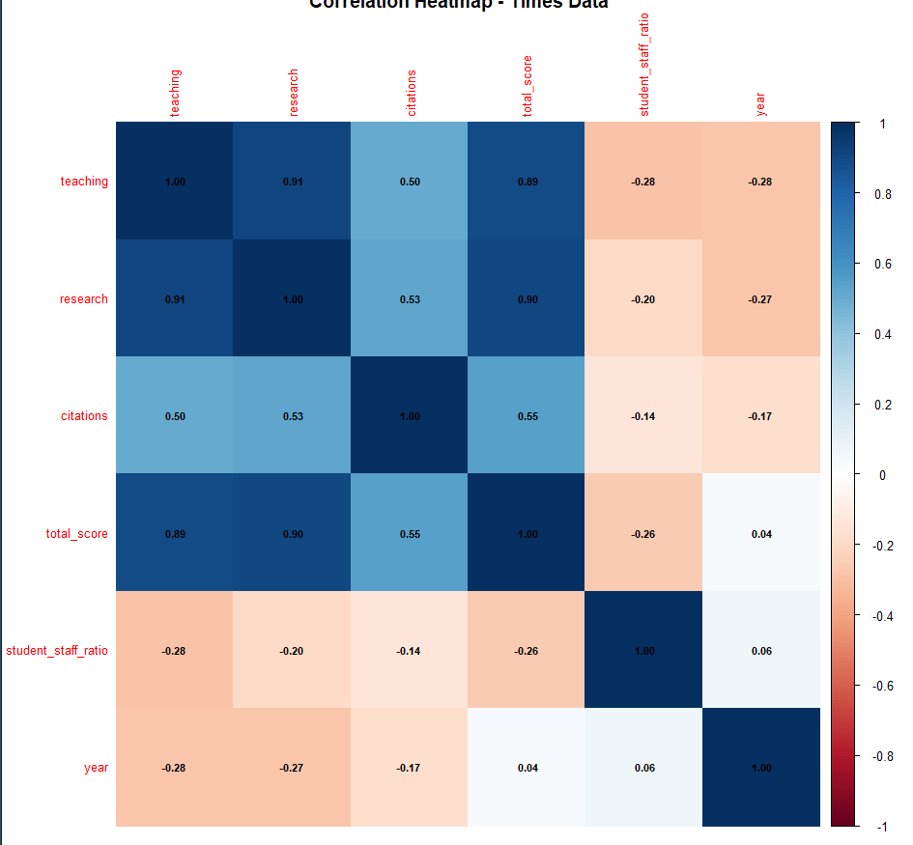

* **Key Findings**:
  + **Teching and Research:** High positive correlation of 0.91.
  + **Citation and Total Score:** Moderate positive correlation of 0.55.
  + **Student-Staff Ratio:** Weak negative correlation (-0.26).

**4. Bar Chart - Country Distribution (CWUR Data)**

* **Insight**:

The USA obviously leads the count in this set of data, with universities, while others are much behind.

* **Key Findings**:
  + USA has far more universities than that of other countries which testifies to its influence in higher education worldwide.

**5. Top 10 University Distribution - Shanghai Data**

* **Insight**:
  + he data set shows that the concentration of universities, such as the University of Maryland and Queen's University, appear in the top 10, and it suggests that these are the most frequently ranking universities in the list.

* **Key Findings**:
  + Top 10 universities are extremely geographically concentrated and are located mostly in the USA and UK.

**6. Top 10 University Distribution - Times Data**

* **Insight**:
  + As in the case with Shanghai data, the top 10 universities on this list too are much represented by California Institute of Technology, Brown University, and others.

* **Key Findings**:
  + Most of the world's top-ranked universities are present in the USA and the UK, reflecting their hegemony in rankings.

**7. Histogram - Distribution of Scores (CWUR Data)**

* **Insight**:
  + The distribution is not uniform, with mostly universities having low scores. Yet some universities reach higher values.

* **Key Findings**:
  + **Right Skew**: Most universities score between 40-60. However, very few score above. Thus, it is a huge variation in university quality

**8. Histogram - Distribution of Total Scores (Times Data)**

* **Insight**:
  + This distribution is more dispersed than that of CWUR, implying a greater variation of scores among universities.

* **Key Findings**:
  + It is peaking at the middle of the distribution, or 50-60, which means that most universities score within this area, although the distribution is more symmetrical.

**9. Histogram - Distribution of Total Scores (Shanghai Data)**

* **Insight**:
  + Like CWUR, the distribution is skewed; there are only a few universities with very high scores, and most fall in between the 20-40 range.

* **Key Findings**:
  + **Right Skew**: Most universities score at the lower end, with a few on the higher side.

**10. Scatterplot Matrix CWUR DATA (Pairplot)**

* **Insight**:
  + The pairplot matrix illustrates the relationships between various pairs of variables. For instance, a notable correlation exists between Citations and Publications, whereas Year exhibits weak correlations with most other metrics.

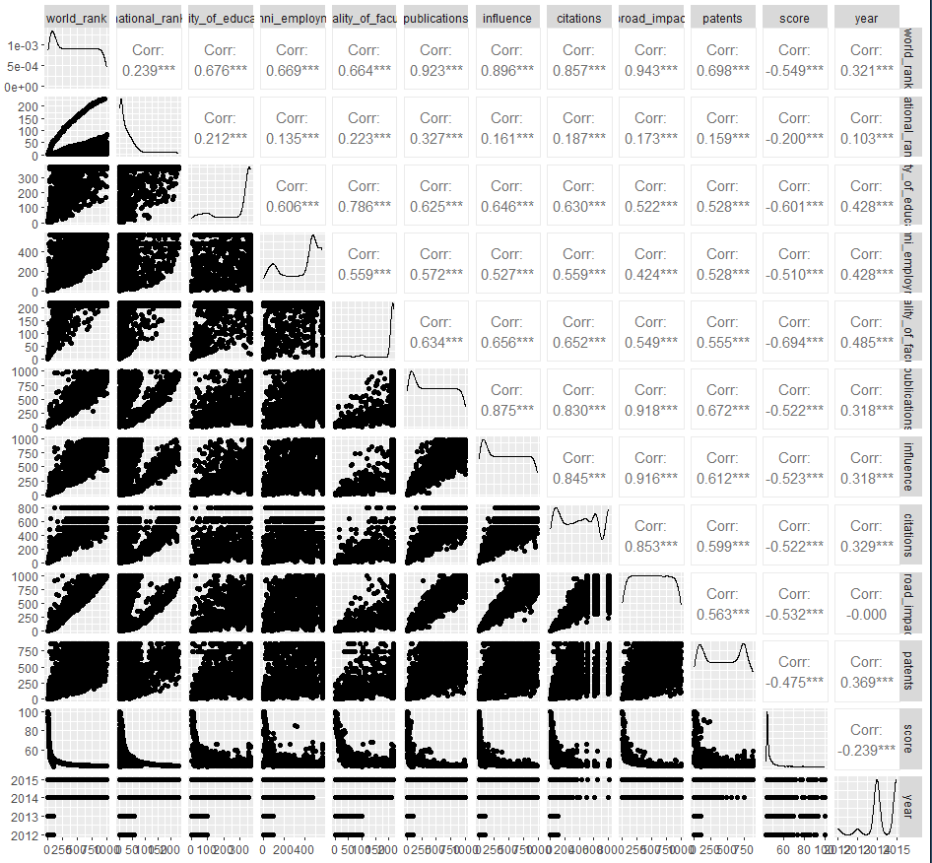

* **Key Findings**:
  + High correlation between Citations and Publications (0.91).
  + A. Again, World Rank is positively correlated with Publications and Influence, but negatively with Score in later years.

**11. Top 20 World Rank Distribution - Shanghai Data**

* **Insight**:
  + he histogram for the international rankings in the Shanghai database shows a few specific ranks dominate, especially in the 200-300 range, with very high frequencies in the ranges of 201-250, 301-350, and 401-450.
  + o The distribution indicates that the rankings in this dataset are more spread out, with a few groups overrepresented, suggesting a few schools at the top ranks, with others generally at lower ranks.

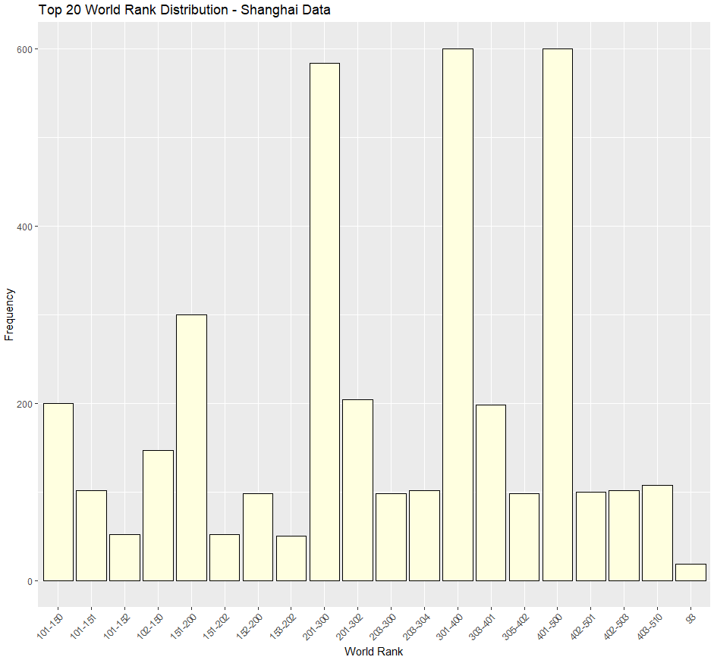

* **Key Findings**:
  + The rank distribution is peaked, especially among 201-300 ranks, meaning that there are intense concentrations of universities in the specific rank categories.
  + This distribution also shows a sharp fall after rank 200 since the count of universities at higher ranks is relatively fewer (101-150 or 501+).

**12. Top 20 World Rank Distribution - Times Data**

* **Insight**:
  + The distribution of world rankings in the Times data is also high within certain rank ranges, particularly in 201-225 and 301-350.
  + While the Shanghai dataset had a stronger number of universities at the middle rankings, this dataset again showed high frequencies in the lower-to-middle ranking categories but dropped significantly as the rankings advanced.

* **Key Findings**:
  + A very sharp peak at 201-225 indicates a concentration of universities here in the middle ranks, which denotes that most of the top-ranked institutions are in this middle range.
  + The prominent tail on the right side of the graph (501-600) suggests that the frequency of rankings larger than 400 are relatively low in the Times dataset.

**13. Distribution of World Rankings - CWUR Data**

* **Insight**:
  + The distribution of CWUR data is highly imbalanced because the peak is mostly on the left, indicating that most universities have lower rankings. This left-skewed peak distribution ensures that most institutions have low global rankings within the 1 to 50 distribution, while only a few universities can reach the top ranks.

* **Key Findings**:
  + This would mean ranking in a very small number, representing highly ranked universities, but with the majority of institutions concentrated in lesser ranking categories (1-1000).
  + This range of 1-50 has shown significant clustering, featuring a strong characteristic of a small elite group of powerful universities in the dataset of CWUR.

**14. Boxplot of Scores - CWUR Data**

* **Insight**:
  + The boxplot of CWUR data shows that scores are mainly tightly bunched together, but in many cases scores between 0-40 university numbers are very high.
  + The existence of outliers reflects the fact that there are several universities with scores that are markedly higher than those of their peers.

* **Key Findings**:
  + A big proportion of universities score below 50%, which implies there must be a gap between the high-ranked and the low-ranked institutions.
  + The presence of a number of outstanding outliers indicates that some institutions truly achieve spectacular scores, whereas universities in general are operating at a significantly different level.

**15. Boxplot of Total Scores - Times Data**

* **Insight**:
  + he Time boxplot shows a similar trend in that most universities are in the range of scores 60-70, thus indicating moderate performance for most universities.
  + With a great number of outliers, this indicates that some universities score well above others.

* **Key Findings**:
  + The boxplot shows a greater consistency in the rankings of the universities because most institutions are distributed between 60-70, while a few universities achieve scores remarkably high.
  + Existence of outliers strengthens the belief that only a few top universities are leading to these inflated rankings in this dataset.

**16. Country Distribution - Education Expenditure**

* **Insight**:
  + Educational expenditures display a uniform geographical distribution as if every country equally contributes to the dataset, indicating that the dataset contains the group of countries under relatively balanced educational expenditure.

* **Key Findings**:
  + The dataset would thus reflect a well-distributed composition, showing equity from different countries, without one nation over-benchmarking the depiction of educational expenditures.
  + The equitable distribution of data can facilitate analysis by mitigating the potential for any individual nation's data to distort the findings associated with educational expenditure.

**17. Top 20 Countries - Educational Attainment**

* **Insight**:
  + Top 20 Countries ranked according to educational attainments distribute across the Continents; it is only a small country like Bhutan and Belize, with an incredible level of their attainments, while in large countries, such as the USA, which was relatively just.

* **Key Findings**:
  + The top 20 countries cover an astonishingly broad range of attainment levels, with some strong outliers showing very high counts in Bhutan and Bermuda and in Benin. The varied distribution of nations underscores the worldwide initiatives aimed at enhancing educational achievement across different areas.

**18. Pairplot for Times Data (Numerical Columns)**

* **Insight:**

At this juncture, for Times Data, the pairplot produced here gives the graphical view of interdependencies of the numerical variables, such as Teaching, Research, Citations, Total Score, Student-Staff Ratio and Year. The diagonal elements take the form of the distribution of each individual metric, and off-diagonal represents scatter plots describing bivariate relationships between pairs of metrics. The correlation coefficient enables the strength and direction of the relationships that exist between variables.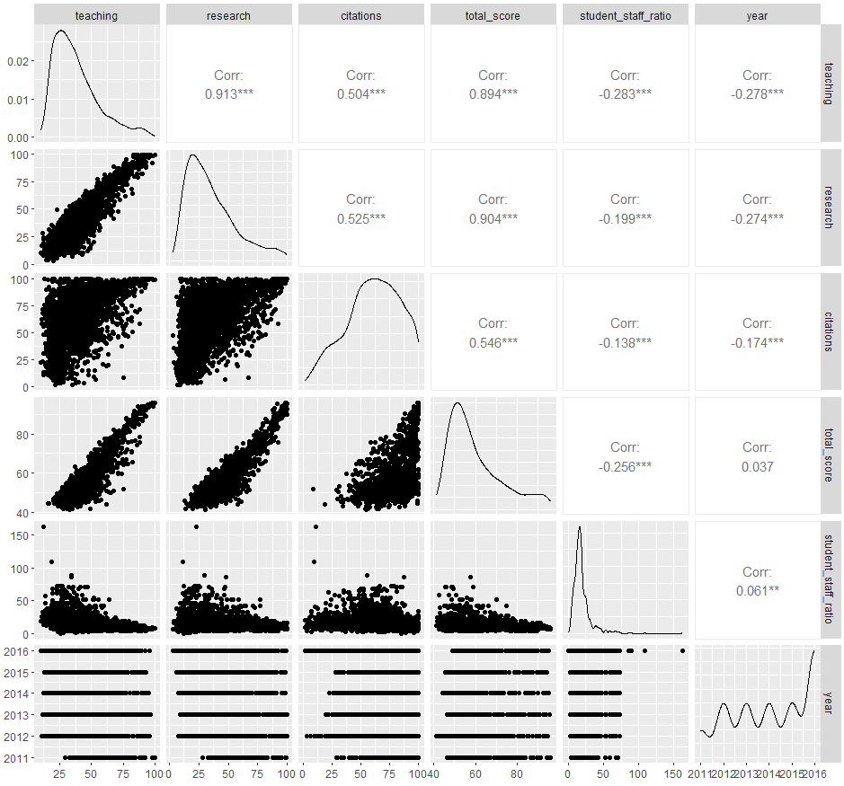

* **Key Findings:**
  + Strong positive correlation (0.91), suggesting that universities excelling in teaching also perform well in research.
  + Moderate positive correlation of 0.52. This means that greater citation counts tend to correspond to more research.
  + High positive correlation (0.89), showing that universities with better research and citation records have higher overall scores.
  + High positive correlation of 0.90, which means that universities which do better in teaching have better rankings.
  + The presence of weak to moderate negative correlations with alternative metrics suggests only a mild decline in performance as the student-staff ratio increases.
  + Weak correlation with most variables, implying low influence over time.