**Part A**

**Stoichiometric matrix (18 x 21):**

|  |  |  |  |  |  |  |  |  |  |  |  |  |  |  |  |  |  |  |  |  |  |
| --- | --- | --- | --- | --- | --- | --- | --- | --- | --- | --- | --- | --- | --- | --- | --- | --- | --- | --- | --- | --- | --- |
|  | v1 | v2 | v3 | v4 | v5,f | v5,r | b1 | b2 | b3 | b4 | B5 | B6 | B7 | B8 | B9 | B10 | B11 | B12 | B13 | H2O | H2O,REV |
| ATP | **-1** | **0** | **0** | **0** | **0** | **0** | **0** | **0** | **0** | **0** | **1** | **0** | **0** | **0** | **0** | **0** | **0** | **0** | **0** | **0** | **0** |
| Citrulline | -1 | 0 | 0 | 1 | 2 | -2 | 0 | 0 | 0 | 0 | 0 | 0 | 0 | 0 | 0 | 0 | 0 | 0 | 0 | 0 | 0 |
| Aspartate | -1 | 0 | 0 | 0 | 0 | 0 | 0 | 1 | 0 | 0 | 0 | 0 | 0 | 0 | 0 | 0 | 0 | 0 | 0 | 0 | 0 |
| AMP | 1 | 0 | 0 | 0 | 0 | 0 | 0 | 0 | 0 | 0 | 0 | -1 | 0 | 0 | 0 | 0 | 0 | 0 | 0 | 0 | 0 |
| PPi | 1 | 0 | 0 | 0 | 0 | 0 | 0 | 0 | 0 | 0 | 0 | 0 | -1 | 0 | 0 | 0 | 0 | 0 | 0 | 0 | 0 |
| Argininosuccinate | 1 | -1 | 0 | 0 | 0 | 0 | 0 | 0 | 0 | 0 | 0 | 0 | 0 | 0 | 0 | 0 | 0 | 0 | 0 | 0 | 0 |
| Fumerate | 0 | 1 | 0 | 0 | 0 | 0 | 0 | 0 | -1 | 0 | 0 | 0 | 0 | 0 | 0 | 0 | 0 | 0 | 0 | 0 | 0 |
| Arginine | 0 | 1 | -1 | 0 | -2 | 2 | 0 | 0 | 0 | 0 | 0 | 0 | 0 | 0 | 0 | 0 | 0 | 0 | 0 | 0 | 0 |
| H20 | 0 | 0 | -1 | 0 | 4 | -4 | 0 | 0 | 0 | 0 | 0 | 0 | 0 | 0 | 0 | 0 | 0 | 0 | 0 | -1 | 1 |
| Ornithine | 0 | 0 | 1 | -1 | 0 | 0 | 0 | 0 | 0 | 0 | 0 | 0 | 0 | 0 | 0 | 0 | 0 | 0 | 0 | 0 | 0 |
| Urea | 0 | 0 | 1 | 0 | 0 | 0 | 0 | 0 | 0 | -1 | 0 | 0 | 0 | 0 | 0 | 0 | 0 | 0 | 0 | 0 | 0 |
| Carbamoyl phosphate | 0 | 0 | 0 | -1 | 0 | 0 | 1 | 0 | 0 | 0 | 0 | 0 | 0 | 0 | 0 | 0 | 0 | 0 | 0 | 0 | 0 |
| Pi | 0 | 0 | 0 | 1 | 0 | 0 | 0 | 0 | 0 | 0 | 0 | 0 | 0 | -1 | 0 | 0 | 0 | 0 | 0 | 0 | 0 |
| O2 | 0 | 0 | 0 | 0 | -4 | 4 | 0 | 0 | 0 | 0 | 0 | 0 | 0 | 0 | 1 | 0 | 0 | 0 | 0 | 0 | 0 |
| NADPH | 0 | 0 | 0 | 0 | -3 | 3 | 0 | 0 | 0 | 0 | 0 | 0 | 0 | 0 | 0 | 1 | 0 | 0 | 0 | 0 | 0 |
| H+ | 0 | 0 | 0 | 0 | -3 | 3 | 0 | 0 | 0 | 0 | 0 | 0 | 0 | 0 | 0 | 0 | 1 | 0 | 0 | 0 | 0 |
| NO | 0 | 0 | 0 | 0 | 2 | -2 | 0 | 0 | 0 | 0 | 0 | 0 | 0 | 0 | 0 | 0 | 0 | -1 | 0 | 0 | 0 |
| NADP+ | 0 | 0 | 0 | 0 | 3 | -3 | 0 | 0 | 0 | 0 | 0 | 0 | 0 | 0 | 0 | 0 | 0 | 0 | -1 | 0 | 0 |

**Part B**

**Elemental balance matrix:**



To determine if the cycle is elementally balanced, you can use the formula

E = AT * S

My cycle is balanced because the first six entries are 0.

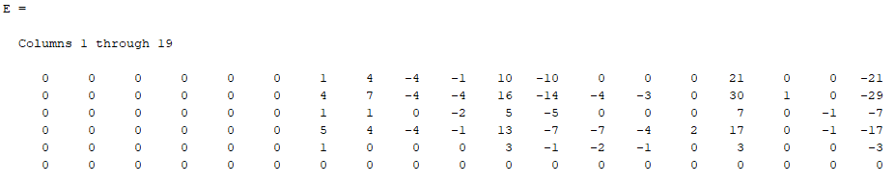

**Part C**

We have the constraints

$$0≤v_{i}≤kcat,i*E* θ* ∏\frac{x_{i}}{K_{M}+x_{i}}$$

$$0≤b_{i}≤10\frac{mmol}{gDW-hr}$$

The max flux is calculated to be:

