Sharon’s Cookbook

# Breads

## Christmas Eggnog Bread

**Category**: Breads  
 **Cooking method**: Baking  
 **Yield**: 1 loaf  
 **Prep time**: PT15M  
 **Cook time**: PT1H  
 **Total time**: PT1H15M

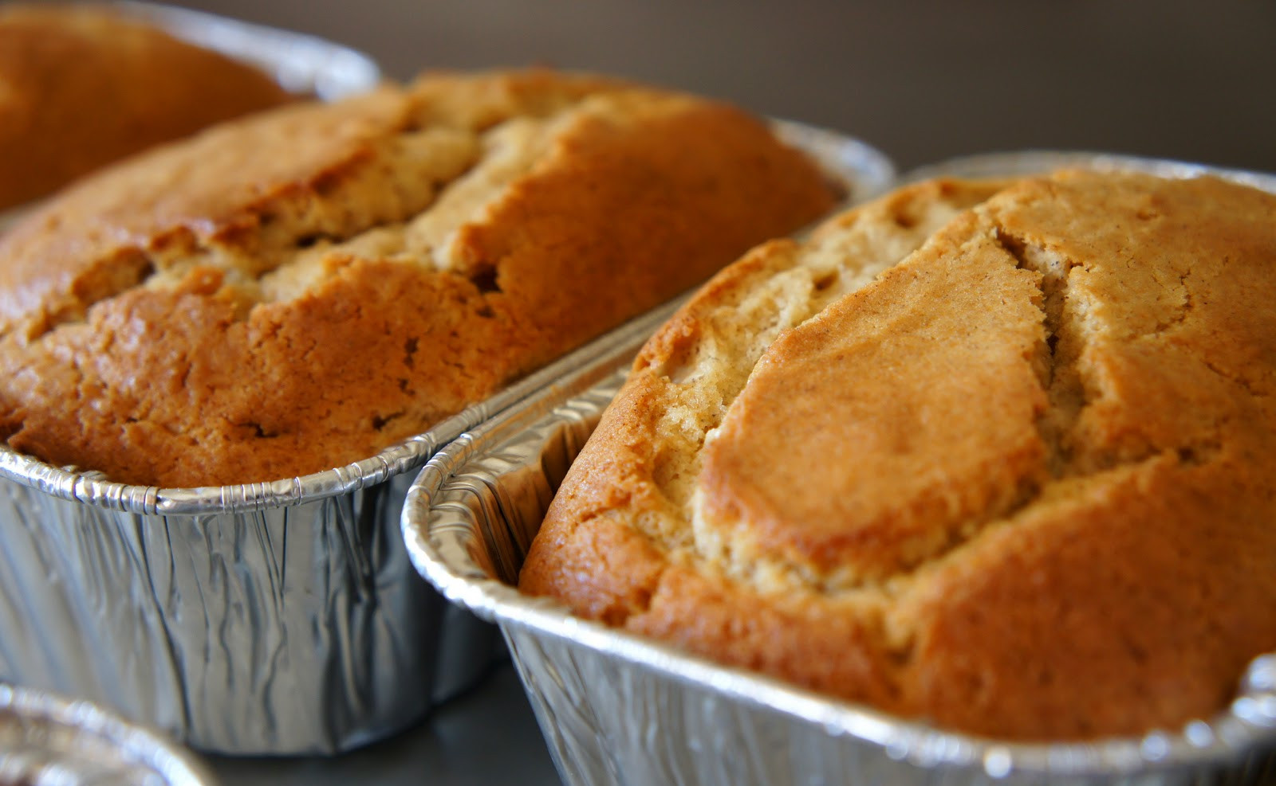

### About

Mom Cz

### Ingredients

* 3 c. flour
* ¾ c. sugar
* 1 t. baking powder
* 1 t. salt
* ½ t. nutmeg
* 1 ½ c. eggnog
* 1 beaten egg
* ¼ c. softened butter
* 1 c. raisins
* ½ c. red cherries
* ½ c. green cherries
* ¾ c. chopped nuts

### Steps

Mix dry ingredients, wet ingredients, and mix.

Bake at 350℉ for 60 minutes in a greased loaf pan.

Cool on rack.

## Unkneaded Homemade Bread

**Category**: Breads

### Steps

### Ingredients

1 package active dry yeast

1 ¼ c. warm water

2 T. butter, softened

2 T. sugar

2 t. salt

3 ½ c. unsifted flour

### Steps

Add yeast to water and stir. Then add the butter, sugar, salt, and 3 c. flour.

Beat until smooth and sticky-looking and no flour sticks to the side of the bowl.

Stir in 1-1 ½ c. more flour to make a soft dough.

Cover with a clean towel and let rise about 35 minutes.

Stir down and spread evenly in greased bread pans (not over half full).

Cover lightly and let rise about 40 minutes.

Bake at 350℉ (glass) or 375℉ (metal) for 45 minutes.

Bread should be lightly browned on top and make a hollow pound.

Cool on racks.

# Cakes

## Blueberry Cake

**Category**: Cakes

### Steps

### Ingredients

#### Cake

2 c. flour, sifted

½ t/ salt

¾ c. sugar

½ c. milk

2 t. baking powder

¼ c. butter

1 egg, unbeaten

2-3 c. blueberries

#### Topping

½ c. sugar

½ t. cinnamon

¼ c. flour

¼ c. butter

### Steps

Mix cake ingredients and topping ingredients separately. Pour cake batter into a flat pan, then cover with the topping. Bake at 375℉ for 40-50 minutes.