**Q2 Answer: Music Streaming Partner X Using AWS Architecture**

**High level overview**

It is a solid decision for the Music Streaming Partner X to adopt using AWS for modernizing their app architecture for cloud enablement. AWS is the leader in the cloud space with the most market share (32% of total cloud) and many hundreds of new features and technologies added each year, including media focused services. The bandwidth is wide reaching across every major geo which allows for redundancy for high availability and fail over and caching so that music can be streamed and searched quickly between regions and zones. Partner X Streaming Subscriber Playlists can saved and backed up without having to worry about losing data or slow retrieval of metadata . Included with AWS Services are a wide range of levels for support and costs. The pay up front options and pay for usage with AWS service monitoring tools will allow for Partner X business to grow. This should also yield an increase in development time, while support, security, and infrastructure shifts to AWS.

**AWS Global Infrastructure Terminology**

Keep in mind that the robust array of AWS services, stability, and high availability across the globe is due to the Global Infrastructure.

**AWS Region:** A physical location of clustered data centers.

* Each AWS Region consists of multiple, isolated, and physically separate Availability Zones's within a geo.

**AWS Availability Zone (AZ):** One or more data centers with redundant power, networking, and connectivity in an AWS Region.

* Host production applications and databases that are more highly available, fault tolerant, and scalable compared to a single data center.
* All AZ’s in each Region are networked with high-bandwidth, low-latency, fully redundant, and high-throughput.
* All traffic between AZ’s is encrypted.

**AWS Edge Locations: L**ocated in most of the major cities around the world and are used by CloudFront Content Delivery Network (CDN) to distribute content to end user to reduce latency

* Maintained by AWS through a worldwide network of data centers for the distribution of content.

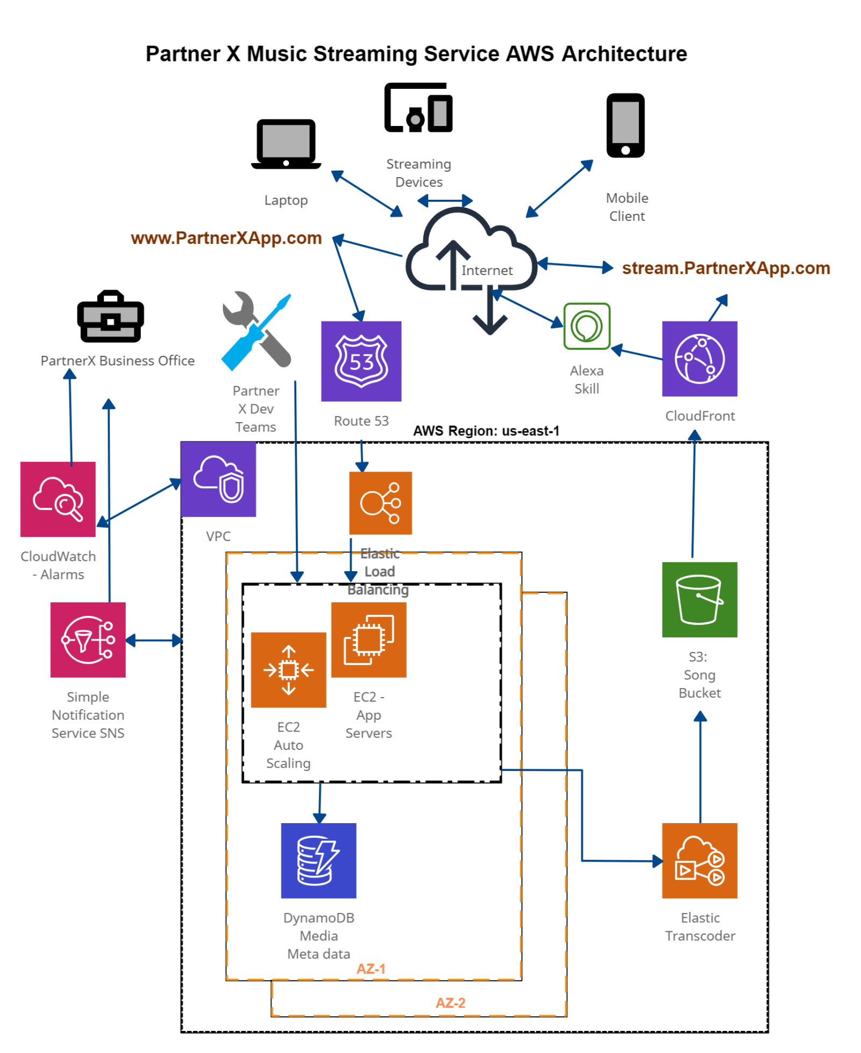

**AWS Services to Leverage for Partner X Music Stream Service**

|  |  |
| --- | --- |
|  |  |
| **EC2** | * Amazon Elastic Compute Cloud (Amazon EC2) is a web service that provides secure, resizable compute capacity * Designed to make web app cloud computing scalable for developers * The Partner X Dev and Ops Teams will be setting up EC2 images for Web App Development. * These are the virtual machines in the cloud on which you have the OS level control. * Nearly 400 instances available for broad and deep computing platforms with choices of processor, storage, networking, and operating systems. * Partner X can increase or decrease capacity within minutes. * AWS EC2 instance is like Partner X is renting a server from AWS on an hourly basis. This results in cost saving for hardware that will depreciate upon arrival. |
|  |  |
| **EC2 Autoscaling** | * EC2 Auto Scaling allows scalability in the EC2 capacity up or down automatically according to defined conditions. * Partner X can ensure that the number of Amazon EC2 instances used increases with demand to maintain performance and auto decreases at lulls to minimize costs. * Dynamic scaling responds to changing demand and predictive scaling automatically schedules the right number of EC2 instances based on predicted demand. * EC2 Auto Scaling detects impaired EC2 instances and unhealthy applications, and replaces the instances without your intervention. * This will allow for the Partner X web apps to perform at a constant and predictable level and help with cost savings. |
|  |  |
| **Elastic Load Balancing** | * Elastic load balancing helps to distribute incoming application traffic across multiple Amazon EC2 instances. * If a server can’t handle the traffic then a replica of that server will be added to balance the load to keep the Partner X streaming service running smoothly. * Elastic Load Balancing automatically distributes incoming application traffic across multiple targets, such as Amazon EC2 instances, containers, IP addresses, and virtual appliances. * It has native awareness of failure boundaries in the AZs to keep Partner X applications available across a region, without requiring Global Server Load Balancing. * This will result in no disruptions of the Partner X app servers for not only the end users, but also the development teams. |
|  |  |
| **VPC** | * VPC (Virtual Private Cloud) is the private network in Cloud in which Partner X will deploy all of it’s resources. Think of it as like host all AWS services in a single hardware rack. * This allows you to better isolate and secure resources and keep all AWS services under the same network. * Partner X will have complete control over your virtual networking environment, including selection of your own IP address range, creation of subnets, and configuration of route tables and network gateways. * VPC will allow Partner X to use multiple layers of security, including security groups and network access control lists, to help control access to Amazon EC2 instances in each subnet. * Partner X will be able to secure their steaming website by creating security group rules which allow the web server to respond to inbound HTTP and SSL requests from the internet while simultaneously prohibiting the web server from initiating outbound connections to the internet. |
|  |  |
| **Route 53** | * Route 53 is the AWS highly available DNS (Domain Name System) service. * Partner X can register domain names through this service. * It is designed to give developers and businesses an extremely reliable and cost effective way to route end users to Internet applications by translating names that computers use to connect to each other. * Partner X can use Amazon Route 53 to configure DNS health checks to route traffic to healthy endpoints or to independently monitor the health of your application and its endpoints. * Amazon Route 53 is built using AWS’s highly available and reliable infrastructure. The distributed nature of our DNS servers helps ensure a consistent ability to route your end users to your application. * This includes failover to re-route your users to an alternate location if Partner X primary application endpoint becomes unavailable. * It is designed to automatically route your users to the optimal location depending on network conditions. * As a result, the service offers low query latency for Partner X music streamers. |
|  |  |
| **S3** | * Amazon Simple Storage Service (Amazon S3) is an object storage service that offers scalability, data availability, security, and performance. * Partner X can use this service to store images and other files for websites. We can keep our backups and share files between our AWS services. * Partner X can use it to store and protect any amount of data for a range of use cases, including music, websites, mobile applications, backup /restore, archives, and IoT devices. * Amazon S3 is designed for 99.999999999% (11 9’s) of data durability because it automatically creates and stores copies of all S3 objects across multiple systems. * Partner X will save costs without sacrificing performance by storing data across the S3 Storage Classes, which support different data access levels at corresponding rates. |
|  |  |
| **CloudFront** | * AWS CloudFront is the highly secure CDN (Content Delivery Network) that includes Edge location that can cache Partner X streaming content and searches. * AWS uses a global network of edge locations and regional edge caches that cache copies of our content close to Partner X end users. * This ensures streaming requests are served by the closest edge location. As a result, music streaming requests travel a short distance, improving performance for the viewers. |
|  |  |
| **DynamoDB** | * DynamoDB is the AWS highly scalable, high-performance NoSQL database and provides single-digit millisecond latency at any scale. * It iss a fully managed, multi-region, multi-active, durable database with built-in security, backup and restore, and in-memory caching for internet-scale applications. * Partner X will no longer need to maintain servers, patch, or manage and no software to install, maintain, or operate. * This will store the Partner X streaming metadata database for mobile, web, IoT, and other applications that need low-latency data access at any scale. * DynamoDB global tables replicate your data across multiple AWS Regions to give you fast, local access to data for your globally distributed applications. * It automatically scales tables up and down to adjust for capacity and maintain performance. |
|  |  |
| **Simple Notification Service (SNS)** | * Amazon SNS (Simple Notification Service) will allow Partner X to send budget alerts to stakeholders across the organization by configuring an Amazon SNS topic. * This can be used to enable Amazon SNS alerts for budgets. * SNS can send Partner X notifications in the form of email, SMS, and ticketing systems regarding the Partner X AWS services. |

**Additional AWS Services to Consider:**

|  |  |
| --- | --- |
|  |  |
| **Amazon Elastic Transcoder** | * Amazon Elastic Transcoder is a highly scalable, easy to use and cost effective way for developers and businesses to convert (or “transcode”) video and audio files from their source format into versions that will playback on devices like smartphones, tablets and PCs. * This will enables Partner X to focus on your content, such as the devices you want to support and the quality levels you want to provide, rather than managing the infrastructure and software needed for conversion. * Partner X can use Amazon Elastic Transcoder to convert video and audio files into supported output formats optimized for playback on desktops, mobile devices, tablets, and televisions. * Partner X will only pay according to the output duration of your content. |
|  |  |
| **Alexa Skills Kit (ASK)** | * AWS’s serverless technology that will allows Partner X to run functions in the cloud without having to chose a computer to run the script. * Alexa skills have both an interaction model—or voice user interface—and application logic. When a Partner X end user asks to stream, Alexa processes the speech in the context of the interaction model to determine the customer request. Alexa then sends the request to your skill application logic, which acts on it. * This will bring the Partner X streaming service to the rapidly growing number of Alexa enabled streaming devices. |
|  |  |
| **CloudWatch** | * CloudWatch is a service that can be used to monitor AWS environments like CPU utilization of EC2 and RDS instances and trigger alarms based on different metrics. * Partner X will use the AWS control panel to keep track of how the services are being used. * This service is a monitors and observes services built for Partner X DevOps engineers, developers, site reliability engineers (SREs), and IT managers. * It provides data and actionable insights to monitor your applications, respond to system-wide performance changes, optimize resource utilization, and get a unified view of operational health. |
|  |  |
| **AWS Cost Explorer** | * AWS Cost Explorer has an easy-to-use interface that lets you visualize, understand, and manage Partner X’s AWS costs and usage over time. * The Partner X Business Office can create custom reports and alerts (using SNS) that analyze cost and usage data. * Analyze Partner X data at a high level (total costs and usage across all accounts) or dive deeper into your cost and usage data to identify trends and help with cost savings. |

**AWS Considerations:**

When using AWS, Partner X should not expect a perfect system with a simple setup without some issues arising with moving towards more cloud enablement. AWS is a complex infrastructure with its own rules and laws that Partner X will grow with and know.

There are AWS service limits set by the platform. The restrictions are there to prevent Partner X from spending too much money on your first encounter with the platform and protect the system itself from uncontrolled resource usage.

The Partner X Business Office and Dev Teams should be prepared to learn and invest time in education. AWS is an excellent and extensive platform, and Partner X will need to know how to uses these services wisely and efficiently. To successfully manage the AWS platform, Partner X will need to budget education investment, time, and patience.

Partner X will need to ensure technical support fees are monitored and reviewed frequently in order to ensure that additional costs that dedicated tech support yields a positive return on investment.

**Case Studies for Partner X to Consider: Streaming Music Services Success with AWS**

SoundCloud: <https://aws.amazon.com/solutions/case-studies/soundcloud/>

KKBOX: <https://aws.amazon.com/solutions/case-studies/kkbox/>

Tuned Global: <https://aws.amazon.com/solutions/case-studies/tuned-global/>

**Reference Websites:**

<https://blog.usejournal.com/what-is-aws-and-what-can-you-do-with-it-395b585b03c>

<https://www.ideaminetech.com/blog/aws-services-in-simple-terms/>

<https://aws.amazon.com/products/>

<https://cloudacademy.com/blog/5-aws-limitations-to-be-aware-of/>

<https://docs.aws.amazon.com/whitepapers/latest/aws-overview/media-services.html>

<https://docs.aws.amazon.com/whitepapers/latest/aws-overview/introduction.html>

<https://www.investopedia.com/articles/investing/011316/what-amazon-web-services-and-why-it-so-successful.asp>

<https://aws.amazon.com/what-is-aws/>

<https://aws.amazon.com/what-is-cloud-computing/>

<https://aws.amazon.com/about-aws/global-infrastructure/regions_az/>

<https://www.channele2e.com/channel-partners/csps/cloud-market-share-2020-amazon-aws-microsoft-azure-google-ibm/#:~:text=AWS%20has%20around%2033%25%20cloud,for%2017%25%20of%20the%20market>.