Accounting application

E&D accounting department has requested a new application for their depreciation department. The depreciation department manages accounting for E&D’s massive global property and assets. They often need to do rapid calculations using various depreciation formulas during online discussions with management and customers. Your dev admin assigns the task of building the first iteration of this app to you.

Implement the following user story in your web site

# User Story:

As an accountant I would like a web form that allows me to calculate depreciation using straight line depreciation.

As an accountant I would like a web form that allows me to calculate depreciation using double decreasing depreciation.

As an accountant I would like to be able to process a table of assets.

As an accountant I would like to be able to add and remove assets to the depreciation table.

As an accountant I would like to be able to set the type of depreciation for each item on the table.

As an accountant I would like to see what the total value of all assets by year in a graph.

# DETAILED REQUIREMENTS:

## Landing Page

Your site should have a landing page that provides a welcome message and a menu.

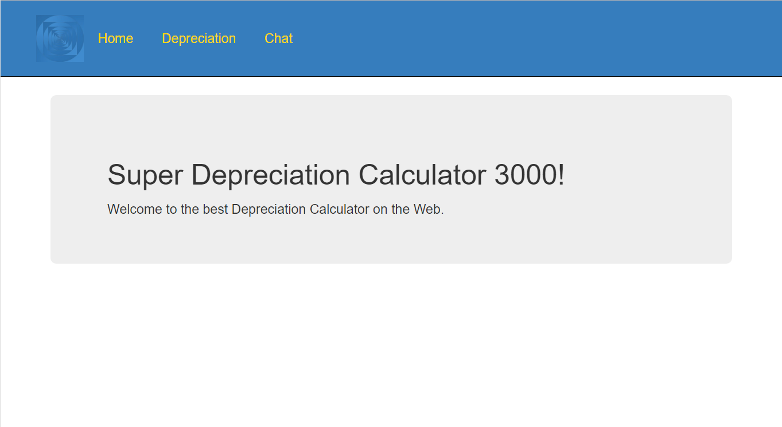

Include a logo and some styling so the page doesn’t look like it was created in the 1990’s.

## Depreciation Calculator

Your dev admin wants you to implement a depreciation form that allows an accountant to input an asset’s starting value, salvage value, expected life in years, current age in years, select the type of depreciation, and obtain the current value of the asset.

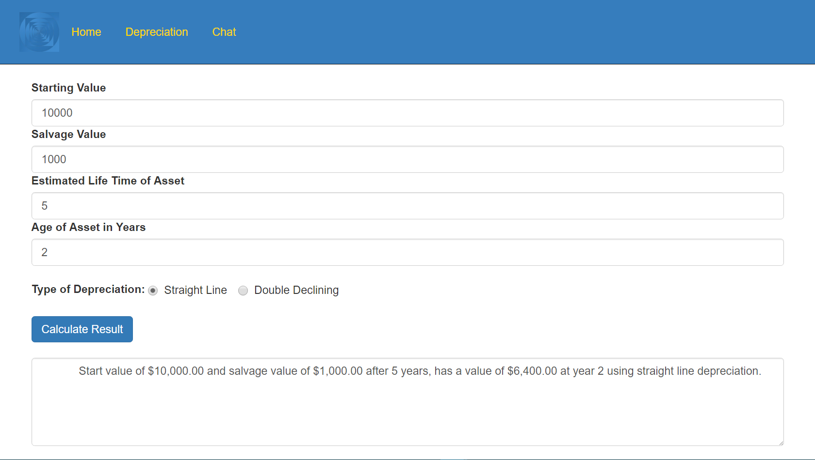

Your program will only provide two depreciation formulas but will be designed so that more can be added later.

Create a class to represent an asset it should have the starting value, when it comes into inventory, it’s estimated lifetime and what kind of depreciation it will follow (straight line or double declining for example). It should have a way to calculate it’s value at a given date. Return 0 before the time in inventory and after it exceeds it’s lifetime.

You will also need to create a class that has a collection of assets and provides the ability to calculate the value of the collection at a given time.

You should use polymorphism to simplify the code and minimize repeating yourself.

Use the description at <http://www.accountingtools.com/straight-line-depreciation> to calculate straight line depreciation.

Use the description at <http://www.accountingtools.com/double-declining-balance-depre> to calculate double declining depreciation.

## Table

You should also provide the ability to create a table of assets. You can use the PizzaPlace example in the text as a guideline on how to make the application work to add and remove assets to the table.

## Graph

You should provide a graph to show the change in value over time. There are several graph frameworks out there on the web. Try the one below or any other you can find.

https://www.webassemblyman.com/blazor/blazorcharts.html

Figure out how to use the library and use it to show the depreciation over time.

Give the user the ability to pick the start and end time for the graph.

# Test Criteria (Not all inclusive):

* Properly comment code (see paper on commenting code)
* Concise efficient code
* All controls properly labeled
* Site clearly explains to user what values to input, what format and what units to input
* No spelling/grammatical errors
* All errors handled
* Correct answers returned for all relevant test cases