**Unit 5 Graded Exercise 2**

The following questions come from the “Check your understanding” examples of Chapters 15 & 16 in your textbook.

After you are finished, please submit a Microsoft Word file that contains screenshots the SQL queries, the output, and please put a comment line in each query with your name. Note: No screen shots are required for Questions 6, 7, and 8, which should be done “by hand,” and simply answered in the same document. Your document should be named  **U5_GradedExercise2_Lastname.docx**.

(15-11) Question 1:

List all the rows and columns of the *l_employees* table. Add a new column that says “Old Timer” for any employee that was hired before the year 2000 and is blank for all other employees. Sort this by the *employee_id* column.

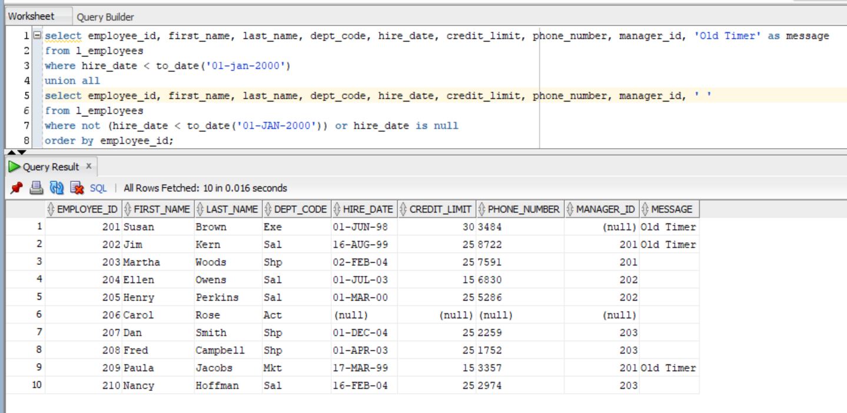

(15-12) Question 2:

List the last name, first name, and hire date of all the people in the *l_employees* table. Divide the hire date column into two columns: one called “old timers” for people hired before the year 2000, and one called “newer hires” for people hired after that year. Sort the result table by last name and then by first name.

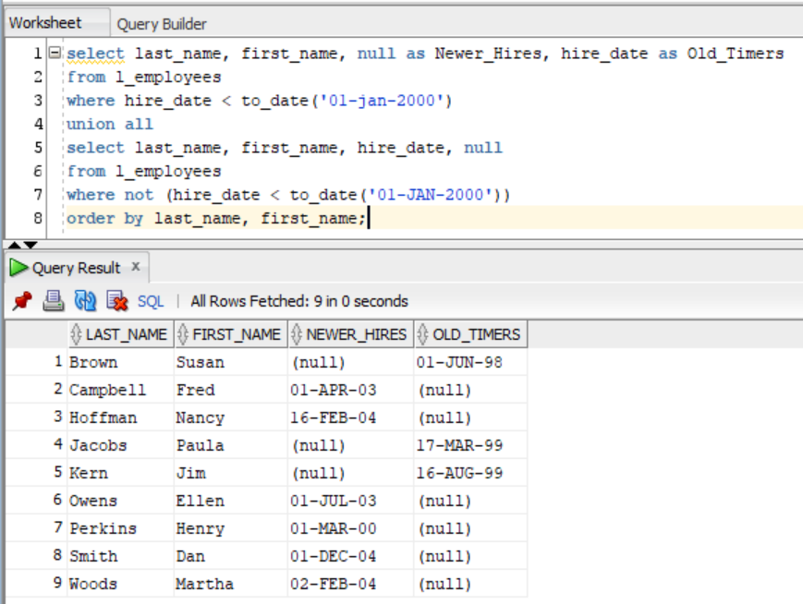

(15-13)Question 3:

The *numbers_0_to_9* table contains the numbers from zero to nine. Multiply all the even numbers by two and multiply all the other numbers by three.

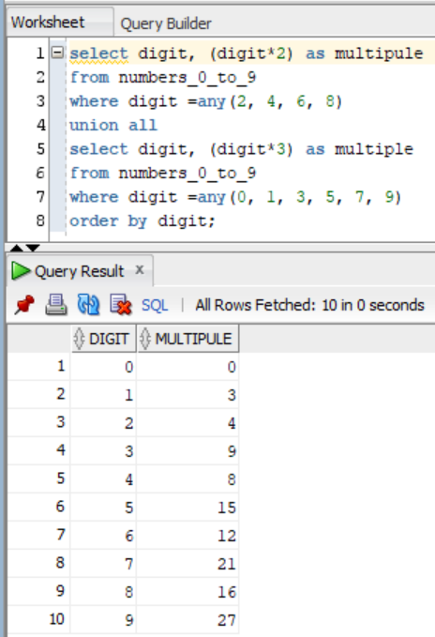

(15-15) Question 4:

Use the method of this section to find the intersection of the *twos* table and the *threes* table.

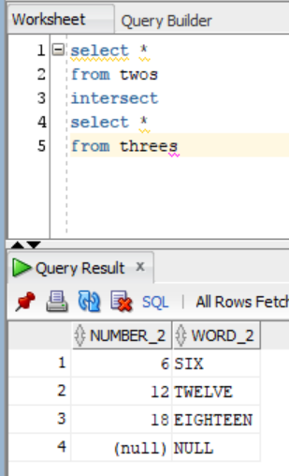

(15-16) Question 5:

Use the method of this section to find the difference of the *twos* table and the *threes* table.

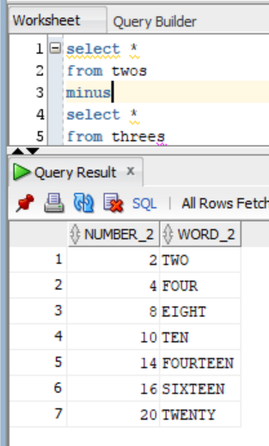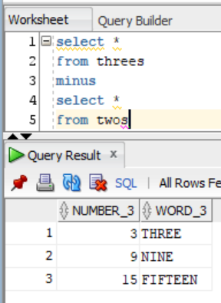

(16-1) Question 6:

By hand, without a computer, write the cross join of the following two tables:

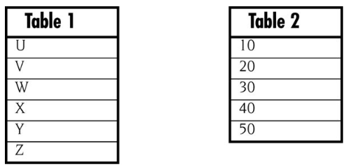

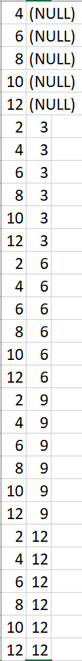(16-3) Question 7:

By hand, without a computer, write the cross join of the following two tables:

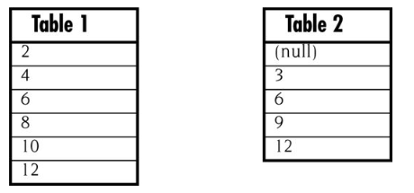

(16-5) Question 8:

Suppose you are developing a new *select* statement. It is fairly complex and you are using several tables. You are expecting a result with about 400 rows, but the result you get is about 2,000 rows. What part of your *select* statement would you examine first?

I would examine my where clause carefully

(16-11) Question 9:

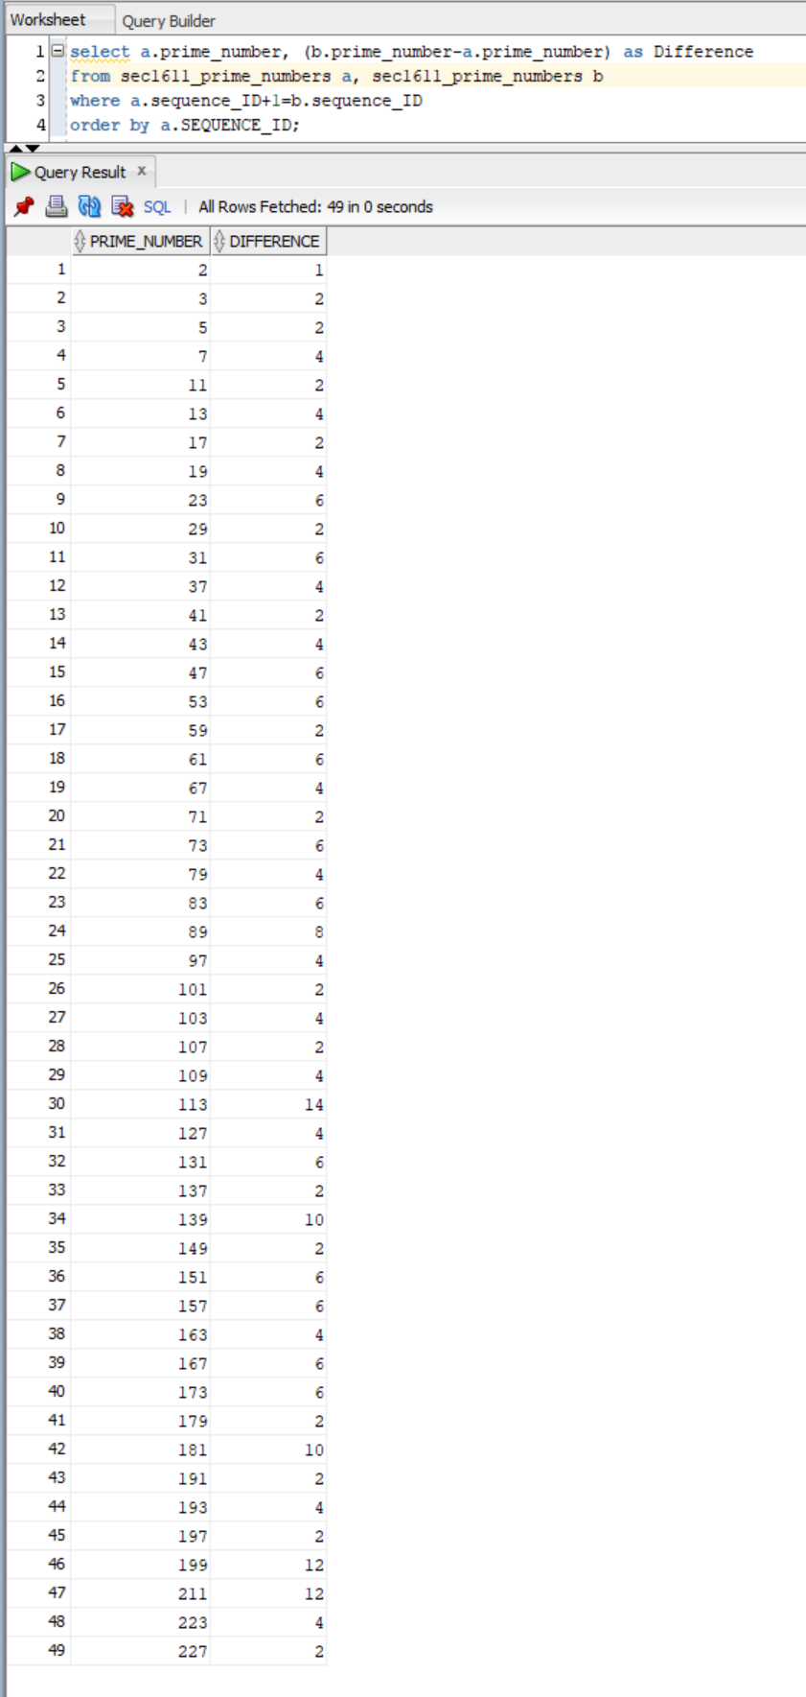Table *sec1611_prime_numbers* contains the first 50 prime numbers. Use a self join to determine the difference between each prime and the next one.

