Aaron OBryant

CMIS 102 6982

08/02/2022

**Design**

#Aaron OBryant

#CMIS 102 6982

#08/02/2022

#This program will allow the user to prepare for their future trip by projecting the amount soent on food and gas and distributing the cost evenly between the attendees.

#Welcome message will appear.

def main():

print("Welcome to Your Trip Calculator!\t")

print("This program will allow you to figure out the cost of your future trip.\t")

print("Let's get started!\t")

#The user will first input how many people will be going on the trip and how long they will be gone.

peopleNumber = int(input("How many people will be going on your trip?:\t"))

daysGone = int(input("How many days will you be gone?:\t"))

#The user will now project how much food will be purchased while on the trip for the group.

R = daysGone

foodPrice = []

for i in range(R):

food = int(input("How much food do you expect to spend this day?:\t"))

foodPrice.append(food)

#The user will project how much money on gas will be spent.

R = daysGone

gasPrice = []

for i in range(R):

gas = int(input("How much do you expect to spend on gas this day?:\t"))

gasPrice.append(gas)

#Variables to determine the price of all gas and food purchased on the trip

gasSum = sum(gasPrice)

foodSum = sum(foodPrice)

int(foodSum) == print("The following lists how much you project you'll spend on food while on your trip: $\t",sum(foodPrice))

int(gasSum) == print("The following lists how much you project you'll spend on gas while on your trip: $\t",sum(gasPrice))

#Variables to determine everyone's share in regards to the expenses of the trip

tripSum = gasSum + foodSum

personCost = tripSum / peopleNumber

#The user will receive the final output.

print("The total amount projected to be spent on the trip is $\t", tripSum)

print("The cost for each person to attend the trip would be $\t", personCost)

print("Thank you for using Your Trip Calculator!\t")

#Execute

main()

**Test Plan/Report**

|  |  |  |  |  |  |  |
| --- | --- | --- | --- | --- | --- | --- |
| **Test** | **Travelers?** | **Length of trip?** | **Food Sum** | **Gas Sum** | **Trip Sum** | **Individual traveler cost** |
| **Test 1** | **2** | **6** | **$145** | **$140** | **$285** | **$142.50** |
| **Test 2** | **4** | **3** | **$250** | **$150** | **$400** | **$100.00** |
| **Test 3** | **5** | **5** | **$500** | **$140** | **$640** | **$128.00** |

**Test 1**

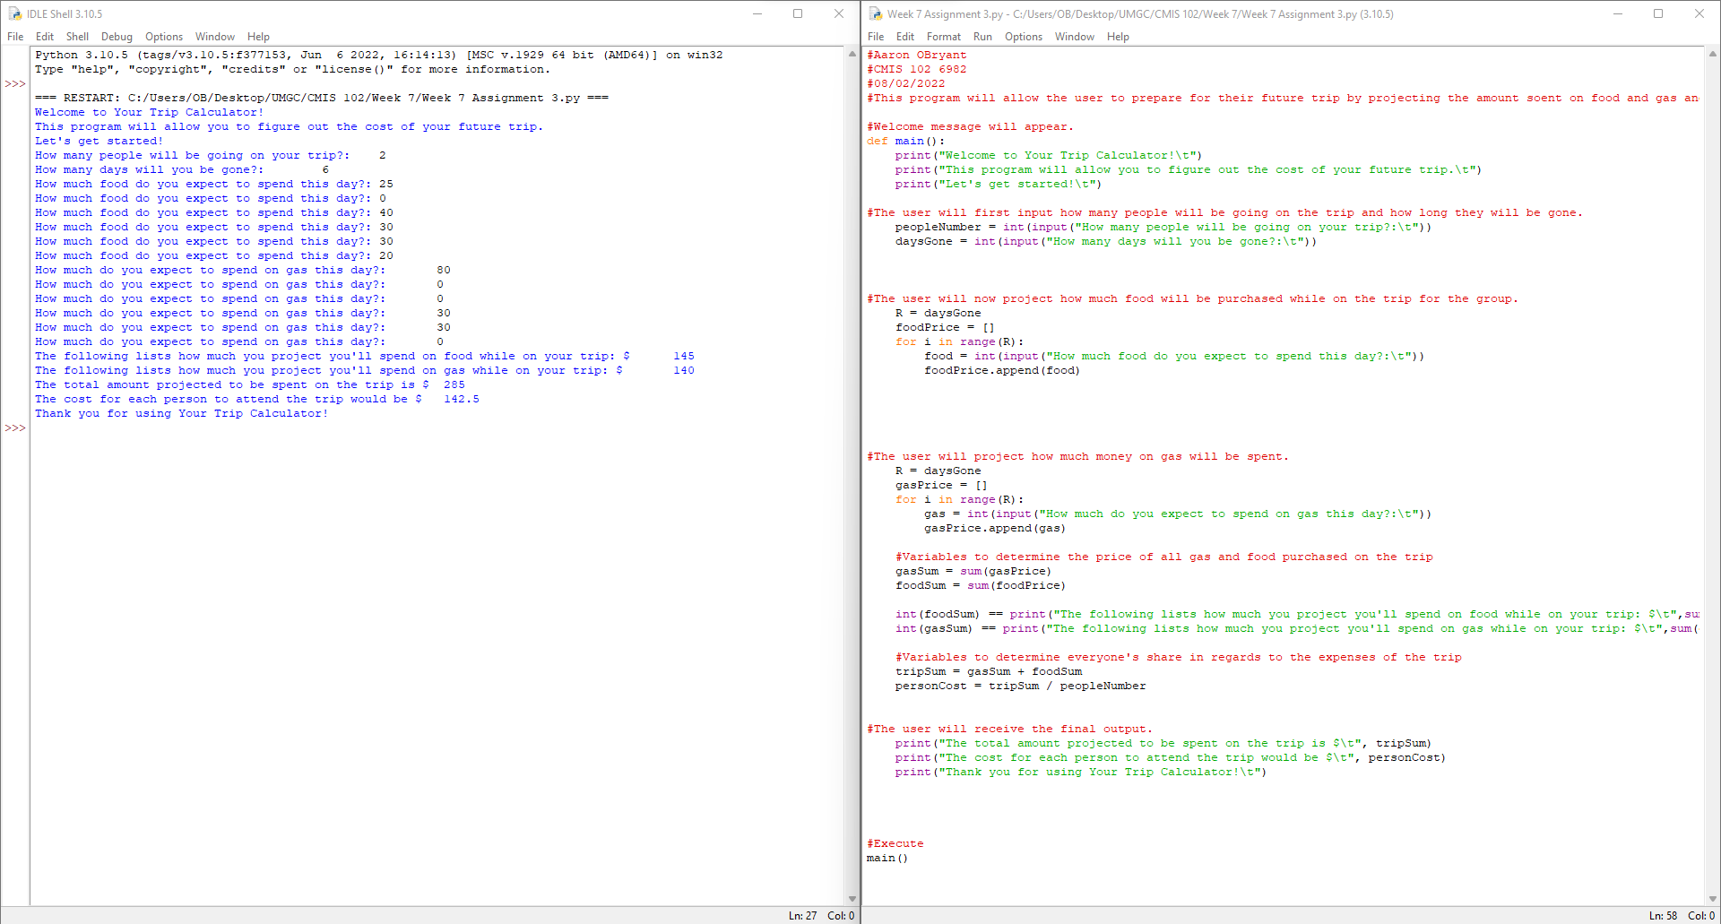

**Test 2**

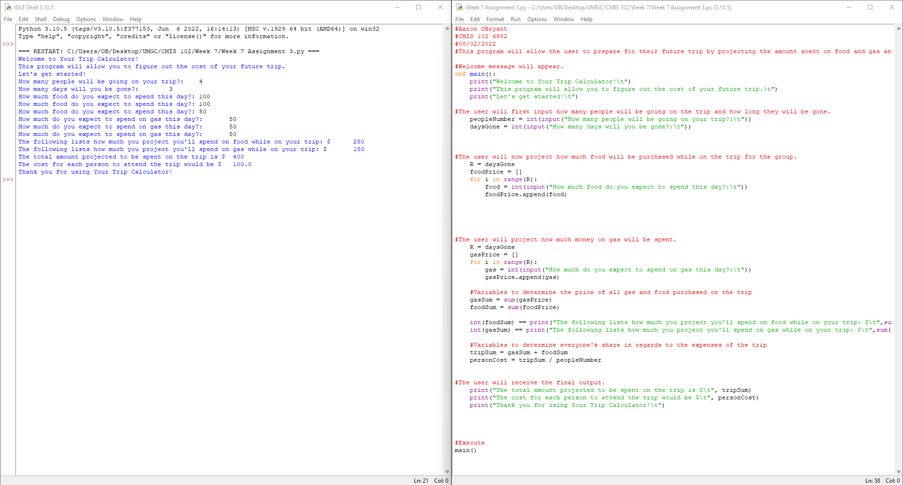

**Test 3**

