CS4375-13948 Fall 2023 Homework #1 Report
Alberto Delgado Submitted on September 19, 2023
aodelgado@miners.utep.edu

HW 1: Introduction to xv6

Please replace red text with your report text and any tables or figures, names of any accompanying files, etc. Remember to commit all the files for your lab submission, to put the URL for your private xv6 repo in the Teams assignment, to submit the Teams assignment, and to give the instructor and TA access to your repo.

Task 1. Boot xv6 and explore utilities
I currently have a Macbook pro that I use VMWare Workstation on and I use this to run the 20.04 LTS version of Ubuntu. Recently though I was able to obtain an old laptop that I have natively installed Ubuntu onto as a dual boot alongside windows. I switch between my laptop and desktop for school work so I was able to work with a native version of Ubuntu.
Although I had Ubuntu running natively, I followed the same steps to get xv6 to work on my systems as given in the instructions. I inputted the information from the xv6-riscv-labs git repo into my private repo, CS4375.
To get QEMU to run on my system I have to install “make” using sudo apt install make. This would allow my system to take the “make qemu” command and run qemu to have to ability to do this assignment. Below is a photo of the build and booting of xv6 on RISC-V.
The “ls” is a list command to my knowledge and is very well known command in the Linux environment. When running qemu in the terminal, we are able to use the “ls” command to show the other commands available to the user. Below is a figure showing the output in the terminal when “ls” is inputted.
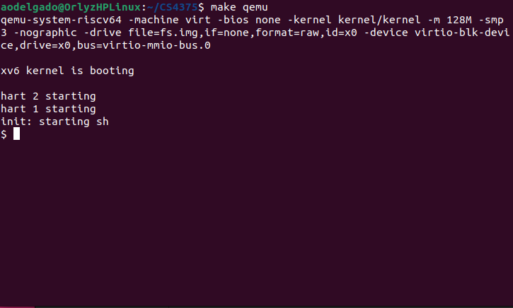

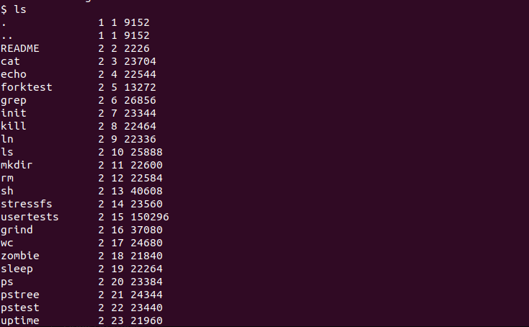

This is the output for the “ls” command and as shown, all the commands are displayed along with my “uptime” command. I will demonstrate the “uptime” command in the second portion of this report.
I tried the “usertests” command and got the following output. The figure below is a portion of the output as the output was reasonably long.

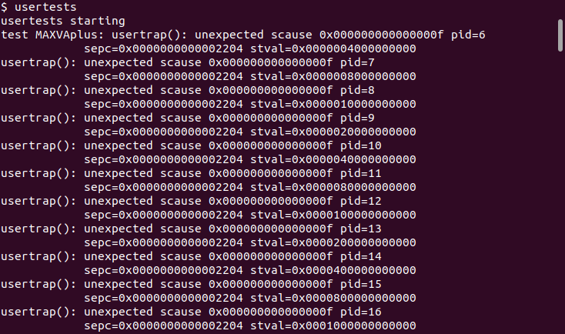

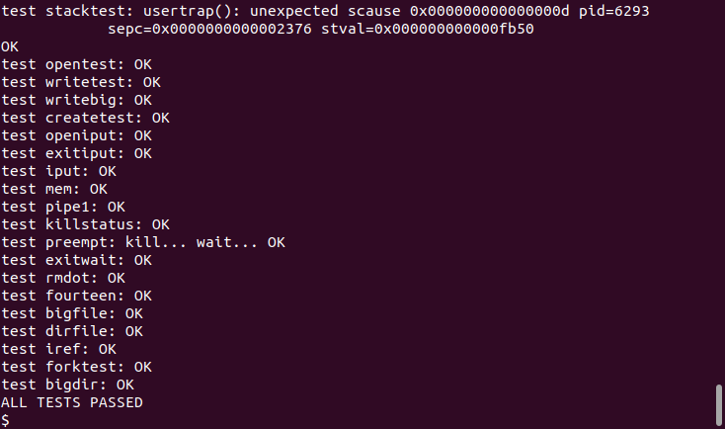

After inputting the “usertests”, the output shows that there was a usertrap that shows the pid (process id) and as the tests are completed we see the tests passing. From the output I assume that the “usertests” command tests certain actions such as opening, writing and forking to name a few. I believe that the tests are for some system call and certain actions given to the user to make sure that the tests are functioning properly.
The second command that I used was the “mkdir” command. This command is used to create directories. To create a directory, a file must be entered to create the directory. I made a directory towards the makefile that is used for the assignment. The command that I entered was “mkdir makefile”. There was no output since there was only a directory created, so there was no need to have an output.

The final command that I explored was the “echo” command. The echo command will simply output an argument. The argument will be entered after echo and that argument will display in the terminal. For the assignment I entered “xv6 RISC-V” and below I attached the output from the terminal.

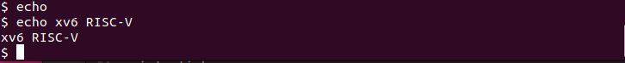
These are the three commands that I ran while running QEMU. Every command I entered worked while running QEMU and for this section of the assignment I did not encounter any issues. The instructions for the installation were simple and easy to follow. The second portion of this assignment is where I ran into some issues.

Task 2. Implement the uptime utility
The uptime.c program was rather simple in the applicability of the code. For my program I used no more than 5 lines of code to get the correct output in QEMU. Below is a photo of my code, which I will explain in this section.

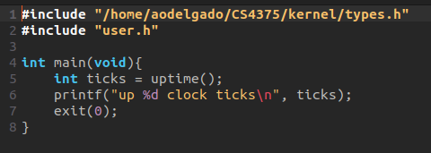
As you can see, the code that I wrote was less than five lines. I simply took the “uptime()” function from the “sysproc.c” file. This was given to us in the instructions for the assignment. I used the user.h file as given in the assignment instructions. The other header file that I user was for “types.h”.
The issue I ran into was an issue of an undeclared type of “uint”. When I only had the user header file, an error would be returned by the compiler. I took a while trying to figure this out and I ended up using the “sysproc.c” as a template since I would be using the uptime function derived from “sysproc.c”. I included all of the headers from the “sysproc.c” file into my “uptime.c” file. Once I included all the headers I no longer encountered the “uint” error. Upon looking into the header files, I saw that the “uint” variable was declared so I understood that the “types.h” file was needed to remove the error. To get the “types.h”, I had to input the directory since I had placed the “uptime.c” file in the user folder.
I declared an integer named “ticks” to keep track of the ticks through each cycle. I then set ticks equal to the uptime() function and used the “%d” to output the ticks in the terminal. I then ran into another issue with the exit() call. For some reason the only way that the exit() would properly work is when I entered “0” as an argument for exit(). Once I fixed the isse with exit(), I then ran QEMU and used the uptime command to see the output. The uptime command then did properly output what I was expecting. Below is a figure of the output of the uptime command.

