IMOS_SOOP-TMV: Ship operations Log September –December 2004

Purpose:
An ongoing log on the observed effects of variation in ship operations beyond the inherent controls that may cause data features from the IMOS_SOOP-TMV facility record. The aim here is to identify the relative signatures observed by the sensors. The examples are taken from the first four months of operation of the IMOS_SOOP-TMV. This is not a data guarantee but simply a guide to assist a user with further processing or interpretation beyond the IMOS packaging

Background
Data from is processed and quality controlled according to the metadata record and follows IMOS protocols that have been developed for the SOOP facility. This includes ensuring one-way flow (series of pressure regulated one-way valves in system), sensor cleaning (daily freshwater flushing & removal of fresh signal), sensor drift and fouling (corrected by offset and calibration), time offsets (corrected PC clock and seasonal time), collation of data streams (joined by PC time stamp), averaging ( time series stability that reflects averaging volumes) and interpolation ( correcting sensor drop-outs using optimal limits).

There are however effects from the ship operations that are not able to be directly logged and can manifest as a feature in the data. The following are list (not exhaustive) of error sources and likely effects.

1. Alternating pump operations
The vessel has four pumps as two pairs respectively located near the port and starboard side intakes to the seachest. Pumps are opened and closed according to efficiency of intake, usually related to sea state (see #3). Can a change in pressure to the sampling system and introduce microbubbles in pumped water flow system.

2. Intake cavitation
Air introduction to intake relates to ship rolling in heavy seas, typically within Bass Strait. It can cause micro-bubbles in stream.

3. Alternating intake levels and pump operations
The ship has a series of intakes on both sides of the vessel from 1-6m below the waterline. Ship engineers can alter flaps counter effects of changing sea state and swell direction. This can also alternate the pump operations causing a change in pressure to the sampling system.

4. Effective sampling depth
Relates to effective mixing/emtrainment by ship hull. Can be defined by coincident insitu CTD profiling off a vessel in highly stratified environment.

5. Effective sampling delay
A time delay occurs due to time taken for water to travel from ship intake to sensor. An offset is applied with respect to PC stamped GPS position. Can be defined by coincident insitu CTD profiling and underway sampling off a vessel in highly stratified environment.

6. Strainer maintenance
5mm strainer on seachest pumps are routinely cleaned every 2-3 weeks to ensure optimal pump operations. Both a poorly serviced strainer or material released downstream during the cleaning process has an ability to release material into the sampling system. This can accelerate fouling and in some instances cause a complete blockage.

7. Human intervention: Accidental turning off of water supply valves, flushing line or power by TTLine staff or contactors. No data, increased fouling or complete system shutdown.

Results:
Sensors show differing sensitivity to ship operations, partly due to sensor accuracy and partly due to indicator type.

Sensor performance ➔In general vulnerability increases from salinity, temperature, to fluorometry and turbidity. Examples are shown in Figure 1, from early trials (June 2008).
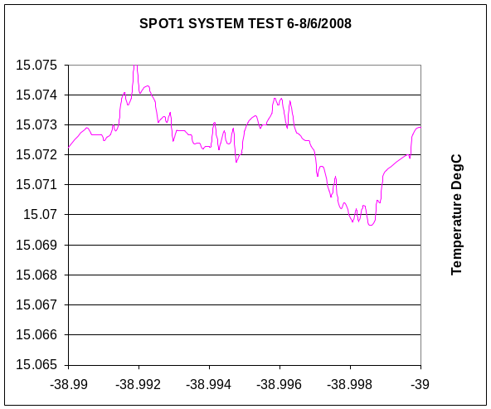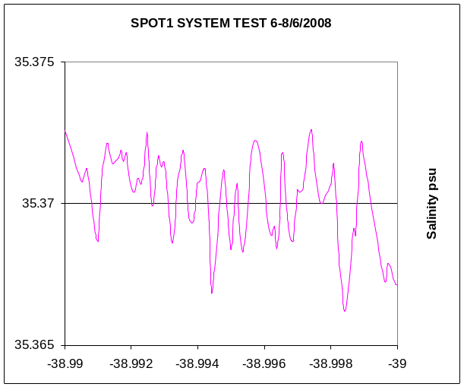
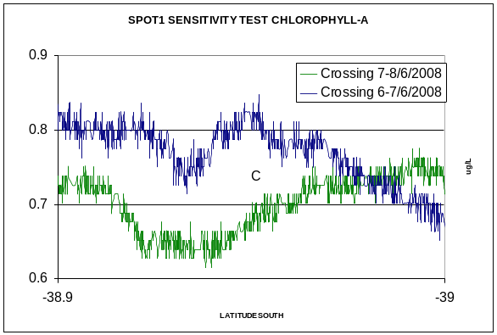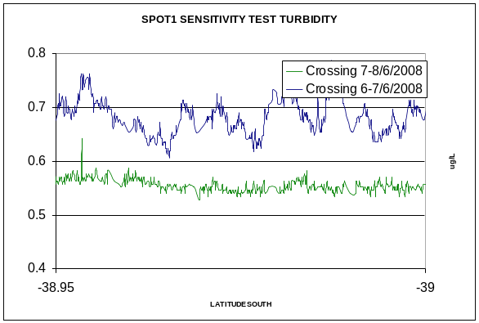
Sensor accuracy and environmental noise measured during trials in June 2008 showing sensitivity to 0.0001 degC; 0.004 psu; 0.02Chl-a and 0.02NTU.

Microbubbles ➔ increased positive noise as short 10-30 sec spikes seen in turbidity and salinity data. Can be smoothed with averaging window filter.
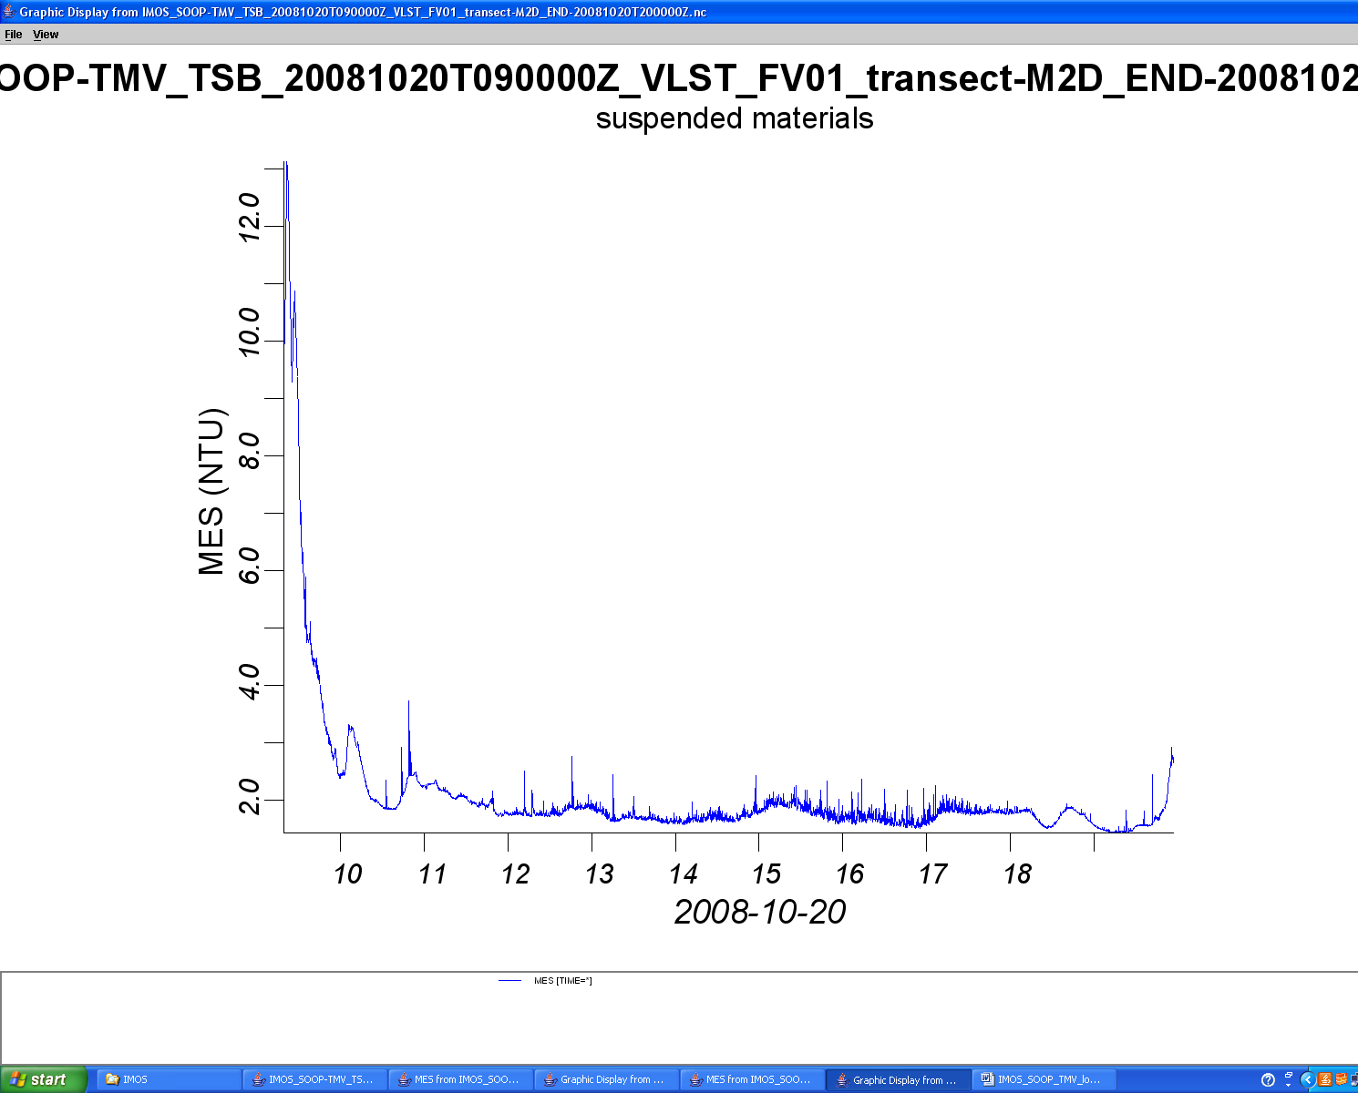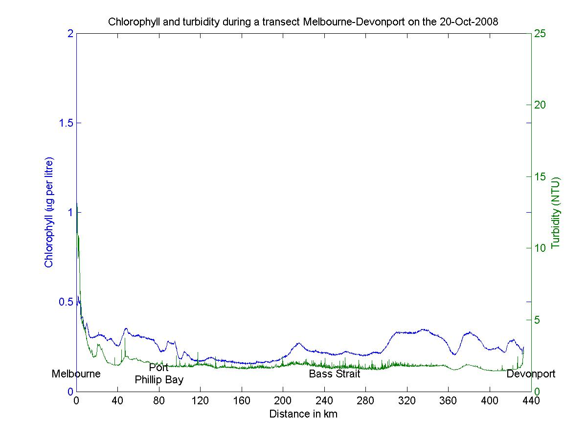
0.5-1NTU data spikes can occur in data record(usually in Bass Strait as a result of heavy seas). Can be processed with smoothing window filter, as shown in IMOS database plot product for the IMOS_SOOP-TMV.

Pump re-routing ➔ Can be identified as a rise above ambient temperature with increased noise, but affects all data. Interpolation possible depending on location limits.

System Blockage ➔ insensitivity to expected changes. Data reconstruction may be possible, depending on duration of blockage.
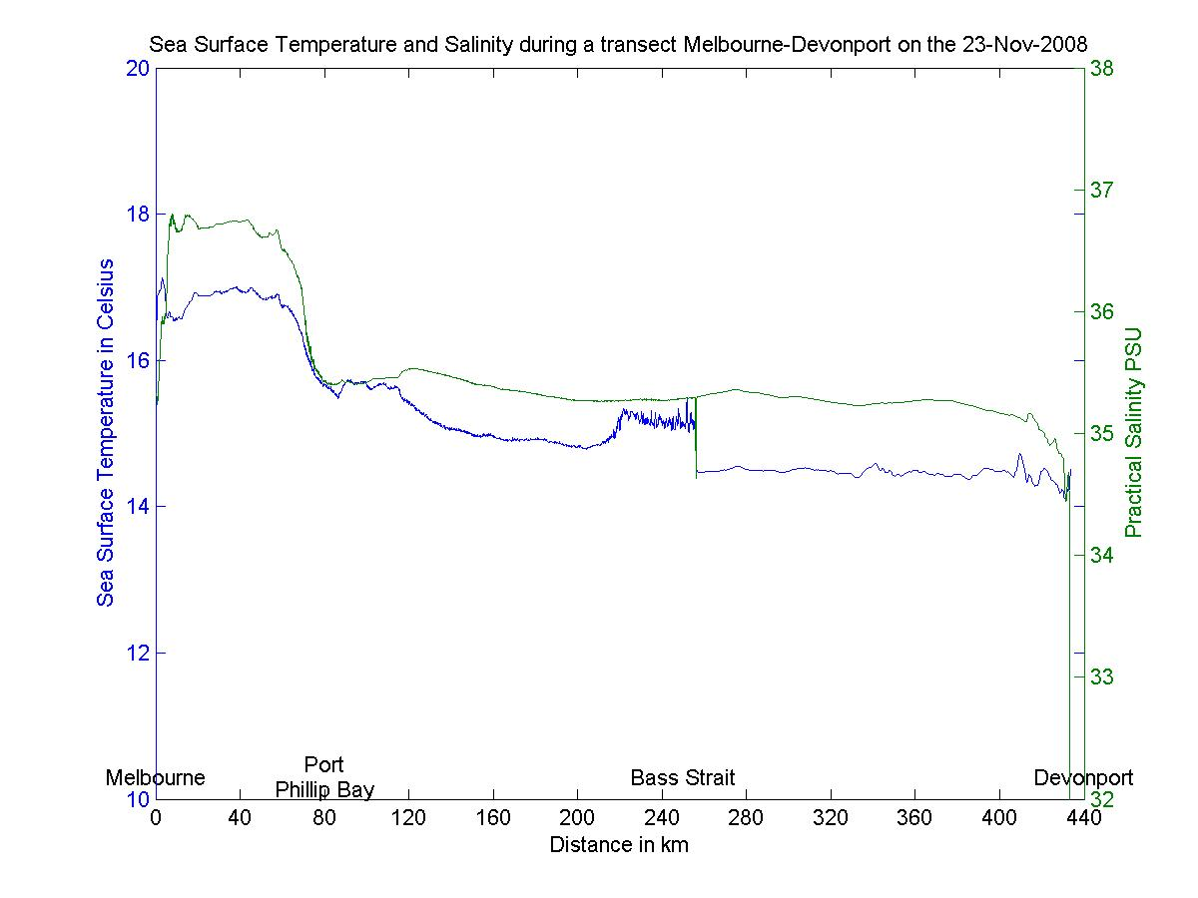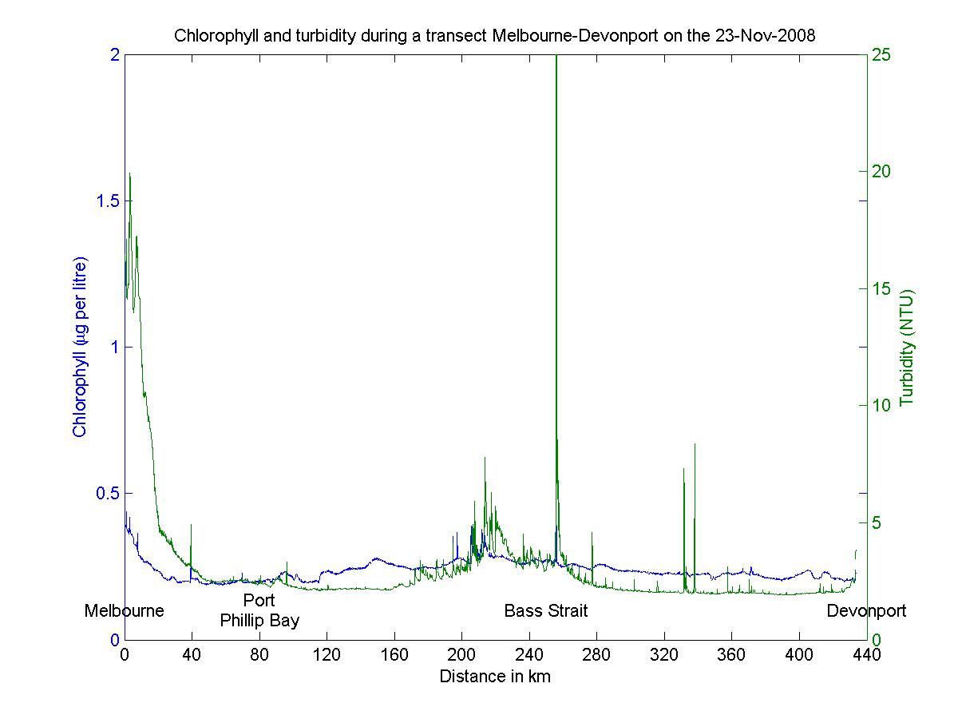
Temperature and turbidity data affected by likely pump re-routing operations. Large spike in turbidity t end of event may relate to release of blockage as normal pumping operations are re-established.
Accelerated fouling ➔increased positive noise in turbidity, and possible decrease in fluorometer performance, can be filtered out. Linear check with offsets and calibration during service usually OK, but may need to be modelled or assessed for a step change for additional processing during the operational period. Issue of step change has not occurred in first four month record.
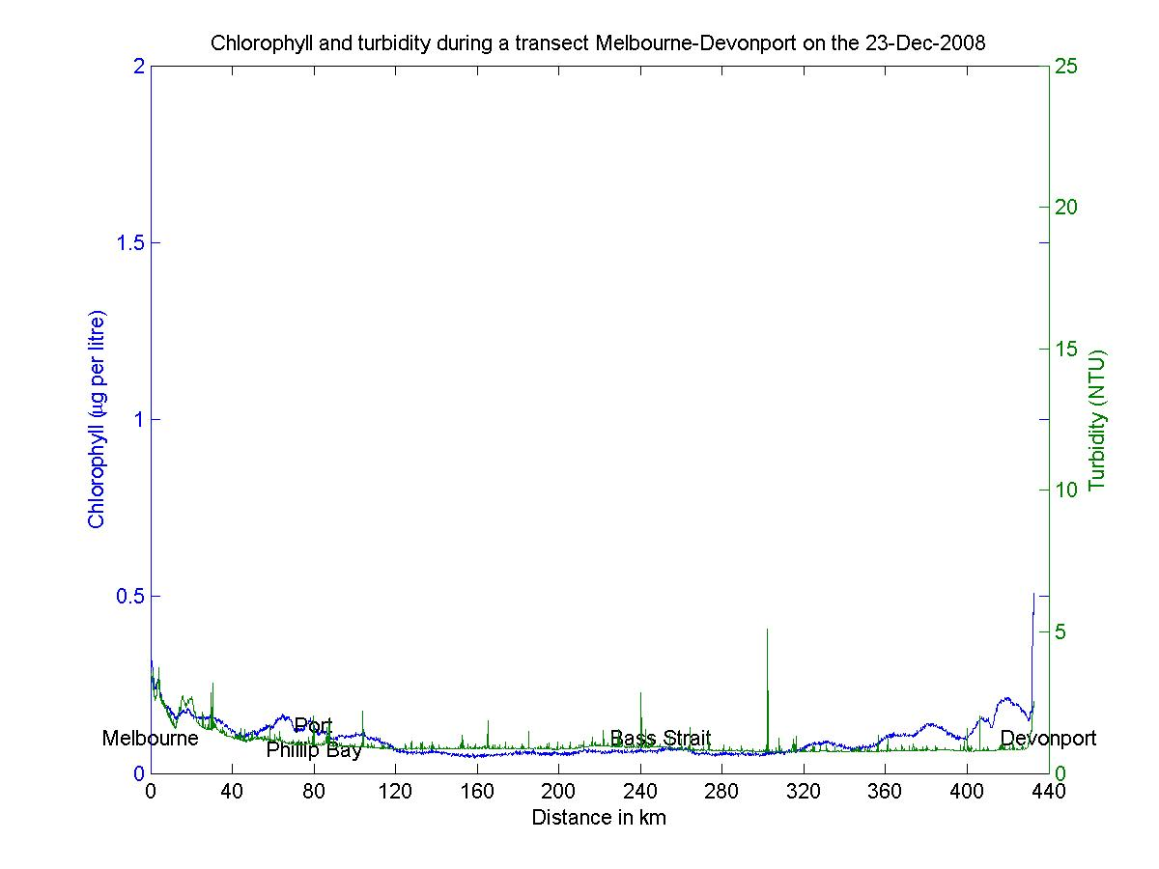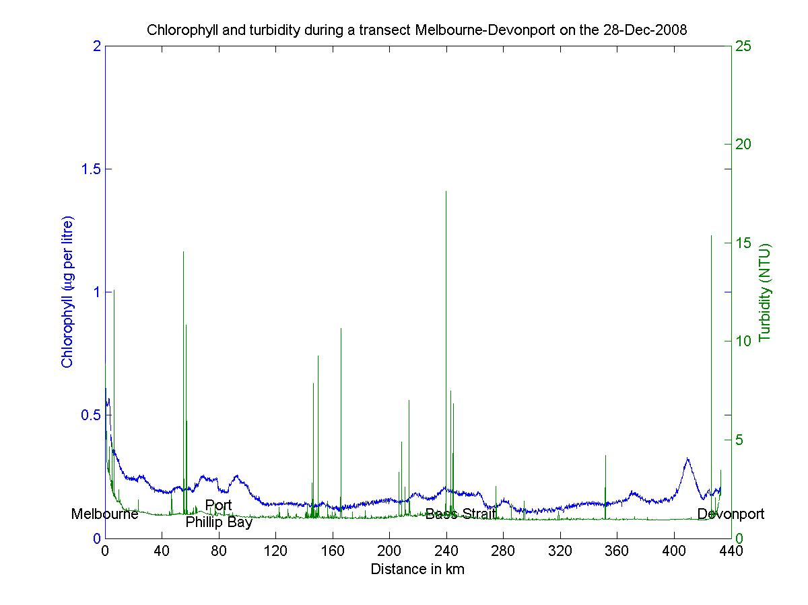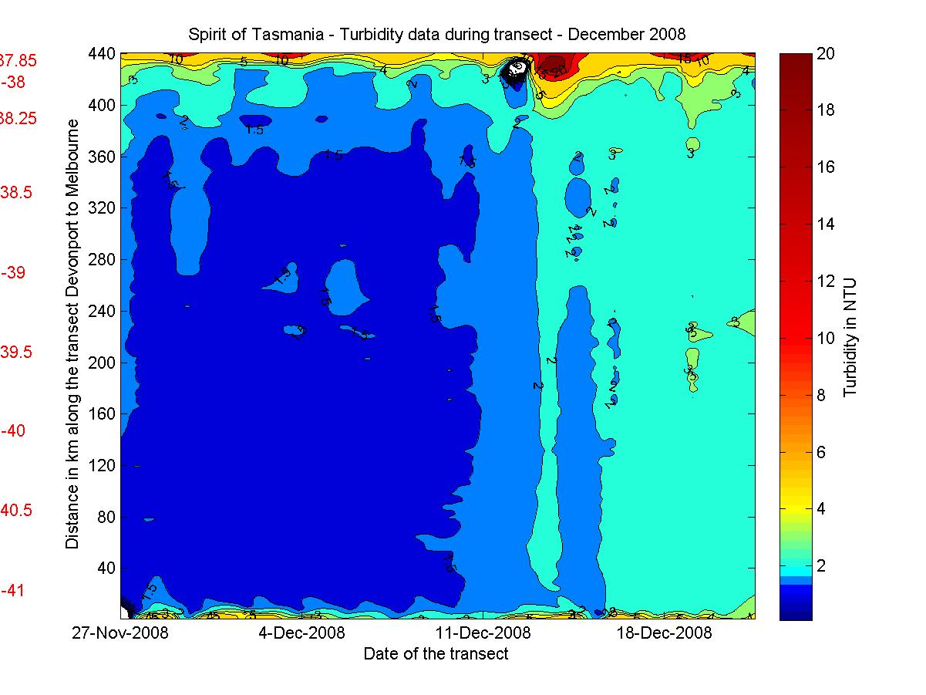
Accelerated noise of 10-30 data spikes in turbidity during 23-28 December. Seasonal IMOS plot product has filtered out noise. 8/1/2009 service identified the daily flushing program had been disabled. Reported to TTLine engineers and noted for information to visiting contractors.
Monthly Log: (to be included & updated in Metadata)

IMOS_SOOP_TMV : Monthly Log

28/8/2009 14:38 EST
Continuous operations commence. PCtime stamp set to 1001msec to minimise
overstamping (seen in earlier trials)

11/9/2009 16:13 EST
data baseline: 1 NTU; 0.3Chl-a; 35.4 psu; 12.5degC, system pressure 15psi.
Positive turbidity spikes of ~2NTU in Bass Strait for 10-30 seconds
1.5psu salinity and 1.5DegC temperature gradients at PPB heads

2/10/2009 13:21 EST
data baseline: 1 NTU; 0.3Chl-a; 35.4 psu; 12.5degC, system pressure 15psi.
Reset all baud rates to 4800, to minimise PCtime overstamping.

30/10/2009 14:20 EST
data baseline: 1 NTU; 0.3Chl-a; 35.4 psu; 13degC, system pressure 15psi.
UPS battery needs replacing. Replace bolt on FLNTU housing.

27/11/2009 15:24 ESDT
data baseline: 1 NTU; 0.3Chl-a; 35.4 psu; 13.5degC, system pressure 15psi.
23 November temperature increase in Bass Strait, Turbidity affected with large spike at sharp temp shift (to ambient) suggesting release of blockage. Sal and Chl-a not affected. Likely change in pump operations.

21/12/2009 6:38 ESDT
data baseline: 1 NTU; 0.3Chl-a; 35.3 psu; 14.5degC, system pressure 15psi.
Power loss to FLNTU during service. Power re-secured.
Accelerated fouling increasing noise 23-28 December in turbidity data. Same 10-30 second spikes but increased from 4 to 15 NTU. Freshwater flushing program had been turned off as observed in 8/1/2009 service.

8/1/2009 13:04 ESDT
data baseline: 1 NTU; 0.2Chl-a; 35.3 psu; 15degC, system pressure 15psi.
Freshwater flushing program was disabled. Reported to TTLine engineers.
Flush program re-engaged.
Scratch on FLNTU sensor window observed during service, cleaning and correction by offsets and calibration indicate sensor stabilities are still OK.
PCTime auto daylight savings time disabled.

