NRS Work-flow

Providing AIMS real time and delayed data of different region around Australia has been a high priority for eMII/IMOS. NRS (Yongala and Darwin) have many sensors and deliver Real Time data. In this document, we will describe the complete work-flow of NRS data from AIMS server to their visibility and accessibility on the IMOS/AODN portal.

- From AIMS server

A web-service has been created to download AIMS data as NetCDF files following IMOS conventions. This web-service creates on the fly a self describing NetCDF file of data points from a specific sensor, which were previously located in one of the AIMS database. Each sensor has a unique Channel Identifier, and all its data can be downloaded easily for its full coverage time in one single HTTP query.

Part of this web-service is a RSS feed entry catalogue of NRS data per QAQC level .
RAW :http://data.aims.gov.au/gbroosdata/services/rss/netcdf/level0/300
QAQC :http://data.aims.gov.au/gbroosdata/services/rss/netcdf/level1/300

Only channels which are configured with QAQC by AIMS are visible on the QAQC RSS feed. The RAW RSS feed has absolutely all the existing channels. It is not necessary the case with the QAQC one.

The RSS feed (available as well as an XML file by adding '.xml' at the end of the RSS link) catalogues all the channels, and adds some useful meta-data as well as a link to download the data. A new channels is added automatically by AIMS when a new sensor has been deployed. These pages are updated continually. Below is an example of one channel entry for a Water Temperature sensor at Davies reef from the FAIMMS RSS feed (similar to the NRS one):

<title>Water Temperature@0.6m Davies Reef Sensor Float 1 from 2009-12-17T02:30:00Z until 2012-04-02T20:50:00Z</title>
<link>http://data.aims.gov.au/gbroosdata/services/data/rtds/270/level0/raw/raw/2009-12-17T02:30:00Z/2012-04-02T20:50:00Z/netcdf/2</link>
<description>The link for this entry downloads a level0 netcdf file for Water Temperature@0.6m Davies Reef Sensor Float 1 from 2009-12-17T02:30:00Zuntil 2012-04-02T20:50:00Z</description>
<pubDate>Tue, 03 Apr 2012 00:59:37 GMT</pubDate>
<guid>http://data.aims.gov.au/gbroosdata/services/data/rtds/270/level0/raw/raw/2009-12-17T02:30:00Z/2012-04-02T20:50:00Z/netcdf/2</guid>
<dc:date>2012-04-03T00:59:37Z</dc:date>
<aims:metadataLink>0c2c71d5-1989-4afd-a439-4f0434d71c58</aims:metadataLink>
<aims:uom>degrees celsius</aims:uom>
<aims:fromDate>2009-12-17T02:30:00Z</aims:fromDate>
<aims:thruDate>2012-04-02T20:50:00Z</aims:thruDate>
<aims:platformName>Davies Reef Sensor Float 1</aims:platformName>
<aims:siteName>Davies Reef</aims:siteName>
<aims:channelId>270</aims:channelId>
<aims:parameter>Water Temperature</aims:parameter>
<aims:parameterType>water temperature</aims:parameterType>
<geo:lat>-18.84162</geo:lat>
<geo:long>147.64076</geo:long>

This entry gives :
-the unique channel identifier : 270 ; and the platform name
-the latitude and longitude of this specific channel. They should be fixed values at least for NRS entries.
-the MEST meta-data record unique identifier. As the Metadata records are downloaded from Townsville to eMII, this value is really helpful to link it within the data we download.
-the first date and last date of data availability (if there are many deployments, and no data between deployments, the file downloaded in this period should be called 'NO_DATA_FOUND')
-a link to download the full dataset. This link can be manually, or automatically modified to download the desired date range of a specific channel.

- To IMOS/AODN portal

A Matlab code has been written at eMII to automate the download of these data in near real time. This is this part of the process we intend to describe in this section.

The main steps of the code are :
- Download the RSS feed as an XML for RAW level (0)
- List what is available (new channels, new dates available), and compare with what has been previously downloaded (informations stored in a local database)
- Download a monthly file from the first of the month (moth of the last downloaded file) until the last date of data availability
- Perform a series of test on the file, to eventually rewrite or reject the NetCDF
- Create a directory structure according to the RSS feed where the monthly file will be copied
- Copy the new good files from the local directory to the DataFabric (ARCS) on an OpENDAP server
- Save useful informations in a local database (used only for the purpose of the MATLAB code)
- Create and update a PostGreSQL table to be used by GeoServer (New downloaded data are visible on the portal from this step). This table is filled with both informations found in the physical NetCDF file as well as in the RSS feed
- Repeat steps 1 to 7 with level 1

This process can be performed so far as a maximum of once an hour, but is usually performed as a current job once a day. Some of these steps are critical as we'll understand later

Description of the different Functions

- NRS.py PYTHON SCRIPT
Aim: Define the location of the NRS_Launcher MATLAB code (cf below) and launch it. This python script also runs the SQL script made by function Insert_DB_NRS. Once this is done, the SQL script is moved to the folder SQL_done

- function NRS_Launcher
Aim: This is the main function. It defines the DataFabric folder location, the local folder on the machine where the files can be downloaded. Then it calls the second main function to download data for each level called NRS.

- function ChannelIDdown=NRS(level)
Aim: Core of the code to download NRS data, and call all the different subroutines to create a folder structure, delete old files, copy new files to the DataFabric (DF)

Function inputs: an integer 0 for RAW or 1 for QAQC data
Function outputs: a list of channels which had problems (empty NetCDF, server down).

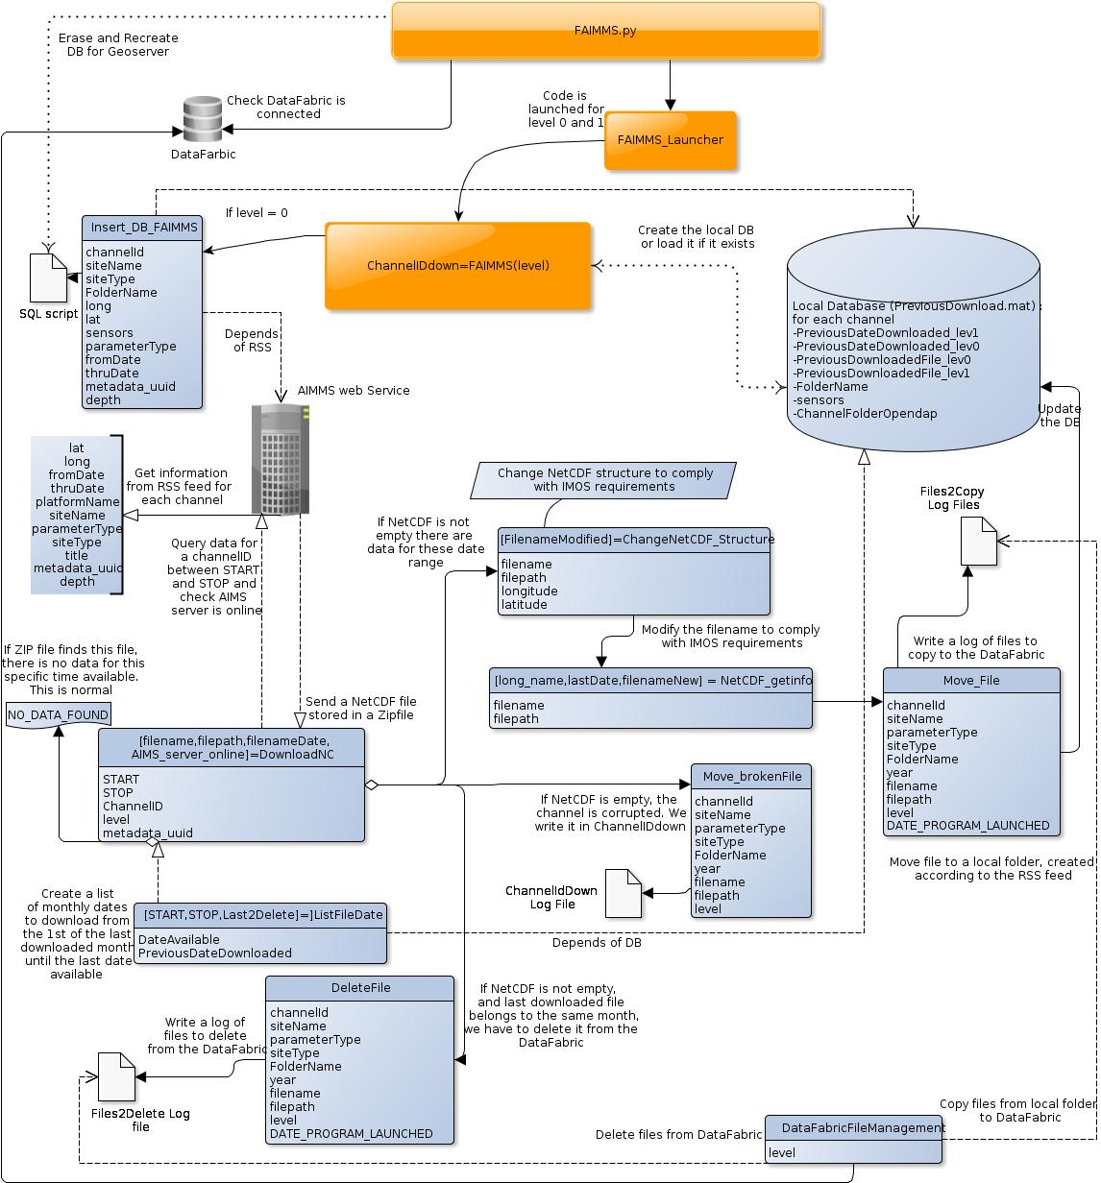
Steps:
- Download the XML RSS feed and create a Matlab structure
- Load if it exists, or create the local DataBase (PreviousDownload.mat),where last downloaded dates are stored for each channel.
- Put in different variables information for each channel of the structure (lat, lon, fromDate …).
- Create a list of date range available for each channel and compare with previous information stored in the local DB.
(i.e. for level 0 : PreviousDateDownloaded_lev0,thruDate)
- Check that any previous channel entry (from the RSS) hasn't change at all (such as parameter or depth modification). This would result otherwise in recreating a new folder. If something has changed, we want to delete all previous entries of this channel from the DataFabric, and the local database. And We redownloaded this entire channel from scratch as if it was just deployed. A log file called 'ChannelID_2removeCompletely_DateProgramLaunch' is created. We check as well that there isn't more than one entry per channel, since this is a recurrent bug at AIMS.
- For each channel, the download process is as following:
  - call of function ListFileDate to get a list of dates to download, and to know if the last file downloaded during the previous run of the code has to be deleted or no.
  - test if AIMS server or channel is online/accessible. As soon as a channel was not downloaded because of a server issue, we report it a 'ChannelID_downDates_DateProgramLaunch' and go to another channel right away.
  - call of function DownloadNC to query AIMS server, download the file, and unzip it in a temporary folder
  - We Perform a series of test on the downloaded file:

*if one ZIP has been downloaded and the filename is 'NO_DATA_FOUND', this is normal. This means that there isn't any data for the requested time period. The channel might have some data for the next month or later. The last downloaded date stored in the local DB will be the last period downloaded where there were data in the NetCDF file.

*if there is a NetCDF file in the ZIP, and it's impossible to open the NetCDF, the channel is considered as down. We report this channel as broken, and don't download the channel any further for now as it is not a normal behaviour. This is stored in log file: 'ChannelID_downDates_DateProgramLaunch'
The last downloaded date stored in the local DB will be the one from the previous launch of the program. At every launch, the script will try again to download.

Call of function isNetCDFempty to see if the file does or does not have any data (time dimension is equal to 0).
*if one NetCDF has metadata but no data, we report this channel as broken, and don't download the channel any further for now as it is not a normal behaviour.
This is stored in log file: 'ChannelID_downDates_DateProgramLaunch'
The last downloaded date stored in the local DB will be the one from the previous launch of the program. At every launch, the script will try again to download.
  - If the NetCDF file is good, we change its structure and filename to comply with the IMOS convention by calling respectively
function ChangeNetCDF_Structure
function NetCDF_getinfo
  - The file is then moved to a meaningful folder for the user created with the RSS feed.
  - A log file called 'file2Copy_DateProgramLaunch'is created where all the new downloaded files are written
  - A log file called 'file2Delete_DateProgramLaunch'is created where all the files to delete are written. At every launch of the program, we download from the 1st of the month until 'today', for example the 15th, and if the last file downloaded was until the 13th , then the previous downloaded file (1st to 13th) has to be deleted from the DataFabric.
  - We update the local DB if required with the last file and date downloaded
- The local DB is saved
- If the DataFabric is still connected, we call function DataFabricFileManagement
to delete and copy files from the datafabric with the different log files stored in 'log_ToDo'
- If the level is the RAW one, we write a SQL script to create a table with function CreateSQL_NRS_Table
and we write a SQL script to fill this table with function Insert_DB_NRS

- function [START,STOP,Last2Delete]= ListFileDate (PreviousDateDownloaded, DateAvailable)
Aim: Give a list of dates range to download.

Function inputs: PreviousDateDownloaded is a date string, should be taken from the local DB. DateAvailable is the last one that should be seen on the RSS feed
Function outputs: START and STOP are respectively a list of dates to download. For example 2010-01-01 and 2010-02-01. Last2Delete is a boolean to know if the previous downloaded file for this channel overlaps with START and STOP.

- function [filename,filepath,filenameDate,AIMS_server_online] = DownloadNC (START,STOP,channelId,level,metadata_uuid)

Aim: Query AIMS server in order to download a data file. The data file is a ZIP, which has to be unzipped. The function retries to download the file for a period of 120secondes if the server had a problem. After that, the channel is considered as down. Some global attributes are also added in the file, such as the Channel Identifier, and the Metadata UUID to link to the MEST metadata record. If there was no data for this time period, the unzipped file is named 'NO_DATA_FOUND'.

Function outputs: if there is no data found, the filename is called 'NO_DATA_FOUND'. If there was an issue with AIMS server, the boolean is 0, and filename is an empty array.

- function [FilenameModified]=ChangeNetCDF_Structure(Names,Path,long,lat)
Aim: Modify the entire structure of the AIMS NetCDF file to comply better with IMOS conventions. We make sure that QC variables are now bytes (take less space), latitude and longitude have a dimension of one and aren't anymore a timeseries. They aren't considered as well as variable, but dimension.

- function [long_name,lastDate,filenameNew] = NetCDF_getinfo (filepath, filename)
Aim: Modify the NetCDF filename. The starting, ending and creation date are written in UTC, and the value comes from the TIME variable itself.

- function Move_File(channelId,siteName,parameterType,siteType, FolderName,year,filename,filepath,level,DATE_PROGRAM_LAUNCHED)
Aim: Move the correct file from its temporary folder to a more meaningful one. A log file called 'file2Copy_DateProgramLaunch' is also created which will be used later by DataFabricFileManagement

- function DeleteFile (channelId,siteName,parameterType,siteType,FolderName, year,filename,level,DATE_PROGRAM_LAUNCHED)
Aim: Write a log file called 'file2Delete_DateProgramLaunch' of files to delete from the DataFabric, according to the Last2Delete boolean.

- function DataFabricFileManagement(level)
Aim: Complete management of the DataFabric.
*Remove an entire channel found in 'ChannelID_2removeCompletely_*' if this logfile exists.
*Remove old files found in 'file2Delete_DateProgramLaunch' .
*Copy new ones found in 'file2Copy_DateProgramLaunch' .

If for any reasons, a file could not be deleted or copied, the concerned log file remains in the folder 'log_ToDo'. If all the files could be copied, or deleted, the log file is moved to the folder 'log_archive'. The issue in this method, is if only one file could not have be removed or copied for any reasons, all the others ones might have been; But as the log file isn't modified, all the succeed file are still in it. But the program cannot do anything with them because, obviously it cannot find them. This requires then a manual check to understand what happened. Once everything has been understood by the user, the log files have to be moved to the folder 'log_archive'.

- function CreateSQL_NRS_Table()
Aim: Write a SQL script called 'DB_CreateTABLE.sql' which creates 2 interdependent tables in the schema NRS:
NRS_platform, NRS_parameters

- function Insert_DB_NRS(channelId,siteName,siteType,FolderName, long,lat,sensors,parameterType,fromDate,thruDate,metadata_uuid,depth)
Aim: Write a SQL script called 'DB_Insert_NRS_TABLE_DateProgramLaunch.sql' which deletes as a cascade the table NRS_site and reset therefor the Primary Keys. This function highly depends of the RSS feed. In case the RSS feed is corrupted, it is very likely these tables might be corrupted. Display on the portal should be then affected. In order to prevent this, once the SQL script has been written, and run by the main python script, NRS.py, this later will move the SQL script to a folder called 'SQL_done'. It is therefor possible to put back the last working version.

- function [status,msg]=NRS_remove_channel(channelID)
Aim: This function intends to delete any traces of the specific channel from the local DB and the DataFabric. Its role is only for maintenance, and to facilitate manual deletion of one sensor (channel), in case of a problem.

- function report(level)
Aim: This function intends to make a report of all data downloaded, and to make a plot of data availability for each site. Plots are stored in the folder 'Report'

General Code Improvements:
- modify function entries into MATLAB structure. This would clarified the code grandly
- Write a subroutine to ensure that the variable code, variable name, longname and standard name in the NetCDF file match the IMOS convention, and check those haven't changed over time.
- Report in the main function if a new channel has appeared in the RSS feed.

