Neumont Virtual Campus Web App
MVP Product + Technical Specification (v4)
Date: 2026-01-26
Summary: Neumont-floorplan-based virtual campus with NPC interactions, daily CS puzzles, persistent profiles, and a live basement chat + in-app forum.
1. Executive summary
Neumont Virtual Campus is a browser-based “virtual Neumont” that lets prospective students explore a recognizable map of the Neumont building, meet faculty/staff through NPC-style interactions, and learn about programs, outcomes, and campus life without requiring phone calls. The MVP includes recurring engagement (daily computer-science puzzles/quizzes, streaks, and leaderboards), a persistent user profile (avatar + skill tree), and community features: an in-app forum plus a live text chat room (Basement). The world itself is not multiplayer in MVP (users do not see other avatars walking around).

2. Goals
- Build excitement, understanding, and intent to apply by making Neumont explorable and self-guided.
- Communicate key differentiators: 3-year program, project-based learning, enterprise/capstone, faculty mentorship, Silicon Slopes/SLC, ROI framing.
- Attract the kind of students Neumont wants more of (curious builders who want “CS all the time”).
- Create recurring engagement: daily puzzles + streaks + leaderboards + rewards.
- Enable safe connection: forum + live text chat (no in-world multiplayer required for MVP).

3. MVP scope (what we are committing to)

3.1 Floors and layout (4 floors total)
MVP commits to 4 explorable floors based on Neumont floor plans:
- Basement: Community hub (forum + live chat + announcements + student projects board).
- Main level (Commons): Welcome + Neumont overview + Apply/Next Steps + navigation pointers.
- Floor 2: Degrees + Faculty hubs (major info via chairs + kiosks).
- Floor 3: Career + Outcomes (career services + enterprise/capstone + alumni outcomes + project gallery).
Note: The provided building blueprint includes additional levels; MVP will map its 4-floor experience to the floors above.

3.2 Target users
- Primary: prospective students (log in via admissions portal identity; admissions.neumont.edu).
- Secondary: guests (can explore, but no progress is saved).
- Supported in MVP if feasible: current students (school identity) with the same profile + community features.

3.3 Key MVP experiences
- Explore Neumont-like floors/rooms, using clear prompts and wayfinding.
- Talk to NPCs (degree chairs, professors, career services, admissions) and use kiosks for structured info and links.
- Daily CS puzzle/quiz (60–120 seconds) to build streak + earn rewards and appear on leaderboards.
- Forum + Basement live chat (real-time text) to ask questions, meet ambassadors, and see what’s happening at Neumont.
- Persistent profile with avatar + skills/skill tree + earned rewards (saved for logged-in users).

4. Product requirements (MVP)

4.1 Campus world and navigation
- Map feels like Neumont: layout based on real floor plans, with recognizable anchors and signage.
- Smooth movement + collision; clear interaction affordances (press/tap to interact).
- Wayfinding: floor selector + simple map/legend + quest markers (minimal but clear).
- Easter eggs placed throughout to reward exploration.

4.2 Degrees and content coverage
MVP must include dedicated NPCs/kiosks for these majors:
- CS
- SE
- IS
- Game Dev
- BS Applied AI (BSAAI)
- BS AI Engineering (BSAIE)
Each major hub includes (minimum):
- Degree Chair NPC: what it is, who it’s for, what you build, how it flows.
- Curriculum snapshot kiosk: high-level progression and key course categories.
- Projects/outcomes kiosk: 3–5 example projects and outcomes (curated placeholders initially are acceptable).

4.3 Career + outcomes content
- Career services NPC: internships, resume support, interview prep, employer connections.
- Enterprise + capstone overview kiosks.
- Alumni outcomes showcase (curated examples).
- Project gallery with short writeups + stable links to demos (MVP can link out).

4.4 Daily engagement loop (required)
- Daily CS quiz/puzzle (60–120 seconds).
- Streak tracking and daily leaderboard (e.g., points, streak length, correct answers).
- Daily quest hook (lightweight): e.g., “visit 1 room”, “talk to 1 chair”, “read 1 project spotlight” for small rewards.
- Reward system: badges + points used for profile cosmetics (avatar accessories/themes) and milestones.

4.5 Community: forum + live chat (required)
- Forum (Discord-like): channels and threads; staff pinned announcements; read + post + react.
- Basement live chat room: real-time text chat (no voice/video).
- Moderation (baseline MVP): mute/ban, delete message, report user, rate limits, guest restrictions.
- No in-world multiplayer in MVP: users do not see other avatars walking around in the map.

4.6 Accounts, profiles, avatar, and skill tree (required)
- Login required for saved progress (admissions portal identity for prospects; exact SSO method finalized with IT).
- Guest mode is always available with no persistence.
- Profile fields (minimum): name, email, intended major, location (state/country).
- Avatar: simple builder (select base character + optional cosmetics unlocked via points).
- Skill tree: curated skills list; user can add skills and tag source (class vs self-taught).
- Saved progress: streaks, badges, puzzle history, and forum/chat identity.

4.7 Admin content management (required)
- Admins can add/remove/edit NPCs (name, role, location, dialogue, links).
- Admins can add/edit daily puzzles/quizzes and daily quest definitions.
- Admins can manage forum structure (channels), pin/lock threads, and publish announcements.
- Admins/moderators can ban/remove guests and users; audit log of moderation actions.

4.8 Accessibility + device support (required)
- Works on desktop and mobile (responsive UI).
- Desktop: keyboard; Mobile: touch joystick/buttons or tap-to-walk.
- Text scaling and readable dialogue UI.
- Clear back/close controls and consistent interaction prompts.

5. Explicitly out of scope for MVP
- In-world multiplayer avatars (seeing other users walking around in the map).
- Voice/video chat or proximity audio.
- Verified skills tied to official course completion (post-MVP).
- Deep analytics dashboards beyond basic logging/metrics.

6. MVP acceptance criteria (definition of “works”)
- Users can access the app from Neumont’s site (or dedicated URL on Neumont domain).
- Users can log in and have persistent profiles; guests can explore without saving.
- All 4 floors are explorable with collisions and working transitions between floors.
- All 6 majors have chair NPC + curriculum kiosk + projects/outcomes kiosk.
- Daily puzzle works end-to-end: question → answer → scoring → streak → leaderboard.
- Forum works: channels + threads + pinned announcements.
- Basement live chat works (real-time) with baseline moderation tools.
- Admins can update NPC/dialogue/puzzles/quests without code changes.

7. Technical stack and architecture (high-level)
Note: The repo structure and tooling are subject to change at the discretion of the dev team.

7.1 Repository + tooling (current intent)
- Single repository with two top-level folders:
  - /client (web app)
  - /server (realtime + API)
- TypeScript everywhere.
- Lint/format: ESLint + Prettier.
- Preferred runtime/tooling: Bun.
- Client tooling fallback: Node.js allowed for Vite/tooling compatibility if needed.

7.2 Client (web game)
- Vite for dev server + build.
- Phaser 3 for 2D world rendering, tilemaps, camera, input.
- UI overlay: React recommended (chat, forum UI, profile, modals), but not required.

7.3 Realtime + data
- WebSockets for realtime (chat + live updates).
- Server runtime: Bun (Bun WebSocket server).
- Schema validation: zod recommended.
- Serialization: JSON first; option to migrate to msgpack later.
- Database: PostgreSQL (profiles, skills, badges, puzzles, forum, chat history).
- Optional Redis later for scale-out/presence/rate limits (not required for single-instance MVP).

7.4 World data and delivery
- Tilemap/chunk approach for performance and future growth.
- Static assets hosted by the school with caching.

7.5 Moderation and safety
- Guest restrictions + rate limiting (per-IP and per-account).
- Basic moderation actions logged (audit trail).
- Content approval workflow for official NPC dialogue/puzzles (school-owned content).

7.6 Bun compatibility note
Bun can run much of the Node ecosystem, but some dependencies can have compatibility edge cases. Plan to pin Bun versions and keep dependencies tight (especially around WebSocket and database libraries).

8 Bun compatibility note Diagrams and visualizations (reference)
Figure 1 — MVP Architecture Diagram (Client ↔ WebSocket Server ↔ Postgres/Redis)
High-level system layout showing the web client (Phaser + optional React UI) communicating with the Bun WebSocket server for realtime features (chat, presence, leaderboard updates). Persistent data (profiles, puzzles, forum, chat history) is stored in Postgres. Redis is shown as optional for scale-out coordination, rate limiting, and pub/sub.
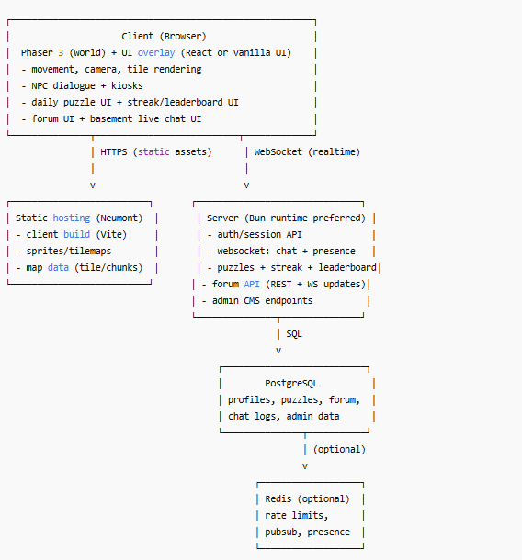
Figure 2 — User Journey Flow (Landing → Login/Guest → Explore → Daily Puzzle → Chat/Forum → Apply CTA)
End-to-end user flow from first entry through recurring engagement loops. Shows the two entry modes (Guest vs Login), how exploration and NPC interactions work, how the daily puzzle drives streak/leaderboards, how community features (chat/forum) fit into the loop, and where the “Apply / Next Steps” calls-to-action appear.
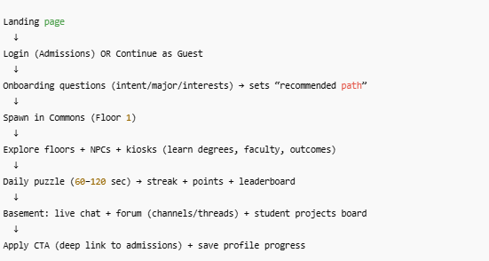
Figure 3 — Content/Admin Workflow (Edit → Review → Publish → Appears In-Game)
Workflow diagram for how staff/admins update content without code changes: editing NPC dialogue, kiosk content, daily puzzles, and daily quests; publishing updates; and having the client reflect updates immediately (or on refresh) via server-backed content APIs.
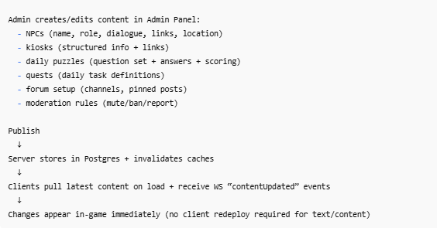
Figure 4 — Data Model Snapshot (Core Tables/Entities)
Conceptual data model showing the MVP entities and their relationships: Users, Profiles, Skills, Badges, DailyPuzzles, PuzzleAttempts, LeaderboardEntries, ForumChannels/Threads/Posts, and ChatMessages (including moderation metadata where applicable).
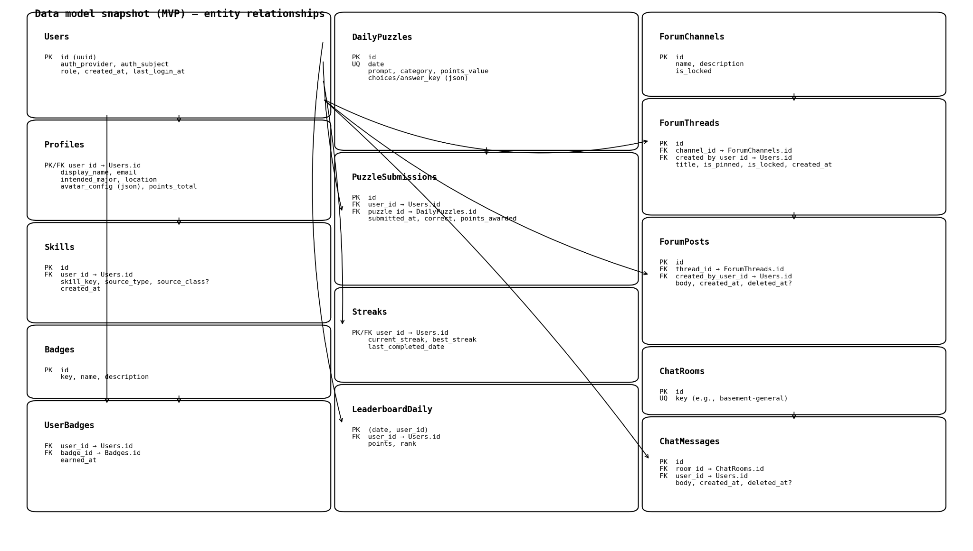

Figure 5— Floor Plan Overlay (Blueprint-to-Game Room Mapping)
Overlay of the Neumont building blueprint with labeled rooms/zones mapped to MVP content: Commons/Welcome, each major hub area (CS/SE/IS/Game Dev/BSAAI/BSAIE), Career Services + outcomes, and Basement community space (forum + live chat). Includes a clear legend so reviewers can see how the real floor plan translates into the 4-floor MVP map.
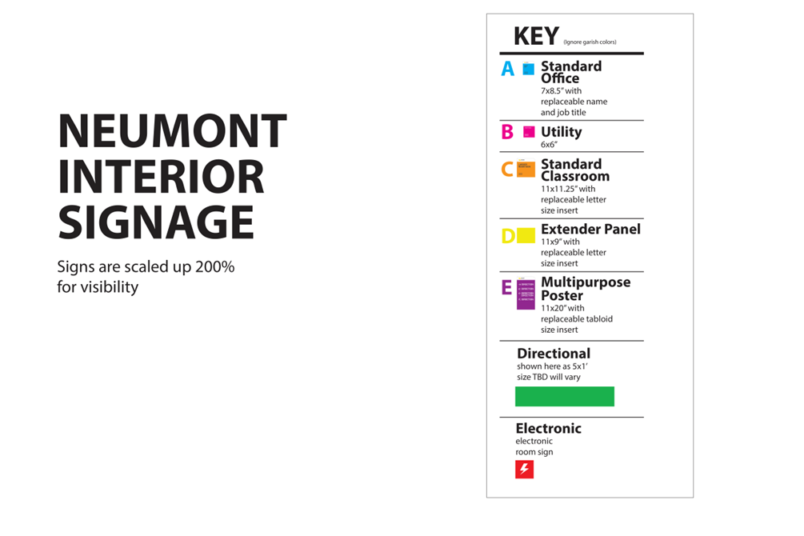
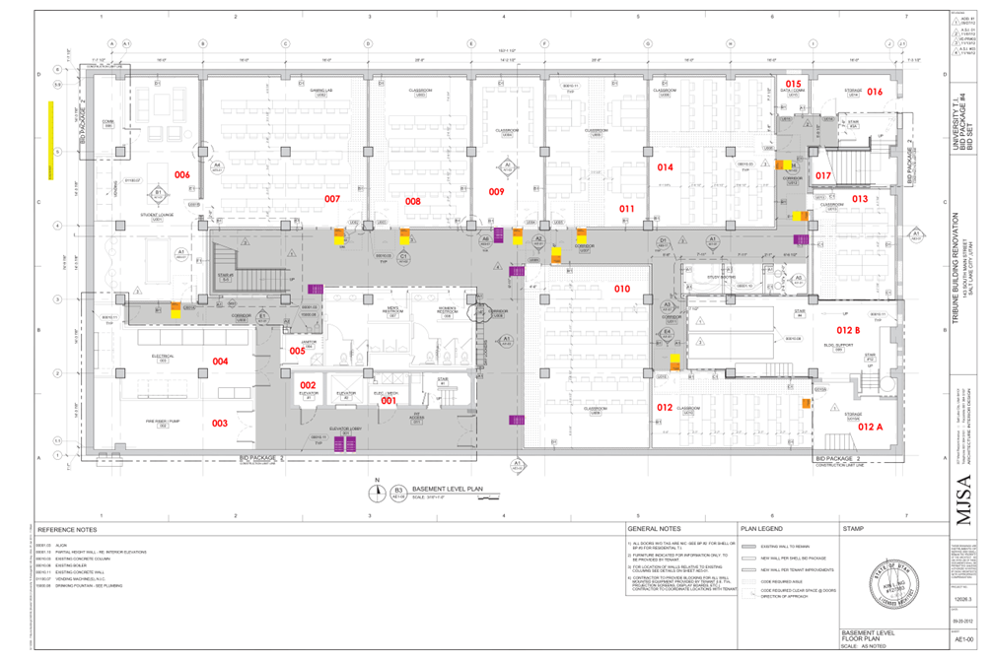
Basement level plan (reference).
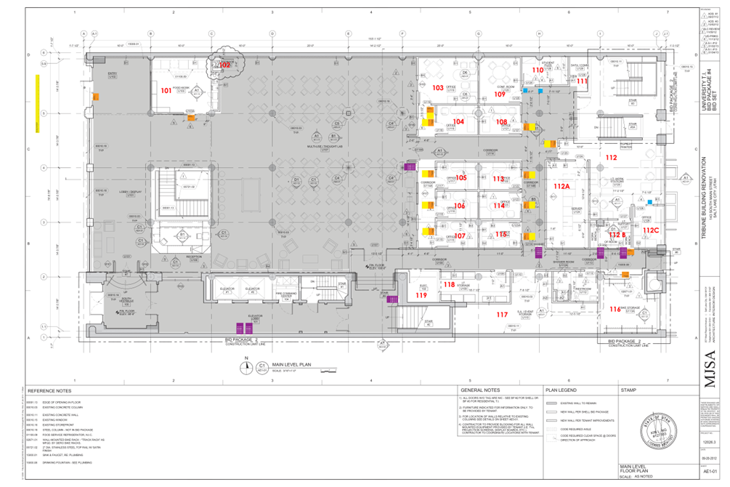
Main level plan (reference).

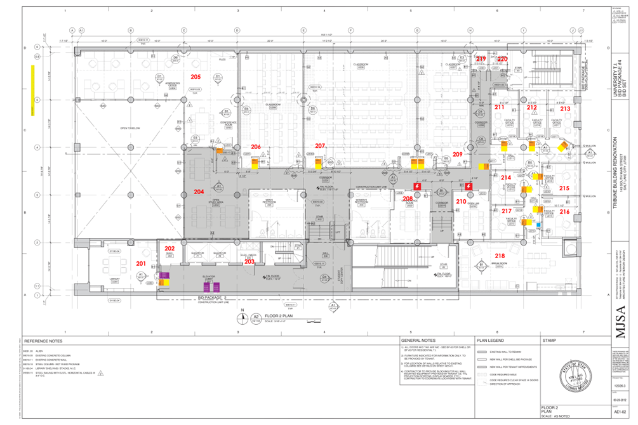
Second level plan (reference).
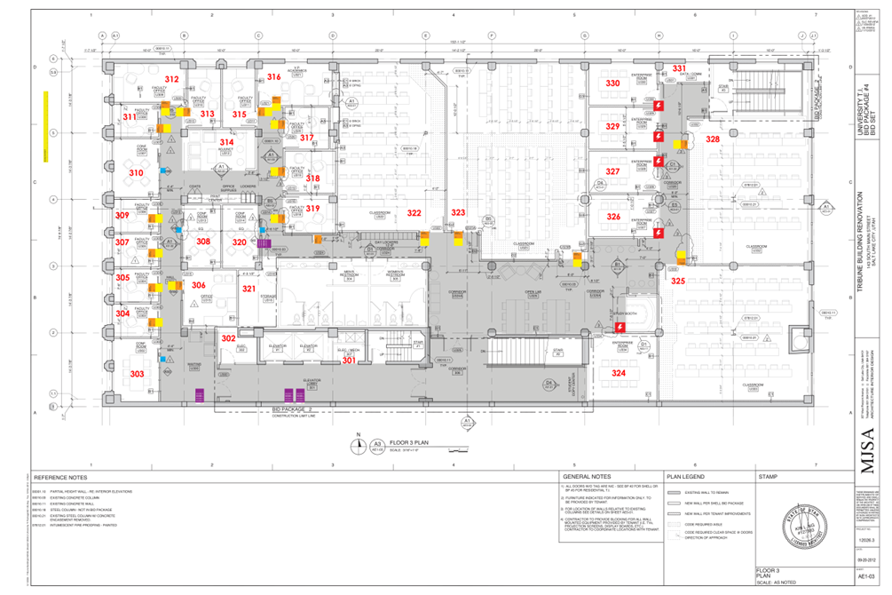
Third level plan (reference).
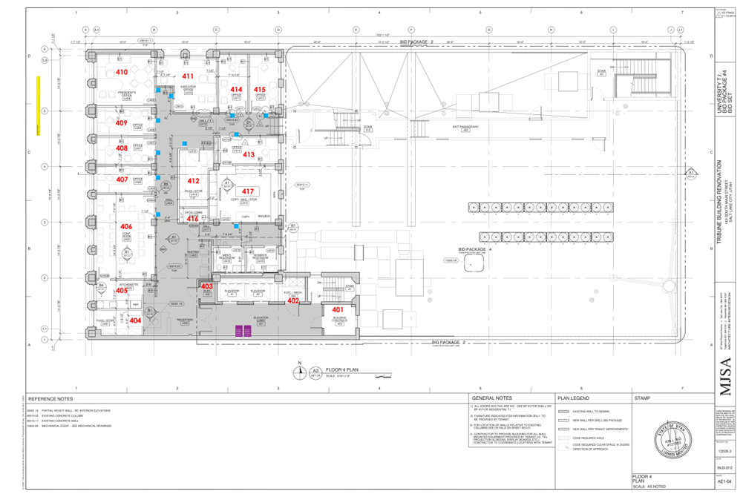
Fourth level plan (reference; may be post-MVP depending on the 4-floor mapping).
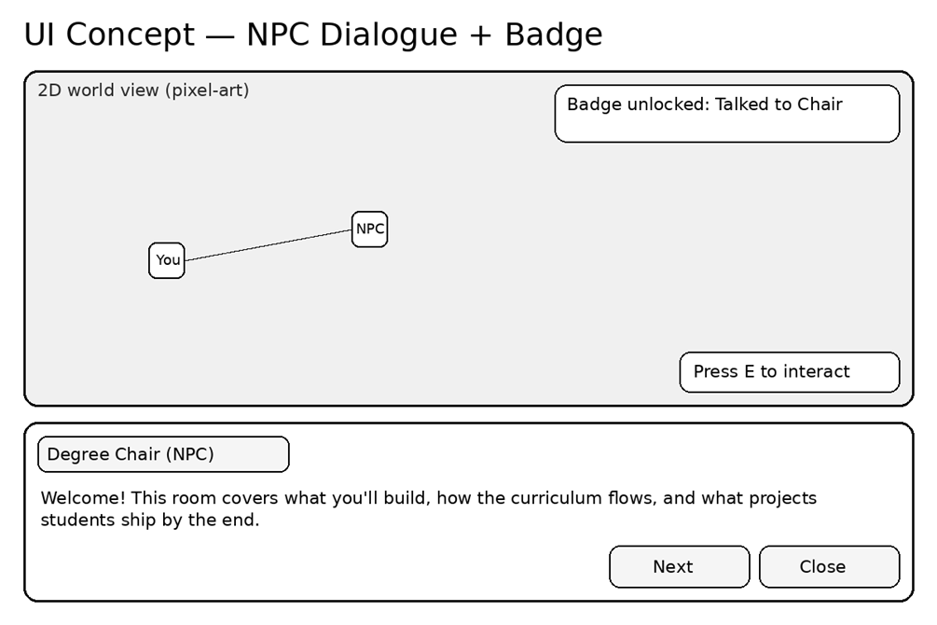
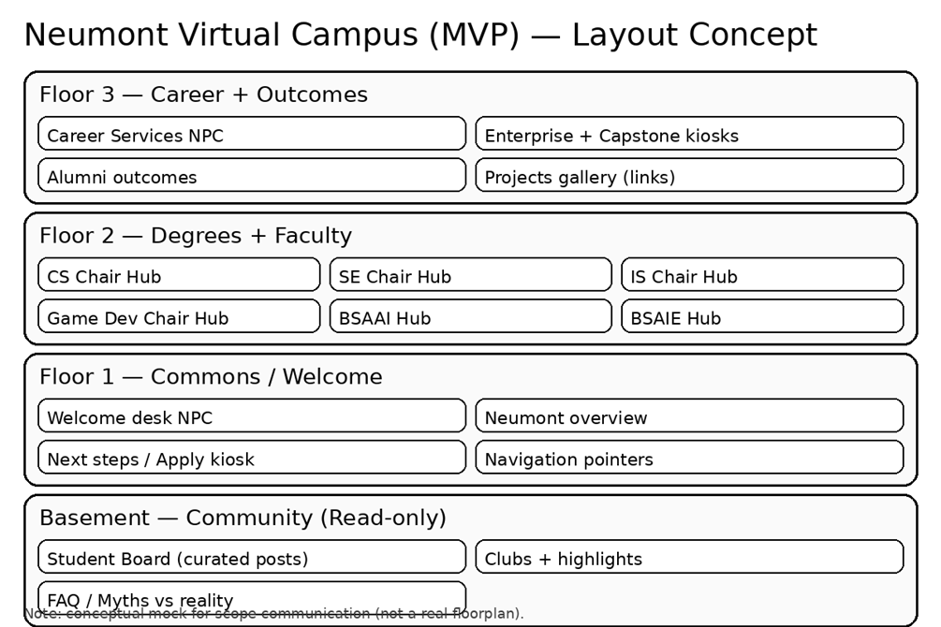

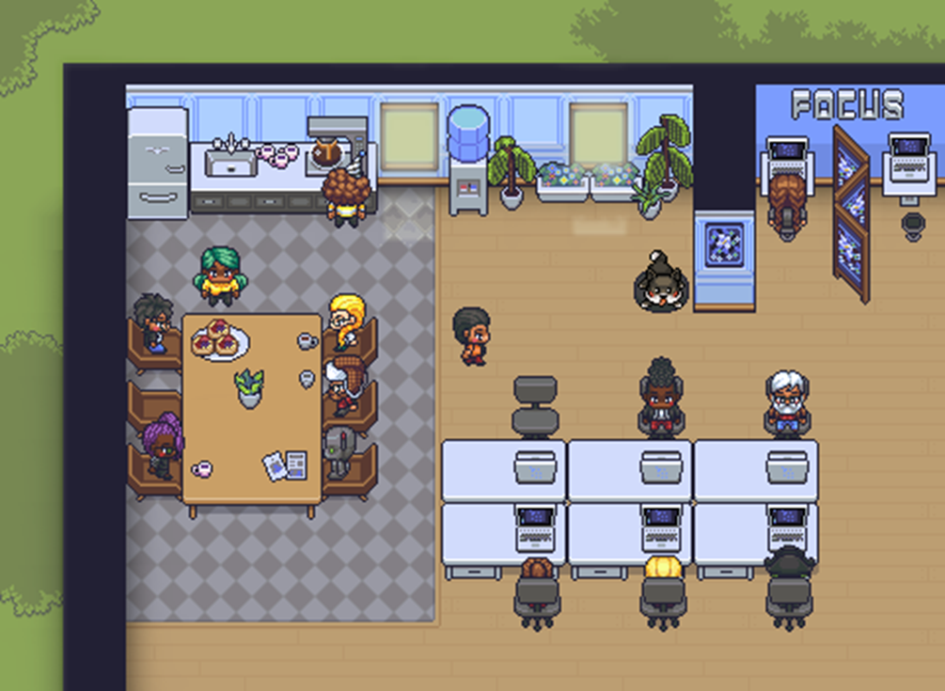
Style reference: Gather-like top-down virtual space concept.

