

Department of Computing and Networking

Games Degree Year 3

***Game Design Document***

## Aoibhinn Mc Auley C00146854

## Darren Kelly C00157765

November 2013

**Table of Contents**

Functionality planned…………………………………………………………………………………….…………….……….………..3

Game mechanics…………………………………………….……………………………………………………………….………….….3

Space………………………………………………………………….……………………………..…………………..…….….……….……3

Objects……………………………………………………………….………………………………..……………..…….….……………….4

Actions…………………………………….…………………..…….………………………………………………….……….………………4

Rules…………………………………………………………………..…..…………………………………………….…….…………..…….4

Skills…………………………………………………………………………...……….………………………………….….……………..…..4

Chance………………………………………………………………………..………….……………………………………………………...4

User and Developer Stories……………………………….……..………………………………………………………………..….5

User Interface………………….……………………………….……..………………………………………………………………..….10

**Functionality planned**

For our second iteration we plan to have the following features implemented into our game:

* Random shapes user story: as a user I want all random shapes spawning and acting appropriately (falling at the right speed, proper collision with other shapes and matrix) with use of the seven bag algorithm.
* Level progression user story: as a user I want when a full grid square is cleared the my score is now increased and displayed on screen, the speed of the falling blocks to increase, and I want to earn more points for each grid square cleared.)
* Audio user story: As a user I want suitable music and sounds to play when expected
* Instant drop user story: as a user I want to be able to press space and the according block/shape to be dropped instantly into position.
* Display next shape user story: As a user I want to be able to see what the next shape will be before It is used.
* Shape shadow user story: As a user I want darkened grid segments below the shape and on each side of the viewable grid to allow ease of movement.

**Game Mechanics**

**Space**

The game world consists of a three dimensional well in which the shapes fall and are placed into. This matrix is stored inside a larger environment that consists of a plane that the grid rests on and a space skybox.

The two 'spaces' don't really have much contact with each other besides the grid resting on the plane the outer larger space exists only to add to the game environment.

The user only has control over the moving shape's inside the grid 'space' e.g. the 5v5x11 well, it resembles the real world in the way that the shape automatically fall down wards as if gravity was acting on them except they don't fall straight down, they are timed to stop and start falling to give the player a chance to decide where to place them. The speed at which they fall is also increased with each level.

**Objects**

* The player interacts with the current falling shape by moving it into a desired location within the grid.
* The player can interact with the camera rotating it to get a better view of the grid.
* The grid is an object that the player appears to interact with but cannot alter it in anyway, it exist purely for collision detection purposes and to help the player achieve a cleared square.

**Actions**

The player will interact with the game as follows:

Left: To move the shape left.

Right: To move the shape to the right.

Space: To instantly drop the shape into place

Shift: Store the current shape or swap it with the shape in storage.

W: Rotate the shape forward on the z axis.

S: Rotate the shape back on the z axis.

A: Rotate the shape left.

D: Rotate the shape right.

1: Rotate the camera left.

2: Rotate the camera right.

**Rules**

The player's objective is to clear as many full grid squares as fast as they can by moving and rotating the shapes they are given. Their level increase when a certain amount of grid squares have been successfully cleared, with each new level the speed of the falling shape's increases and so does the amount of point earned for each cleared square. If the blocks stack up beyond the height of the matrix then the game is over.

**Skills**

This is a puzzle solving game so the skills required are mental. The player is required to fit together the many spawning shapes that fall to complete a full grid square, this becomes increasingly more difficult because the speed of the shapes increase per level requiring the player to be able to identify suitable places for the shape to go as quick as possible, without letting the shapes stack up higher than the matrix.

Skills - every game requires players to exercise certain skills (physical, mental, social skills).

**Chance**

The sequence the shapes fall in is determined with use of the seven bag algorithm. This algorithm states that if one shape has been used out of whatever amount of shapes then this shape cannot be used again until every shape has been cycled through once. This means the only time the player will get a shape twice is when the last shape of a cycle and first shape of the next cycle are equal.

This will greatly help game play as the player cannot continuously get the same shape as it is not completely random. It will help the player have much more of a chance positioning shapes appropriately with this approach.

Another aspect of chance we were thinking of adding is the idea of an awkwardly shaped difficult to place shape being given to the player at random but very seldom. This will help with difficulty and could cause confusion to the player adding a fun, different, difficult element to usual game play. This will be an-add on to the existing game so it will be one of the last things we will implement depending on time and position of completion.

**User and Developer Stories**

**Title:** Create a game environment.

**Conditions of satisfaction**

As a user I want the game to have a textured plane. I want the matrix to be visible and the background to be appropriately textured. We completed this user story and we were happy with its outcome.

Storyboard:

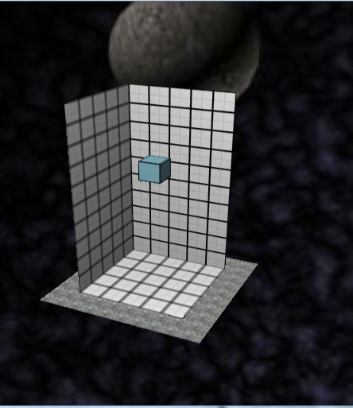

This is a screenshot of our game showing a custom textured grid, a cube with a custom texture also, an appropriately textured plane and a skybox which all help add to the immersion of the game’s environment and making it more appealing to the player.

# Title: Create Shapes and have them falling.

**Conditions of satisfaction**

As a user I want there to be different shapes that fall down the screen slowly in increments of a cubes width. For the first sprint the only shape we wanted to create was a cube.

# Title: Add Collision detection between shapes and plane user story

**Conditions of satisfaction:**

As a user I want the shapes to land on the plane when they reach it.



**Storyboard**:

This image shows the cube we created.

# Title: Add Collision detection between shapes and sides of the matrix

**Conditions of satisfaction**

As a user I want the shapes to stay inside the matrix even if I try to move them out of it.

**Title:** Have a new shape spawn after the pervious one has stopped moving.

**Conditions of satisfaction:**

After I have placed the current shape I want a new shape to spawn above the grid.

**Storyboard:**

This image shows a cube falling to the bottom of the grid while another one waits above it, which will start to fall when the one before it lands.

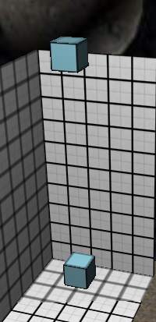

# Title: Add Collision detection between shapes

**Conditions of satisfaction**

As a user I want the shapes to land on each other properly. For this sprint we will use just use cubes.

**Storyboard:**

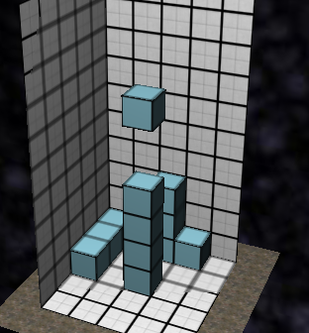

This screen shot shows the cube objects colliding as expected and landing on each other appropriately.

**Title:** Shape Movement

**Conditions of satisfaction**

As a player I want to be able to move the shapes on the screen appropriately so that I can place them where I want and progress in the game. I want to be able to use the left and right directional keys to move the shape to the left or the right, I want to be able to instantly drop a piece by pressing the spacebar and rotate it by pressing the W,A,S,D keys.

**Storyboard:**

This is demonstrated in the positioning of the blocks in the screenshot above.

**Title:** Clearing a full grid square

**Conditions of satisfaction**

When I have placed enough shapes to make up a full square on the grid I want all sections of the shapes associated with it to disappear and for my score to increase.

**Storyboard:**

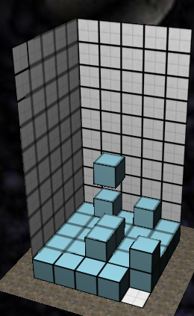

This image shows an almost full grid square, which when the last cube falls into place, all associated cubes will vanish and any cube resting on them will subsequently fall into place on the grid.

**Title:** Random shapes user story:

**Conditions of satisfaction:**

As a user I want all random shapes spawning and acting appropriately (falling at the right speed, proper collision with other shapes and matrix). Also I want each shape to have a corresponding colour assigned to it.

**Storyboard:**

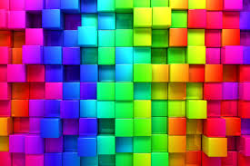

This image displays colours we may use for the different shapes.

**Title:** Level progression user story:

**Conditions of satisfaction:**

When a full grid square is cleared my score should be increased and displayed on screen, the speed of the falling blocks should also increase, and I want to earn more points for each grid square cleared per level. )

**Storyboard:**

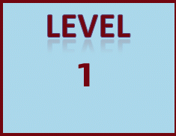

Example of how the level could be displayed on the screen to the player.

**Title:** Audio user story:

**Conditions of satisfaction:**

As a user I want suitable music and sounds to play when expected for example when a shape is instantly dropped into place and when a full grid square is cleared.

**Storyboard:**



**Title:** Instant drop user story

**Conditions of satisfaction:**

As a user I want to be able to press the space key and the current block/shape to be dropped instantly into position.

**Storyboard**



This image represents a shape being dropped instantly.

**Title:** Display next shape user story

**Conditions of satisfaction:**

As a user I want the next available shape to be displayed clearly on the screen.

**Storyboard:**

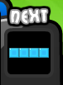

This image shows how we might display the next shape to the user.

**Title:** Shape shadow user story

**Conditions of satisfaction:**

As a user I want to be able to see an outline of the current shape below it to help me fit it correctly.

Also I would like shadow’s to be cast on the outer bounds of the grid.

**Storyboard:**

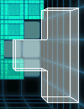

Example of how we might display the shape’s shadow to the player.

**User Interface**

Our planned user interface will consist of:

* A greeting screen which will welcome the player to the game and give them an option to play either by themselves or against another player.
* During the game the players score, current level, and the next shape available will all be displayed on screen.
* At the end of the game the player’s final score will be displayed along with a positive message such as ‘Good game!’ they will also have the option to play again.

Our welcome screen may resemble something along the lines of this:

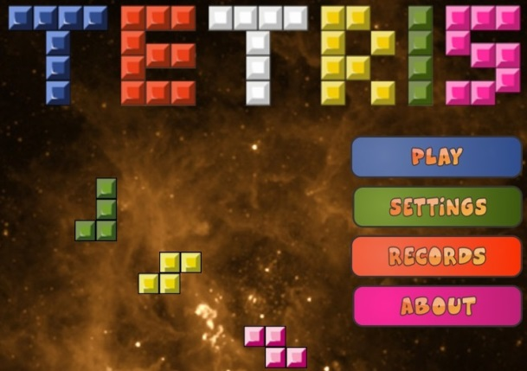

Our in game interface will look something like the following image:

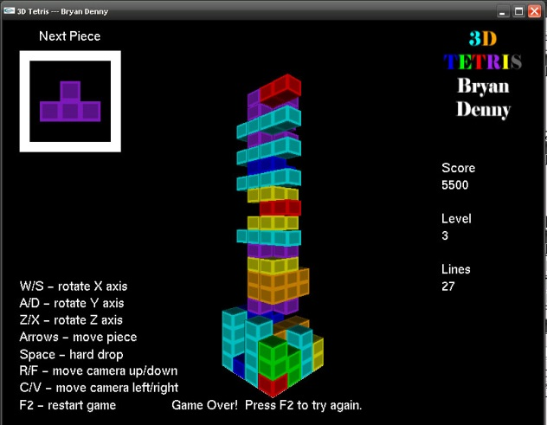

Our end game screen may be similar to this following image:

