Assignment 1 – Personal Website
Name: Aoife Cunningham
Student No.: 20117133
Course: Computer Forensics and Security
Group: w1

Overview:
This website is a personal website that shows my hobbies and interests. It includes my name and a photograph of myself on the home page.
For my hobbies and interests I decided to create webpages on camogie and travel.
For my camogie pages I plan to include..
- Information about my camogie career from underage camogie to adult camogie
- Information about my camogie career at county level
- A table to show what my weekly plan would look like.
- Information about my camogie club
For my travel pages I plan to include..
- Photos showing some places I have been
- Links to an external website of a place I have been (a hotel).
- I plan to include a background image on this webpage.
Across all pages I will have a navigation bar linking all pages together.

Wireframes For All Webpages:
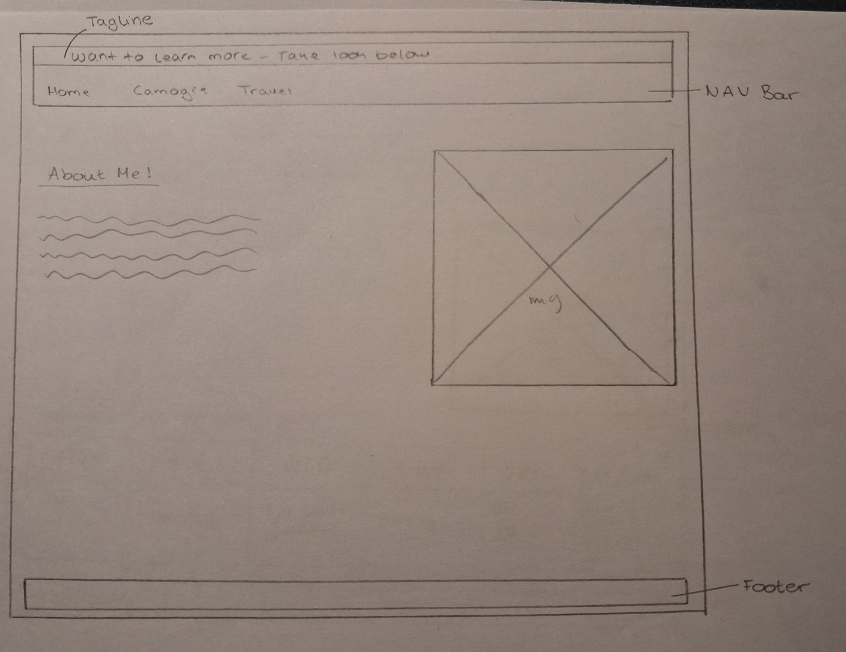
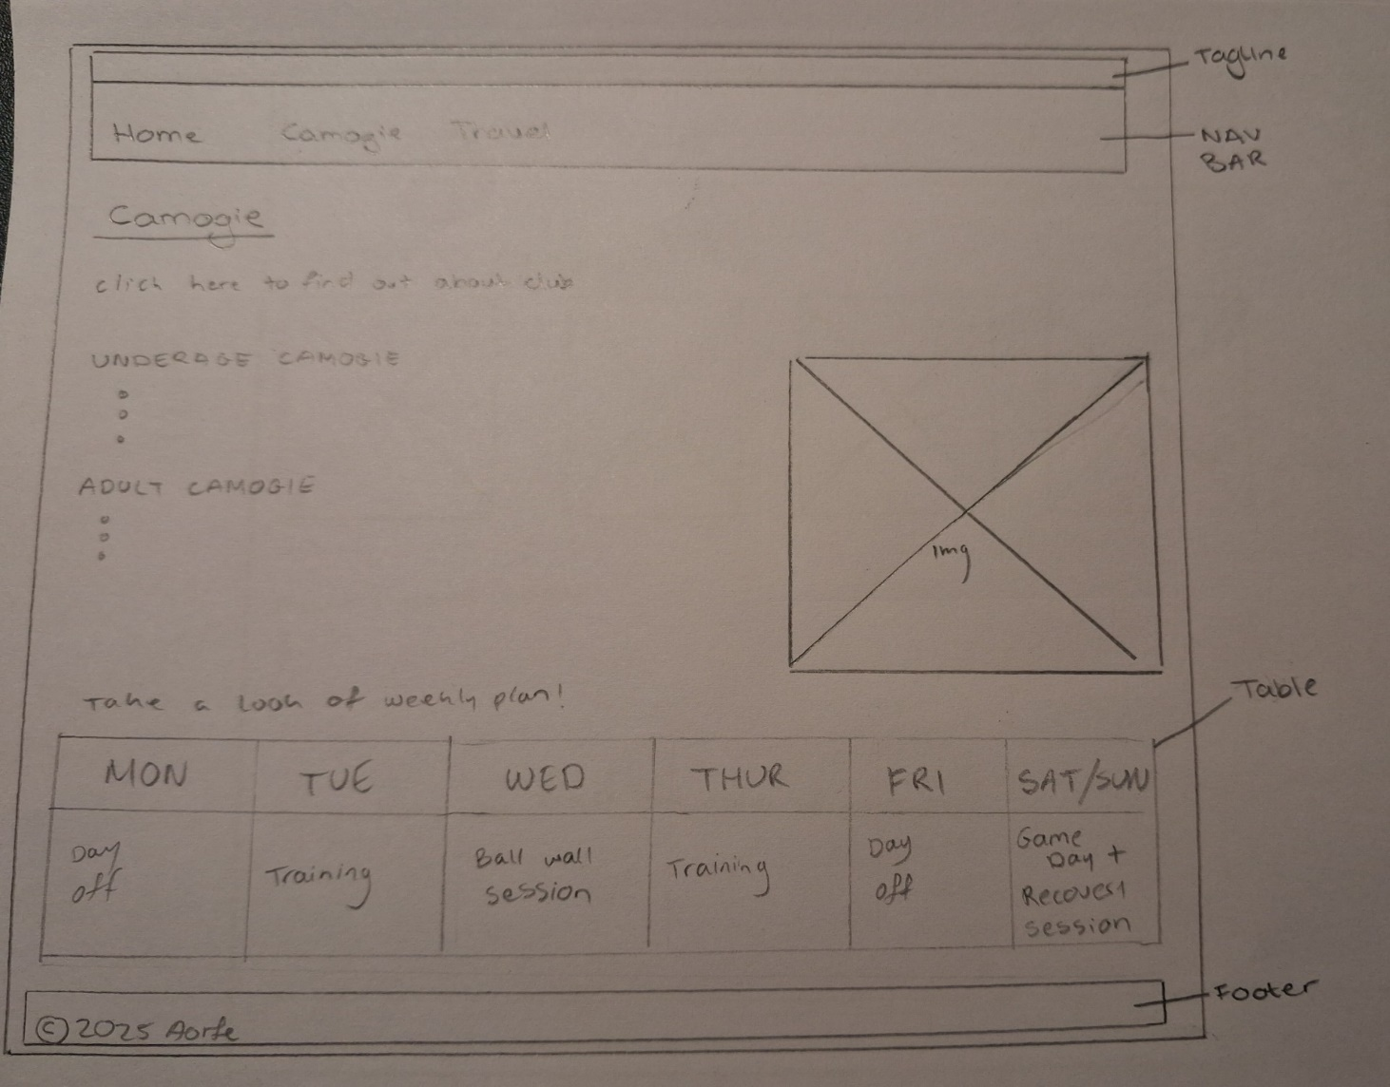

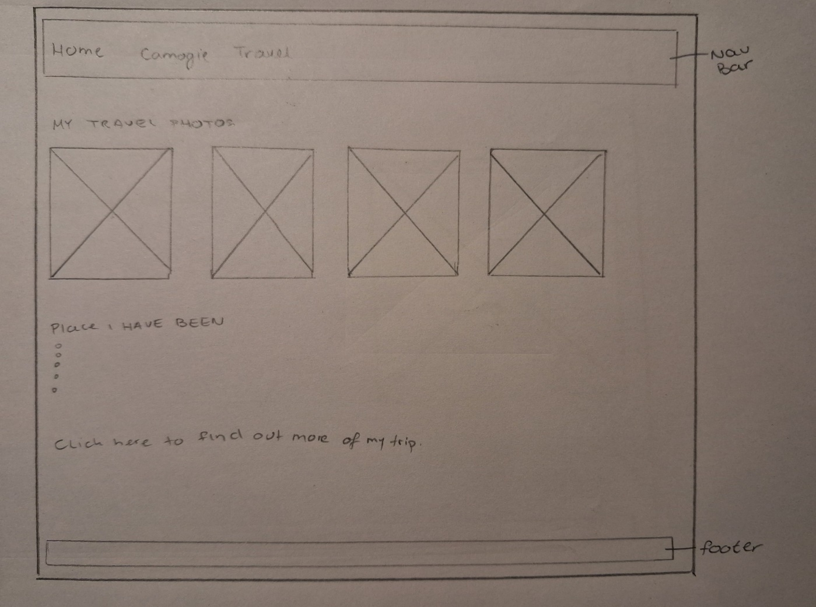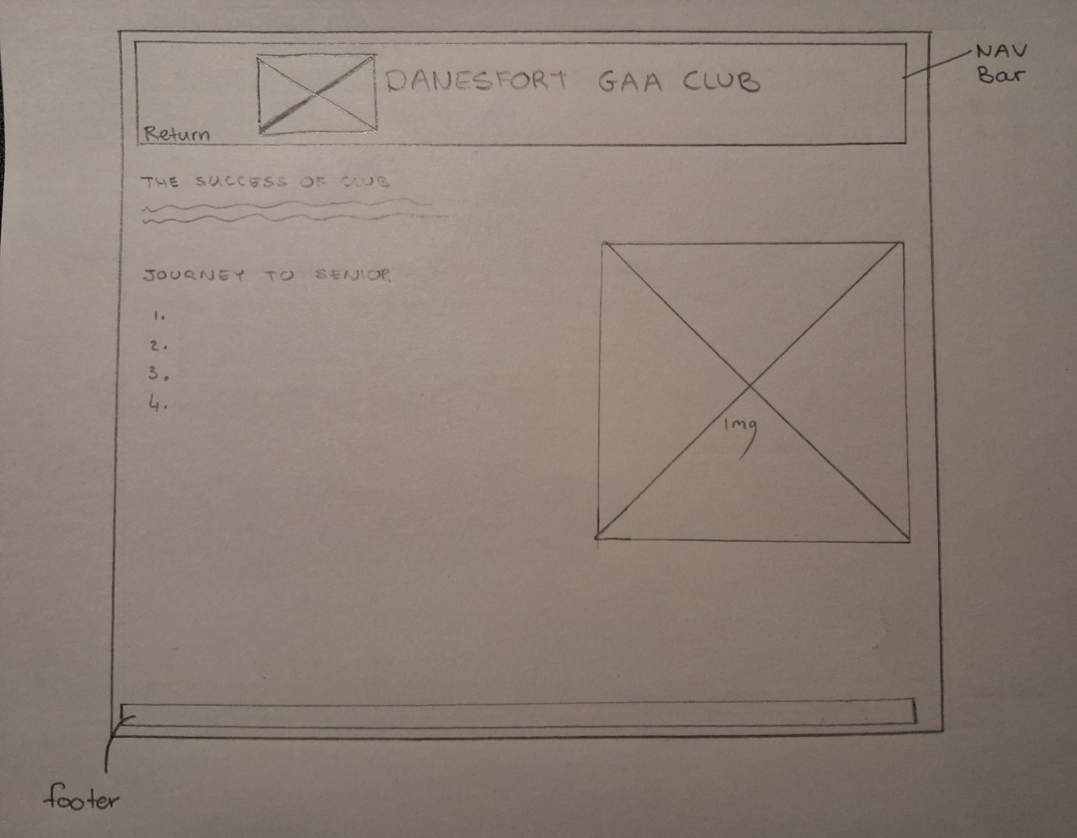
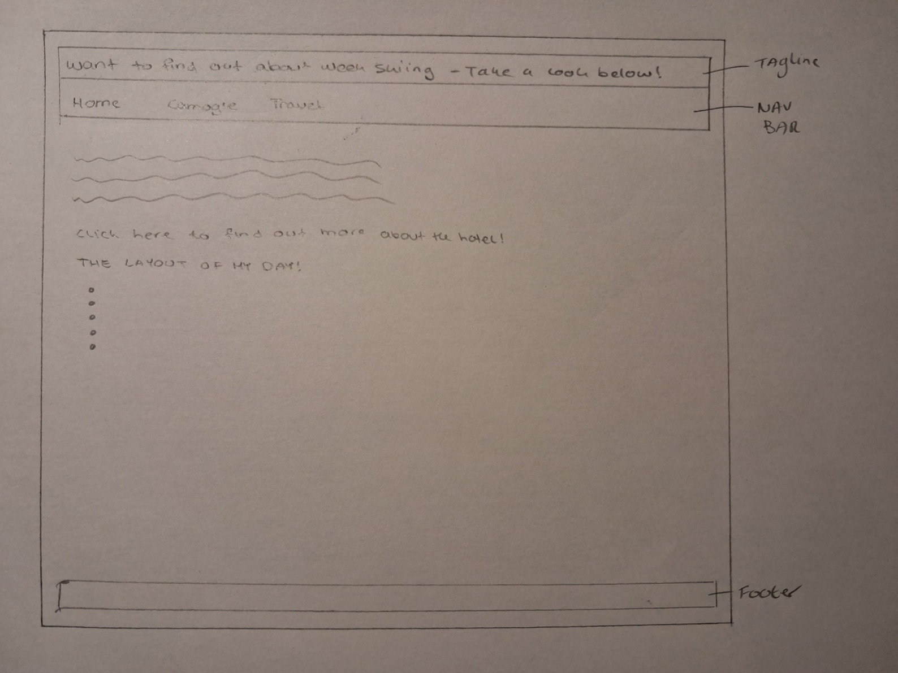

Visual Design:
Colours: Across all my webpages I would like to keep a consistent colour theme to create a consistent look and visually appealing . The main colour would be blue and would be used across all webpages. I then plan to use different shades of blue for the navigation bar and headings.

Fonts: Throughout my website I would use different heading sizes. But also use the same font across all the website to help create a consistent look . For heading I would use italic style and use fonts such as Georgia, Times, serif fonts.

