Project 2 - XML in Technical Communication

Contents

IBM StoredIQ Deployment and Configuration Guide 0

Notes: 0

About this publication 0

IBM StoredIQ product library 0

Contacting IBM StoredIQ customer support 0

IBM StoredIQ components 0

Solution components 0

Applications of IBM StoredIQ 0

Planning for deployment 0

Open Virtual Appliance (OVA) configuration requirements 0

Network and port requirements 0

TCP: port ranges for the firewall 0

Default open ports 0

SSH port 22 0

Default open ports on the AppStack 0

Default open ports on the IBM StoredIQ data server 0

Enable or disable ports or services on the IBM StoredIQ data server 0

Default open ports on the nodes in the Elasticsearch cluster 0

Default open ports on the IBM StoredIQ gateway 0

Supported chain and rules on the IBM StoredIQ gateway 0

Open ports for desktop client access to the data server 0

Environment sizing guidelines 0

Stack-provisioning prerequisites 0

License usage metrics 0

Security 0

Deploying IBM StoredIQ 0

Deploying the virtual appliances 0

Deploying IBM StoredIQ on Microsoft Hyper-V 0

Glossary 0

# IBM StoredIQ Deployment and Configuration Guide

## Notes:

The following is a reference of the elements used to create this document.

|  |  |
| --- | --- |
| Hierarchical Links | Numerous topics are included in the master map of this document in a hierarchical structure. |
| Cross references | Images are referenced in this section using a second map and conkeyref. |
| Links | There are many external and internal links added using xref. |
| Glossary | The required Glossary is included at the end of this document. |

# About this publication

IBM StoredIQ Deployment and Configuration Guide provides information about how to plan, deploy, and configure the IBM StoredIQ product.

## IBM StoredIQ product library

The following documents are available in the IBM® StoredIQ® product library.

* IBM StoredIQ Overview Guide
* IBM StoredIQ Deployment and Configuration Guide
* IBM StoredIQ Data Server Administration Guide
* IBM StoredIQ Administrator Administration Guide
* IBM StoredIQ Data Workbench User Guide
* IBM StoredIQ Policy Manager User Guide
* IBM StoredIQ Insights User Guide
* IBM StoredIQ Integration Guide

## Contacting IBM StoredIQ customer support

For IBM StoredIQ technical support or to learn about available service options, contact IBM StoredIQ customer support at this phone number:

* 1-866-227-2068

Or, see the Contact IBM web site at <http://www.ibm.com/contact/us/>.

**IBM Knowledge Center**

The IBM StoredIQ documentation is available in [IBM Knowledge Center](https://www.ibm.com/support/knowledgecenter/).

Contacting IBM

For general inquiries, call 800-IBM-4YOU (800-426-4968). To contact IBM customer service in the United States or Canada, call 1-800-IBM-SERV (1-800-426-7378).

For more information about how to contact IBM, including TTY service, see the Contact IBM website at <http://www.ibm.com/contact/us/>.

# IBM StoredIQ components

The IBM StoredIQ solution consists of these components: the application stack, the gateway, the data server, and optionally the Elasticsearch cluster.

## Solution components

IBM StoredIQ provides three solution components: the gateway, data servers, and application stack (AppStack).

|  |  |
| --- | --- |
| Gateway | The gateway communicates between the data servers and the application stack. The application stack polls the gateway for information about the data on the data servers. The data servers push the information to the gateway. |

|  |  |
| --- | --- |
| Data servers | A data server obtains the data from supported data sources and indexes it. By indexing this data, you gain information about unstructured data such as file size, file data types, file owners.  The data server pushes the information about volumes and indexes to the gateway so it can be communicated to the application stack. Multiple data servers feed into a single gateway.  Data servers can be categorized in two types: DataServer - Classic and DataServer - Distributed. A data server of the type DataServer - Classic uses the embedded PostgreSQL database for storing the index. With a data server of the type DataServer - Distributed, the index is stored in an Elasticsearch cluster. Data servers of this type also provide better performance in search queries. They can manage much larger amounts of data than data servers of the type DataServer - Classic, thus making the IBM StoredIQ deployments more scalable.  You can have both types of data servers in your IBM StoredIQ deployment.  In addition to completing standard administrative tasks, administrators can deploy the IBM StoredIQ Desktop Data Collector and index desktops from the data server. |

|  |  |
| --- | --- |
| Application stack | The application stack provides the user interface for the IBM StoredIQ Administrator, IBM StoredIQ Data Workbench, IBM StoredIQ Insights, and the IBM StoredIQ Policy Manager products.  The synchronization feature for integration with a governance catalog is also part of the application stack. |

|  |  |
| --- | --- |
| Elasticsearch cluster | The Elasticsearch cluster attached to a data server of the type DataServer - Distributed provides a single data store for all metadata and content of harvested objects. Indexed data is distributed automatically across the nodes in the cluster. Indexing and queries are load-balanced across all nodes. Nodes can be added dynamically without downtime and the indexing process can use these newly added nodes without further setup. |

## Applications of IBM StoredIQ

IBM StoredIQ provides interface applications that help fulfill its solution goals.

IBM StoredIQ Data Server

IBM StoredIQ Data Server user interface provides access to data server functionality. It allows administrators to view the dashboard and see the status of the jobs and system details. Administrators can manage information about servers and conduct various configurations on the system and application settings. 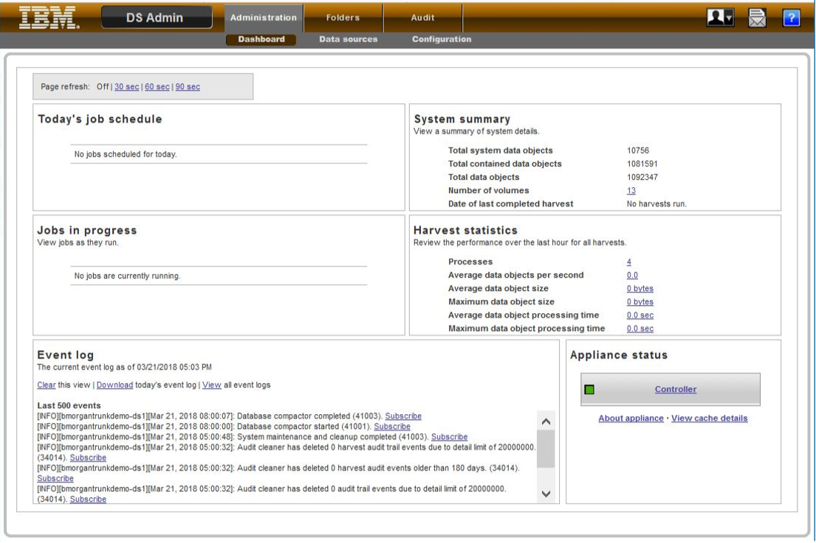

IBM StoredIQ Administrator

IBM StoredIQ Administrator helps you manage global assets common to the distributed infrastructure behind IBM StoredIQ applications. 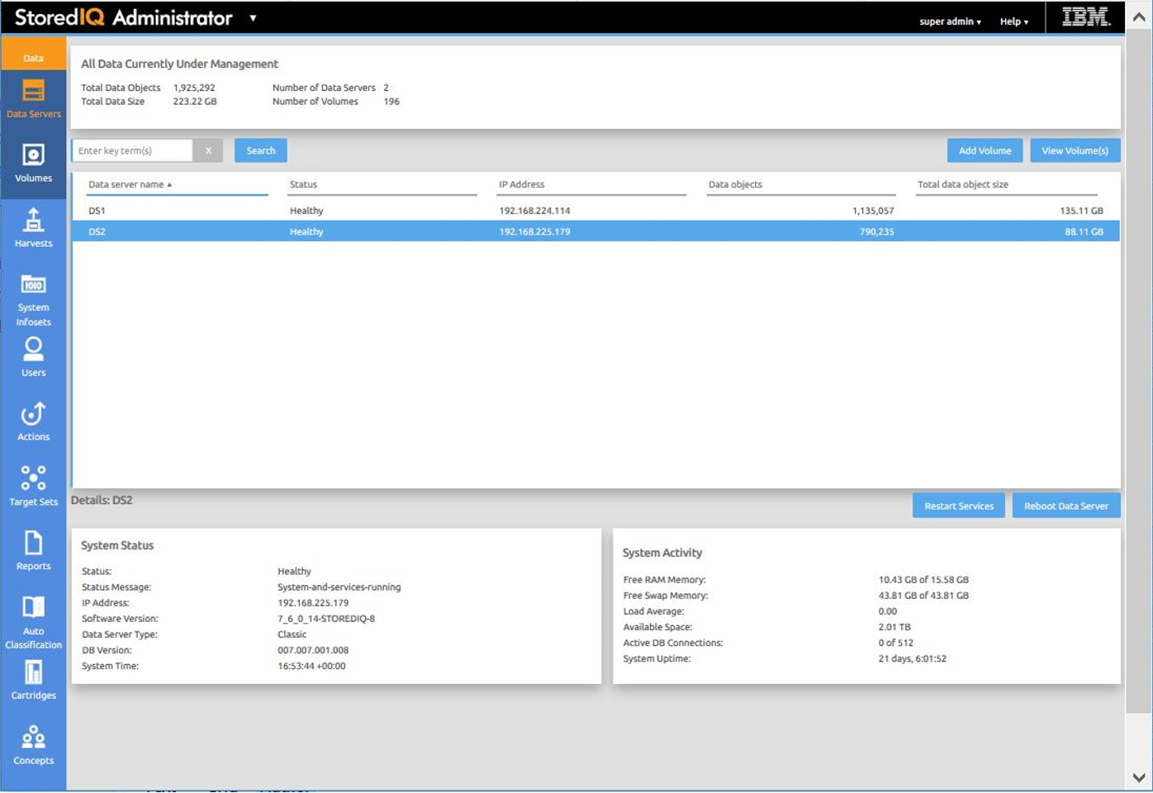

IBM StoredIQ Administrator provides at-a-glance understanding of the different issues that can crop up in the IBM StoredIQ environment. These views are unique to the IBM StoredIQ Administrator application as they provide an overview of how the system is running. They allow access to various pieces of information that are being shared across applications or allow for the management of resources in a centralized manner.

The administrator is the person responsible for managing the IBM StoredIQ. This individual has strong understanding of data sources, indexes, data servers, jobs, infosets, and actions. This list provides an overview as to how IBM StoredIQ Administrator works:

* **Viewing data servers and volumes:** Using IBM StoredIQ Administrator, the Administrator can identify what data servers are deployed, their location, what data is being managed, and the status of each data server in the system. Volume management is a central component of IBM StoredIQ. IBM StoredIQ Administrator also allows the Administrator to see what volumes are currently under management, which data server is responsible for that volume, the state of the volume after indexing, and the amount and size of information that is contained by each volume. Administrators can also add volumes to and delete volumes from data servers through this interface.

If IBM StoredIQ is configured for integration with Information Governance Catalog, the Administrator can also manage which volumes are published to the governance catalog.

* **Scheduling harvests:** Harvesting, which can also be referred to as indexing, is the process or task by which IBM StoredIQ examines and classifies data in your network. Using IBM StoredIQ Administrator, harvests can be scheduled, edited, and deleted.
* **Creating system infosets:** System infosets that use only specific indexed volumes can be created and managed within IBM StoredIQ Administrator. Although infosets are a core component of IBM StoredIQ Data Workbench, system infosets are created as a shortcut for users in IBM StoredIQ Administrator.
* **Managing users:** The user management area allows administrators to create users and manage users' access to the various IBM StoredIQ applications.
* **Configuring and managing actions:**  An action is any process that is taken upon the data that is represented by the indexes. Actions are run by data servers on indexed data objects. Any errors or warnings that are generated as a result of an action are recorded as exceptions in IBM StoredIQ Data Workbench.

**Note:** Actions can be created within IBM StoredIQ Administrator and then made available to other IBM StoredIQ applications such as IBM StoredIQ Data Workbench.

* **Managing target sets:**  Provides an interface that allows the user to set the wanted targets for specific actions that require a destination volume for their actions.
* **Reports:**  IBM StoredIQ Administrator provides a number of built-in reports, such as summaries of data objects in the system, storage use, and the number of identical documents in the system. You can create custom reports, including Query Analysis Reports for e-discovery purposes, and automatically email report notifications to administrators and other interested parties.
* **Auto-classification:** Automated document categorization, what IBM StoredIQ refers to as autoclassification models, integrates the IBM® Content Classification's classification model into the IBM StoredIQ infoset-generation process. Data Experts can use IBM Content Classification to train a classification model, which is then registered with IBM StoredIQ Administrator. The registered classification model can be applied to an existing infoset in IBM StoredIQ Data Workbench to generate new metadata for the objects in the infoset. Metadata can be used in rule-based filters to create new infosets.
* **Cartridges:** Cartridges are compressed files that contain analysis logic. When you add a cartridge to IBM StoredIQ AppStack, it can detect new data in documents during indexing and make these new insights searchable. For example, a sensitive pattern cartridge can enable IBM StoredIQ to detect passport numbers, phone numbers, and other IDs.

To apply the analysis logic contained in the cartridge, you must run a Step-up Analytics action that uses the cartridge on an infoset. IBM StoredIQ examines all documents in the infoset, applies the analytics, and then stores the analysis results in the IBM StoredIQ index.

* **Managing concepts:** Provides the ability to relate business concepts to indexed data.
* **Managing Mule scripts:**  Helps you to create Mule scripts and upload script packages. These Mule scripts are used by IBM StoredIQ Policy Manager to create policies using the automation workflow.
* **DataServer - Classic:**  Data servers can be categorized in two types: DataServer - Classic and DataServer - Distributed. DataServer - Classic refers to the regular data servers. It uses either the current PostgreSQL or Lucene index as an index.
* **DataServer - Distributed:** The distributed data server uses an Elasticsearch cluster instead of an embedded Postgres database. It increases the scalability and flexibility of the IBM StoredIQ deployment in a way that it can manage much larger amounts of data. Without adding more data servers, data that is managed by the IBM StoredIQ deployment can be increased by adding new nodes to the Elasticsearch cluster. Search queries perform better on DataServer - Distributed.
* **Connector API SDK:**  A connector is a software component of IBM StoredIQ that is used to connect to a data source such as a network file system and access its data. Using IBM StoredIQ Connector API SDK, developers of other companies can develop connectors to new data sources outside the IBM StoredIQ development environment. These connectors can be integrated with a live IBM StoredIQ application to index, search, manage, and analyze data on the data source.

IBM StoredIQ Data Workbench

Big data is a pervasive problem, not a one-time occurrence. It is easy for most companies to realize that big data is problematic, but it is hard to identify what problems they have. Big data is all about the unknown, but the unknown cannot be off limits. IBM StoredIQ Data Workbench can help you learn about your data, make educated decisions with your most valuable asset, and turn your company's most dangerous risk into its most valuable asset. 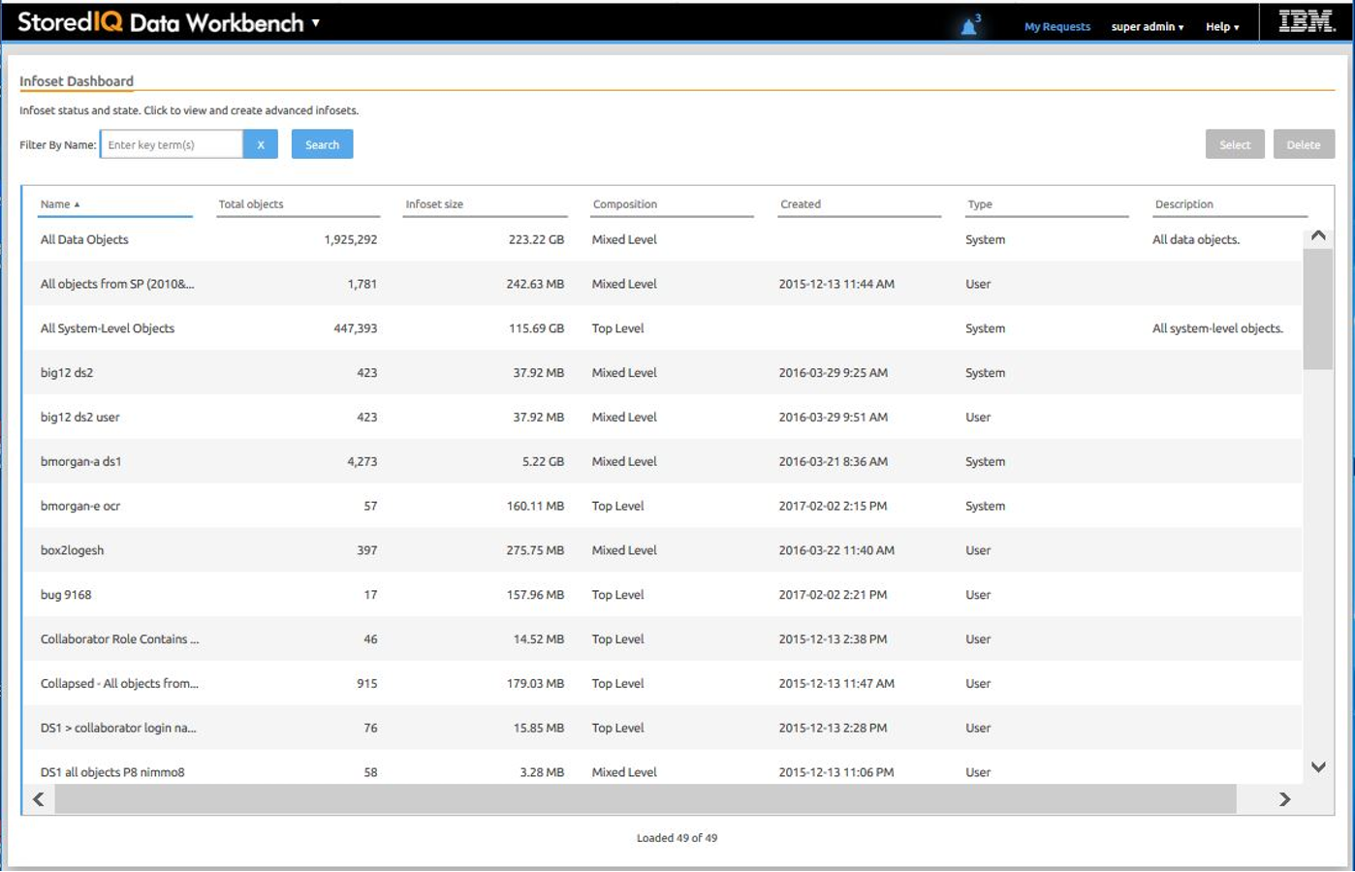

IBM StoredIQ Data Workbench is a data visualization and management tool that helps you to actively manage your company's data. It helps you to determine how much data you have, where it is, who owns it, and when it was last used. When you have a clear understanding of your company's data landscape, IBM StoredIQ Data Workbench helps you take control of data. You can make informed decisions about your data and act on that knowledge by copying, copying to retention, or conducting a discovery export.

Here are just some examples of how you can use IBM StoredIQ Data Workbench.

* You need to find all company email that is sent from or received by Eileen Sideways (esideways@thecompany.com). You can use IBM StoredIQ Data Workbench to find all email and then copy that data to a predefined repository. You can also use IBM StoredIQ Data Workbench to find all of the esideways@thecompany.com email that occurred between specific dates and then make that email available for review.
* As an administrator, you want to rid your networks and storage of unused data. You can use IBM StoredIQ Data Workbench to find all files that were not modified in more than five years.
* You want to find all image files that are created in 2007. Not only can IBM StoredIQ Data Workbench find all image files that were created in 2007. It also shows how much space they occupy on your network.
* A user needs to understand how data about Windows is being retained. Using IBM StoredIQ Data Workbench, you can provide that user with a visual overview of the number of objects that are retained and a breakdown of files per data source. Additionally, you can apply overlays to show the user if those files contain forbidden information such as credit-card numbers or Social Security numbers.
* If IBM StoredIQ is configured accordingly, you can select the infosets and filters that are published to the governance catalog for unified governance of structured and unstructured information. When integrating with Information Governance Catalog, you can also analyze and classify the data governed by IBM StoredIQ based on the data classes that are synchronized from the governance catalog.

IBM StoredIQ Insights

IBM StoredIQ Insights provides dynamic and interactive filtering for your data with easy access to all metadata and instant plain-text preview of document content for full-text indexed volumes.

Faceted search lets you drill down to refine your search results as needed. In addition, you can apply any valid IBM StoredIQ filter query. Tags let you categorize the data for easier management. Visual representations of search results help you gain further insights into your data. Several chart types let you look at and explore data from different perspectives, thus helping you identify patterns and relationships very quickly.

With IBM StoredIQ Insights, you can search data that is managed and indexed by a data server of the type DataServer - Distributed. In mixed deployments that have classic and distributed data servers, only the content from distributed data servers will be searchable.

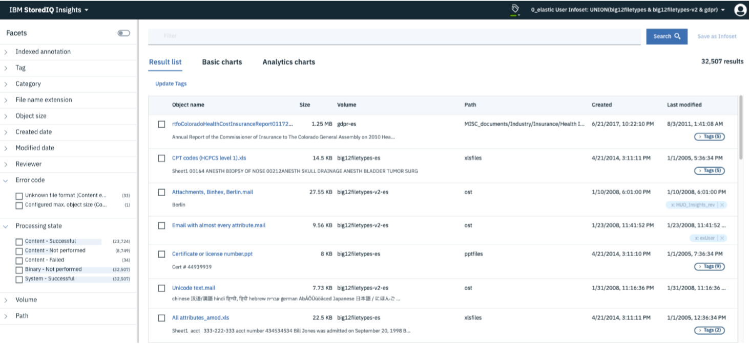

IBM StoredIQ Policy Manager

IBM StoredIQ Policy Manager allows users to run mature policies and processes at scale across a wider range of data.

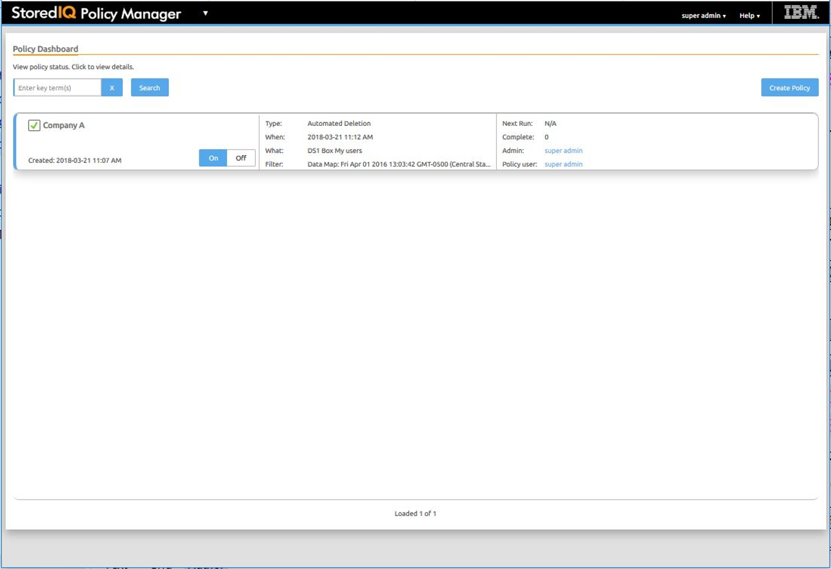

The users can define and run systemwide policies, focusing on the execution of the process rather than understanding or reviewing affected data objects. Additionally, with reports of IBM StoredIQ Policy Manager, you can record what actions were conducted, when they were conducted, and what data was affected by the policy's execution.

IBM StoredIQ Desktop Data Collector

IBM StoredIQ Desktop Data Collector (also referred to as desktop client indexes desktops as volumes. The volumes appear in IBM StoredIQ Data Server and in IBM StoredIQ Administrator, where they can be used like any other data source.

The data server maintains an index using the information sent by the desktop client. After indexing, desktops - even offline or unreachable ones - can be viewed, searched, or targeted for later policy action.

# Planning for deployment

When you plan a deployment of IBM StoredIQ, evaluate several infrastructure considerations.

In addition to the information in this section, review the requirements detailed in the IBM Software Product Compatibility Reports (SPCR) tool at: [Software Product Compatibility Reports: StoredIQ 7.6](https://www.ibm.com/software/reports/compatibility/clarity-reports/report/html/softwareReqsForProduct?deliverableId=CC1291B0F4AF11E3ACBD4447721DA353)

If you plan to use IBM StoredIQ for Legal Identification and Collection to create and manage data boxes and data requests that are to be fulfilled by IBM StoredIQ, also check the system requirements for StoredIQ for Legal at: [Software Product Compatibility Reports: StoredIQ for Legal 2.0.3](https://www.ibm.com/software/reports/compatibility/clarity-reports/report/html/softwareReqsForProduct?deliverableId=8A0331A0C50D11E58D9C0D684F363D68)

Generate customized reports with the SPCR tool

Go to the page at [Software Product Compatibility Reports](https://www.ibm.com/software/reports/compatibility/clarity/index.html) to create a high-level report for supported operating systems, related software, hypervisors, and supported translations for any product. You can also create an in-depth report to get detailed system requirements, hardware requirements, and end of service information for each product. You can search for a product in all of the report types and reports are generated based on your query values.

The following report types are the most commonly generated reports from software product compatibility reports:

|  |  |
| --- | --- |
| Detailed system requirements | When you select your product version for the detailed system requirements report, you can set a report filter for **Operating system platforms, Product components,** and **Capabilities,** including prerequisites and support software. After you view the report, you can save it as a URL to generate anytime or download it as a PDF. |
| Hardware requirements | When you select your product version for the hardware requirements report, you can set a report filter by the **Operating system families** option. Set the operating system filter by selecting some or all of the operating systems that are supported by your product. After you view the report, you can save it as a URL to generate anytime or download it as a PDF. |
| End of service | The end of service report shows the service window of the products that you specify over an eightyear span. For example, you can find out when your product is scheduled to go out of service. |

## Open Virtual Appliance (OVA) configuration requirements

IBM StoredIQ is deployed as virtual appliances and is supported in VMware ESXi 5.0 (all fix pack levels) or VMware ESXi 6.0 (all fix pack levels) environments. You must have a virtual infrastructure that meets the IBM StoredIQ hardware requirements.

|  |  |
| --- | --- |
| Application stack | * vCPU: 2 * Memory: 4 GB * Storage:   + Primary disk (vmdisk1): 21 GB   + Data disk (vmdisk2): 10 GB |
| Gateway server | * vCPU: 4 * Memory: 8 GB * Storage:   + Primary disk (vmdisk1): 100 GB   + Data disk (vmdisk2): 75 GB   + Swap disk (vmdisk3): 40 - 100 GB |
| DataServer - Classic | * vCPU: 4   Even though increasing the number of vCPUs increases performance, the actual benefits depend on whether the specific host is oversubscribed or not.   * Memory: 16 GB   While the minimum value works under light-load condition, as the load increases, the data server quickly starts using swap space. For high load situations, increasing RAM beyond 16 GB can benefit performance. Monitoring swap usage can provide insight.   * Storage:   + Primary disk (vmdisk1, SCSI 0:0): Default is 150 GB   This virtual disk has an associated VMDK that contains the IBM StoredIQ operating code. Do not change its size.  **Attention:** If you delete the primary disk, you delete the operating system, and the IBM StoredIQ software; the virtual machine might need to be scrapped.   * + Data disk (vmdisk2, SCSI 0:1): Default is 2 TB   This virtual disk can be resized according to expectations on the amount of harvest data to be stored. For purposes of estimation, the index storage requirement for metadata is about 30 GB per TB of managed source data. Full-text indexing requires an extra 170 GB per TB. Therefore, the default data disk size is targeted for managing 10 TB of source information.   * + Swap disk (vmdisk3, SCSI 0:2): Default is 40 GB   When under load, the data server can use much RAM; therefore, having ample swap space is prudent. The minimum swap size is equal to the amount of RAM configured for the virtual machine. For best performance under load, place this disk on the highest speed data store available to the host.  The general size limits for a data server are 150 million objects or 500 defined volumes, whichever limit is reached first. Assuming an average object size of 200 KB equals about 30 TB of managed storage across 30 volumes of 5 million objects each, the index storage requirement for metadata on ~30 TB of storage that contains uncompressed general office documents is ~330 GB (11 GB per TB). Add 100 GB per TB of managed storage for full-text or snippet index. For example, to support 30 TB of storage that is indexed for metadata, you need 8 TB indexed for full-text search and extracted text (snippet cache) of 8 TB for auto-classification. A total of 1.9 TB of storage is required (metadata: 330 GB, full-text: 800 GB, snippet cache: 800 GB).  Data-server performance is impacted by the IOPS available from the storage subsystem. For each data server under maximum workload, at least 650 IOPS generally delivers acceptable performance. In the situations where there is a high load on the system, the IOPS that is used can reach up to 7000 with main write operations. |
| DataServer - Distributed | * vCPU: 4 * Memory: 16 GB * Storage:   + Primary disk (vmdisk1, SCSI 0:0): Default is 150 GB   + Data disk (vmdisk2, SCSI 0:1): Default is 2 TB   + Swap disk (vmdisk3, SCSI 0:2): Default is 40 GB   If you deploy this type of data server, you must also deploy an Elasticsearch cluster with at least one node. If you deploy a cluster with more nodes, each of the Elasticsearch nodes must meet the listed requirements. |
| Each Elasticsearch node | * vCPU: 1 * Memory: 32 GB * Storage:   + Primary disk (vmdisk1): 100 GB   + Data disk (vmdisk2): 1 TB   The required memory depends on the index size that is handled by the data node. For a better performance, consider increasing the memory. The total memory available to the node must be distributed between the host operating system, the Elasticsearch java heap space, and the kernel file system caches. For example, if the system has 32 GB memory, 2 GB must be allocated for the host operating system, 15 GB for the java heap space, and the remaining 15 GB for the file system caches.  The data disk (vmdisk2) can be resized according to expectations on the amount of harvest data to be stored. |

## Network and port requirements

For proper communication, the IBM StoredIQ components must be able to connect to each other.

You must enable network connectivity from the following locations:

* The data server IP address to the gateway IP address on port 11103
* The gateway IP address to and from the application stack IP address on port 8765 and 5432
* Ports 80, 443, and 22 from the administrative workstation to the application stack and data server IPaddresses
* Port 22 from the administrative workstation to the gateway IP address.

### TCP: port ranges for the firewall

To ensure the network access for desktop volumes, the following port ranges must be open through a firewall.

* 21000-21004
* 21100-21101
* 21110-21130
* 21200-21204

### Default open ports

The following ports are open by default on the IBM StoredIQ.

#### SSH port 22

By default, port 22 is open on all IBM StoredIQ hosts. The port is used for Secure Shell (SSH)communication and allows remote administration access to the VM. In general, traffic is encrypted usingpassword authentication. To add a layer of security, you can establish key-based authentication forpasswordless SSH logins to any of the IBM StoredIQ nodes in your environment as described in“Configuring SSH key-based authentication” on page 45.

#### Default open ports on the AppStack

| Port number | Protocol |
| --- | --- |
| 22 | tcp |
| 80 | tcp |
| 443 | tcp |

#### Default open ports on the IBM StoredIQ data server

| Port number | Protocol | Service |
| --- | --- | --- |
| 22 | tcp | PROD-ssh |
| 80 | tcp | PROD-web |
| 443 | tcp | PROD-https (UI and WebServices APIs) |
| 11103 | tcp | PROD-transport (IBM StoredIQtransport services;communication between thegateway and the data server) |
| 11104 |

#### Enable or disable ports or services on the IBM StoredIQ data server

To manage ports, you can use the /usr/local/storediq/bin/util/port_handler.pyc script withthe appropriate parameter:

python /usr/local/storediq/bin/util/port_handler.pyc -*parameter*

|  |  |
| --- | --- |
| -s | To list the current rules in iptables |
| -l | To list the supported services |
| -d port_number|'port_range' | To delete a port or a range of port numbers from iptables, for example:  python /usr/local/storediq/bin/util/port_handler.pyc -d '21200:21299' |
| -e 'service_name' | To enable a specific service, for example, to enable HTTPS services:  python /usr/local/storediq/bin/util/port_handler.pyc -e 'PROD-https' |
| -d 'service_name' | To disable a specific service, for example, to disable HTTPS services:  python /usr/local/storediq/bin/util/port_handler.pyc -d 'PROD-https' |

#### Default open ports on the nodes in the Elasticsearch cluster

| Port number | Protocol | Service |
| --- | --- | --- |
| 21 | tcp | ftp |
| 22 | tcp | sshd |
| 80 | tcp |  |
| 443 | tcp |  |
| 8888 | tcp | SimpleHTTPServer (used forcopying the siq-elasticsearch.ymlconfigurationfile from theElasticsearch node to the dataserver) |
| 9200 | tcp6 | docker-proxy (listening for RESTrequests)  You can restrict access to thisport by either enabling SearchGuard or by setting up a firewall.For more information, see“Securing Elasticsearch clustercommunication with SearchGuard” on page 51 or“Restricting access to port 9200on Elasticsearch nodes” on page52. |
| 9300 | tcp6 | docker-proxy (internodecommunication) |

#### Default open ports on the IBM StoredIQ gateway

| Port number | Protocol | Service |
| --- | --- | --- |
| 22 | tcp | PROD-ssh |
| 80 | tcp | PROD-web |
| 443 | tcp | PROD-https (UI and WebServices APIs) |
| 5432 | tcp | PROD-postgres |
| 5434 | tcp | PROD-transport (IBM StoredIQtransport services;communication between thegateway and the data server) |
| 8765 |
| 7766 |
| 11102 |
| 11103 |
| 11104 |

#### Supported chain and rules on the IBM StoredIQ gateway

In iptables, the following firewall and chain rules are defined:

'PROD-transport':['5434','8765','7766','11102','11103','11104'],              
                    'PROD-https':['443'],  
                    'PROD-ssh':['22'],              
                    'PROD-web':['80'],              
                    'PROD-postgres':[’5432’]

'desktop' service:              
                        'PROD-broker':['21000'],              
                        'PROD-collectionsvc':['21300:21399'],              
                        'PROD-desktopupgrade':['21004'],              
                        'PROD-objlistmgr':['21100:21199'],              
                        'PROD-objlistsvc':['21200:21299'],              
                        'PROD-registration':['21001'],              
                        'PROD-session':['21002'],              
                        'PROD-task':['21003'],

#### Open ports for desktop client access to the data server

To open ports for desktop client access to the data server on OVA deployed systems, follow these steps:

1. Log in to the data server as root and run this command:

python /usr/local/storediq/bin/util/port_handler.pyc -e desktop

1. Run this command: iptables -L INPUT

In the output of the command, check the list position of the rule that is named PROD-reject, forexample, the 6th position on the list.

1. Run this command: iptables -A INPUT -j PROD-reject
2. Run this command: iptables -D INPUT list_position

list_position is the position number of the PROD-reject rule that you determined in step 2.

1. Run the following command:

python /usr/local/storediq/bin/util/port_handler.pyc -e desktop

**Tip:** These steps are required only on an IBM StoredIQ OVA deployed system. The correct ports are openon an upgraded system.

## Environment sizing guidelines

To size an environment precisely, you must understand the factors such as harvest frequency, complexityof the source, and use case scenarios that drive application use and action execution.

The general design guidelines for IBM StoredIQ are as follows:

* For data servers of the type DataServer - Classic:
  + One data server for up to 30 TBs of data (which can vary based on the number of volumes, objectsper volume, and object types).
  + p to 500 volumes per data server.

**Tip:** When you're sizing an environment that includes Sharepoint data sources, keep in mind thatvolumes must be defined at Sharepoint site collection level, not the Sharepoint server level.

* + Up to 150 million objects per data server.
* One gateway per 50 data servers.
* One application server.
* NFS is slightly faster than CIFS for metadata only, but assume CIFS/NFS even for this exercise.
* Full-content processing of file (for example, .ZIP, .RAR, .GZ) and email archive (.PST, .NSF, .EMX)processing are slower as items must be extracted from the archives. If there is a significant number ofthese files in the file system and they are not excluded from content processing, the full-content processing rate can be too high. Until you have an initial index of the file system, you do not know howto weigh full-content processing of archives.
* An object/time metric is appropriate for metadata only NOT computing a hash, membership in theNational Institute of Standards and Technology (NIST) or enumerating objects that are contained inarchives. Converting it to a bytes/time metric is a function of the average object size and might varytremendously. An average object size of 250 KB was used for the metric that is provided earlier.
* A bytes/time metric is appropriate for metadata-only computing a hash and full-content processing.The object per second rate can vary tremendously depending on the object type and sizes encountered.For example, processing an email or file archive is much more expensive than a PDF document.
* Metadata-only not computing a hash, membership in the NIST list, or enumerating objects that arecontained in archives is requesting only the file-attribute information from the NAS. Individual files arenot opened and read. The processing rate is high, but that does not translate into a large amount of datathat traverses a network between the NAS and data server. The bytes/time rate does not translate intobytes served by the NAS and sent over the network.
* Metadata-only computing a hash, membership in the NIST list, or enumerating objects that arecontained in archives opens and reads the contents of each file. The content of all requested filestraverses the network between the NAS and data server. The maximum load that the data server canplace on a NAS is metadata-only processing. It requires all file content to be read to compute a hash orenumerate objects that are contained in archives. The bytes/time rate translates into bytes served upby the NAS and network traffic that must be considered.
* Full-content processing opens and reads the contents of each file to extract all text. The content of allrequested files traverses the network between the NAS and data server. The processing time toenumerate archives, extract text, index words, and extract entities on the data server reduces the ratethat data is requested from a NAS compared to metadata-only with full hash. The bytes/time ratetranslates into bytes served up by the NAS and network traffic that must be considered.
* The interrogator process count on the data server for "metadata only not reading all content indexing" isset to eight for optimal performance.
* The interrogator process count for all other processing that involves reading all content default settingis four per data server.
* The interrogator count can be viewed as the number of client connections that are made to a datasource actively requesting data. It is important for capacity planning for the data source.
* The data servers are assumed to be "network close" to the NAS data sources. Network latency under 10ms with at least 1000 Mbps bandwidth is assumed (connected through local area network). The dataservers need a low latency high-bandwidth connection to a NAS data source for acceptable indexingperformance.
* The gateway and application stack can be located remotely from the data servers. Network connectionswith latency greater than 10 ms and bandwidth of at least 2+ Mbps are acceptable.

VMware requirements

* VMware vSphere v5.0 and fix packs or v6.0 and fix packs.
* VMware ESXi v5.0 and fix packs, v6.0 and fix packs, or v6.5 and fix packs.
* VMware virtual machine hardware version 8.0 or later. For more information, see the VMware productdocumentation.
* The appropriate VMware license to enable the required processor cores and memory for the virtualmachine.

## Stack-provisioning prerequisites

Before a deployment, verify that you meet these prerequisites.

* At least one physical server with sufficient processor, RAM, and hard disk configuration for the plannedmanagement project.
* VMware ESX or ESXi on CD/DVD or USB drive.
* P addresses, cables, and physical switch ports for at least the ESXi/ESX interface, one data server, onegateway server, and one application stack.
* Network connectivity that is enabled from the following locations:
  + The data server IP address to the gateway IP address on port 11103
  + The gateway IP address to and from the application stack IP address on port 8765 and 5432
  + Ports 80, 443, and 22 from the administrative workstation to the application stack and data server IPaddresses
  + Port 22 from the administrative workstation to the gateway IP address.
* Network connectivity that is enabled from the data server IP address to any data sources to beharvested and managed.
* A management station computer or notebook from where the load-management work is done.

## License usage metrics

Using the IBM License Metric Tool, you can generate license consumption reports that count IBMStoredIQ license usage.

IBM StoredIQ is licensed by Resource Value Unit (RVU). RVU calculation is based on terabytes IBMStoredIQ.

On the IBM StoredIQ application stack, a license program writes usage information to an IBM SoftwareLicence Metric Tag (SLMT) file. This file has the extension .slmtag and can be read periodically by the IBMLicense Metric Tool (ILMT) after it has been configured to scan for these files. You can generate reportsthat summarize usage.

By default, the license program retrieves the size of the **All Data Objects** infoset in terabytes once per dayand writes this information to the /var/siq/ilmt/3cd1469042433ee7010fe09f661dc67b.slmtagfile. The .slmtag file can store information up to a maximum file size of 1 MB, after which the file isarchived and a new log file is created. A maximum of 10 log files are kept.

The .slmtag file contains usage information in the following format, where new metric records areappended to the end of the file:

<SchemaVersion>2.1.1</SchemaVersion><SoftwareIdentity>          
<PersistentId>cb98e260a2a14872902578de1b8e2016</PersistentId>          
<Name>IBM StoredIQ Data Assessment</Name>          
<InstanceId>/var/siq/ilmt</InstanceId>  
</SoftwareIdentity><Metric logTime="2019-01-25T15:58:26+00:00">          
<Type>TERABYTE</Type>          
<SubType>All Data Objects</SubType>          
<Value>0.005</Value>          
<Period>                  
<StartTime>2019-01-25T15:58:26+00:00</StartTime>                  
<EndTime>2019-01-25T15:58:26+00:00</EndTime>          
</Period>  
</Metric>

Integration with IBM License Metric Too

Versions of IBM License Metric Tool (ILMT) that support IBM Software License Metric Tag (SLMT) cangenerate license consumption reports. An ILMT agent can scan in configurable intervals the file systemfor .slmtag files, collect information, and send it to the corresponding ILMT server. ILMT reports thenumber of terabytes managed by IBM StoredIQ. This number is to be used as input for the RVU LicenseConversion Table specified in the license information (li_languagecodefile) that comes with IBMStoredIQ. On the application stack, you can find the license information in the License directory.

For more information about using IBM License Metric Tool, see the[IBM License Metric Tool documentation](https://www.ibm.com/support/knowledgecenter/SS8JFY_9.2.0/com.ibm.lmt.doc/welcome/LMT_welcome.html)

## Security

Plan and implement specific security measures to protect the application and the data it manages,especially when you deploy IBM StoredIQ into sensitive environments.

IBM StoredIQ keeps your data secure through encryption, security hardening, and auditing.

Federal Information Processing Standard (FIPS)

FIPS is a standard recommended by the National Institute of Standards and Technology (NIST) and theUS Federal Government. It ensures certain security standards are met for software or hardwarecomponents deployed at US government sites. Enabling FIPS ensures that the SSL/TLS engine that iscompliant with the US Government recommendation is used. IBM StoredIQ supports FIPS Level 1.

Secure gateway communication can be enabled without FIPS. If FIPS is enabled, IBM StoredIQ uses FIPScompliant versions of OpenSSL.

Secure communication and encryption of data in motion

In a production environment, you should configure or install certificates on the AppStack to enable HTTPScommunication and to enable encryption of data in motion between the browser and the AppStack. Youcan to this during installation and initial configuration or at any time afterward. For details, see theinstructions for configuring certificates

The gateway handles the communication between the data servers and the application stack. By default,the communication between the gateway, any data servers, and the AppStack is in plain text and is notencrypted. If your enterprise security policy mandates encryption of data in motion, enable securegateway communication. In this case, secure gateway communication must be configured on all three IBM StoredIQ components. You can enable secure gateway communication during installation and initial configuration or at any time afterward. For details, see “Managing the status of secure gatewaycommunication” on page 54.

IBM StoredIQ then uses stunnel to ensure secure communication between the components. If yourenvironment includes data servers of the type DataServer - Distributed, stunnel can also be used toencrypt the communication between the nodes within the Elasticsearch cluster but not for encrypting thecommunication between the data server and the Elasticsearch cluster.

To secure the communication between the data server and the Elasticsearch cluster and thecommunication within the Elasticsearch cluster likewise, you can enable Search Guard. For moreinformation, see “Securing Elasticsearch cluster communication with Search Guard” on page 51. If youdon't want to do that but still want to restrict client access to port 9200 on the Elasticsearch nodes, you can set up the firewall accordingly. For more information, see “Restricting access to port 9200 on Elasticsearch nodes” on page 52.

If FIPS is not enabled, the following cipher suites and encryption algorithm are used for data at rest:

TLS_ECDHE_ECDSA_WITH_AES_128_GCM_SHA256

TLS_ECDHE_RSA_WITH_AES_128_GCM_SHA256

You can configure these cipher suites in the configurationfiles listed in the list of key and certificatefiles.However, if you run the utilities for enabling stunnel, you might need to make the respective configurationchanges again.

Encryption of data at rest

Starting with IBM StoredIQ version 7.6.0.15, the disk volume on which the Elasticsearch indexes arestored is encrypted by default. IBM StoredIQ uses Linux Unified Key Setup (LUKS) for disk encryption. Fordetails about key management, see “Key and certificate management” on page 41.

Optionally, you can encrypt the application data on the IBM StoredIQ application stack. For moreinformation, see “Enabling encryption of IBM StoredIQ AppStack application data” on page 50.

Network isolation

If full-text harvesting and Step-up Analytics actions (cartridges) are applied, Elasticsearch indexes cancontain potentially sensitive content. Therefore, you should deploy the Elasticsearch nodes in an isolatedlocation on the network (for example, as an enclave or behind a firewall) that is properly securedaccording to the sensitivity of the data being harvested. Only the IBM StoredIQ application stack and dataservers should be allowed to communicate with the Elasticsearch nodes.

Also, any data servers and the gateway should be deployed in an isolated network location to allow forcommunication with authorized clients only.

Access control

The following administrative accounts are required. The builder and siqadmin accounts are IBMStoredIQ-specific accounts. For more information about these accounts, see “Default user accounts” onpage 17.

|  |  |
| --- | --- |
| root and builder accounts on the Elasticsearch cluster nodes | Remote login for root can be disabled. However, local root login is required, either log in as root oruse the **su** command to obtain root permissions temporarily.  You set the passwords for the root and builder accounts during the configuration process when you start the VM for the first time. You can change these passwords anytime. |
| siqadmin account on the AppStack | Administration of the AppStack usually does not require direct root access. For day-to-day administration, the siqadmin account can be used.  You set the password for the siqadmin account during the configuration process when you start the VM for the first time. You can change this password anytime. |

Default user accounts

IBM StoredIQ comes with a set of default user accounts.

For security reasons, change the passwords for these default accounts after the installation is completeso that they are unique and different from the default values. The new password must be 8 to 64characters long and must contain characters from at least three of these categories:

* Uppercase letters: A - Z
* Lowercase letters: a - z
* Digits: 0 - 9
* Punctuation marks or special characters: . : = * ˆ / $ # _ + @ & % -

| Account | Default password | Description |
| --- | --- | --- |
| admin | admin | Administrative account for accessingIBM StoredIQ Data Server. Use thisaccount for the initial setup of the dataserver and to create furtheradministrative accounts for routineadministration.  Change the password in IBM StoredIQData Server under **Administration > Configuration > Manage users.** |
| audituser | Passw0rd! |  |
| builder | None. Password is set during initialconfiguration. | Account for setting up and configuring the Elasticsearch cluster.  You can change the password by using the Linux **passwd** command. |
| reportuser | St0red1q | Account for accessing the reportdatabase on the AppStack.  Change the password by running the **change_audituser_password** script as siqadmin user on the AppStack. |
| siqadmin | Passw0rd! | Administrative account for managing the AppStack server. For more information,see the administration guide.  With new installations, you are prompted for a new password during the initial configuration of the AppStack. Inupdated deployments, change thepassword by using the Linux **passwd** command. |
| superadmin | admin | Administrative account for accessingIBM StoredIQ Administrator and IBMStoredIQ Data Server. Use this accountfor the initial setup of IBM StoredIQ andto create further administrativeaccounts for routine administration sothat their actions can be audited.  Change the password in IBM StoredIQAdministrator: go to **Users** and edit thesuperadmin account.  The superadmin account has access toall IBM StoredIQ applications on theapplication stack. To switchapplications, click the triangle arrowicon and select the application that youwant to access from the list of theavailable applications. |

# Deploying IBM StoredIQ

IBM StoredIQ is a virtual appliance that you deploy and configure in a VMWare virtual host environment.

## Deploying the virtual appliances

Use VMware vSphere Client to deploy the virtual appliances to an ESX server. Deploy OVAs for thegateway, the data server, and the application stack, preferably in this order. If an Elasticsearch cluster isalso being deployed, those OVAs must be deployed first.

Ensure that all prerequisites for the deployment described in the planning section are met and that therequired software packages are available on your local system before you start this task.

Download the latest version of IBM StoredIQ from either IBM Fix Central or IBM Passport Advantage®. Forinformation about the package names and part numbers and the links to the proper download locations,see the [download document](https://www.ibm.com/support/pages/download-ibm-storediq-version-76019).

The number of Elasticsearch OVAs deployed depends on the planned size of your Elasticsearch cluster.The default setup is a three-node cluster. Each Elasticsearch node requires a separate OVA deployment.

The number of data server OVAs deployed depends on the number of data servers needed. Each dataserver requires a separate OVA deployment.

1. Connect to the ESX server or vCenter server.
2. Open VMware vSphere Client.
3. Select **File > Deploy OVF Template**.
4. Within the **Deploy OVF Template** wizard, complete these steps.
   1. Within the Select source page, click Local file, and then browse to and select the appropriate OVF.Click Next.
   2. Within the Review details page, review the OVF template details.

These storage requirements are critical and will be used to select a data store during deployment.Click Next to proceed.

* 1. Within the Select name and folder page, enter a name for the deployed template or use the defaultname. Click Next.
  2. Within the Select a resource page, select the resource pool where the deployed OVF templateruns. Click Next.
  3. Within the Select storage page, select a data store on which to store the deployed OVF templatefiles. Click Next.
  4. Within the Disk Format list, select the disk format to be deployed. Note that although ThinProvision saves disk space, it can negatively affect performance. If possible, select ThickProvision Lazy Zeroed. Click Next.
  5. Within the Network Mapping, map the network to the appropriate network. Click Next.
  6. Within the Ready to Complete page, review the deployment settings. Click Finish to complete theDeploy OVF Template.

At this point, you can select the Power on check box to turn on the VM after deployment iscomplete.

**Important:** If your IBM StoredIQ environment includes an Elasticsearch cluster, do not select this option when you're deploying the data server OVA. The Elasticsearch cluster setup must becomplete before you run the data server first-boot process.

1. Repeat steps 3 and 4 for each OVA.

Configure the components of your IBM StoredIQ environment in this order:

1. Elasticsearch cluster (if applicable)
2. Gateway
3. One or more data servers
4. Application stack

## Deploying IBM StoredIQ on Microsoft Hyper-V

As an alternative to installing on an ESX server, the IBM StoredIQ gateway, data server, and applicationstack can be installed on Microsoft Hyper-V. This option is not supported for the Elasticsearch virtualappliance.

Installing IBM StoredIQ on Microsoft Hyper-V requires the use of third-party software. For the proceduredescribed here, the following software prerequisites must be met:

* Microsoft Hyper-V Manager must be installed on a Windows system.
* 7-zip for Windows or tar for the Linux operating system must be available to extract contents of theOVA.
* 7-zip for Windows or gunzip for the Linux operating system must be installed to decompress thevmdk.gzfile.
* Microsoft Virtual Machine Converter 3.0 (Windows) or qemu-img (Linux) or must be installed to convertthe files from VMWare .vmdkfiles to Hyper-V .vhdxfiles.

Microsoft Hyper-V does not support OVAs and OVFs. The virtual machine needs to be built manually.

Consider the following instructions a sample procedure. The instructions might differ depending on theversion of the third-party software.

Complete these steps for the gateway, the data server, and the AppStack:

1. Extract the vmdkfile from the OVA.
   1. Download the OVA.
   2. Extract the contents of the OVA by using 7-zip for Windows or tar for the Linux operating system.
   3. Decompress the vmdk.gz archive by using 7-zip for Windows or gunzip for Linux.
   4. Delete everything except the vmdkfile when the OVA extraction is complete.
2. Convert the VMWare .vmdk file to a Microsoft Hyper-V .vhdx file.

For instructions about converting .vmdk files to .vhdx files, see the following links:

* + <https://docs.microsoft.com/en-us/previous-versions/windows/it-pro/windows-server-2012-R2-and-2012/dn874008(v=ws.11)?redirectedfrom=MSDN>Use Microsoft Virtual Machine Converter
  + <https://access.redhat.com/documentation/en-us/red_hat_enterprise_linux/5/html/virtualization/sect-virtualization-tips_and_tricks-using_qemu_img>Using qemu-img

1. Build a virtual machine.
   1. Select New Virtual Machine > Next from Hyper-V Manager.
   2. Enter the name of the virtual machine in the Specify Name and Location window and click Next.
   3. Select Generation of the machine in the Specify Generation window.
   4. Enter the startup memory in the Assign Memory window.
   5. Select the correct network in the Configure Network window and click Next.
   6. Select Use an existing virtual hard disk in the Connect Virtual Hard Disk window. Search the disklocation, select one of the primary disks, and then click Next.
   7. Click Finish.
   8. Repeat these previous steps for all IBM StoredIQ disks.
2. Optional: Add disks.
   1. Select a virtual machine in Microsoft Hyper-V Manager.
   2. Select the settings for the virtual machine under Actions.
   3. Select the IDE controller and highlight Hard Drive in the Settings window.
   4. Select Hard Drive and virtual hard disk and click New.
   5. Click Next in the New Virtual Hard Disk wizard.
   6. Select VHDX in Choose Disk Format and then click Next.
   7. Select Dynamically expanding in Choose Disk Type and then click Next.
   8. Enter a name for the disk in the Specify Name and Location window and the click Next.
   9. Select Create a new blank virtual hard disk and enter a size in the Configure Disk window andthen click Finish.
   10. Repeat this procedure for all additional disks.

Complete the installation process by following the instructions in “Configuring IBM StoredIQ” on page22.

# Glossary

|  |  |
| --- | --- |
| Application stack | The application stack provides the user interface for the IBM StoredIQ Administrator, IBMStoredIQ Data Workbench, IBM StoredIQ Insights, and the IBM StoredIQ Policy Managerproducts. |
| Auto-classification | Automated document categorization, what IBM StoredIQ refers to asautoclassification models, integrates the IBM® Content Classification's classification model intothe IBM StoredIQ infoset-generation process. |
| Cartridges | Cartridges are compressed files that contain analysis logic. When you add a cartridge toIBM StoredIQ AppStack, it can detect new data in documents during indexing and make these newinsights searchable. |
| Connector API SDK | A connector is a software component of IBM StoredIQ that is used to connectto a data source such as a network file system and access its data. |
| Data Servers | Data servers obtain data from supported data sources and indexes it. |
| DataServer - Classic | DataServer - Classic refers to the regular data servers. It uses either thecurrent PostgreSQL or Lucene index as an index. |
| DataServer - Distributed | The distributed data server uses an Elasticsearch cluster instead ofan embedded Postgres database. |
| Gateway | The gateway communicates between the data servers and the application stack. |
| IBM StoredIQ Insights | Provides dynamic and interactive filtering for your data with easy access to allmetadata and instant plain-text preview of document content for full-text indexed volumes. |