**SWARM ROBOTICS - ROB-GY 6333**

**Graph**

* Each **vertex** or **node** is a robot
* Each **edge** models the interaction between two robots
* The **graph** describes the connectivity properties of the system
* Many properties about the dynamics of the system can be inferred from the graph (without looking at differential equation)

**Undirected Graph**

An **undirected graph** G= (V, E) is composed of:

**Directed Graph**

**Neighbor**

**Degree**

**Path**



A **cycle\*\*** is a sequence of vertices, such that ***only*** the first and last vertex are equal.

*Walk, Trail, vs. Path: Walks can repeat both vertices and edges. Trails can repeat vertices but not edges.

**Circuit vs Cycle. A circuit is any walk where the first and last vertex are equal. Note that a cycle is a trail, but not a path!

**Connectedness**

* A directed graph is **strongly connected** if there exists a **directed path** from any vertex to any other vertex
* A directed graph is **weakly connected** if there exists a path from any vertex to any other vertex when the graph is viewed as undirected

* A **tree** is a connected graph without any cycles.

* A **forest** is a graph without any cycles (Not necessarily connected!)

**Special Graphs**

**Adjacency Matrix A**

Example:

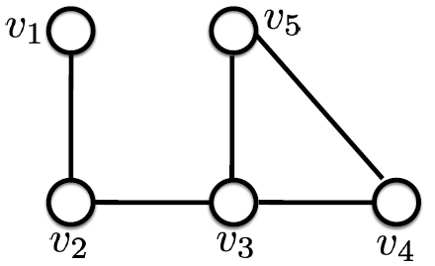

**Degree Matrix**

The degree matrix Δ ∈ ℝ(*n*×*n)* is a diagonal matrix with the node degrees as diagonal elements

**Incidence (Only undirected graphs)**



**Laplacian Matrix L**

The Laplacian matrix L is the difference between the degree matrix and the adjacency matrix

**Control Theory**

**Real Symmetric Matrices**

Jordan Normal:

**Weighted Directed Graphs**

**Connectivity**

**Consensus**

Initial states is x_0

Because of how Laplacians are created, all its eigenvalues must be non-negative.

**Stability**

**Symmetric Laplacian (Undirected Graph)**

1. **Intuition:** A directed graph might not arrive at a consensus
2. **Math:** Gershgorin’s Theorem tells us that the worst we can expect are zero eigenvalues, but it does not tell us the number of zero eigenvalues.
3. **Directed Graphs**
4. A white background with black text

   AI-generated content may be incorrect.

**Rooted out-branching**

**Consensus Protocol on Digraphs**

**Balanced Digraph**

**Connected**

Find local control rule to get agents to **agree on the same value** in a distributed manner

* The rate of (exponential) convergence is defined by the second smaller (real part) eigenvalue of *L*, also known as algebraic connectivity or Fiedler eigenvalue

**Stability Review For Undirected Graphs**

**Lypaunov Stability**

* the origin (*x*= 0) is stable if a trajectory starting close to it does not go away as time increases
* the origin (*x*= 0) is **asymptotically stable** if a trajectory starting sufficiently close to it converges to it as time increases

**The consensus protocol with Lyapunov**

when graph is connected

**Switching Connected graphs**

**Formation Specification**

Specification: set of desired relative distances between agents, The constraints that define the formation can always be written as relative distance constraints between agents (pair-wise geometrical constraints).

**Framework**



**Rigidity Mapping**

**1stDefinition of Rigidity**

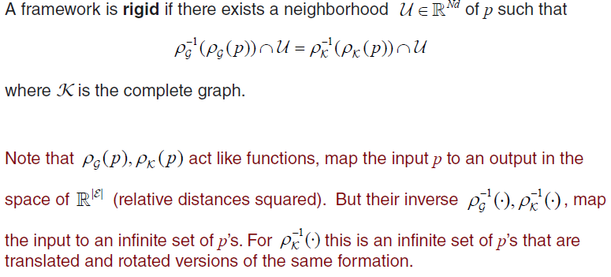

**Equivalence and Congruence of Frameworks**



**Infinitesimal Rigidity**

**Rigidity Matrix**



