Questions and Answers from the February 8th session – DP-201 Crash Course

* 1. Do you recommend taking two exams or one exam? (DP-200, 201 vs. DP-203)?
     1. If you are already preparing for two exams, then go for it. I would take both exams before June. There are new topics added to the DP-203 skillset which need more preparing.
  2. Can we only design Azure Data Factory solutions on Microsoft’s website (Azure portal) or is there any client-side tool?
     1. We are discussing the latest version of DF (V2). There was a Visual Studio extension for Azure Data Factory V1, but I would not recommend working with V1. For V2, Azure portal is the best authoring tool.
  3. Is there any way to backup the Azure Data Factory “code” to a file so that we can put it in the version control systems?
     1. No need. Azure Data Factory has native integration with Git. You can setup this integration when provisioning Azure Data Factory or after. See <https://docs.microsoft.com/en-us/azure/data-factory/source-control>
  4. 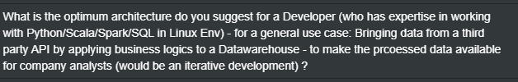
     1. I believe the combination of Azure Data Lake and Azure Databricks will do the trick.
  5. How to run Azure Databricks notebooks remotely (online)?
     1. You can create jobs and run them using REST APIs. See <https://docs.microsoft.com/en-us/azure/databricks/dev-tools/api/> & <https://docs.microsoft.com/en-us/azure/databricks/dev-tools/api/latest/jobs>
  6. What is the difference between Azure Synapse Serverless SQL pool and Dedicated SQL pool?
     1. See <https://docs.microsoft.com/en-us/azure/synapse-analytics/sql/overview-features>

*End of document*