**Counting vitae**

Screenshot from console output

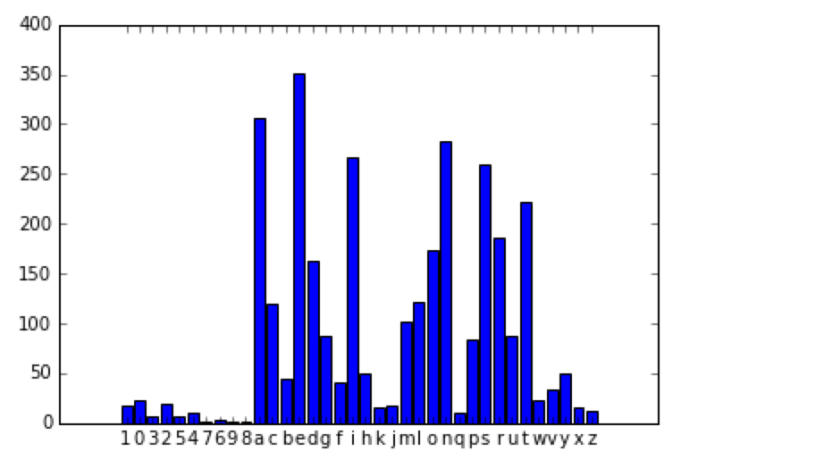

**Friendly competition**

* Who has the most openings?
* Which departments have the highest and the lowest paying positions (based on current job openings)?
* Which jobs do you think are the hardest to fill? (What makes you say that?)

For current job openings, the “posting updated” column is used to extract rows in February 2016.

To determine the highest and lowest paying positions, the “salary frequency” column is used to group the payment method into annual and hourly; computation is then done on both categories.

Screen shot (next page)

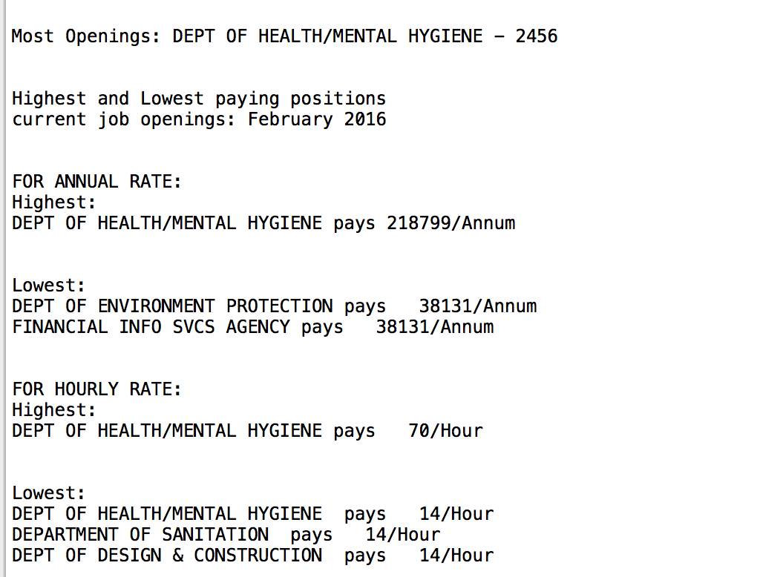

The jobs that are hardest to fill are those with restrictions:

Posting type that are internal and having multiple openings could be hard to fill internally.

Residency requirement could be hard to satisfy.

Academic and year of experience also make some openings hard to fill.