**第一题：**

**x[n]=[1,2,1,4,5,1],n=−1:4;**

**计算：**

**y_1[n]=x[2n−1]**

**y_2[n]=x[−2n+2]**

|  |  |  |  |  |  |  |  |  |
| --- | --- | --- | --- | --- | --- | --- | --- | --- |
| n | -2 | -1 | 零点 | 1 | 2 | 3 | 4 |  |
| x[n] |  | 1 | 2 | 1 | 4 | 5 | 1 |  |
| y1[n] |  |  | =x[-1]=1 | =x[1]=1 | =x[3]=5 |  |  |  |

**先平移在拉伸**

|  |  |  |  |  |  |  |  |  |
| --- | --- | --- | --- | --- | --- | --- | --- | --- |
| n | -2 | -1 | 零点 | 1 | 2 | 3 | 4 |  |
| x[n] |  | 1 | 2 | 1 | 4 | 5 | 1 |  |
| Y2[n] |  | =x[4]=1 | =x[2]=4 | =x[0]=2 |  |  |  |  |

**先平移在拉伸在反转**

**第二题：**

第一问可以用平移法（此处省略了第一题的代换验证部分）

|  |  |  |  |  |  |  |  |  |  |
| --- | --- | --- | --- | --- | --- | --- | --- | --- | --- |
|  |  |  |  |  | 零点 |  |  |  |  |
| y[n] |  | 3 | 1 | 4 | 8 | 2 |  |  |  |
| y[n+1] | 3 | 1 | 4 | 8 | 2 |  |  |  |  |
| x[n] |  |  |  | 1 | 2 | 1 | 4 | 5 | 1 |
| l[n] | 3 | 1 | 4 | 9 | 4 | 1 | 4 | 5 | 1 |

第二/三问 由于关于n不是平移运算，不能使用箭头平移法，应使用列表法

先确定 $n$ 的范围， 对于 $x\left[n\right], 2n= -1:4, -1≤n≤2 ∪ z\left[n\right]: n=-2:3 ⇒ n= -2:3$

所以

|  |  |  |  |  |  |  |
| --- | --- | --- | --- | --- | --- | --- |
|  |  |  |  |  |  |  |
|  |  |  | 零点 |  |  |  |
| n | -2 | -1 | 0 | 1 | 2 | 3 |
| x[2n] | 0 | 0 | 2 | 4 | 1 | 0 |
| z[n] | 1 | 6 | 4 | 2 | 5 | 1 |
| l[n] | 1 | 6 | 6 | 6 | 6 | 1 |

第二问：

先确定 $n$ 的范围， 对于 $x\left[n\right], n^{2}= -1:4, 0≤n≤2 ∪ y\left[n\right]: n-1=-3:1, -2≤n≤2 ∪ z\left[n\right]: n=-2:3 ⇒ n= -2:3$

|  |  |  |  |  |  |  |
| --- | --- | --- | --- | --- | --- | --- |
|  |  |  | 零点 |  |  |  |
| n | -2 | -1 | 0 | 1 | 2 | 3 |
|  | x[4] | x[1] | x[0] | x[1] | x[4] | x[9] |
| x[n^2] | 1 | 1 | 2 | 1 | 1 | 0 |
|  |  |  |  |  |  |  |
| y[n-1] | 3 | 1 | 4 | 8 | 2 | 0 |
| ny[n-1] | -6 | -1 | 0 | 8 | 4 | 0 |
| z[n] | 1 | 6 | 4 | 2 | 5 | 1 |
| l[n] | -4 | 6 | 6 | 11 | 10 | 1 |

**第三题**

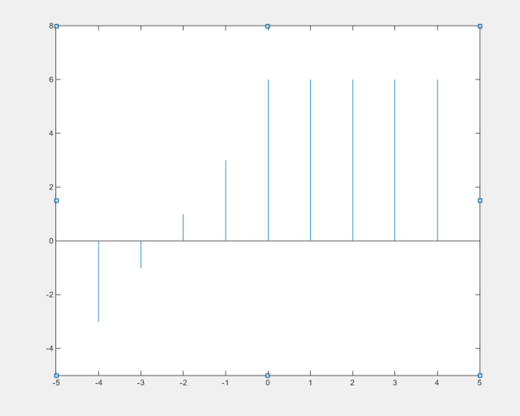

2） y =

$$y\left[n\right]=\left[-3, -1, 1, 3, 6, 6, 6, 6, 6\right], n= -4:4$$

所以

$$y\left[n\right]=\sum_{k=-4}^{-1}{\left(2k+5\right)δ\left[n-k\right]}+6∙\sum_{k=0}^{4}{δ\left[n-k\right]}$$

将 $y[n]$ 完全展开也算对

3）

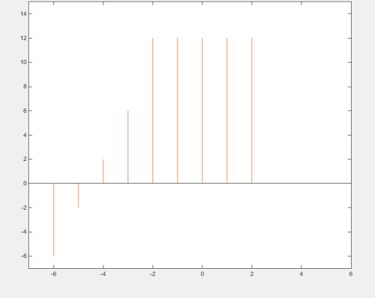

4）

|  |  |  |  |  |  |  |  |
| --- | --- | --- | --- | --- | --- | --- | --- |
| n | -4 | -3 | -2 | -1 | 0 | 1 | 2 |
| -2-2n | 6 | 4 | 2 | 0 | -2 | -4 | -6 |
| x[-2-2n] | 0 | 6 | 6 | 6 | 1 | -3 | 0 |

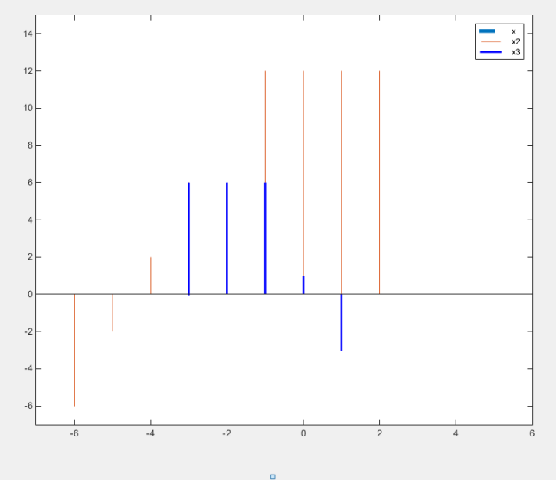

**第四题**

$$x\left[n\right]=\left[1,1,1\right], n=0:2; h\left[n\right]=\left[4,3,2,1\right], n=0:3$$

使用快速卷积则有

|  |  |  |  |  |  |  |
| --- | --- | --- | --- | --- | --- | --- |
| x[n] |  |  | 4 | 3 | 2 | 1 |
| h[n] |  |  |  | 1 | 1 | 1 |
|  |  |  | 4 | 3 | 2 | 1 |
|  |  | 4 | 3 | 2 | 1 |  |
|  | 4 | 3 | 2 | 1 |  |  |
| y[n] | 4 | 7 | 9 | 6 | 3 | 1 |

循环卷积

|  |  |  |  |  |  |  |  |
| --- | --- | --- | --- | --- | --- | --- | --- |
|  |  | 循环矩阵 | |  |  |  |  |
|  |  | h[n] |  |  | x[n] |  | y[n] |
| 4 | 1 | 2 | 3 |  | 1 |  | 7 |
| 3 | 4 | 1 | 2 | * | 1 |  | 8 |
| 2 | 3 | 4 | 1 |  | 1 |  | 9 |
| 1 | 2 | 3 | 4 |  | 0 |  | 6 |

1. 上述为矩阵和向量的乘法
2. 可以自行验证，将x[n]生成循环矩阵，将h[n]作为向量，结果一样

|  |  |  |  |  |  |  |  |  |  |  |  |
| --- | --- | --- | --- | --- | --- | --- | --- | --- | --- | --- | --- |
|  |  |  | h[n] |  |  |  |  |  | x[n] |  | y[n] |
| 4 | 0 | 0 | 0 | 0 | 1 | 2 | 3 |  | 1 |  | 4 |
| 3 | 4 | 0 | 0 | 0 | 0 | 1 | 2 |  | 1 |  | 7 |
| 2 | 3 | 4 | 0 | 0 | 0 | 0 | 1 |  | 1 |  | 9 |
| 1 | 2 | 3 | 4 | 0 | 0 | 0 | 0 |  | 0 |  | 6 |
| 0 | 1 | 2 | 3 | 4 | 0 | 0 | 0 |  | 0 |  | 3 |
| 0 | 0 | 1 | 2 | 3 | 4 | 0 | 0 |  | 0 |  | 1 |
| 0 | 0 | 0 | 1 | 2 | 3 | 4 | 0 |  | 0 |  | 0 |
| 0 | 0 | 0 | 0 | 1 | 2 | 3 | 4 |  | 0 |  | 0 |

可以看到循环矩阵当 循环长度 $≥n+k-1$ 时 和线性卷积结果相同

**第五题**

**卷积推导**

卷积的定义

$$z\left[n\right]=\sum_{k=-∞}^{+∞}{x\left[k\right]y[n-k]}$$

此时由于 $x[k]$ 的范围是 -2:4， 所以

$$z\left[n\right]=\sum_{k=-2}^{4}{x\left[k\right]y[n-k]}$$

又有 $y[n-k]$ 对于序列 $y[n]$ 序列的取值，所以由列表法，令 $z\left[n\right]=y[n-k]$

为了遍历 $y[n]$,所以需要 $n-k=-1$

$$n=k-1$$

已知 $k=-1$ (最小), 所以

$$n=-2-1=-3$$

又有卷积长度为7+4-1=10

所以 $z\left[n\right], n=-3:6$

**第六题**

差分公式

二阶差分

$$z\left[n\right]=y\left[n\right]-y\left[n-1\right]=x\left[n\right]-x\left[n-1\right]-\left(x\left[n-1\right]-x\left[n-2\right]\right)$$

$$=x\left[n\right]+x\left[n-2\right]-2x[n-1]$$

三阶差分

$$k\left[n\right]=z\left[n\right]-z\left[n-1\right]=x\left[n\right]+x\left[n-2\right]-2x\left[n-1\right]-\left(x\left[n-1\right]+x\left[n-3\right]-2x\left[n-2\right]\right)=x\left[n\right]+x\left[n-2\right]-2x\left[n-1\right]-x\left[n-1\right]-x\left[n-3\right]+2x\left[n-2\right]=x\left[n\right]-3x\left[n-1\right]+3x\left[n-2\right]-x\left[n-3\right]$$

四阶差分

$$l(n) =k(n) -k(n-1) = [x(n) - 3x(n-1) + 3x(n-2) - x(n-3)] - [x(n-1) - 3x(n-2) + 3x(n-3) - x(n-4)] y_4(n) = x(n) - 4x(n-1) + 6x(n-2) - 4x(n-3) + x(n-4)$$

**第七题：**

根据 相关性定义

$$l_{xx}\left(k\right)=\sum_{n=-∞}^{∞}{x\left[n\right]x\left[n-k\right]}$$

所以有 $l_{xx}\left(0\right)=\sum_{n=-∞}^{+∞}{x{\left[n\right]}^{2}}$

此时对于任意的 $k$， 我们对于序列变为 $l_{xx}\left(0\right)=\frac{1}{2}\sum_{n=-∞}^{+∞}{x{\left[n\right]}^{2}}+\frac{1}{2}\sum_{n=-∞}^{+∞}{x{\left[n-k\right]}^{2}}$

此时由于 $k$ 是给定常数，而 $n=-∞:+∞$，

所以有 $\frac{1}{2}\sum_{n=-∞}^{+∞}{x{\left[n\right]}^{2}}=\frac{1}{2}\sum_{n=-∞}^{+∞}{x{\left[n-k\right]}^{2}}=\frac{1}{2}l_{xx}\left(0\right)$

此时对于每一个 $n$, 都有 $\frac{1}{2}x{\left[n\right]}^{2}+\frac{1}{2}x{\left[n-k\right]}^{2}≥\frac{1}{2}×2 x\left[n\right]∙x\left[n-k\right]=x\left[n\right]∙x\left[n-k\right]$

注： ${\left(a-b\right)}^{2}≥0⇒a^{2}+b^{2}≥2ab$

所以 $l_{xx}\left(0\right)=\frac{1}{2}\sum_{n=-∞}^{+∞}{x{\left[n\right]}^{2}}+\frac{1}{2}\sum_{n=-∞}^{+∞}{x{\left[n-k\right]}^{2}}=\sum_{n=-∞}^{+∞}{\left(\frac{1}{2}x{\left[n\right]}^{2}+\frac{1}{2}x{\left[n-k\right]}^{2}\right)}≥\sum_{n=-∞}^{+∞}{\left(x\left[n\right]∙x\left[n-k\right]\right)}$

即 $l_{xx}\left(0\right)≥l_{xx}(m)$

**第八题：**

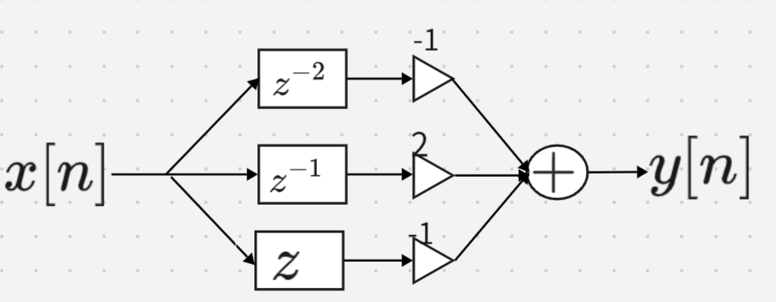

**第九题：**

1. 无限长序列对应的通常是实时序列，即“不知什么时候开始，也不知什么时候结束”
2. 加法，数乘，乘法（卷积），时移, 微分，积分（累加器）都可以处理无限长序列，基本思路是“随来随处理”，即在一个滑动窗范围内进行短时间的“即时”处理。
3. 反转、上下采样（拉伸）不可以处理无限长序列，他们的操作和时域（x轴）有关，对于实时序列（无限长序列）无法处理，例如上采样会造成序列信号的“淤塞”

**第十题**

滑动窗要求在 $n$ 的范围上建立一个固定长度为 $k$ 窗口，然后随着 $n$ 的变化，将窗延展沿 $n$ 滑动，对应着时域信号的“随着接受，随着处理”的概念

典型的就是卷积操作；

延展窗要求在 $n$ 的范围上建立一个长度为 $k$ 窗口，然后将窗延展，并判定窗内的信号处理效果，在一个稳定/收敛的状态下进行计算。

典型的操作包括 对无限长序列加窗，计算DFT；在一个无限长序列内计算相关性等。