Suitcase Lock

Bill keeps his most treasured savings in a home safe with a combination lock. Each time he wants to put there the treasures that he's earned fair and square, he has to open the lock.

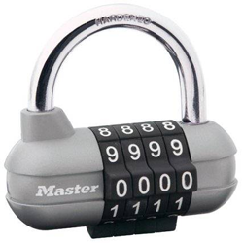

The suitcase lock is represented by *n* rotating disks with digits from 0 to 9 written on them. Bill has to turn some disks so that the combination of digits on the disks forms a secret combination. In one move, he can rotate one disk one digit forwards or backwards. In particular, in one move he can go from digit 0 to digit 9 and vice versa. What minimum number of actions does he need for that?

**Input**

The first line contains a single integer *n* (1 ≤ *n* ≤ 1000) — the number of disks on the combination lock.

The second line contains a string of *n* digits — the original state of the disks.

The third line contains a string of *n* digits — Bill’s suitcase key that opens the lock.

**Output**

Print a single integer — the minimum number of moves Bill needs to open the lock.

**Examples**

**input**

5  
82195  
64723

**output**

13

**Note**

In the sample he needs 13 moves:

* 1 disk: http://codeforces.com/predownloaded/40/c3/40c33805aa17a2d817202e2a33d8662abdbb7cda.png
* 2 disk: http://codeforces.com/predownloaded/2d/6e/2d6e84f31439a847c85cb7612d8ee372e6393288.png
* 3 disk: http://codeforces.com/predownloaded/26/1a/261a5dcadfb94d0a0b9bc5d7de43bb036ccfa32c.png
* 4 disk: http://codeforces.com/predownloaded/60/87/6087393a4b805b8964372834ad38016470872ac2.png
* 5 disk: http://codeforces.com/predownloaded/57/a7/57a7f7e99a4fea9b62086f92cb2e413caa555acf.png