Assignment 1, Part 1: Pacemaker modes

Muntakim Ali – 400210016

Theodor Aoki – 400202020

Sameer Marok –400201508

Boris Samardzic –400204693

Gurkaran Sondhi –400193807

Table of Contents

1 Introduction 2

2 Variables 2

2.1 Measured 2

2.2 Input 2

2.3 Constant 2

2.4 Controlled 3

2.5 Internal 3

2.6 Output 3

3 Modes 4

3.1 AOO 4

3.1.1 Variables 4

3.1.2 Requirements 4

3.1.3 State Transitions 5

3.1.4 State Transitions 5

3.1.5 Design details 5

3.1.6 Testing 5

3.2 VOO 5

3.2.1 Variables 5

3.2.2 Requirements 5

3.2.3 State Transitions 5

3.2.4 Design details 6

3.2.5 Testing 6

3.3 AAI 6

3.3.1 Variables 6

3.3.2 Requirements 6

3.3.3 State Transitions 6

3.3.4 Design details 6

3.3.5 Testing 6

3.4 VVI 6

3.4.1 Variables 6

3.4.2 Initial Values 7

3.4.3 Requirements 7

3.4.4 State Transitions 8

3.4.5 State details 9

3.4.6 Testing 9

# Introduction

The following documentation gives a concise and general description tailored to the end-user, of Part 1 of the SFWRENG 3K04 Pacemaker Project. The aim of this project is to construct a working pacemaker that acts and reacts to its environment accordingly, as a normal pacemaker would. This documentation will solely focus on the State flow Implementation in MATLAB Simulink, which is used to simulate the 4 pacing/sensing modes (AOO, VOO, VVI, AAI) which are required for this early stage of the project. More pacing modes will be created in stage 2 of the project. A summary of these 4 modes will be introduced, but the documentation will provide a more in-depth analysis of each mode. But first, just to avoid any confusion, pacing refers to depolarization of the atria or ventricles. Sensing refers to detection of chamber signals. The VVI and AAI modes both provide sensing and pacing of the heart. VVI is used for the ventricles, while AAI is used for the Atrium. Those two modes act on an inhibited basis, meaning that the pacemaker is deactivated on a certain activity from the corresponding chamber. AOO and VOO only pace (no sensing) the atrium and ventricle, respectively.

# Variables

## Measured

|  |  |  |  |
| --- | --- | --- | --- |
| **Name** | **Units/Type** | **Description** | **Range** |
| t | ms | Time since last pulse | – |
| h_atr_pulse_detected | boolean | Pulse detected in atrium | {true, false} |
| h_vent_pulse_detected | boolean | Pulse detected in ventricle | {true, false} |

## Constant

|  |  |  |  |
| --- | --- | --- | --- |
| **Name** | **Units/Type** | **Description** | **Range** |
| p_mode | mode | Pacemaker operational mode | {AOO,VOO,AAI,VVI} |
| p_lower_rate_limit | ms | Lowest allowable heart rate | 343–2000 ± 8 ms |
| p_upper_rate_limit | ms | Highest allowable heart rate | 343–1200 ± 8ms |
| p_vrp | ms | Ventricular Refractory Period | 150–500 ± 8 ms |
| p_arp | ms | Atrial Refractory Period | 150–500 ± 8 ms |
| p_hysteresis_enable | boolean | Hysteresis mode enabled | {true, false} |
| p_hysteresis_limit | ms | Hysteresis rate limit | 343–2000 ± 8 ms |
| p_rate_smoothing_enable | boolean | Rate smoothing enabled | {true, false} |
| p_rate_smoothing_down | percent | Maximum allowable pacing rate decrease | 3–25 ± 1% |
| p_rate_smoothing_up | percent | Maximum allowable pacing rate increase | 3–25 ± 1% |

## Controlled

|  |  |  |  |
| --- | --- | --- | --- |
| **Name** | **Units/Type** | **Description** | **Range** |
| A_pace_start | boolean | Commence atrial pulse | {true, false} |
| V_pace_start | boolean | Commence ventricular pulse | {true, false} |

## Internal

|  |  |  |  |
| --- | --- | --- | --- |
| **Name** | **Units/Type** | **Description** | **Range** |
| i_last_period | ms | Last period between pulses | – |

# Modes

## **AOO**

### Description

### Variables

#### Measured

|  |  |  |
| --- | --- | --- |
| **Name** | **Abbreviation** | **Reference** |
| t | t |  |

#### Constant

|  |  |  |
| --- | --- | --- |
| **Name** | **Abbreviation** | **Reference** |
| p_lower_rate_limit | LRL |  |
| p_upper_rate_limit | URL |  |

#### Controlled

|  |  |  |
| --- | --- | --- |
| **Name** | **Abbreviation** | **Reference** |
| A_pace_start | PS |  |

### Requirements

|  |  |  |
| --- | --- | --- |
| **Last pulse Type** | **t** | **Pace** |
| X | t<URL | False |
| Sensed (no sensing in AOO) | X | X |
| Paced | t<LRL | False |
| t=LRL | True |

### State Transitions

|  |  |  |  |  |
| --- | --- | --- | --- | --- |
| Next State  Current State | INITIAL | PACED | UPPER RATE LIMIT | LOWER RATE LIMIT |
| INITIAL | – | t = LRL | – | – |
| PACED | – | – | – | t=LRL |
| LOWER RATE LIMIT | – | t = LRL | – | – |

### Design details

### Testing

1. **AOO**

Chamber paced: Atrium

Chamber sensed: None

Response to Sensing: None

**Test Cases:**

1. Natural Atrium: **OFF |** Natural Ventricle: **OFF**

In AOO mode also, as we are not sensing any chamber, only a single test case (when both atrium and ventricle are not working) can demonstrate correctness of our pacemaker.

*The graph of artificial pulse from HeartView*

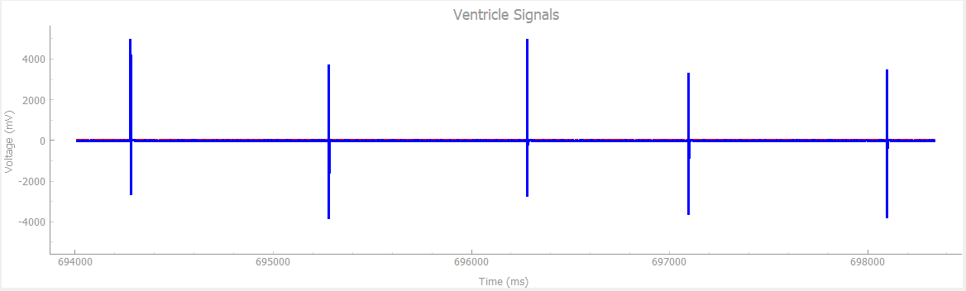

## **VOO**

### Description

### Variables

#### Measured

#### Constant

|  |  |  |
| --- | --- | --- |
| **Name** | **Abbreviation** | **Reference** |
| p_lower_rate_limit | LRL |  |
| p_upper_rate_limit | URL |  |

#### Controlled

|  |  |  |
| --- | --- | --- |
| **Name** | **Abbreviation** | **Reference** |
| V_pace_start | PS |  |

### Requirements

|  |  |  |
| --- | --- | --- |
| **Last pulse Type** | **t** | **Pace** |
| X | t<URL | False |
| Sensed (no sensing in VOO) | X | X |
| Paced | t<LRL | False |
| t=LRL | True |

### State Transitions

|  |  |  |  |  |
| --- | --- | --- | --- | --- |
| Next State  Current State | INITIAL | PACED | UPPER RATE LIMIT | LOWER RATE LIMIT |
| INITIAL | – | t = LRL | – | – |
| PACED | – | – | – | t=LRL |
| LOWER RATE LIMIT | – | t = LRL | – | – |

### Design details

### Testing

**VOO**

Chamber paced: Ventricle

Chamber sensed: None

Response to Sensing: None

**Test Cases:**

1. Natural Atrium: **OFF |** Natural Ventricle: **OFF**

In VOO mode, as we are not sensing any chamber, only a single test case (when both atrium and ventricle are not working) can demonstrate correctness of our pacemaker.

*the graph of artificial pulse from HeartView*

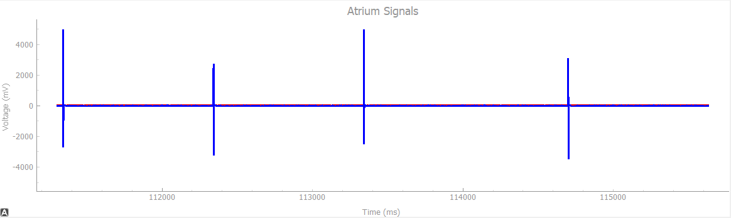

## **AAI**

### Description

### Variables

#### Measured

|  |  |  |
| --- | --- | --- |
| **Name** | **Abbreviation** | **Reference** |
| t | t |  |
| h_atr_pulse_detected | PD |  |

#### Constant

|  |  |  |
| --- | --- | --- |
| **Name** | **Abbreviation** | **Reference** |
| p_lower_rate_limit | LRL |  |
| p_upper_rate_limit | URL |  |
| p_arp | ARP |  |
| p_hysteresis_enable | HE |  |
| p_hysteresis_limit | HL |  |
| p_rate_smoothing_enable | RSE |  |
| p_rate_smoothing_down | RSD |  |
| p_rate_smoothing_up | RSU |  |

#### Controlled

|  |  |  |
| --- | --- | --- |
| **Name** | **Abbreviation** | **Reference** |
| A_pace_start | PS |  |

#### Internal

|  |  |  |
| --- | --- | --- |
| **Name** | **Abbreviation** | **Reference** |
| i_last_period | LP |  |

### Requirements

#### Hysteresis and Rate Smoothing Disabled

|  |  |  |  |  |
| --- | --- | --- | --- | --- |
| Last Pulse Type | Last Period | t | Spontaneous pulse resets timer | PS |
| X | X |  | false | false |
|  | true | false |
|  | true |

#### Hysteresis Disabled and Rate Smoothing Enabled

|  |  |  |  |  |
| --- | --- | --- | --- | --- |
| Last Pulse Type | Last Period | t | Spontaneous pulse resets timer | PS |
| X | X |  | false | false |
| X |  | true | false |
|  |  | true |
|  |  | false |
|  | true |
|  |  | false |
|  | true |

#### Hysteresis Enabled and Rate Smoothing Disabled

|  |  |  |  |  |
| --- | --- | --- | --- | --- |
| Last Pulse Type | Last Period | t | Spontaneous pulse resets timer | PS |
| X | X |  | false | false |
|  | true | false |
| Sensed |  | false |
|  | true |
| Paced |  | false |
|  | true |

#### Hysteresis and Rate Smoothing Enabled

|  |  |  |  |  |
| --- | --- | --- | --- | --- |
| Last Pulse Type | Last Period | t | Spontaneous pulse resets timer | PS |
| X | X |  | false | false |
| X |  | true | false |
| Sensed |  |  | true |
|  |  | false |
|  | true |
|  |  | false |
|  | true |
| Paced |  |  | false |
|  | true |
|  |  | false |
|  | true |
|  |  | false |
|  | true |

### State Transitions

|  |  |  |  |  |  |  |  |  |
| --- | --- | --- | --- | --- | --- | --- | --- | --- |
| Next State  Current State | INITIAL | PACED | SENSED | UPPER RATE LIMIT | LOWER RATE LIMIT | HYSTERESIS LIMIT | RATE SMOOTHING DOWN | RATE SMOOTHING UP |
| INITIAL | – | HE = true  t = HL  **or**  HE = false  t = LRL | PD = true | – | – | – | – | – |
| PACED | – | – | – | – | RSE = true  LP ≥ LRL(1-RSD)  LP ≤ LRL(1+RSU)  **or**  RSE = false | – | RSE = true  LP < LRL(1-RSD) | RSE = true  LP > LRL(1+RSU) |
| SENSED | – | – | – | RSE = true  LP≤URL(1-RSD) | HE = false  RSE = false  **or**  HE = false  RSE = true  LP≥ LRL(1-RSD) | HE = true  RSE = true  LP≥HL(1-RSD)  **or**  HE = true  RSE = false | HE = true  RSE = true  LP > URL(1-RSD)  LP < HL(1-RSD)  **or**  HE = false  RSE = true  LP > URL(1-RSD)  LP < LRL(1-RSD) | – |
| UPPER RATE LIMIT | – | t = URL | PD = true | – | – | – | – | – |
| LOWER RATE LIMIT | – | t = LRL | PD = true | – | – | – | – | – |
| HYSTERESIS LIMIT | – | t = HL | PD = true | – | – | – | – | – |
| RATE SMOOTHING DOWN | – | t=LP(1+RSD) | PD = true | – | – | – | – | – |
| RATE SMOOTHING UP | – | t=LP(1-RSD) | PD = true | – | – | – | – | – |

### State details

|  |  |
| --- | --- |
| **State** | **Description** |
| INITIAL | If hysteresis is enabled, pacemaker listens for sensed pulses until p_hysteresis_limit before pacing.  If hysteresis is not enabled, pacemaker listens for sensed until p_lower_rate_limit before pacing. |
| PACED | Sends a 1 ms pulse on A_pace_start and waits for the duration of p_arp |
| SENSED | Waits for the duration of p_arp |
| UPPER RATE LIMIT | Listens for sensed pulses until p_upper_rate_limit |
| LOWER RATE LIMIT | Listens for sensed pulses until p_lower_rate_limit |
| HYSTERESIS LIMIT | Listens for sensed pulses until p_hysteresis_limit |
| RATE SMOOTHING DOWN | Listens for sensed pulses until limit defined by maximum allowable rate decrease |
| RATE SMOOTHING UP | Listens for sensed pulsed until limit defined by maximum allowable rate increase |

### Future changes

There are no foreseeable changes to this mode.

### Testing

**AAI**

Chamber paced: Atrium

Chamber sensed: Atrium

Response to Sensing: Inhibited

**Test Cases:**

1. Natural Atrium: **ON**, Pulse Width: **1ms** |Natural Ventricle: **OFF** | Heart Rate: **30bpm**

At very low Heat Rate and low Pulse Width, pacemaker is supposed to generate pulse (because heart produces pulse every 2000ms, and pacemaker is supposed to maintain Hear rate of 60bpm which is pulse after every 1000ms).

As we can see from the graph below, our pacemaker provides a pulse after every 1000ms to bridge the gap.

*The graph of natural and artificial pulse from HeartView*

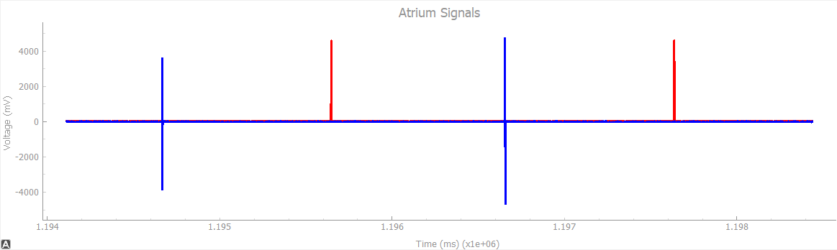

1. Natural Atrium: **ON**, Pulse Width: **10ms** |Natural Ventricle: **OFF** | Heart Rate: **30bpm**

When we increase the pulse width to 10ms and keep hear rate same, still the gap between 2 consecutive pulses is more than 1000ms, so pacemaker is supposed to produce the pulse.

As we can see from the graph below, our pacemaker does the same, it provides the pulse to bridge the time gap.

*The graph of natural and artificial pulse from HeartView*

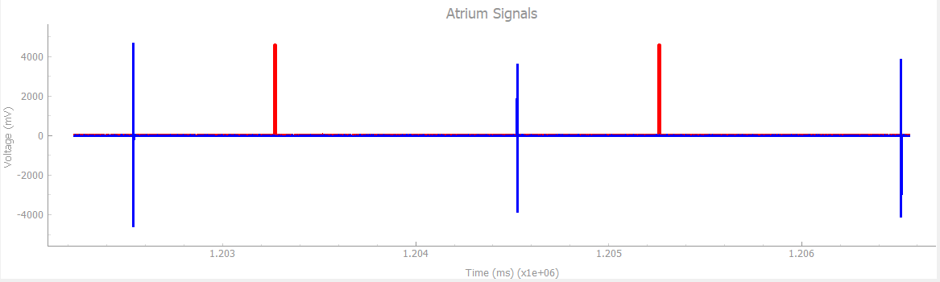

1. Natural Atrium: **ON**, Pulse Width: **1ms** |Natural Ventricle: **OFF** | Heart Rate: **50bpm**

When our heart rate is just below the natural rate but pulse width is not big enough to reach the natural rate (i.e. 60bpm or pulse after every 1000ms), pacemaker is supposed t provide artificial pulse.

From the graph below, it is clear that our pacemaker takes care of the delay.

*The graph of natural and artificial pulse from HeartView*

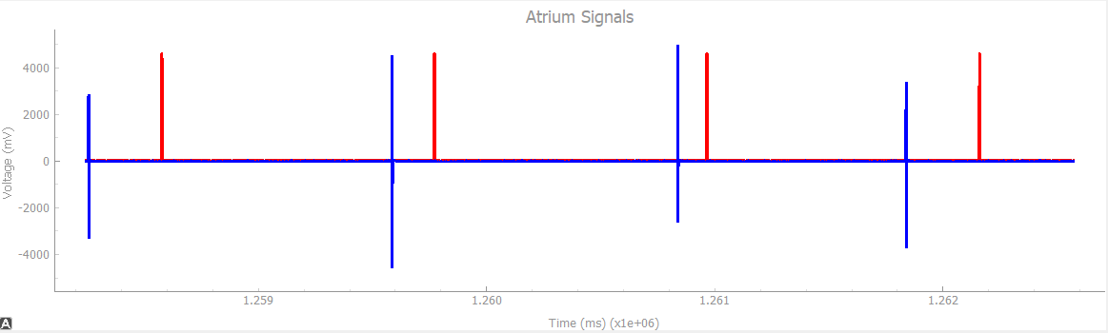

1. Natural Atrium: **ON**, Pulse Width: **10ms** |Natural Ventricle: **OFF** | Heart Rate: **50bpm**

When the heart rate is below normal but pulse width is big enough to account for the gap, pacemaker is not supposed to provide any artificial pulse.

As we can see from the graph below, our pacemaker is not providing any additional pulse to the heart.

*The graph of natural pulse from HeartView*

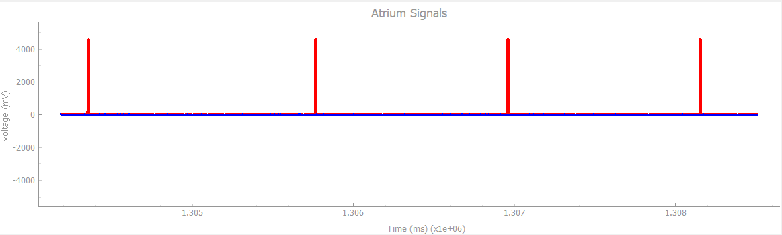

## **VVI**

### Description

### Variables

#### Measured

|  |  |  |
| --- | --- | --- |
| **Name** | **Abbreviation** | **Reference** |
| t | t |  |
| h_vent_pulse_detected | PD |  |

#### Constant

|  |  |  |
| --- | --- | --- |
| **Name** | **Abbreviation** | **Reference** |
| p_lower_rate_limit | LRL |  |
| p_upper_rate_limit | URL |  |
| p_vrp | VRP |  |
| p_hysteresis_enable | HE |  |
| p_hysteresis_limit | HL |  |
| p_rate_smoothing_enable | RSE |  |
| p_rate_smoothing_down | RSD |  |
| p_rate_smoothing_up | RSU |  |

#### Controlled

|  |  |  |
| --- | --- | --- |
| **Name** | **Abbreviation** | **Reference** |
| V_pace_start | PS |  |

#### Internal

|  |  |  |
| --- | --- | --- |
| **Name** | **Abbreviation** | **Reference** |
| i_last_period | LP |  |

### Initial Values

V_pace_start = false

|  |  |
| --- | --- |
| **p_hysteresis_enable** | **i_last_period** |
| true | p_hysteresis_limit |
| false | p_lower_rate_limit |

### Requirements

#### Hysteresis and Rate Smoothing Disabled

|  |  |  |  |  |
| --- | --- | --- | --- | --- |
| Last Pulse Type | Last Period | t | Spontaneous pulse resets timer | PS |
| X | X |  | false | false |
|  | true | false |
|  | true |

#### Hysteresis Disabled and Rate Smoothing Enabled

|  |  |  |  |  |
| --- | --- | --- | --- | --- |
| Last Pulse Type | Last Period | t | Spontaneous pulse resets timer | PS |
| X | X |  | false | false |
| X |  | true | false |
|  |  | true |
|  |  | false |
|  | true |
|  |  | false |
|  | true |

#### Hysteresis Enabled and Rate Smoothing Disabled

|  |  |  |  |  |
| --- | --- | --- | --- | --- |
| Last Pulse Type | Last Period | t | Spontaneous pulse resets timer | PS |
| X | X |  | false | false |
|  | true | false |
| Sensed |  | false |
|  | true |
| Paced |  | false |
|  | true |

#### Hysteresis and Rate Smoothing Enabled

|  |  |  |  |  |
| --- | --- | --- | --- | --- |
| Last Pulse Type | Last Period | t | Spontaneous pulse resets timer | PS |
| X | X |  | false | false |
| X |  | true | false |
| Sensed |  |  | true |
|  |  | false |
|  | true |
|  |  | false |
|  | true |
| Paced |  |  | false |
|  | true |
|  |  | false |
|  | true |
|  |  | false |
|  | true |

### State Transitions

|  |  |  |  |  |  |  |  |  |
| --- | --- | --- | --- | --- | --- | --- | --- | --- |
| Next State  Current State | INITIAL | PACED | SENSED | UPPER RATE LIMIT | LOWER RATE LIMIT | HYSTERESIS LIMIT | RATE SMOOTHING DOWN | RATE SMOOTHING UP |
| INITIAL | – | HE = true  t = HL  **or**  HE = false  t = LRL | PD = true | – | – | – | – | – |
| PACED | – | – | – | – | RSE = true  LP ≥ LRL(1-RSD)  LP ≤ LRL(1+RSU)  **or**  RSE = false | – | RSE = true  LP < LRL(1-RSD) | RSE = true  LP > LRL(1+RSU) |
| SENSED | – | – | – | RSE = true  LP≤URL(1-RSD) | HE = false  RSE = false  **or**  HE = false  RSE = true  LP≥ LRL(1-RSD) | HE = true  RSE = true  LP≥HL(1-RSD)  **or**  HE = true  RSE = false | HE = true  RSE = true  LP > URL(1-RSD)  LP < HL(1-RSD)  **or**  HE = false  RSE = true  LP > URL(1-RSD)  LP < LRL(1-RSD) | – |
| UPPER RATE LIMIT | – | t = URL | PD = true | – | – | – | – | – |
| LOWER RATE LIMIT | – | t = LRL | PD = true | – | – | – | – | – |
| HYSTERESIS LIMIT | – | t = HL | PD = true | – | – | – | – | – |
| RATE SMOOTHING DOWN | – | t=LP(1+RSD) | PD = true | – | – | – | – | – |
| RATE SMOOTHING UP | – | t=LP(1-RSD) | PD = true | – | – | – | – | – |

### State details

|  |  |
| --- | --- |
| **State** | **Description** |
| INITIAL | If hysteresis is enabled, pacemaker listens for sensed pulses until p_hysteresis_limit before pacing.  If hysteresis is not enabled, pacemaker listens for sensed until p_lower_rate_limit before pacing. |
| PACED | Sends a 1 ms pulse on V_pace_start and waits for the duration of p_vrp |
| SENSED | Waits for the duration of p_vrp |
| UPPER RATE LIMIT | Listens for sensed pulses until p_upper_rate_limit |
| LOWER RATE LIMIT | Listens for sensed pulses until p_lower_rate_limit |
| HYSTERESIS LIMIT | Listens for sensed pulses until p_hysteresis_limit |
| RATE SMOOTHING DOWN | Listens for sensed pulses until limit defined by maximum allowable rate decrease |
| RATE SMOOTHING UP | Listens for sensed pulsed until limit defined by maximum allowable rate increase |

### Future changes

There are no foreseeable changes to this mode.

### Testing

**VVI**

Chamber paced: Ventricle

Chamber sensed: Ventricle

Response to Sensing: Inhibited

**Test Cases:**

1. Natural Atrium: **OFF** |Natural Ventricle: **ON**, Pulse Width: **1ms** | Heart Rate: **30bpm**

At very low heart rate, pacemaker is expected to provide pulse at sufficient interval to maintain overall normal heart rate.

As we can see from graph below, our pacemaker provides artificial pulses whenever the time till last pulse is more than 1000ms, which helps in maintaining normal heart rate of 60bpm or pulse after every 1000ms.

*The graph of natural and artificial pulse from HeartView*

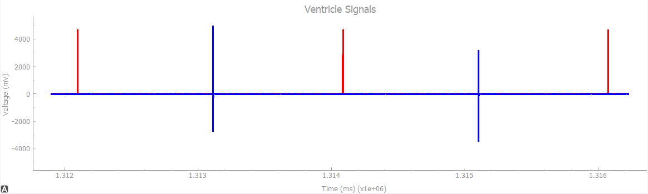

1. Natural Atrium: **OFF** |Natural Ventricle: **ON**, Pulse Width: **10ms** | Heart Rate: **30bpm**

When the heart rate is low, high pulse width is not able to bridge the gap and pacemaker is supposed to provide pulses in order to make sure proper functioning of the heart.

From the graph below, it is clear that our pacemaker sends artificial pulses to the heart and maintains normal functioning.

*The graph of natural and artificial pulse from HeartView*

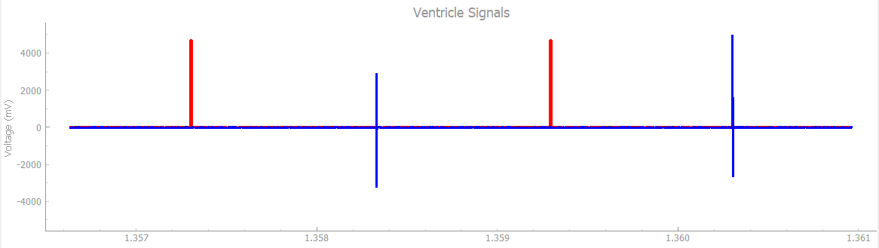

1. Natural Atrium: **OFF** |Natural Ventricle: **ON**, Pulse Width: **1ms** | Heart Rate: **50bpm**

When heart is beating just below normal rate but pulse width is not big enough to bridge the gap, pacemaker is expected to come into play and send pulses to the heart.

From the graph below, we can see that our pacemaker does exactly what is expected.

*The graph of natural and artificial pulse from HeartView*

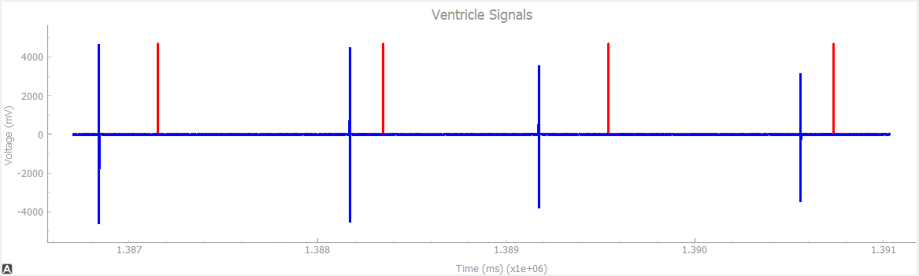

1. Natural Atrium: **OFF** |Natural Ventricle: **ON**, Pulse Width: **10ms** | Heart Rate: **58bpm**

When heart rate is just below the normal and pulse width is wide enough to bridge the gap, pacemaker should not do anything.

As we can see from the graph below, our pacemaker if not producing any artificial pulses to the heart.

*The graph of natural pulse from HeartView*

