**TESTING**

This document provides a number test cases for different modes of operation of the pacemaker

1. **AOO**

Chamber paced: Atrium

Chamber sensed: None

Response to Sensing: None

**Test Cases:**

1. Natural Atrium: **OFF |** Natural Ventricle: **OFF**

In AOO mode, as we are not sensing any chamber, only a single test case (when both atrium and ventricle are not working) can demonstrate correctness of our pacemaker.

*the graph of artificial pulse from HeartView*

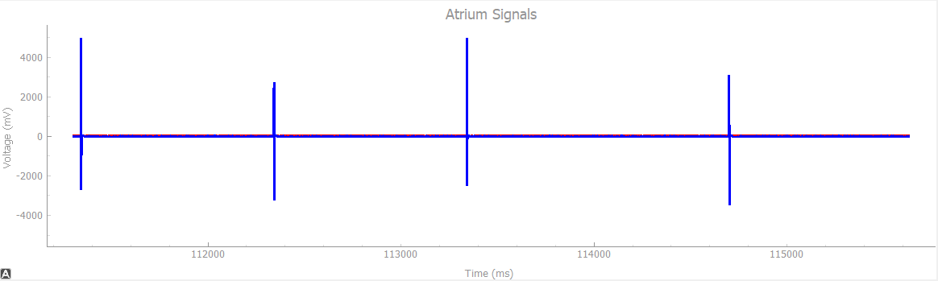

1. **VOO**

Chamber paced: Ventricle

Chamber sensed: None

Response to Sensing: None

**Test Cases:**

1. Natural Atrium: **OFF |** Natural Ventricle: **OFF**

In VOO mode also, as we are not sensing any chamber, only a single test case (when both atrium and ventricle are not working) can demonstrate correctness of our pacemaker.

*The graph of artificial pulse from HeartView*

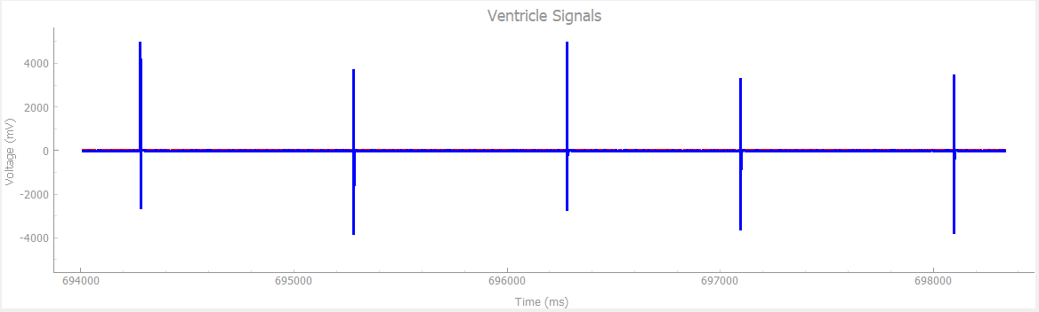

1. **AAI**

Chamber paced: Atrium

Chamber sensed: Atrium

Response to Sensing: Inhibited

**Test Cases:**

1. Natural Atrium: **ON**, Pulse Width: **1ms** |Natural Ventricle: **OFF** | Heart Rate: **30bpm**

At very low Heat Rate and low Pulse Width, pacemaker is supposed to generate pulse (because heart produces pulse every 2000ms, and pacemaker is supposed to maintain Heart rate of 60bpm which is pulse after every 1000ms).

As we can see from the graph below, our pacemaker provides a pulse after every 1000ms to bridge the gap.

*The graph of natural and artificial pulse from HeartView*

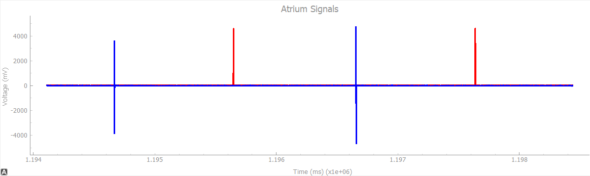

1. Natural Atrium: **ON**, Pulse Width: **10ms** |Natural Ventricle: **OFF** | Heart Rate: **30bpm**

When we increase the pulse width to 10ms and keep hear rate same, still the gap between 2 consecutive pulses is more than 1000ms, so pacemaker is supposed to produce the pulse.

As we can see from the graph below, our pacemaker does the same, it provides the pulse to bridge the time gap.

*The graph of natural and artificial pulse from HeartView*

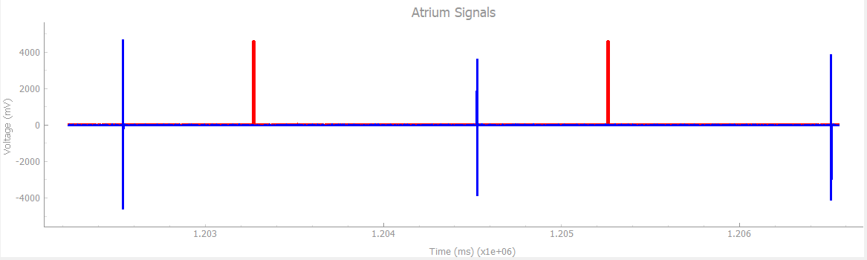

1. Natural Atrium: **ON**, Pulse Width: **1ms** |Natural Ventricle: **OFF** | Heart Rate: **50bpm**

When our heart rate is just below the natural rate but pulse width is not big enough to reach the natural rate (i.e. 60bpm or pulse after every 1000ms), pacemaker is supposed t provide artificial pulse.

From the graph below, it is clear that our pacemaker takes care of the delay.

*The graph of natural and artificial pulse from HeartView*

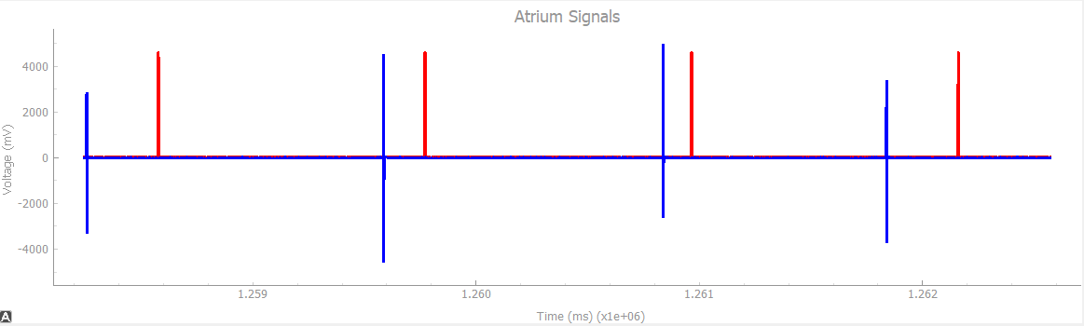

1. Natural Atrium: **ON**, Pulse Width: **10ms** |Natural Ventricle: **OFF** | Heart Rate: **50bpm**

When the heart rate is below normal but pulse width is big enough to account for the gap, pacemaker is not supposed to provide any artificial pulse.

As we can see from the graph below, our pacemaker is not providing any additional pulse to the heart.

*The graph of natural pulse from HeartView*

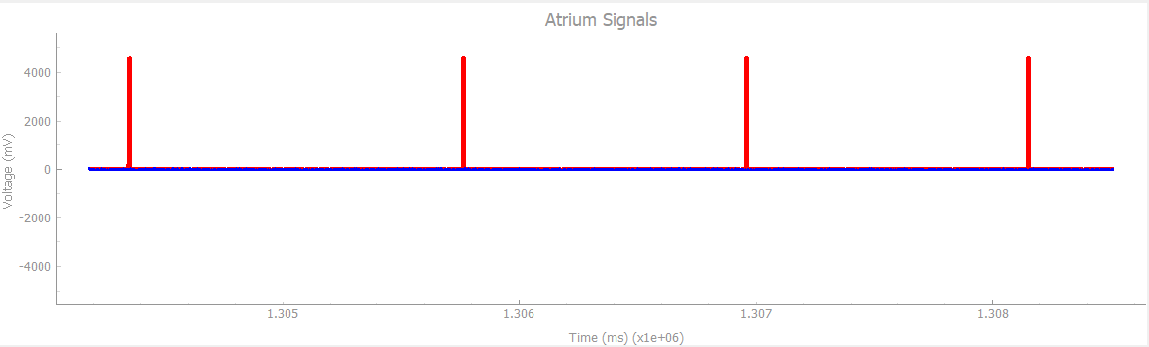

1. **VVI**

Chamber paced: Ventricle

Chamber sensed: Ventricle

Response to Sensing: Inhibited

**Test Cases:**

1. Natural Atrium: **OFF** |Natural Ventricle: **ON**, Pulse Width: **1ms** | Heart Rate: **30bpm**

At very low heart rate, pacemaker is expected to provide pulse at sufficient interval to maintain overall normal heart rate.

As we can see from graph below, our pacemaker provides artificial pulses whenever the time till last pulse is more than 1000ms, which helps in maintaining normal heart rate of 60bpm or pulse after every 1000ms.

*The graph of natural and artificial pulse from HeartView*

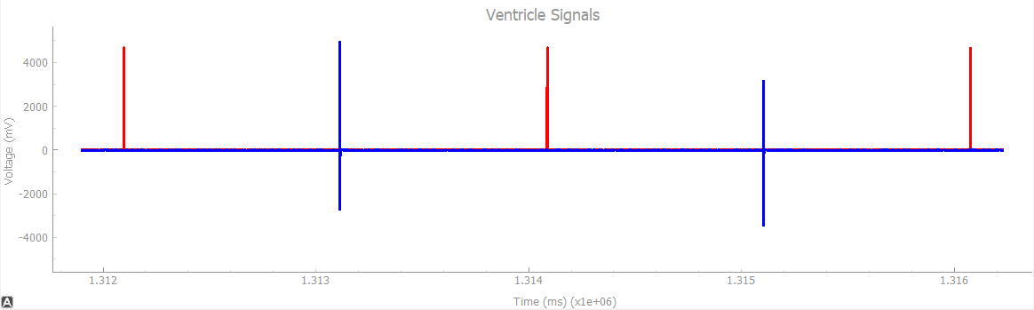

1. Natural Atrium: **OFF** |Natural Ventricle: **ON**, Pulse Width: **10ms** | Heart Rate: **30bpm**

When the heart rate is low, high pulse width is not able to bridge the gap and pacemaker is supposed to provide pulses in order to make sure proper functioning of the heart.

From the graph below, it is clear that our pacemaker sends artificial pulses to the heart and maintains normal functioning.

*The graph of natural and artificial pulse from HeartView*

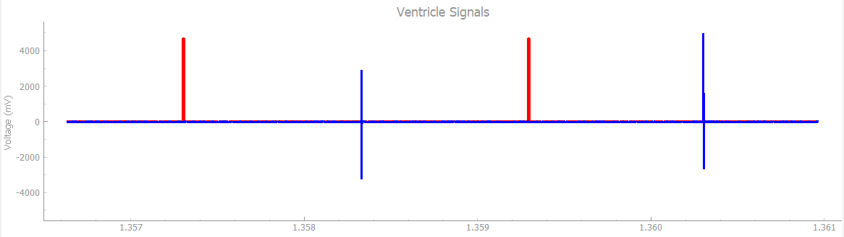

1. Natural Atrium: **OFF** |Natural Ventricle: **ON**, Pulse Width: **1ms** | Heart Rate: **50bpm**

When heart is beating just below normal rate but pulse width is not big enough to bridge the gap, pacemaker is expected to come into play and send pulses to the heart.

From the graph below, we can see that our pacemaker does exactly what is expected.

*The graph of natural and artificial pulse from HeartView*

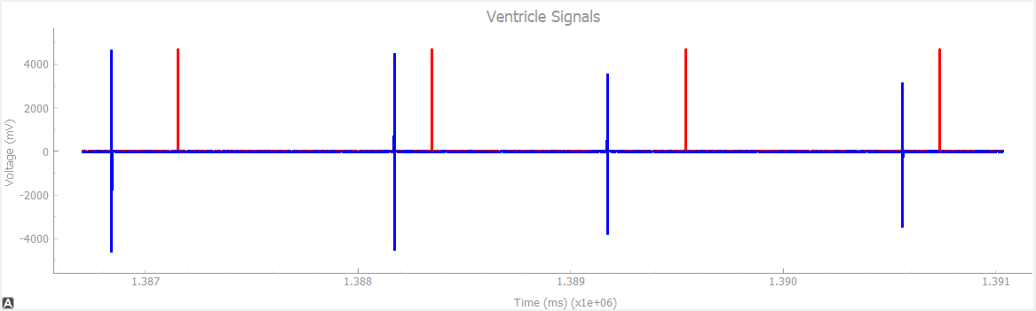

1. Natural Atrium: **OFF** |Natural Ventricle: **ON**, Pulse Width: **10ms** | Heart Rate: **58bpm**

When heart rate is just below the normal and pulse width is wide enough to bridge the gap, pacemaker should not do anything.

As we can see from the graph below, our pacemaker if not producing any artificial pulses to the heart.

*The graph of natural pulse from HeartView*

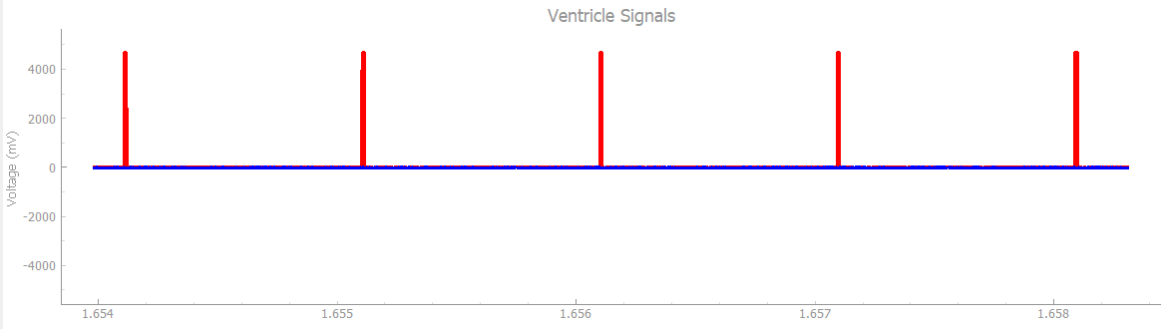

1. **DOO**

Chamber paced: Atrium and Ventricle

Chamber sensed: None

Response to Sensing: None

Rate Modulation

Heartview signals: Natural Atrium: **OFF |** Natural Ventricle: **OFF**

DCM signals:

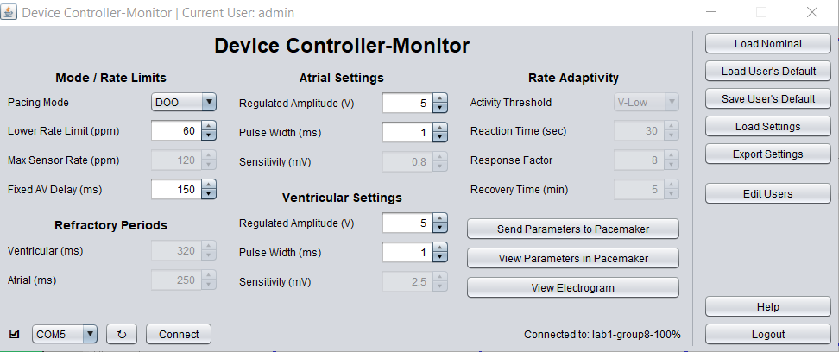

In DOO mode also, as we are not sensing any chamber, only a single test case (when both atrium and ventricle are not working) can demonstrate correctness of our pacemaker.

*The graph of artificial pulse from HeartView*

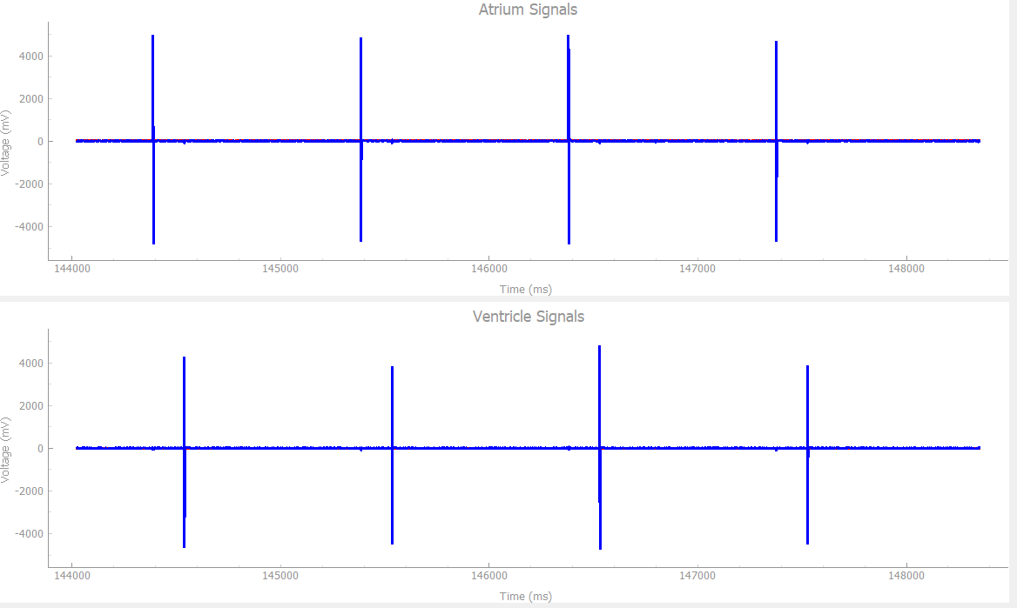

Pace to Ventricle and Atrium with LRL of 60 ppm and an AV delay of 150 ms

**Result**: Passed

1. **AOOR**

Chamber paced: Atrium

Chamber sensed: None

Response to Sensing: None

Rate Modulation

Heartview signals: Natural Atrium: **OFF |** Natural Ventricle: **OFF**

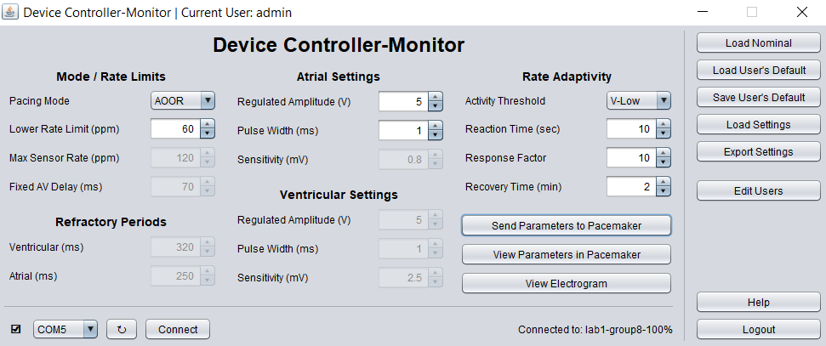

1. **No Activity sensed**

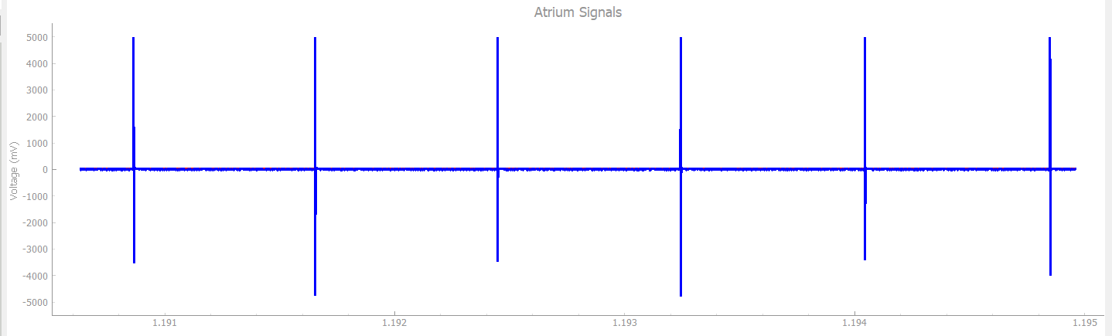

If no Activity is sensed above Threshold, Pace to Atrium with an LRL of 60 ppm

1. **Activity sensed**

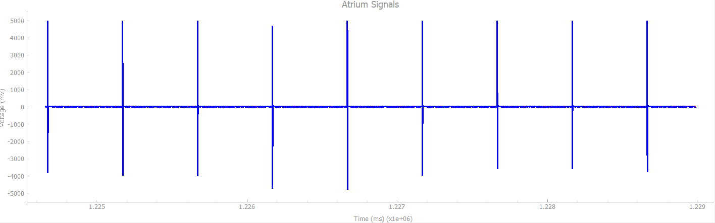

After sensing Activity above Threshold, increase LRL within a response time of 10 seconds and a recovery time of 2 minutes

**Result**: Passed

1. **VOOR**

Chamber paced: Ventricle

Chamber sensed: None

Response to Sensing: None

Rate Modulation

Heartview signals: Natural Atrium: **OFF |** Natural Ventricle: **OFF**

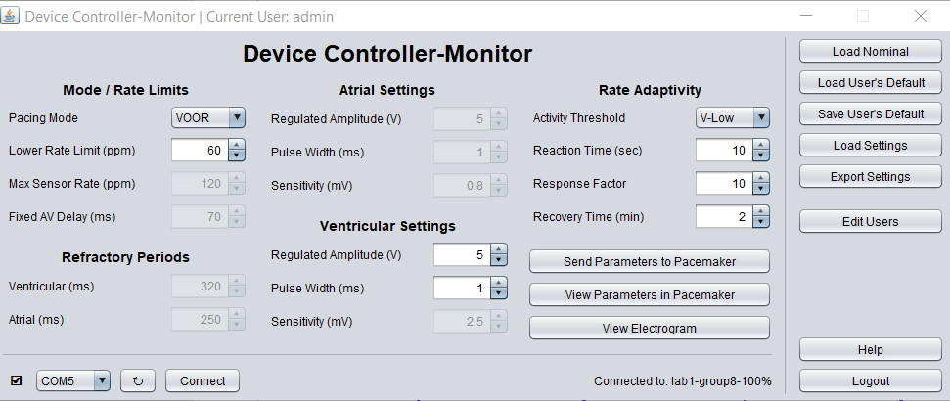

1. **No Activity sensed**

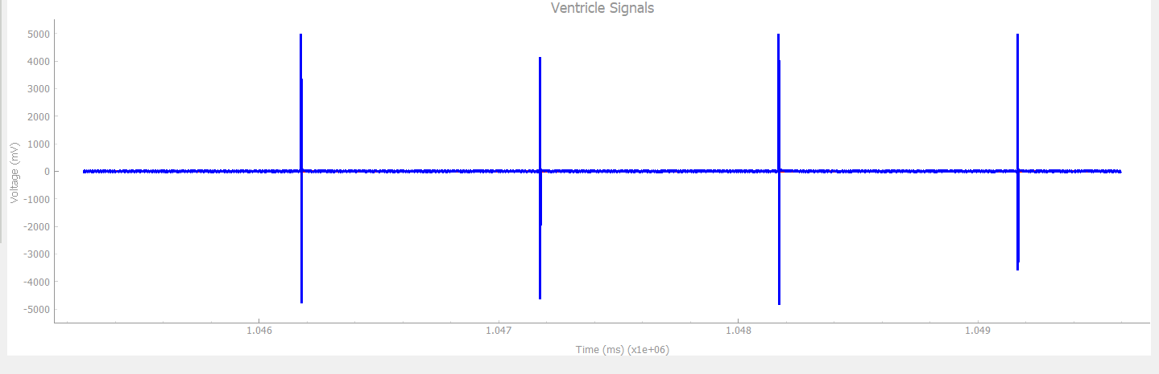

If no Activity is sensed above Threshold, Pace to Ventricle with LRL of 60 ppm

1. **Activity Sensed**

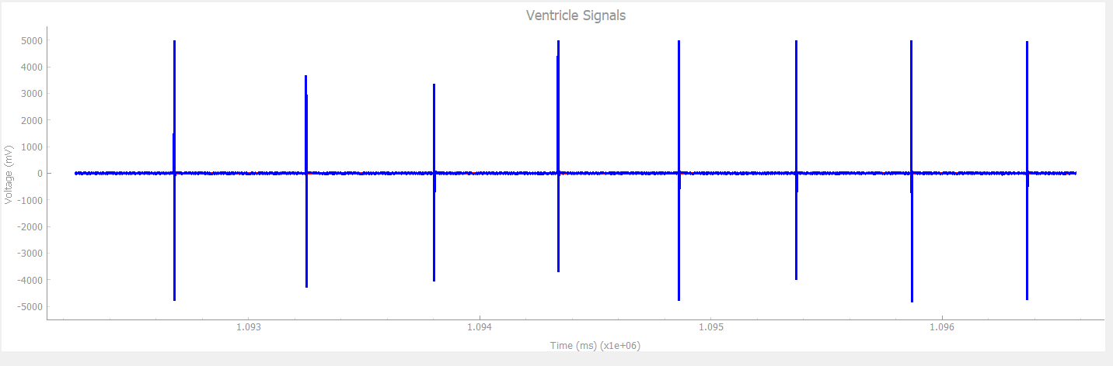

After sensing Activity above Threshold, increase LRL within a response time of 10 seconds and a recovery time of 2 minutes

**Result**: Passed

**8. DOOR**

Chamber paced: Atrium and Ventricle

Chamber sensed: None

Response to Sensing: None

Rate Modulation

Heartview signals: Natural Atrium: **OFF |** Natural Ventricle: **OFF**

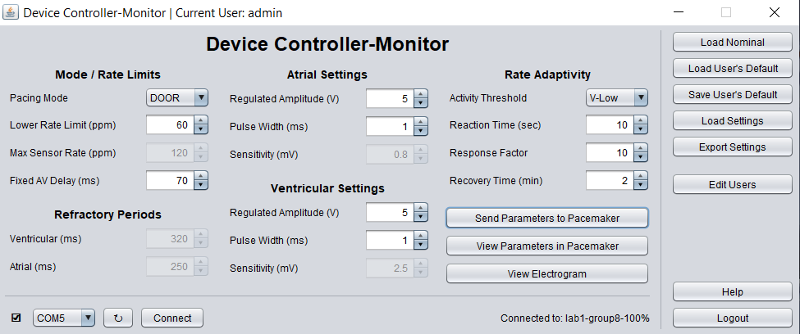.

1. **No Activity sensed**

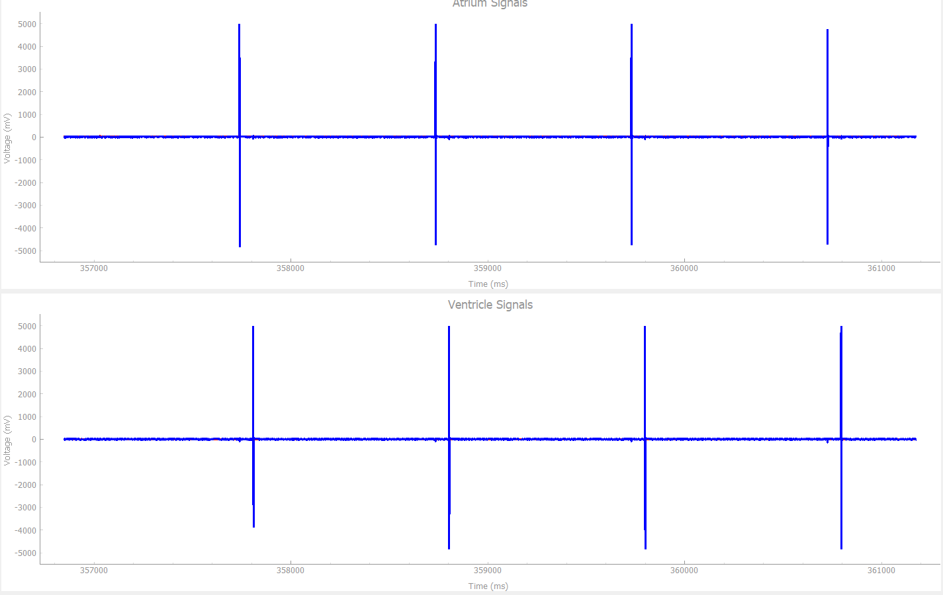

If no Activity is sensed above Threshold, Pace to Ventricle and Atrium with an LRL of 60 ppm and AV delay of 70 ms

1. **Activity sensed**

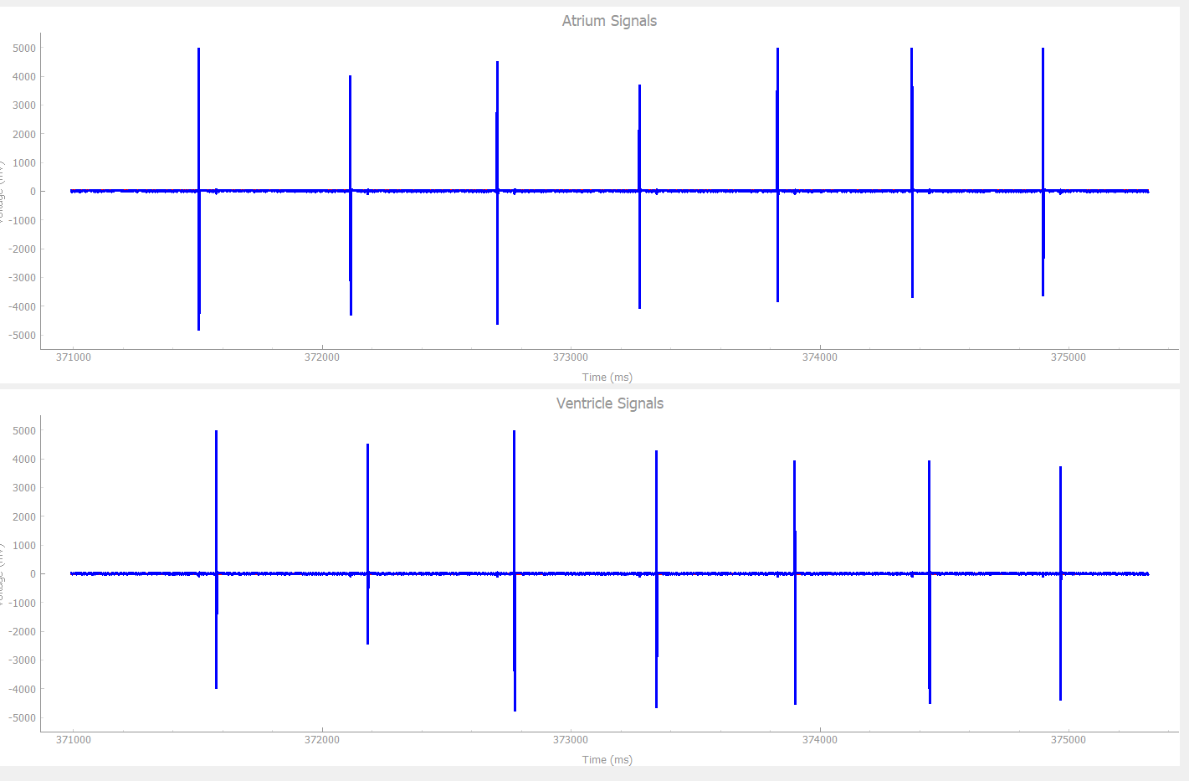

After sensing Activity above Threshold, increase LRL within a response time of 10 seconds and a recovery time of 2 minutes

**Result:** Passed

1. **AAIR**

Chamber paced: Atrium

Chamber sensed: Atrium

Response to Sensing: Inhibited

Rate Modulation

**Test Cases:**

1. **No activity**

Heartview signals: Natural Atrium: **On |** PW: 1ms | Heart rate: 30Bpm

DCM signals:

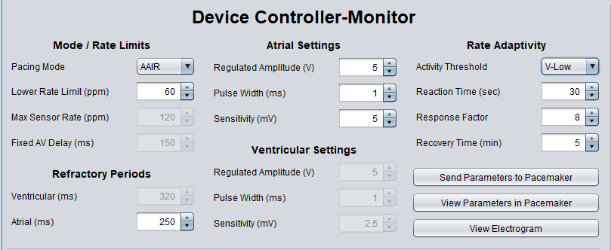

Explanation: When we are operating on AAIR mode with no activity in pacemaker and heart rate is below normal, pacemaker is supposed to produce the pulse to bridge the gap. As we can see from graph below, our pacemaker does the same.

*The graph of artificial and natural pulse from HeartView*

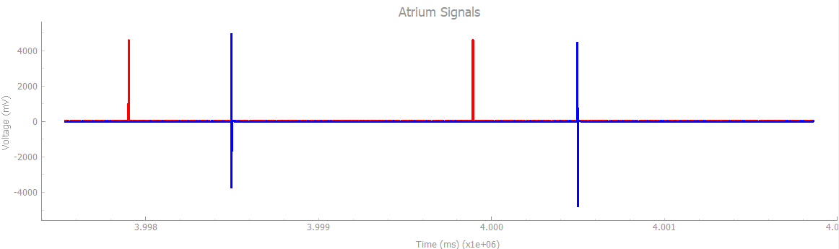

1. **Physical activity**

Heartview signals: Natural Atrium: **On |** PW: 1ms | Heart rate: 30Bpm

DCM signals:



Explanation: When there is some physical activity, our pacemaker produces more pulses than under normal conditions.

*The graph of artificial and natural pulse from HeartView*

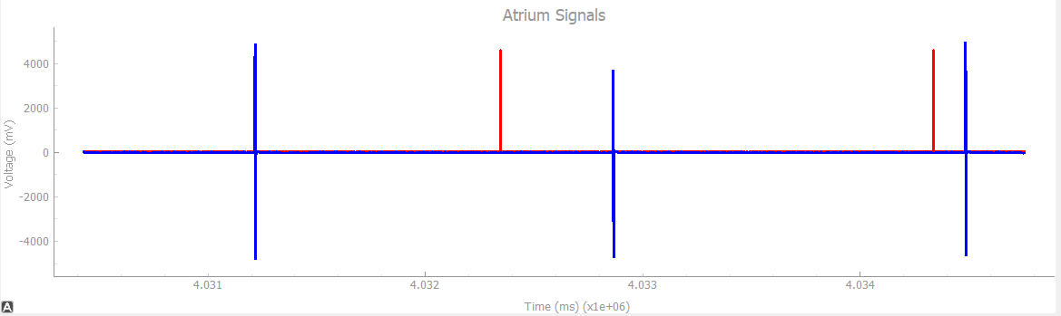

1. **No activity**

Heartview signals: Natural Atrium: **On |** PW: 1ms | Heart rate: 60Bpm

DCM signals:



Explanation: When there is no physical activity and heart is beating at natural rate, pacemaker is not supposed to provide any additional pulse. Our pacemaker does the same which is clear from following graph.

*The graph of artificial and natural pulse from HeartView*

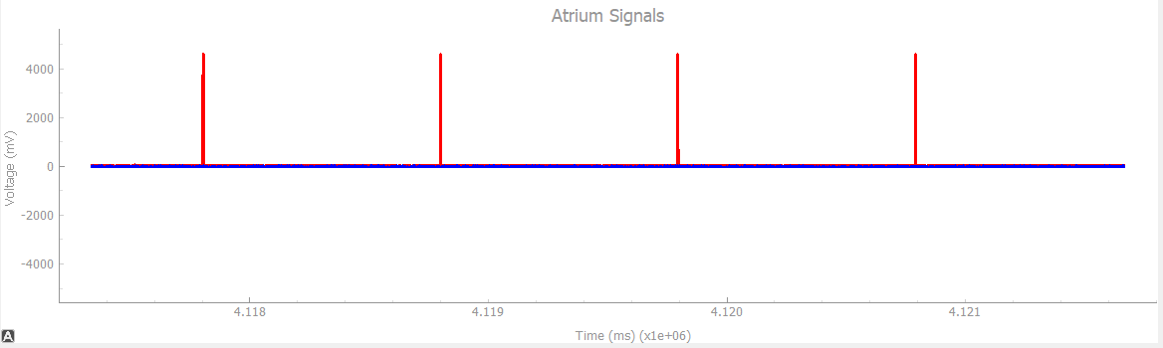

1. **Physical activity**

Heartview signals: Natural Atrium: **On |** PW: 1ms | Heart rate: 60Bpm

DCM signals:



Explanation: When there is some physical activity and heart is beating at regular rate, pacemaker should provide additional pulse to account for the physical activity. It is clear from the below graph that our pacemaker does exactly the same.

*The graph of artificial and natural pulse from HeartView*

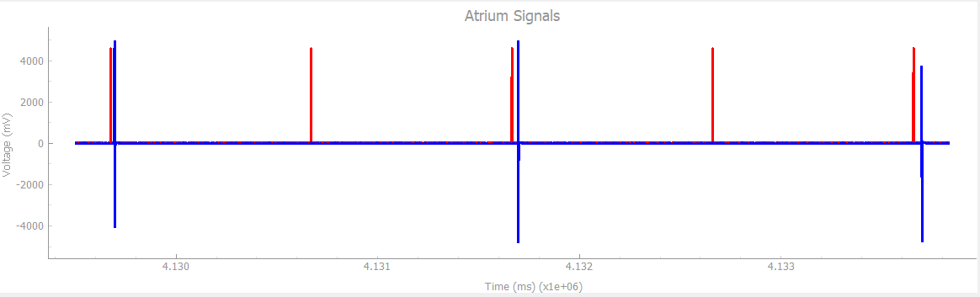

1. **VVIR**

Chamber paced: Ventricle

Chamber sensed: Ventricle

Response to Sensing: Inhibited

Rate Modulation

**Test Cases:**

1. **No activity**

Heartview signals: Natural Ventricle: **On |** PW: 1ms | Heart rate: 30Bpm

DCM signals:

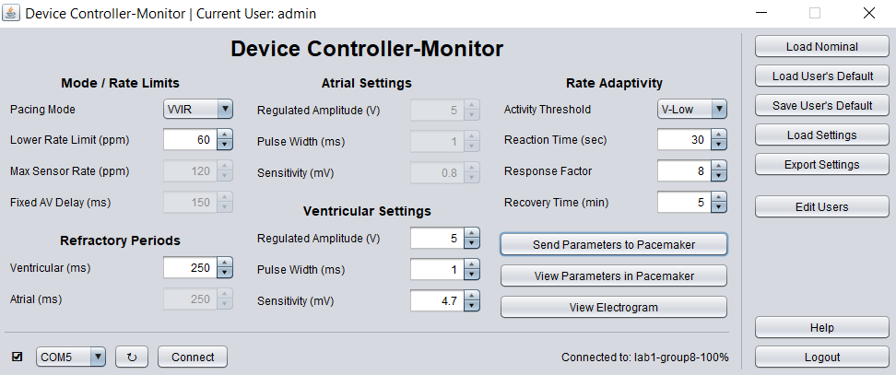

Explanation: When we are operating on VVIR mode with no activity in pacemaker and heart rate is below normal, pacemaker is supposed to produce the pulse to bridge the gap. As we can see from graph below, our pacemaker does the same.

*The graph of artificial and natural pulse from HeartView*

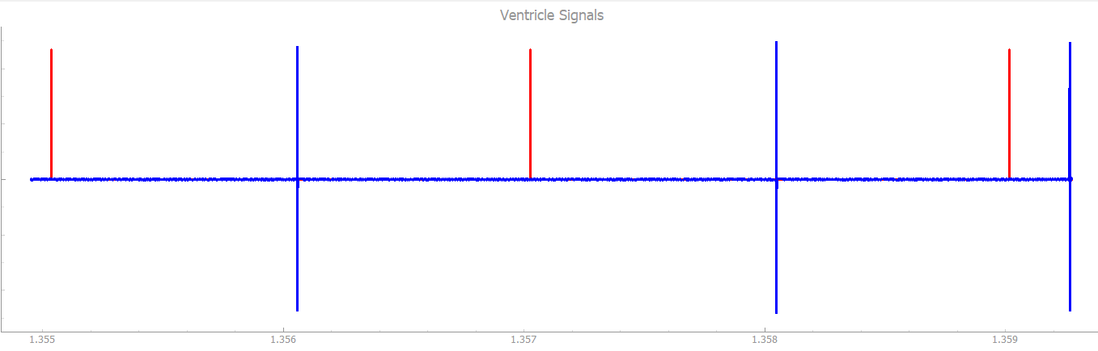

1. **Physical activity**

Heartview signals: Natural Ventricle: **On |** PW: 1ms | Heart rate: 30Bpm

DCM signals:



Explanation: When there is some physical activity, our pacemaker produces more pulses than under normal conditions.

*The graph of artificial and natural pulse from HeartView*

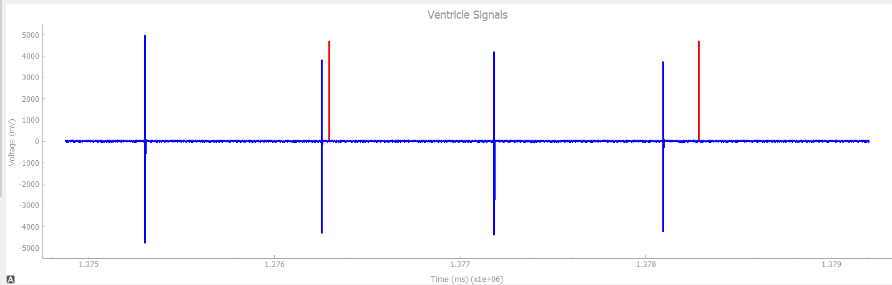

1. **No activity**

Heartview signals: Natural Ventricle: **On |** PW: 1ms | Heart rate: 60Bpm

DCM signals:



Explanation: When there is no physical activity and heart is beating at natural rate, pacemaker is not supposed to provide any additional pulse. Our pacemaker does the same which is clear from following graph.

*The graph of artificial and natural pulse from HeartView*

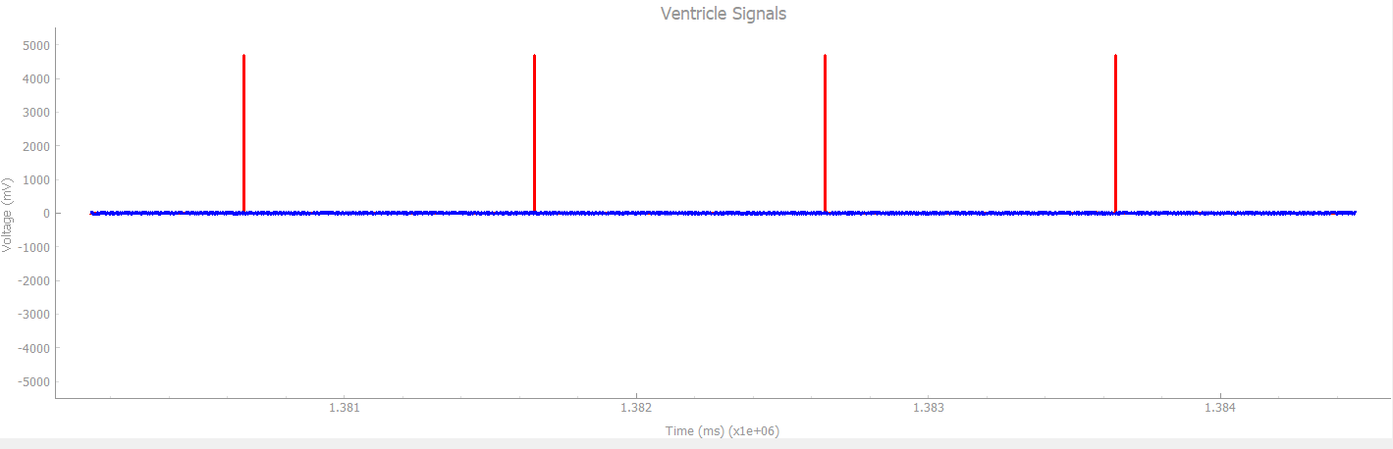

1. **Physical activity**

Heartview signals: Natural Ventricle: **On |** PW: 1ms | Heart rate: 60Bpm

DCM signals:



Explanation: When there is some physical activity and heart is beating at regular rate, pacemaker should provide additional pulse to account for the physical activity. It is clear from the below graph that our pacemaker does exactly the same.

*The graph of artificial and natural pulse from HeartView*

