Assignment 4 Dynamic Programming and String Algorithms
Pashanov Yelnur | SE2523 | Design and Analysis of Algorithms

Experiment Design Card
Questions. How does edit-distance work grow for recursion and dynamic programming? How does pattern structure affect naive search and KMP?
Sizes. Edit distance: n = 2, 4, 8, 10 for equal-length strings; the recursive limit keeps the run practical. Search: text length n = 2,048, 4,096, 8,192, 16,384 with a 32-character pattern. The ranges grow by five and eight times, respectively.
Inputs. Edit distance uses fixed-seed random ACGT strings, identical strings, and disjoint A...A versus B...B strings, respectively showing typical behavior, the matching shortcut, and maximum branching. Search uses random ACGT strings and an adversarial text A...A with pattern A repeated 31 times followed by B; the latter forces repeated naive comparisons.
Metrics. Recursive calls or DP cell updates count edit work; character comparisons in preprocessing and search count string-search work. Each measurement records elapsed milliseconds; charts use the median of five runs after three warm-ups. Counters are incremented inside the algorithms.
Predictions. Recursive work should grow much faster on disjoint strings than the quadratic DP tables, while identical strings follow one branch. The adversarial search should cause roughly 32 comparisons per candidate for naive search; KMP should remain linear.
Plots. Edit work on a logarithmic axis compares growth; search comparisons reveal input sensitivity; median search time shows the observed timing. After exploratory runs, disjoint edit strings were added to expose worst-case recursion. Before the final rerun, edit sizes were changed from 4, 6, 8, 10 to 2, 4, 8, 10 to meet the fourfold-range rule.

Plots and Results
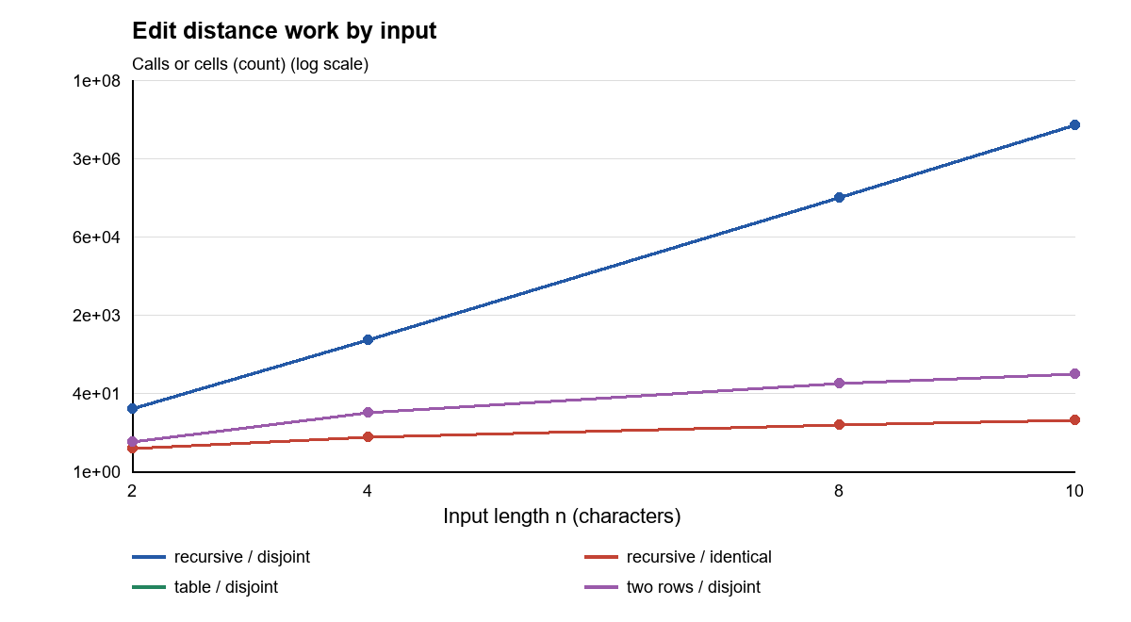
The disjoint recursive case grows sharply, while both DP implementations perform n² cell updates and overlap on the graph.
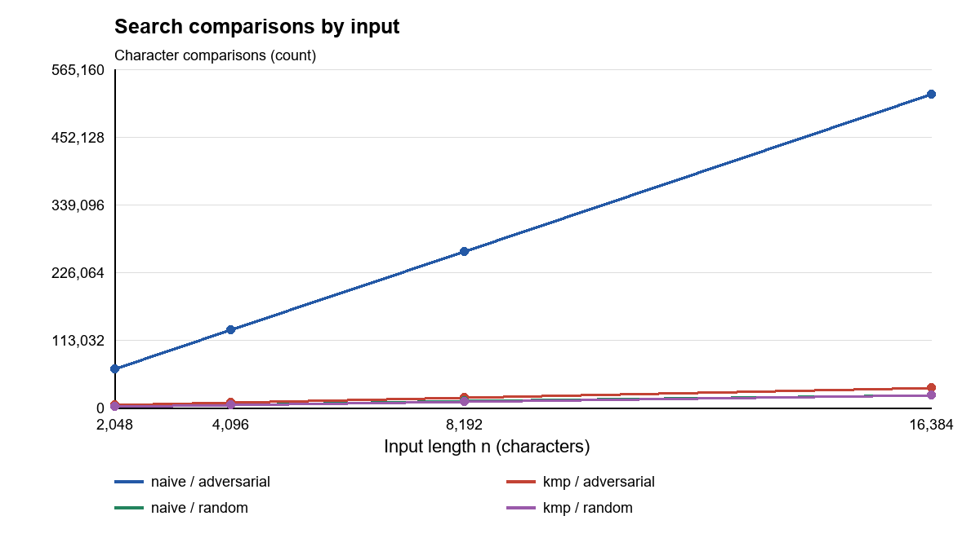
At n = 16,384, naive search makes 523,296 comparisons on the adversarial input versus 32,798 for KMP.

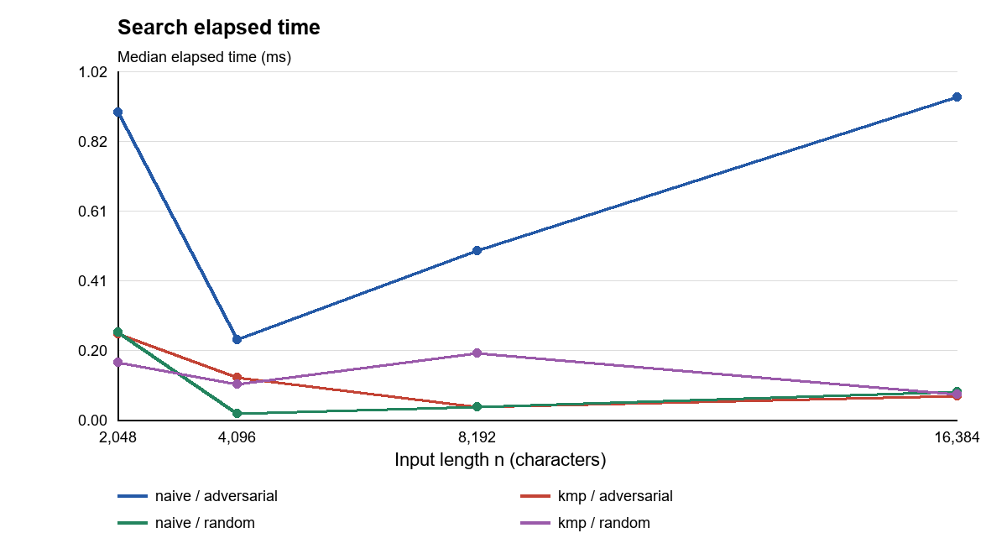
The adversarial naive search has the highest median at n = 16,384, but short-run timings fluctuate.

Prediction versus Result
Edit distance. The result supports the prediction: at n = 10, disjoint recursion made 12,146,179 calls, versus 100 cell updates for either DP method and 11 calls for identical recursion. Random recursion made 453,595 calls at that size. Thus input structure, as well as length, determines recursive work.
String search. At n = 16,384, adversarial naive search made 523,296 comparisons and KMP made 32,798, including LPS construction. On random input they made 21,713 and 20,459 comparisons, respectively. This agrees with the predicted adversarial advantage, although a fixed pattern length makes both curves linear in text length.

Short Answers
Which input made search slowest? The adversarial text of repeated A and pattern ending in B produced the largest search time and comparison count for naive search at the largest size. Naive search checks 31 matching characters before failing at each candidate. KMP reuses the LPS values and does not move backward in the text.
How large could recursion handle? The largest measured equal-length input was n = 10, including the disjoint worst case. It took a median of about 21.383 ms and 12,146,179 calls. Larger sizes were not measured; repeated branching, rather than a proven hard limit, motivated the chosen bound.

Short Answers Continued
What do two rows gain and lose? They reduce extra storage from O(nm) to O(m) while preserving the distance and O(nm) time. The full table is no longer available for directly tracing an edit sequence. Recovering that sequence would require extra work or another method.
Which search for the city platform? KMP is a sound default for long logs or repetitive text because its O(n + m) worst-case work is predictable and it finds overlapping matches. For short typical queries, naive search is simpler and may be competitive. The workload and fixed 32-character patterns here do not prove KMP is always faster.

Time Measurements
On Windows with Microsoft OpenJDK 17.0.20.1, at n = 16,384 the median times were 0.944 ms for adversarial naive search and 0.070 ms for adversarial KMP; random cases were 0.081 ms and 0.076 ms. Short timings are sensitive to JVM warm-up, scheduling and timer noise. Five runs and three warm-ups reduce but do not eliminate noise. The in-algorithm counters provide a repeatable second measure; a rerun reproduces generated inputs and counts, not exact elapsed times.

Correctness
JUnit 5 checks the supplied distances, prefix arrays and match positions, empty inputs and patterns, overlaps, and 100 fixed-seed random cross-checks per family. The three distance methods agree on the tested cases, and both searches return the same results.

