

***Project Name: “Beauty Parlor Management System”***

***Group members:***

MD. AOLAD HOSSAIN ANNA (17- 33513-1)

MD. SAJID BIN FAISAL (17-33596-1)

KHONDOKER SHAHRINA (17-33461-1)

MD ASHIQUL HAQUE (17-33578-1 )

MOHAMMAD AFZAR AL MUNEM (17-33469-1)

***COURSE NAME:*** **INTRODUCTION TO DATABASE**.

***COURSE TEACHER:* JUENA AHMED NOSHIN** **Section: [I].**

***OBJECTIVES***

* **Introduction**
* **Scenario Description**
* **ER Diagram**
* **Normalization**
* **Table Creation**
* **Data Insertion**
* **Query Writing**
* **Conclusion**

***Introduction:***

The title of the project is *“beauty parlor management system”.*  We have made the relational tables to make the database system and their information. We have the descriptions of the query that is required to create the tables and insert the values in the tables. We had to go through the normalization process to overcome data insertion, deletion and update anomalies to decide the tables to be created.

We do believe that this project will be beneficial to a lot of new or updatable parlor management system.

*Scenario description:*

The scenario is of a beauty parlor management system.

1. The parlor will be owned by 1 owner. The owner will have the properties like owner country, owner city and owner name. The parlor may have the attributes like men’s section and women’s arena. The parlor will have the unique attribute named branch code.
2. The parlor will hire many employees. Each employee may have properties as employee name, employee id, employee mobile number, the salary of the employee and the skill which is a multivalued attribute.
3. The parlor will offer many packages and each of the package may have the properties as follows:

=>Package type (multivalued attribute)

=>package code (unique key)

=>package name

=>discount percentage

4. The parlor will provide many services and each of the

Service may have attributes as service name, service type

(Multivalued attribute) and a primary key named service

Code.

5. The services will be booked by many clients as a many to

Many relationship and the clients will have these attributes

As follows:

=>gender

=>client name

=>client mobile number (multivalued)

=>client id (unique identity)

6. In the end, the clients will be served by many employees.

This is a many to many relationship.

Normalization:

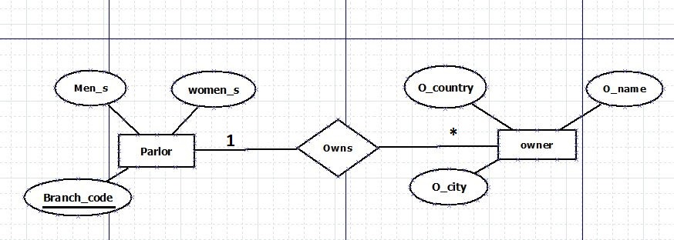

UNF:

owns(O_name,O_country,O_city,men_s,women_s , branch_code)

1NF:

(O_name,O_country,O_city,men_s,women_s , branch_code)

2NF:

(O_name,O_country,O_city, branch_code )

(**branch_code**, men_s ,women_s)

3NF:

(**O_city,** O_country **)**

(O_name,O_city, )

(**branch_code**, men_s ,women_s)

Normalization:

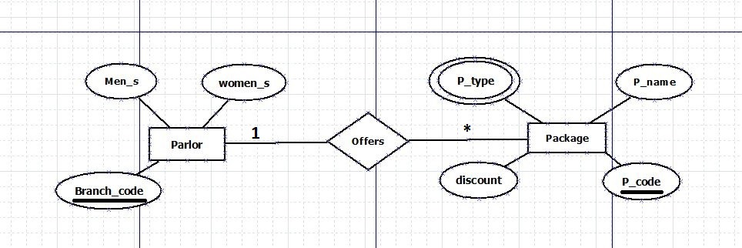

UNF:

Offers (**branch_code ,** men_s,women_s, **p_code ,** p_name, p_type,discount)

1NF:

(**branch_code ,** men_s,women_s, **p_code ,** p_name, p_type,discount)

2NF:

(**branch_code,** men_s,women_s)

(**p_code ,** p_name, p_type,discount, )

3NF is as same as 2NF.

Normalization:

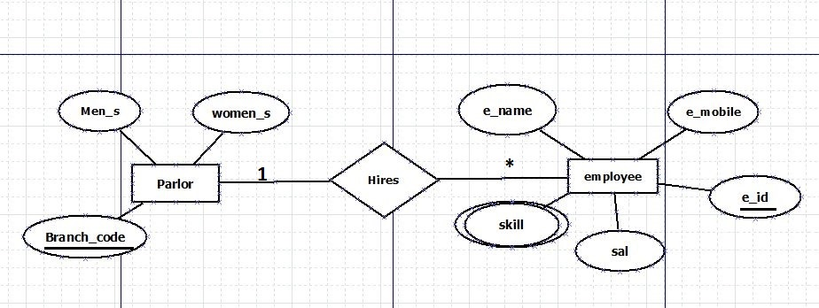

UNF:

Hires(**branch_code,** men_s,women_s,**e_id,**e_name,e_mobile,sal,skill)

1NF:

**(branch_code,** men_s,women_s,**e_id,**e_name,e_mobile,sal,skill)

2NF:

(**branch_code,** men_s,women_s)

(**e_id,**e_name,e_mobile,sal,skill, )

3NF is as 2NF.

Normalization:

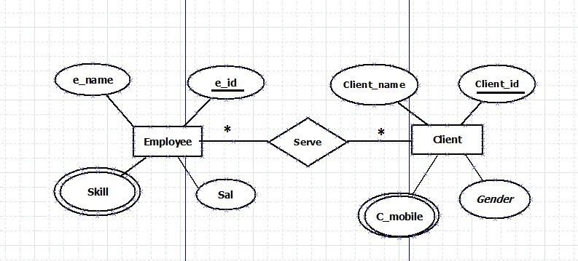

UNF:

Serve(**e_id,**e_name,e_mobile,sal,skill,**c_id,**c_name,c_mobile,gender)

1NF:

(**e_id,**e_name,e_mobile,sal,skill,**c_id,**c_name,c_mobile,gender)

2NF:

(**e_id,**e_name,e_mobile,sal,skill)

**(c_id,**c_name,c_mobile,gender)

(**e_id, c_id)**

3NF is as same as 2NF.

Normalization:

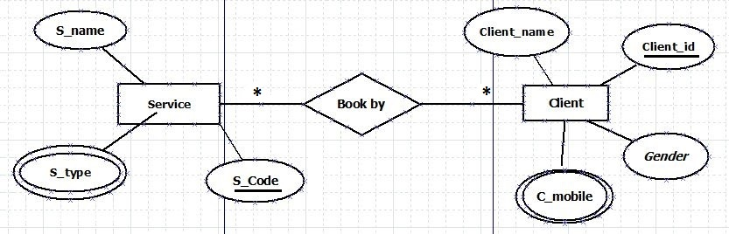

UNF:

Book-by**(c_id,**c_name,c_mobile,gender,**s_code,**s_name,s_type)

1NF:

**(c_id,**c_name,c_mobile,gender,**s_code,**s_name,s_type)

2NF:

**(c_id,**c_name,c_mobile,gender)

**(s_code,**s_name,s_type)

**(c_id, s_code)**

3NF IS AS 2NF.

Normalization:

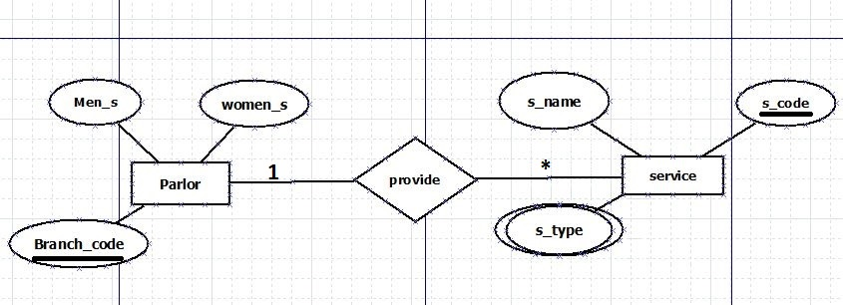

UNF:

Provide**( branch_code** , men_s,women_s, s_name,**s_code,** s_type)

1NF:

**( branch_code** , men_s,women_s, s_name,**s_code,** s_type)

2NF:

**( branch_code** , men_s,women_s)

(s_name,**s_code,** s_type, )

3NF is as 2NF.

**FINALIZATION:**

1. (**branch_code,** men_s,women_s)

1. (O_name, O_city, )
2. (**e_id,**e_name,e_mobile,sal,skill, )
3. **(c_id,**c_name,c_mobile,gender)

5. (s_name,**s_code,** s_type, )

1. (**O_city,** O_country)
2. (**p_code ,** p_name, p_type,discount, )
3. (**e_id, c_id)**
4. **(c_id, s_code)**

***Table Creation:***

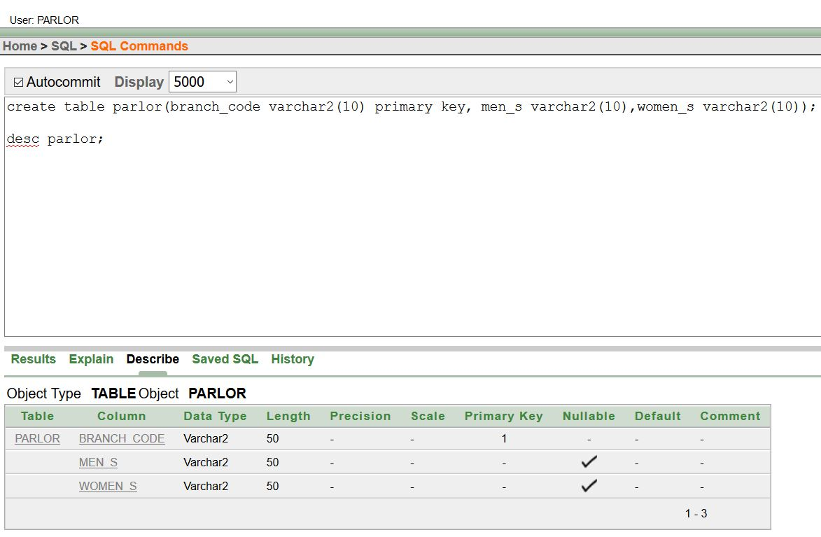

***Table Creation:***

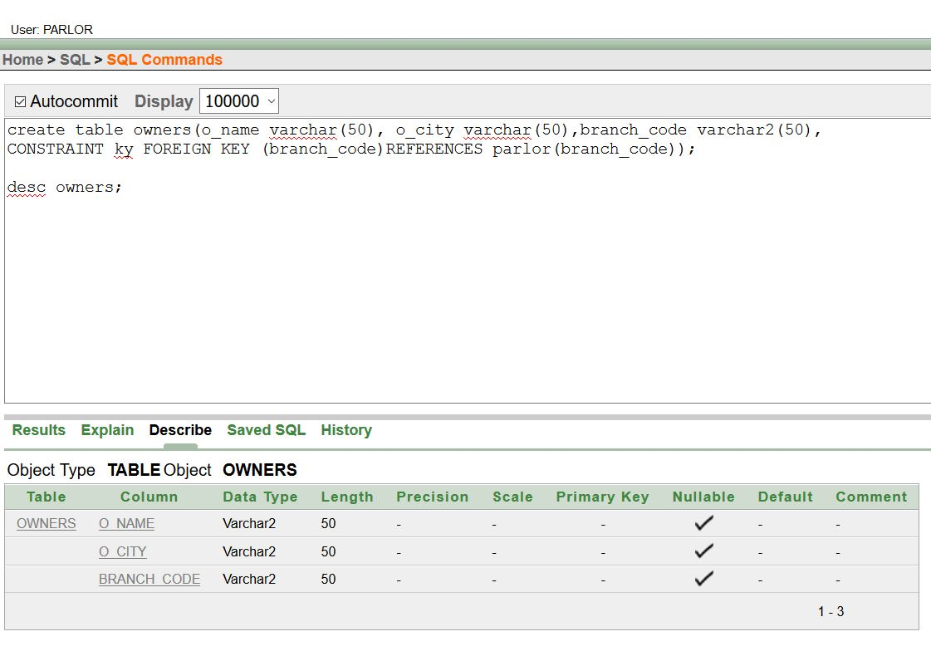

***Table Creation:***

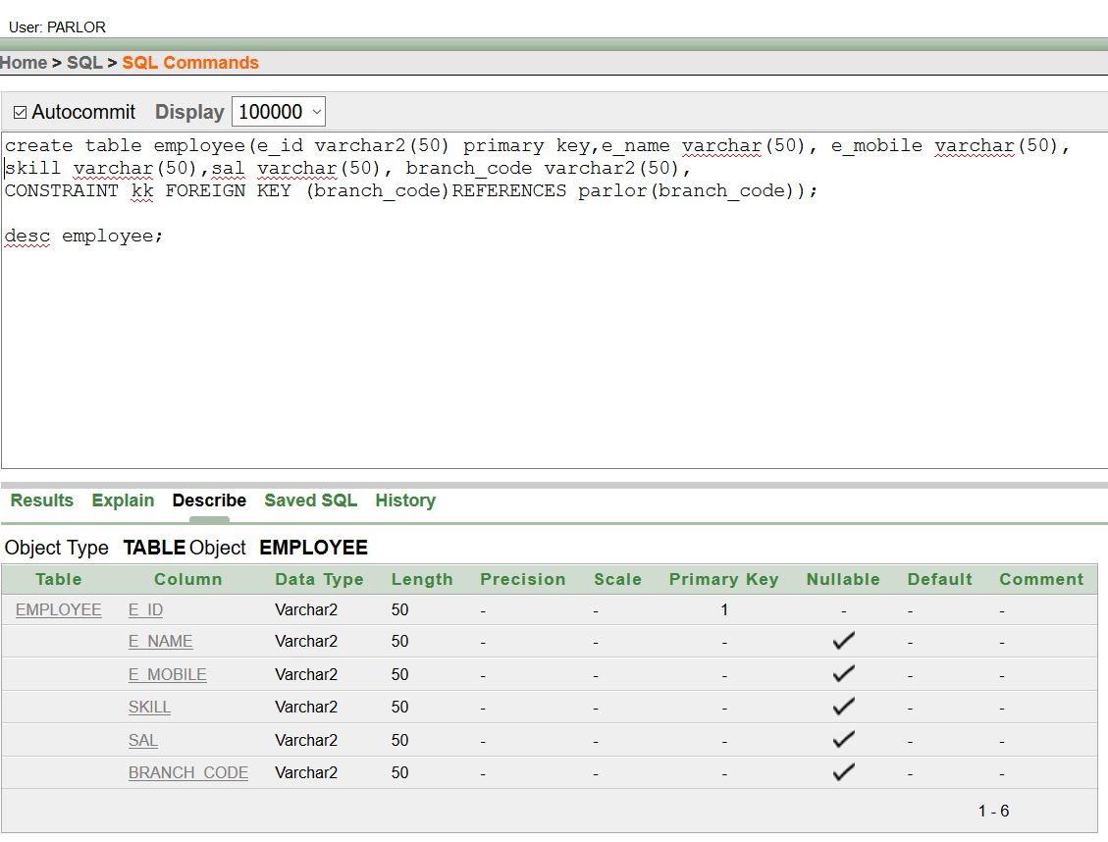

***Table Creation:***

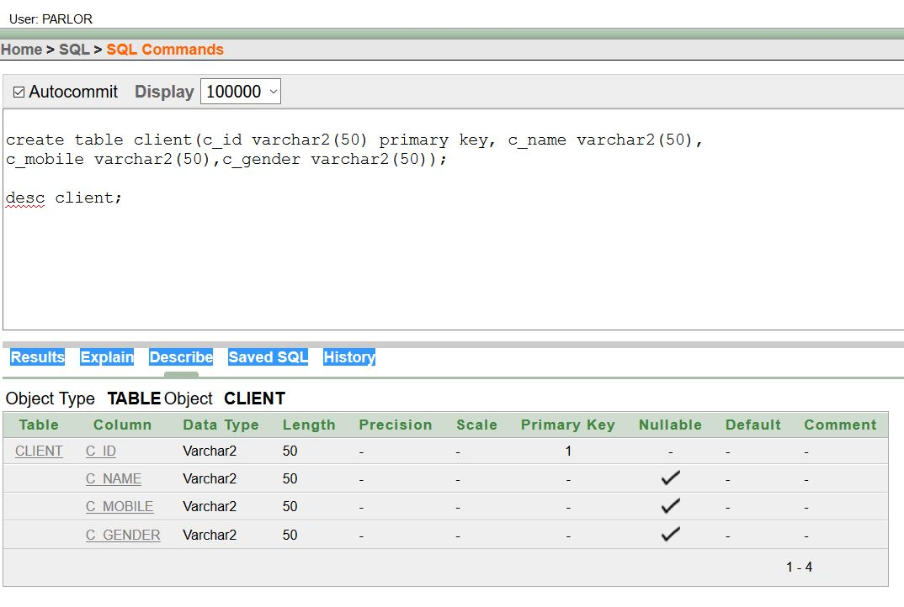

***Table Creation:***

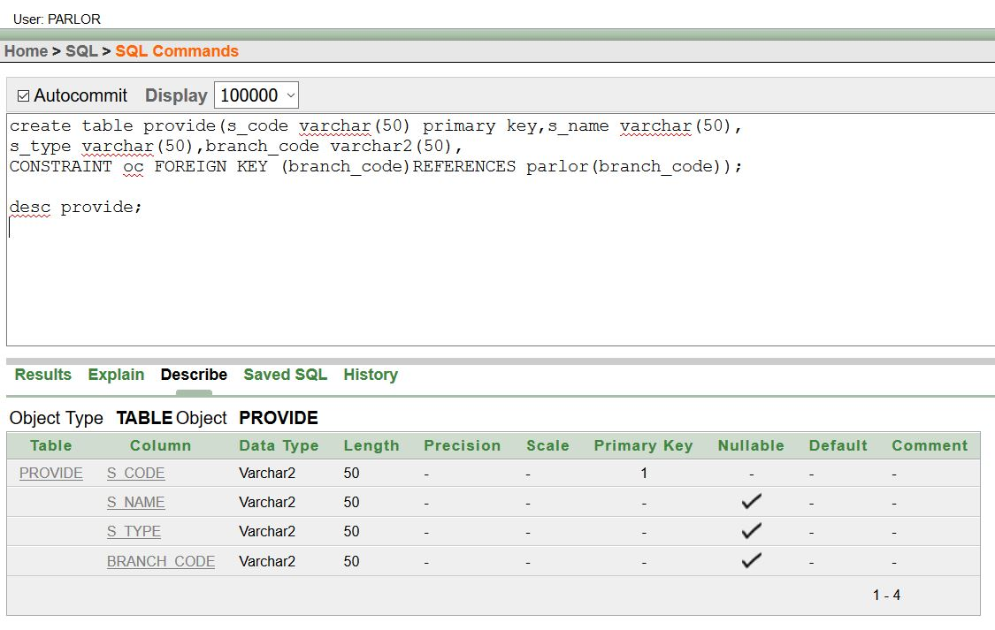

***Table Creation:***

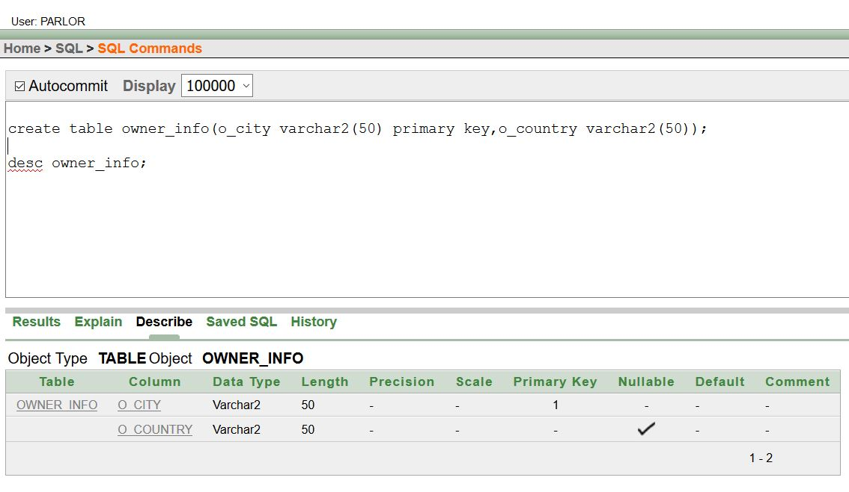

***Table Creation:***

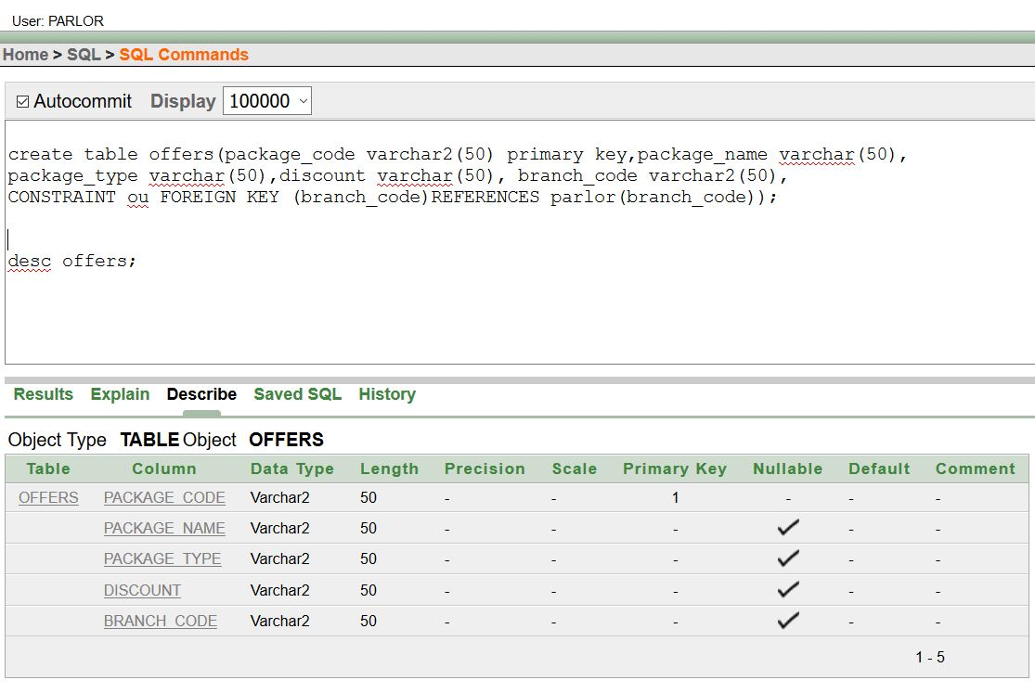

***Table Creation:***

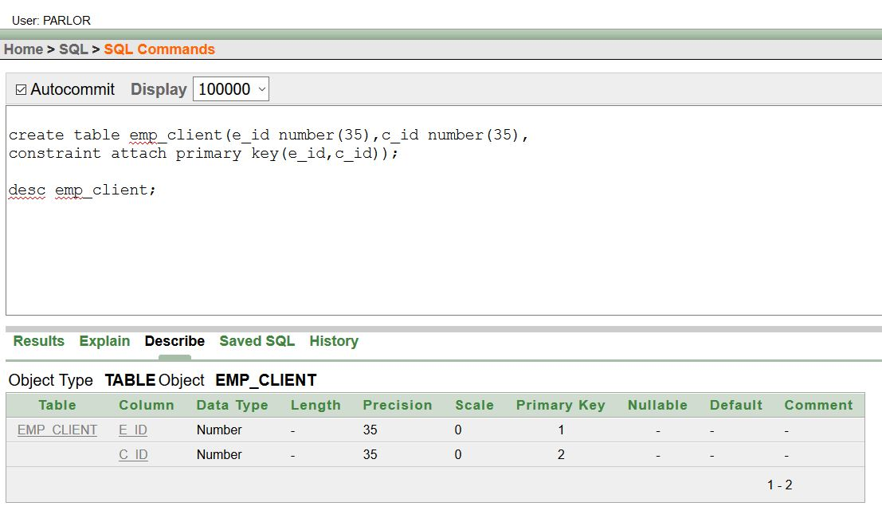

***Table Creation:***

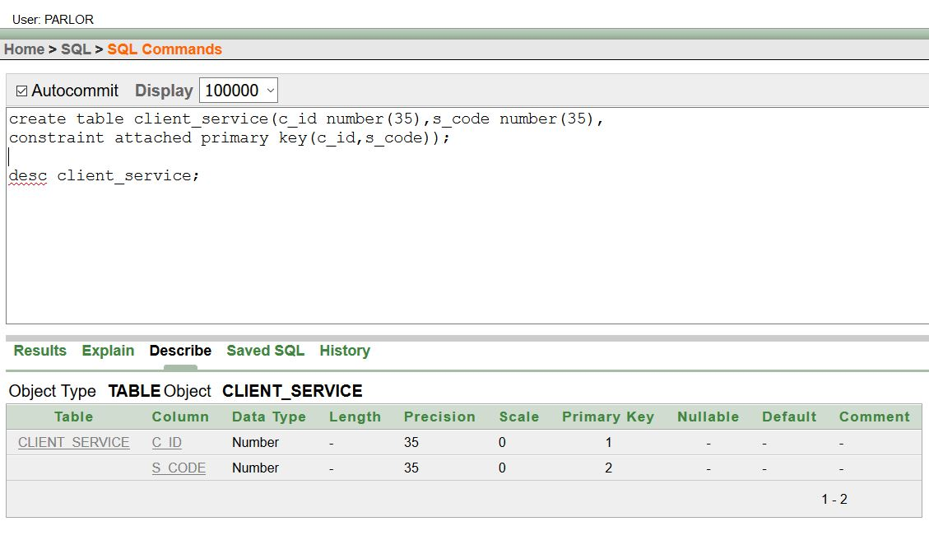

***Data Insertion:***

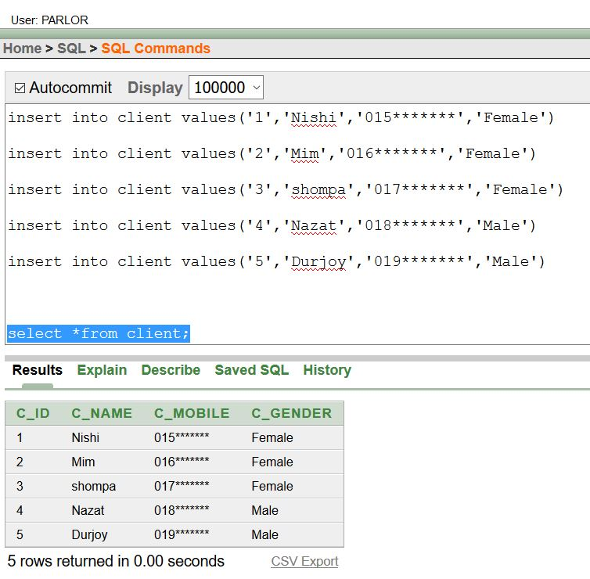

***Data Insertion:***

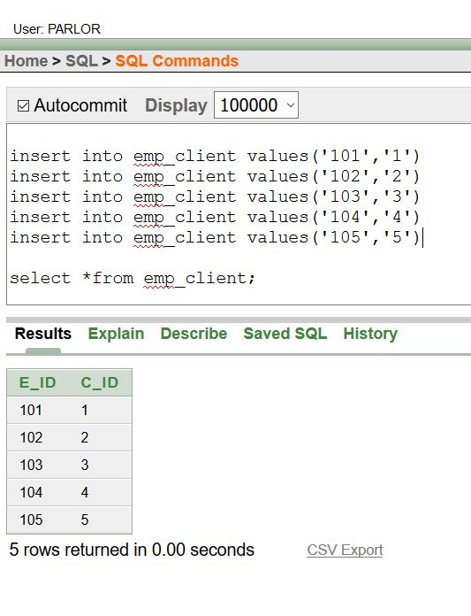

***Data Insertion:***

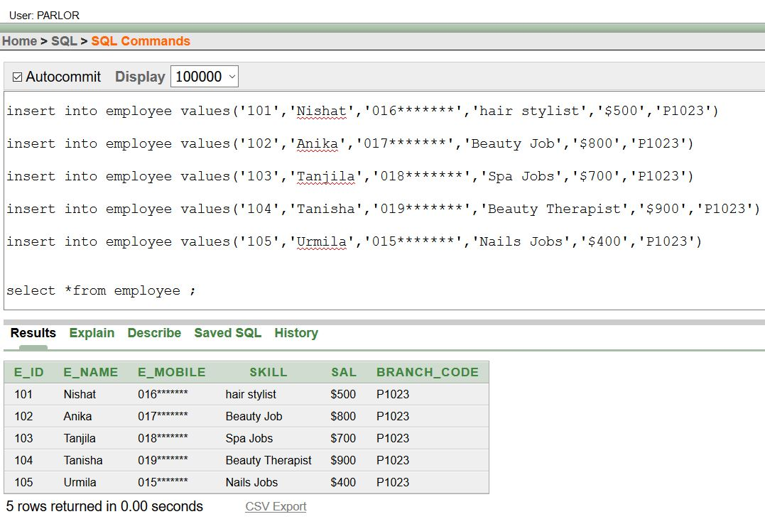

***Data Insertion:***

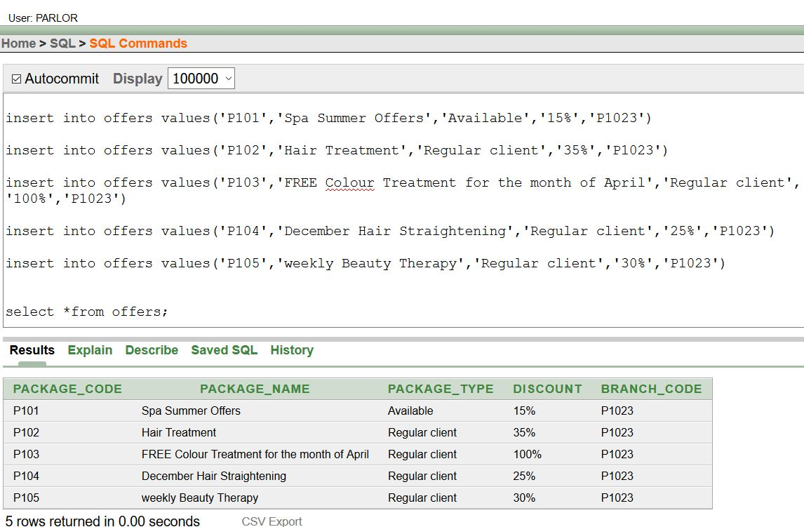

***Data Insertion:***

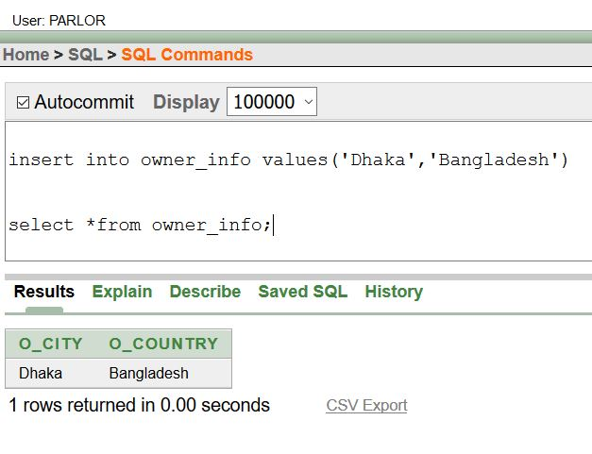

***Data Insertion:***

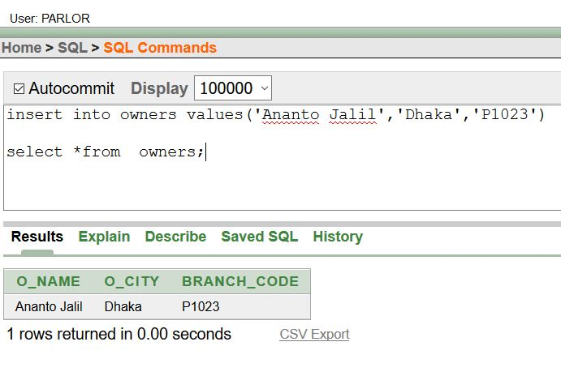

***Data Insertion:***

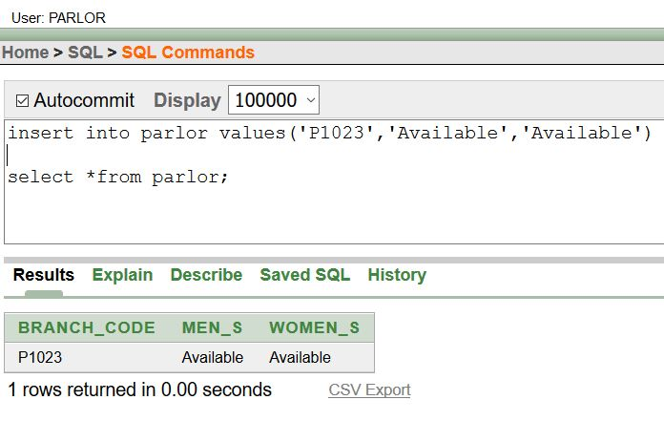

***Data Insertion:***

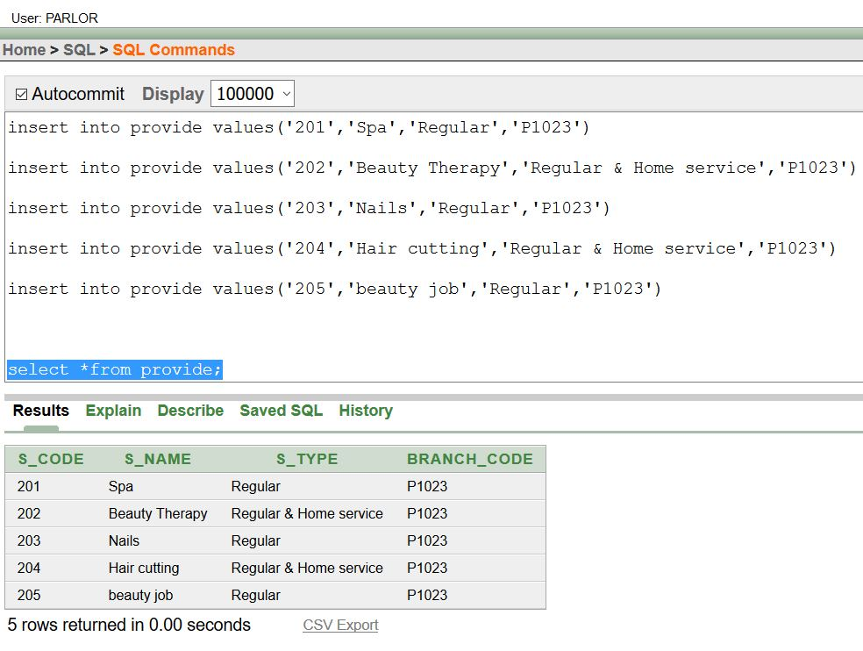

***Data Insertion:***

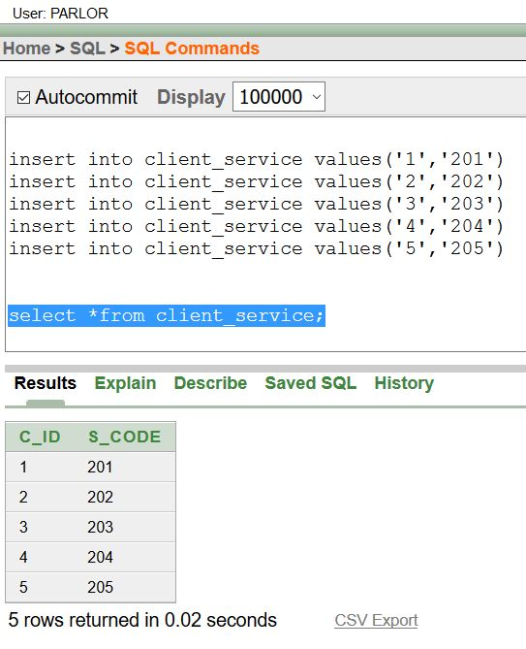

***Query Writing:***

***Single row queries:***

1. **Display the package_code, Package_name,package_type where discount is less than 35%.**

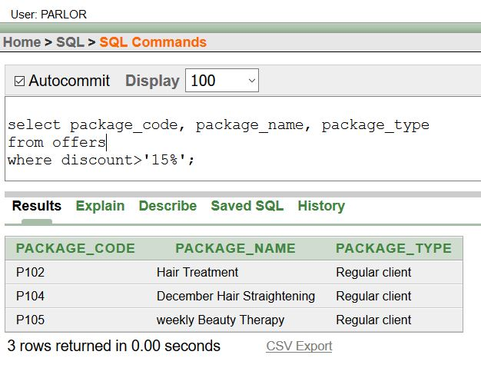

***Single row queries:***

1. **Display the id and name of all the female client.**

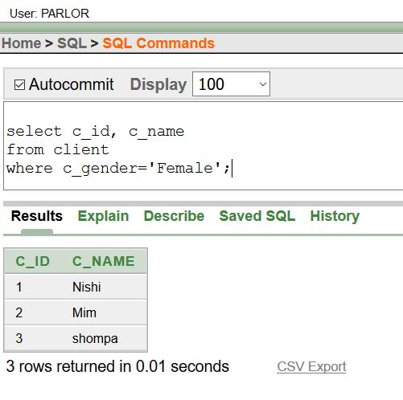

***Group function query:***

1. **Display the name of the employees having the minimum salary of $700.**

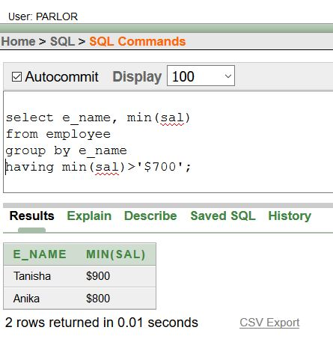

***Group function query:***

1. **Display the count show of the client who’s name is “mim”.**

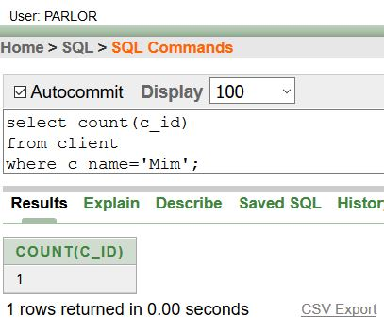

***Subquery:***

1. **Display the salary of the employees who’s salary is greater than id of 105.**

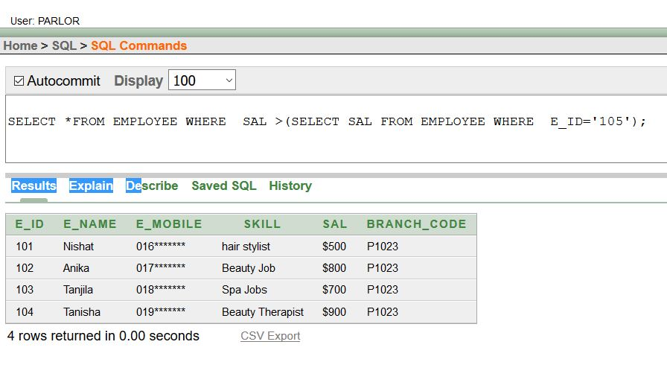

***Subquery:***

1. **Display the name and id of the client who’s id is 5.**

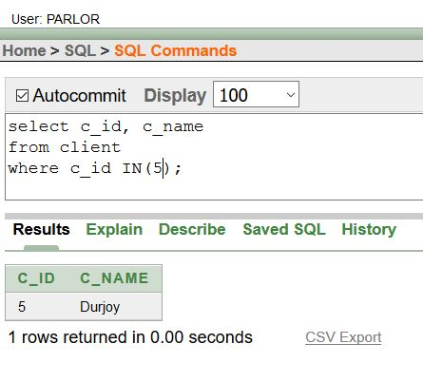

***Subquery:***

1. **Display the name, skill and id of the employee who’s salary is greater than all other employees.**

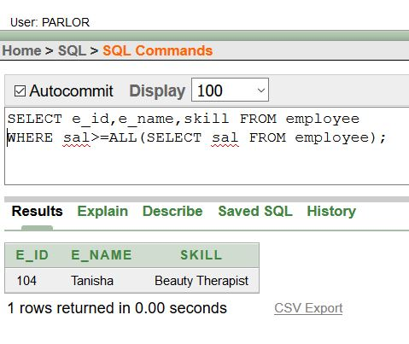

***Joining:***

1. **Join the employee name and client id with the employee id from employee and client table.**

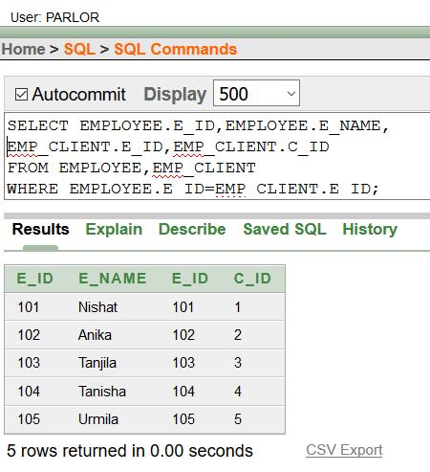

***Joining:***

1. **Join the service code with the client id and service type from the tables named provide and client service.**

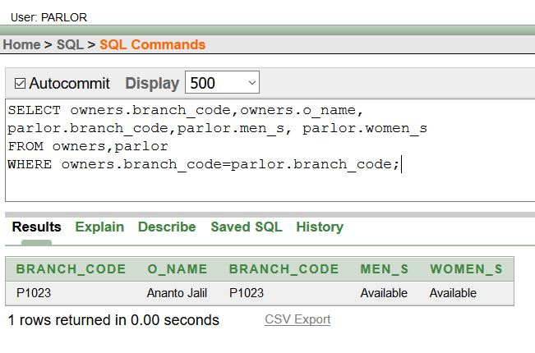

***Joining:***

1. **Join the branch code with the owner name with the availability of men’s section and female section.**

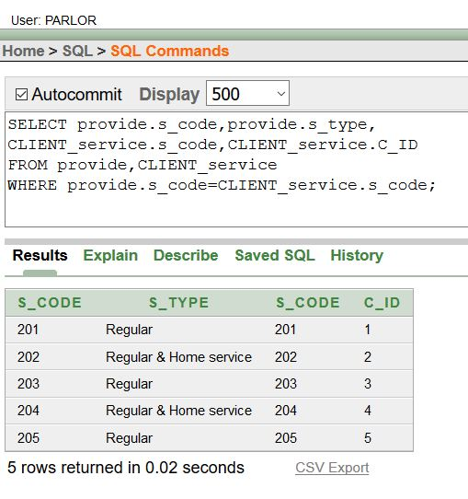

***Conclusion:***

We have shown all the queries to create the tables in *‘oracle 10g’.* Also, we had shown the queries to insert the values and took their screen-shots. Here, we made 6 different relations among the entities.

The normalization process has made our work easier.

***IN THE FUTURE:***

We can make the relational data base tables as a database management system as we have made this project. This job of ours can help a parlor in their data storing systems.