

**AD 571: Business Analytics Foundations**

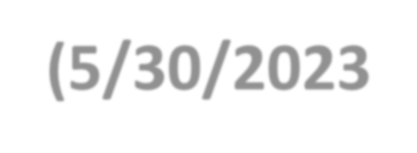

**LCR Session (Entire Class) Week 4 (5/30/2023)**

**AGENDA Summary Weeks 1 to 3: Q & A**

1

**Preparation for Week 4:**

2

**Introduction to Lecture 07 and Lecture 08**

A

**Individual Exercise: Tutorial: Preparation For Assignment 4 - Predictive Tutorial: Time Series Analysis in R**

B

**Tutorial: Regression Analysis in R**

**Group Discussion Forum W4 & Quiz 4, Exercise M4: Q & A**

C

**Assignment 4: Preview & Examples (Due: 06/05/2023 at 11:59 pm ET)**

3

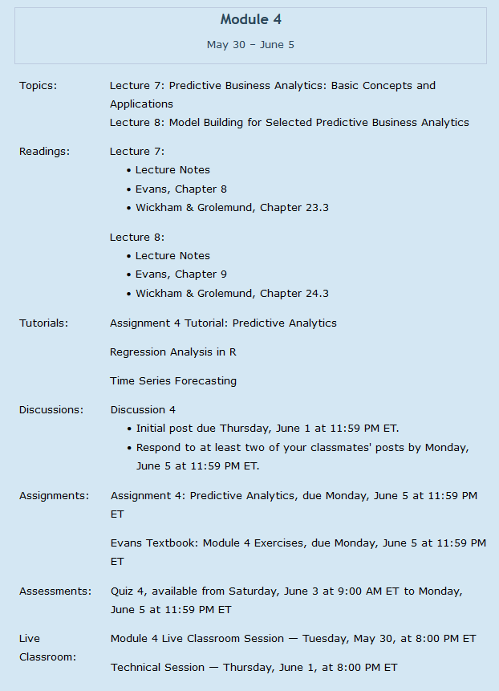

2



**Preparation for Week 4:**

2

A



**Preparation for Week 4**

**Statistical Forecasting (Time Series with Unknown Causals & Regression)**

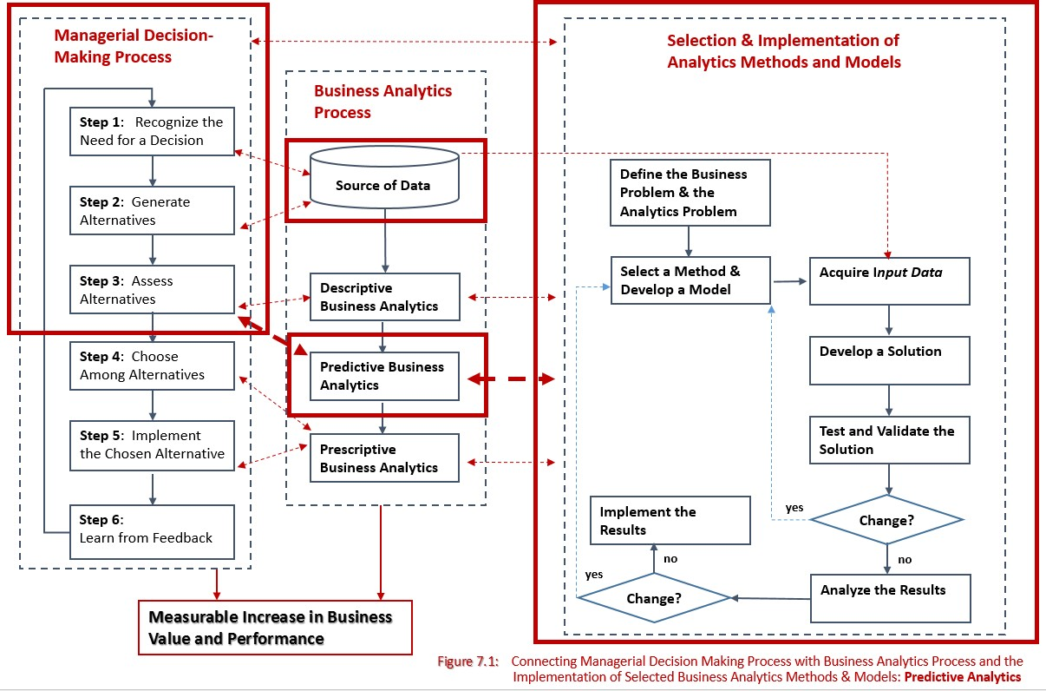

**Moving Averages**

**Single Exponential Smoothing Double Exponential Smoothing Triple Exponential Smoothing Multiple Regression**

**Evaluation of the Results**

**Recommendations**:

➔ Business Analytics Process (overall & next steps)

➔ Managerial Decision-Making Process (overall & next steps)

2

A



**Preparation for Week 4**

Data

Next 8 weeks forecast

Next 8 weeks forecast

Sales forecast generated for the next 24 weeks

The management information system collects last week data from all sales

The management information system collects price and promotion data from the marketing system

Supply chain system translate forecasts into production, shipments, purchases, and inventory

Down stream partners adjust their forecast based on their knowledge of the local market

Forecasting group adjusts its forecast based on its knowledge of the markets by regions

Data

24 weeks forecast

Weeks 9-24 forecast

MONDAY TUESDAY

MORNING

TUESDAY

AFTERNOON

WEDNESDAY THURSDAY

2

A

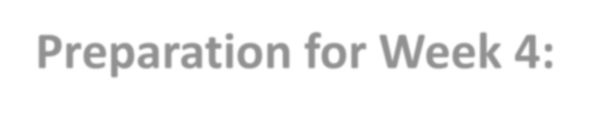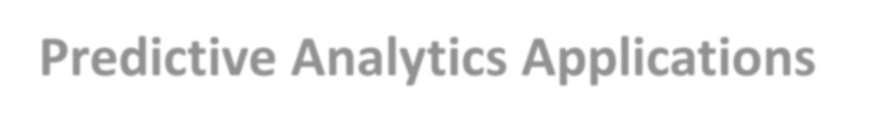

**Preparation for Week 4:**

**Predictive Analytics Applications**

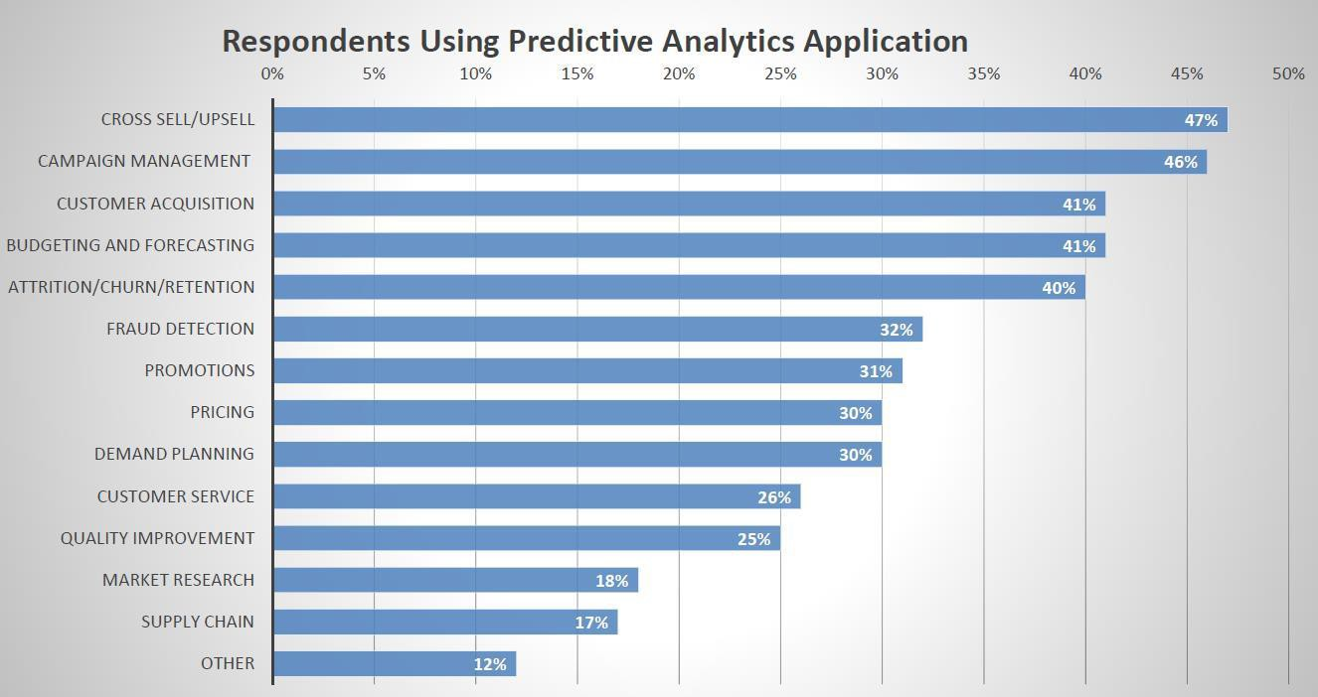

2



**Preparation for Week 4:**

**Predictive Analytics Applications: Predictive Lead Scoring**

A



Target the lead who is most likely to convert and will be the highest value. Algorithms can use explicit and implicit data from CRM.



$$ $$ $$

2

A

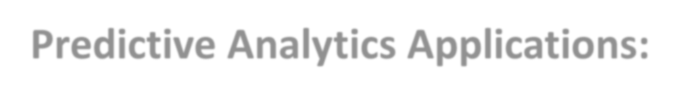

**Preparation for Week 4:**

**Predictive Analytics Applications: Cross-Sell / Up-Sell**

**Problem**: Customer acquisition costs are high



?



Database

Online Activity Data

Search Data

Behavioral Data

Promotional

Data

Point of Sale Data



$

We don’t know customer well until data is collected

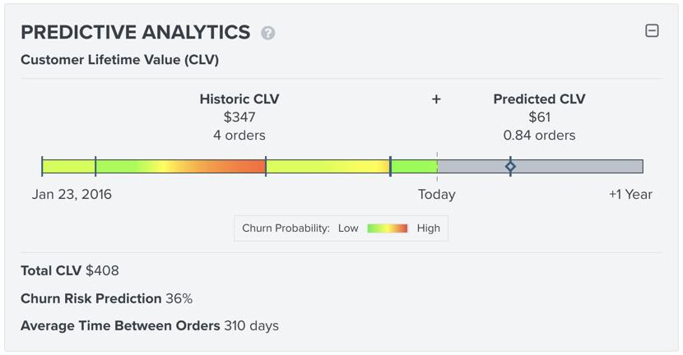

**Preparation for Week 4: Predictive Analytics Applications**

2

A

**Attrition/Churn/Retention**

Source: https://klaviyo.com

2

A



**Preparation for Week 4:**

**Predictive Analytics Applications – Customer Churn**

**Evolution of Churn and Retention**

We want all customers

**Sophistication Level**

Standard Signal Same for all. (Renewal time)

Retention - untargeted

Churn Risk

Targeting

Looking at

Value at risk

targeting

Is this a valuable customer we are spending to keep? (Churn Risk * Value)

Savable value targeting

Likelihood * Value Who will respond and who will leave faster?

Acquire All

variables that increase churn risk

Bad vs. Good Customer

**Past Future**

2

A



**Preparation for Week 4:**

**Predictive Analytics Applications**

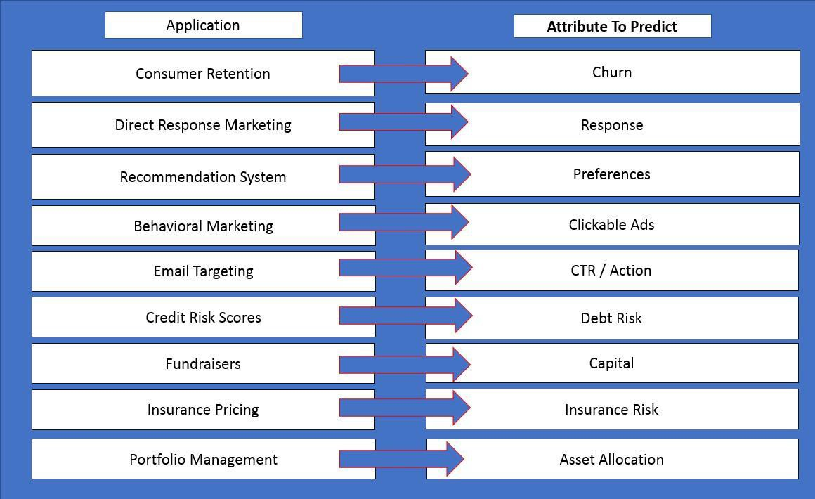

2

A



**Preparation for Week 4:**

**Predictive Analytics Applications – Risk Reduction**

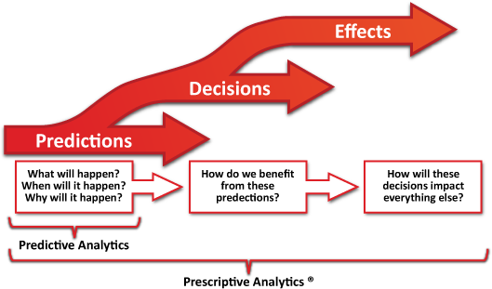

Source: https://commons.wikimedia.org/

**Preparation for Week 4: Predictive Analytics Applications – Financial Modeling**

2

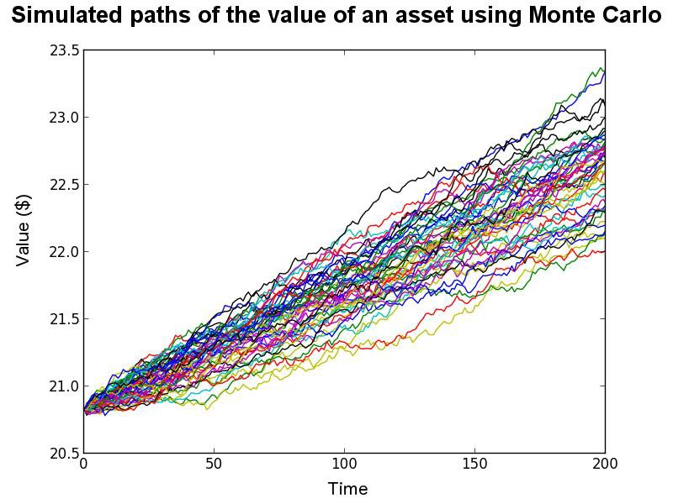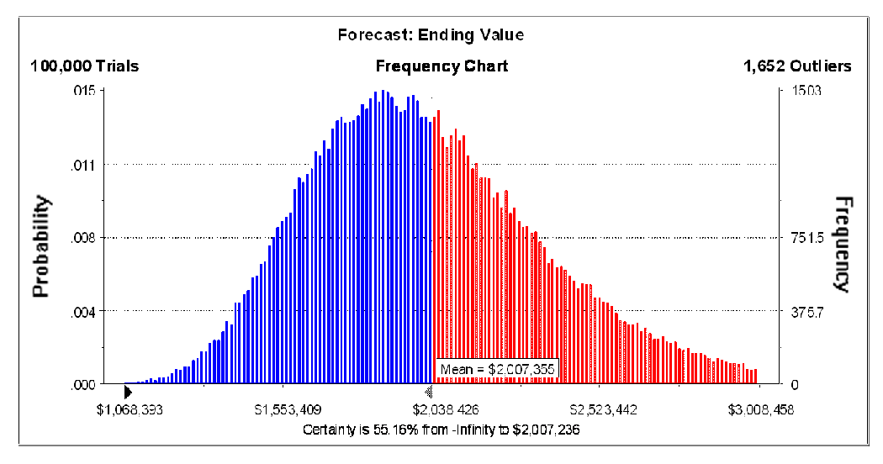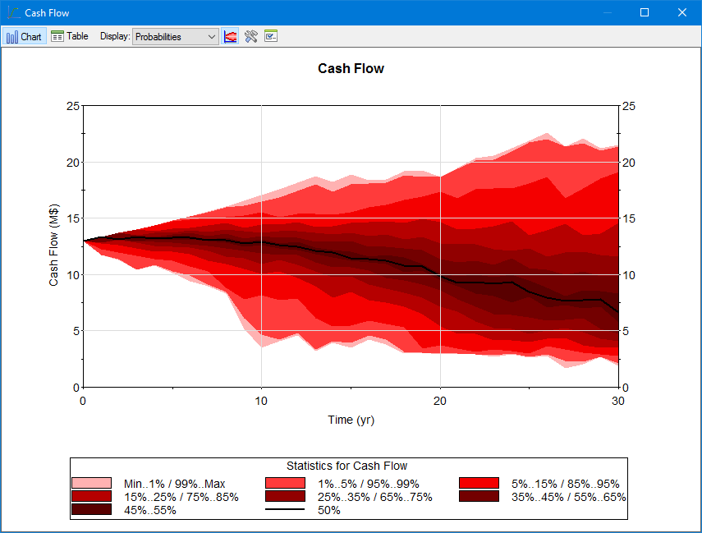

A

[http://goldsim.com](http://goldsim.com/)

Source: Financialplanningbodyofknowledge.com

2

A



**Preparation for Week 4:**

**Predictive Analytics Applications – Risk Reduction**

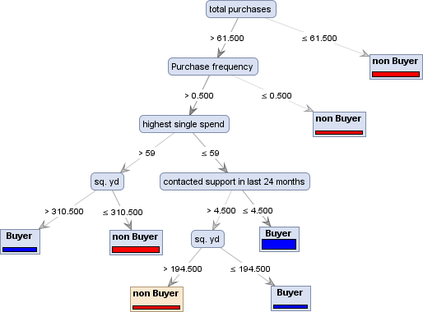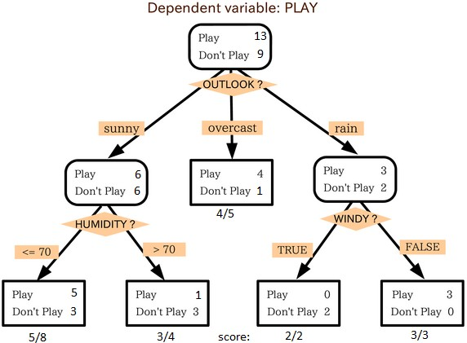

Source: [http://simafore.com](http://simafore.com/) Source: [http://stackexchange.com](http://stackexchange.com/)

2

A



**Preparation for Week 4:**

**Predictive Analytics Applications – Recommendations**

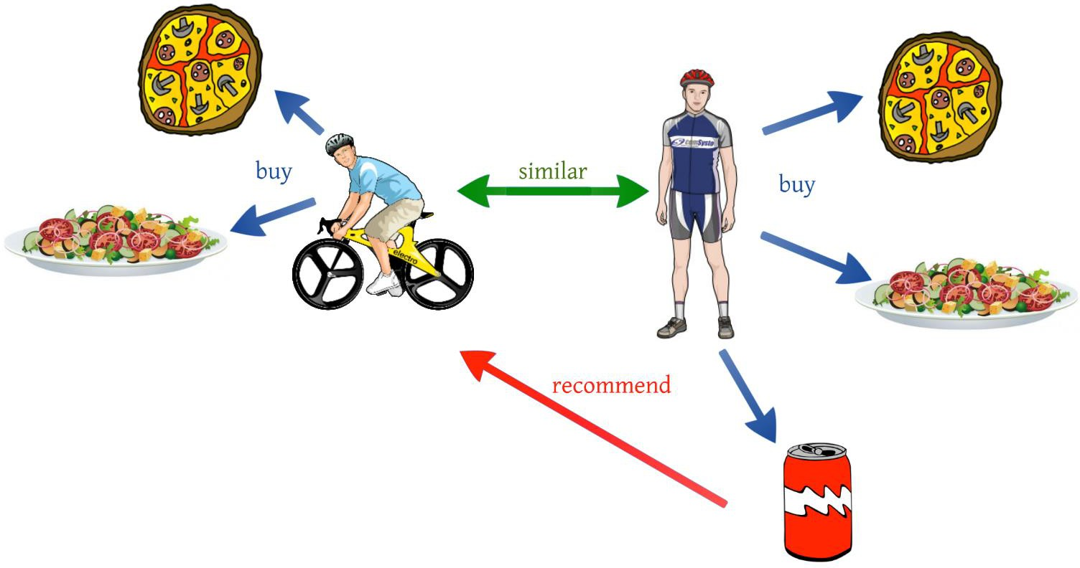

Source: [http://medium.com](http://medium.com/) Source: [http://Sflscientific.com](http://Sflscientific.com/)

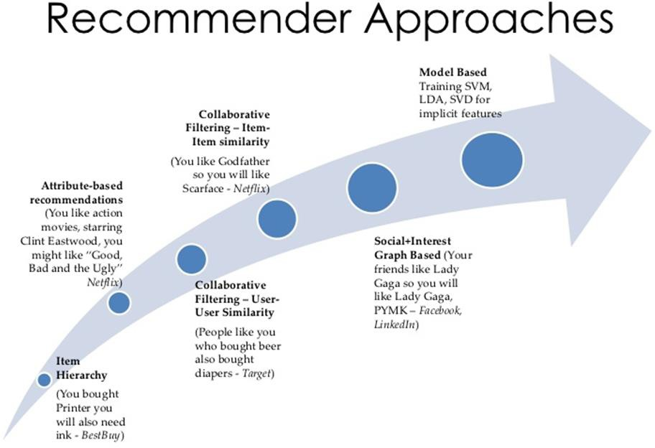

2

A

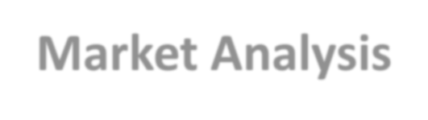

**Preparation for Week 4:**

**Predictive Analytics Applications – Market Analysis**

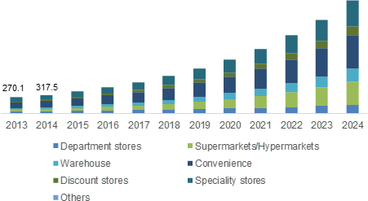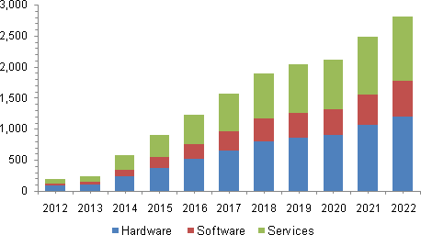

Telehealth Hardware

Source: [http://www.gminsights.com](http://www.gminsights.com/)

Source: [http://chironhealth.com](http://chironhealth.com/)

**Preparation for Week 4: Predictive Analytics Applications – Digital Advertising**

2

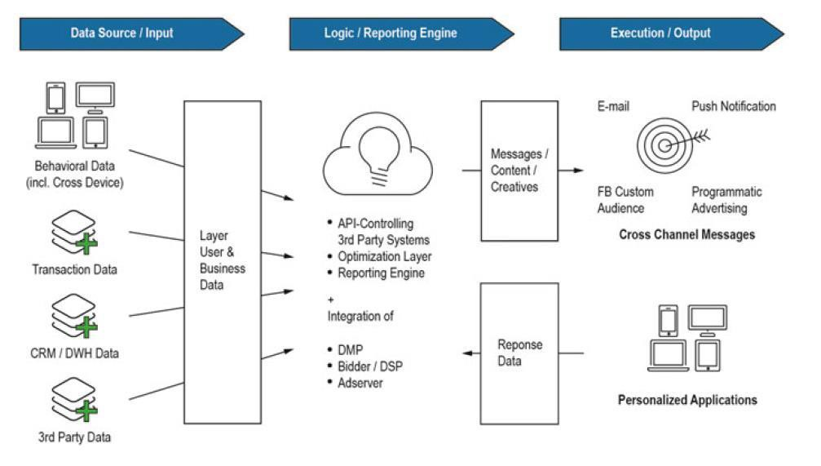

A

Source: Heinemann, F.(2016) Driving Performance with Programmatic CRM



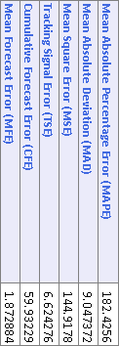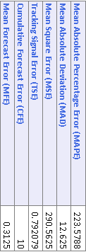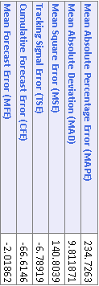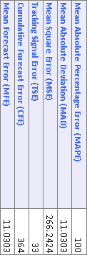

Dec-10 Apr-11 Aug-11 Dec-11 Apr-12 Aug-12 Dec-12 Apr-13 Aug-13 Dec-13 Apr-14 Aug-14 Dec-14 Apr-15 Aug-15



Dec-10 May-11 Oct-11 Mar-12 Aug-12 Jan-13 Jun-13 Nov-13 Apr-14 Sep-14 Feb-15 Jul-15



Dec-10 May-11 Oct-11 Mar-12 Aug-12 Jan-13 Jun-13 Nov-13 Apr-14 Sep-14 Feb-15 Jul-15



Dec-10 May-11 Oct-11 Mar-12 Aug-12 Jan-13 Jun-13 Nov-13 Apr-14 Sep-14 Feb-15 Jul-15

**Preparation for Week 4: Time Series**

2

A

**Single Exponential**

**Smoothing**

**Moving Averages**

**Smoothing**

**Dou****ble Exponential**

**Smoothing**

**Triple Exponential**

**Smoothing**

45

40

35

30

25

20

15

10

5

0

45

40

35

30

25

20

15

10

5

0

45

40

35

30

25

20

15

10

5

0

-5

45

40

35

30

25

20

15

10

5

0

**AD571**

**Business Analytics Foundations © 2023 Dr. Vladimir Zlatev**

**17**

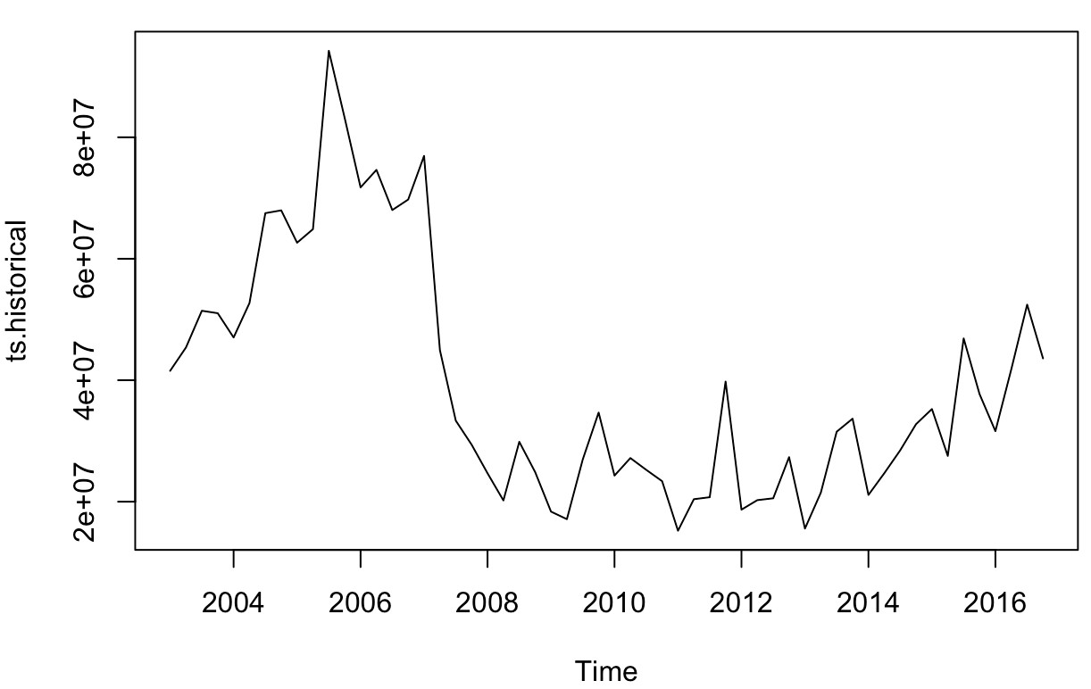

**Preparation for Week 4: Tutorial For Predictive Analytics: Time Series Visualization**

2

B

250

200

150

100

50

0

-50

-100

-150

1 2 3 4 5 6 7 8 9 10 11 12 13 14 15 16 17 18 19 20 21 22 23 24 25 26 27 28 29 30 31 32 33 34 35 36

Values Forecast Lower Confidence Bound Upper Confidence Bound

# 18



**AD571 Business Analytics Foundations © 2023 Dr. Vladimir Zlatev**

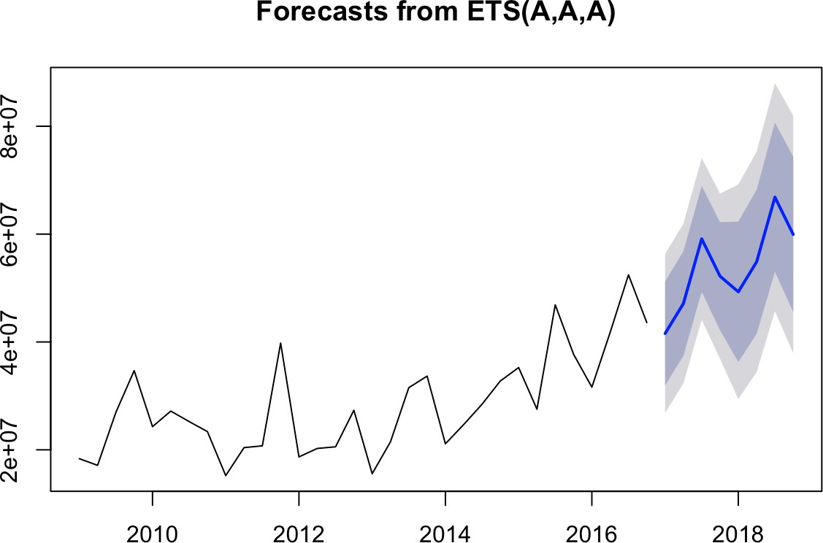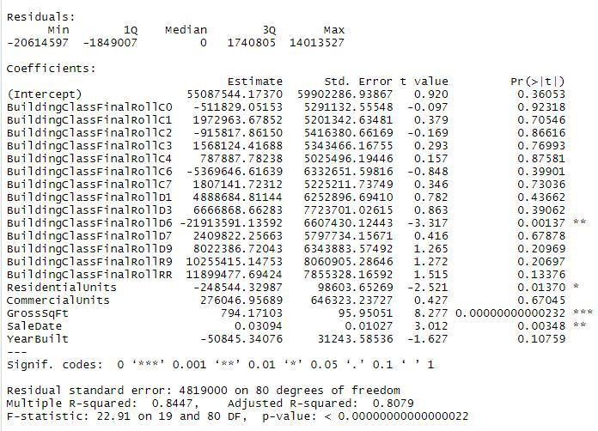

**How do I know which variables to add?**

Generally, additional variables should have:

* Theoretical validity
* Explanatory power
* Avoid high correlation with another explanatory variable
* >.6 correlation is the standard cut-off.

**Why we will use Adjusted R-squared**

* R2 will often increase if you add more predictors to the model
* A large R-squared may be an outcome of adding more

predictor to the model

* We make use of the adjusted R-squared to account for the number of predictor in the model

2

B



**Preparation for Week 4:**

**Predictive Analytics Applications – Multiple Regression**

**Preparation for Week 4: Group Discussion Forum W4**

2

C

**Please select just one of the bullet points listed below:**

* Discuss a use case for a regression model that can be applied to your professional field
* Discuss a use case for smoothing techniques that can be applied to your professional field
* Discuss the significance of the different types of regression models
* Discuss the significance of the different types of smoothing techniques
* Discuss topics of your choice from Lecture 7 and Lecture 8
* Discuss topics of your choice from Evans Chapters 8 and 9

**Preparation for Week 4: Quiz 4: Q & A**

2

C

Quiz 4 consists of 10 multiple choice and true-false questions.

Quiz 4 will cover information from the

* Online lecture notes (Lecture 7 and Lecture 8),
* Online discussion Week 4.

The quiz is open-book.

**Format**

* You will have 30 minutes to complete the quiz. There is a clock in the upper right corner of the screen keeping time for the exam.
* You can take the quiz only once.
* Each question will be delivered one at a time.
* You can revisit the questions and change your answers as many times as you want before submitting the exam.

**Module 4 Exercise: Q & A**

2

C



**Preparation for Week 4:**

**Questions are located at the end of Chapter 8**

**Section: Problems and Exercises**

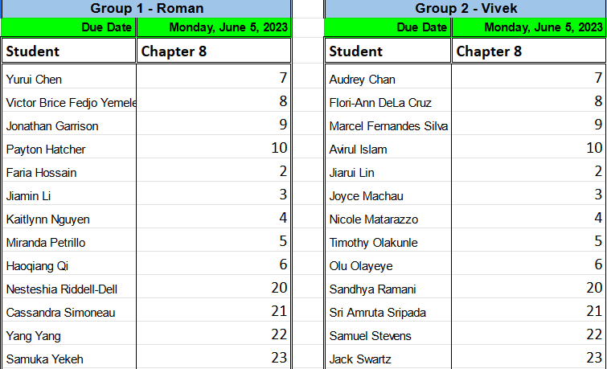

**Business Running Case–Targeted Outcomes: Application of Predictive Analytics**

3

**Term Project A2**. Data Manipulation In R

**Term Project A1**: Data Import and

Visualization

W-2

**Term Project A4**. Predictive Analytics Techniques In R



W-3

**Term Project A3**. Descriptive Analytics Techniques In R

W-4

W-6

**Term Project A5**. Prescriptive

Analytics Techniques in R and Excel

W-7

**Term Project A6**. **Term Project Final**

**Presentation** Model Deployment

V-Lab Instructions

All course tools and SQL Server can be

accessed from the V-Lab, which is included in tuition.

Assignment 4 Requires access to R Studio and SQL Server

# Metropolitan College, AD571 Business Analytics Foundations

**Assignment 4: Predictive Analytics**

**Assignment 4 Objective:** Prepare a managerial report, starting with an executive summary; expected length up to 4 pages APA format, excluding cover page, table of content, and appendixes.

1. Perform time series analysis on the total dollar amount of residential real estate sales on your neighborhood. Use sales beginning in the year 2009 to develop your model. Develop a forecast for the next 8 quarters of sales.
2. Use a multiple regression model to come up with another forecast for the next 8 quarters of sales. Include time and seasonality. Use sales beginning in the year 2009 to develop your model.
3. Use a multiple regression model to determine the sale of a given

residential property in your neighborhood. Include:

* 1. Sale Date
  2. Year built
  3. Building type (categorical)
  4. Gross Square Feet
  5. Number of Units

1. According to your model from (3), what are the most and least useful predictors of the amount of a sale?
2. Are there any redundant independent variables in your model from (3)?

How can you tell?

1. According to your model from (3), which properties were the biggest bargains and which were the most overpriced? How might you account for these disparities?
2. Write 3-4 pages summarizing your findings with a focus on the output, interpretation of the output, and what the insights mean for our decision- making process

[Hint: your model may be more accurate if you discard data from prior to the

housing market crash]

# Business Running Case: New York City Real Estate

**LOCATION OF THE INFORMATION AND SOFTWARE**

**Course Website**

Page on Blackboard:

“Assignments”>>Assignment 4

**Tutorials Section**

**Link**

[Tutorial – Assignment 4](https://mymedia.bu.edu/media/Assignment%2B4%2BTutorial/1_1ntwexao)

**23**



**Q & A**

**24**



**AD571 Business Analytics Foundations © 2023 Dr. Vladimir Zlatev**