MTK工作笔记
Thursday, March 9, 2023
12:00 PM

http://192.168.12.238/admin/users/cxq
12345678

ssh:chenxq@192.168.12.18
chenxq
cxq123456

MT8163_O1_MP5_V1
lunch 44

************************************************************************************************************************************************************************
kernel-4.9 is not clean, please run ‘make mrproper 报错的解决方法
总结一下：

遇上这种错误的解决方法：

1、运行make mrproper删除kernel目录下的.config

2、删除kernel顶级目录下include目录下的config这个目录，便能解决问题。

开发服务器上文件复制到公共服务器上
scp -r chenxq@192.168.12.18:/home/chenxq/mtk/mtk8163_o/MT8163_O1_MP5_V1/out/target/product/a8316/*.img Y:\cxq

scp -r chenxq@192.168.12.18:/home/chenxq/mtk/mtk8163_o/MT8163_O1_MP5_V1/out/target/product/a8316/*.bin Y:\cxq

scp -r chenxq@192.168.12.18:/home/chenxq/mtk/mtk8163_o/MT8163_O1_MP5_V1/out/target/product/a8316/*.txt Y:\cxq

mtk8163_o/MT8163_O1_MP5_V1/kernel-3.18/kernel/reboot.c

A8163 AM400
光机GPIO定义路径
mtk8163_o/MT8163_O1_MP5_V1/vendor/mediatek/proprietary/bootable/bootloader/lk/platform/mt8163/dlpc343x.c
#define GPIO_DLPC_PROJECT_ON (GPIO32| 0x80000000)

参考
mtk8163_o/MT8163_O1_MP5_V1/vendor/mediatek/proprietary/bootable/bootloader/lk/platform/mt8163/dlpc2607.c
#define GPIO_DLPC_PROJECT_ON (GPIO30 | 0x80000000)

dlpc_set_gpio_output(GPIO_343x_Galvanometer,0);
mdelay(20);
mdelay(2000);
dlpc_set_gpio_output(GPIO_DLPC_PROJECT_DCDC,0);
mdelay(2000);
dlpc_set_gpio_output(GPIO_DLPC_PROJECT_ON,0);
mdelay(2000);
dlpc_set_gpio_output(GPIO_DEPC_PROJECT_POWER_EN,0);
LPC_DBG("%s dlpc pjon power off!!!\n",__func__);

gpio_proj_on 开关电源

AM400
mtk8163_o/MT8163_O1_MP5_V1/vendor/mediatek/proprietary/bootable/bootloader/lk/dev/lcm/c106_tc358775/c106_tc358775.c

MTK改GPIO时序
1.查看dwt文件看下GPIO的定义，有可能 GPIO默认配置成高电平或低电平，此时一通电会做GPIO初始化。
2.修改GPIO初始化
mtk8163_o/MT8163_O1_MP5_V1/vendor/mediatek/proprietary/bootable/bootloader/lk/platform/mt8163/mt_gpio_init.c
mt_gpio_set_default_chip()
mtk8163_o/MT8163_O1_MP5_V1/vendor/mediatek/proprietary/bootable/bootloader/preloader/platform/mt8163/src/drivers/gpio_init.c
mt_gpio_set_default_chip()
这两个函数.
3.在platfom.c文件中的平台初始化配置想要的电平
mtk8163_o/MT8163_O1_MP5_V1/vendor/mediatek/proprietary/bootable/bootloader/lk/platform/mt8163/platform.c

4.AM关机设置GPIO电平
关机只要在kernel中设置IO即可，修改路径
mtk8163_o/MT8163_O1_MP5_V1/kernel-3.18/kernel/reboot.c
在执行关机前不管是power off 还是halt都会走函数
kernel_shutdown_prepare()
在这个函数中添加要设置的IO中

5.持续输出日志
有的机器进系统后不再输出日志。修改路径
mtk8163_o/MT8163_O1_MP5_V1/kernel-3.18/kernel/printk/printk.c
void mt_disable_uart(void)
{
if (mt_need_uart_console == 0)
printk_disable_uart = 0; //1,modify to 0
}
void mt_enable_uart(void)
{
if (mt_need_uart_console == 1) {
if (printk_disable_uart == 0)
return;
printk_disable_uart = 0;
}
}

6.检测是否按键开机还是只充电,路径
mtk8163_o/MT8163_O1_MP5_V1/vendor/mediatek/proprietary/bootable/bootloader/lk/platform/mt8127/mt_kernel_power_off_charging.c

kernel_power_off_charging_detection();

7.先初始化PMIC然后再初始化LCM

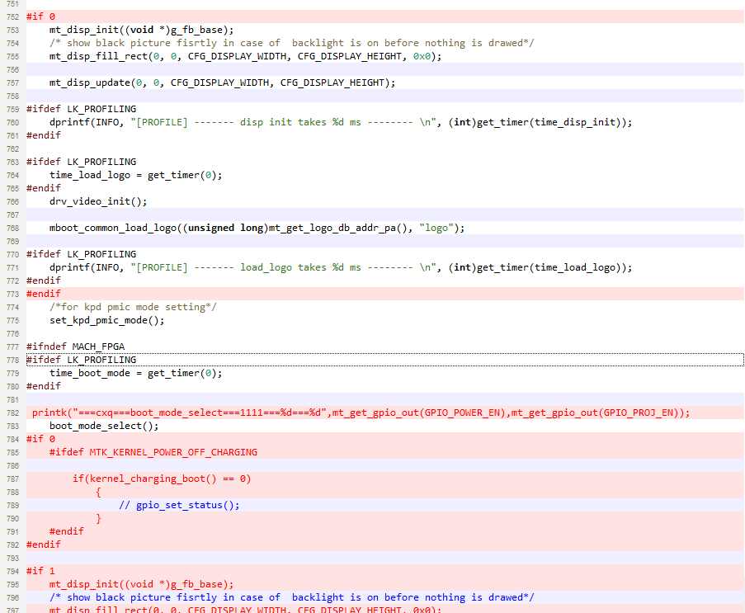

8.关机前的一些操作可在这个目录中添加
mtk8163_o/MT8163_O1_MP5_V1/kernel-3.18/kernel/reboot.c

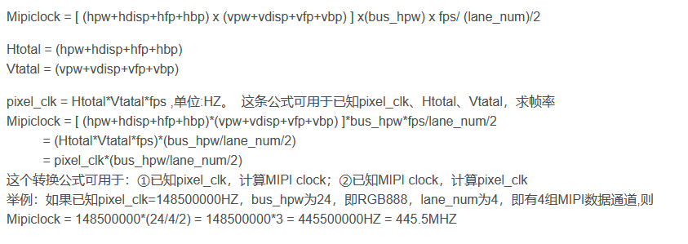

AM400默认打开OTG功能目录位置
mtk8163_o/MT8163_O1_MP5_V1/kernel-3.18/drivers/misc/mediatek/video/mt8163/dispsys/ddp_drv.c

//yan end
//leung add for otg
else if (0 == strcmp(attr->name, "usb_otg_enable"))
{
otg_enable = (buffer[0] == '1') ? true : false;
switch_usb_mode(otg_enable);
if(otg_enable) {
bq24296_reg_config_interface(0x01, 0x2C);//enable otg 5v supply
realphone_gpio_direction_output(USB_OTG_EN,1);
}else {
bq24296_reg_config_interface(0x01, 0x1C);//enable charging only
realphone_gpio_direction_output(USB_OTG_EN,0);
}

bq24296_reg_config_interface(0x01, 0x2C);//enable otg 5v supply
realphone_gpio_direction_output(USB_OTG_EN,1);
}

