11/12/20

Excel Homework: Kickstart my Chart

Austin Olea

DU Bootcamp

1. Given the provided data, what are three conclusions we can draw about Kickstarter campaigns?

* Outcomes based on Launch Date
  + As depicted by the graph below we can see that the best time to launch based of success rate is late April.
  + The worst time to launch a campaign based on the failure rate gets a little more complicated as we see three different areas that pose a potential answer. Based on failure rate alone the worst time to launch would be either early July or early October. We must also consider that throughout the month of November failure rates trend upwards while success rates trend sharply downward.

* Outcomes Based on Categories and Sub-Categories:
  + Categories
    - The most successful category of Kickstarter campaigns from this data set was music and lest successful was food.
      * \*An argument could be made that journalism is the least successful category as all of their campaigns were canceled. However, as we are focused on failure vs success for this analysis, I have noted it as an outlier for this data set.

* + - The success rate of sub-categories of Kickstarter seem to have a strong similarity to the success rate of the main category they are most corelated to (e.g., rock and music.)

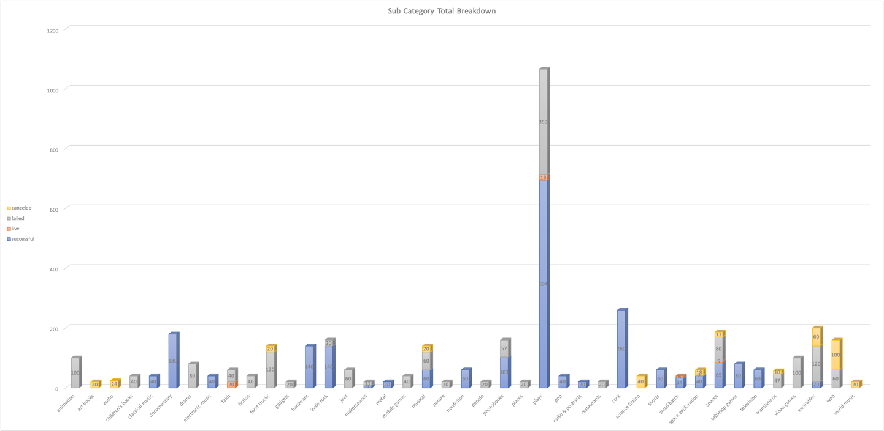

* Outcomes Based on Size of Goal (Bonus 1):
  + Although the data seems to be evenly split there are a few areas of interest to note.
    - First, the data seems to suggest that a goal size of <$1K has the highest likelihood of success. Additionally, on the high end of goal size 35k looks like another point with high potential for success. At this point of intersection failure rates are declining while success rates are rising to a secondary peak.
    - Second, it should be noted that goals set at 45k+ appear to have a high rate of failure and low rate of success coupled with a growing cancelation rate.

* Conclusion:
  + Based on the data set provided and the analysis above the Kickstarter campaigns most likely to succeed or fail are listed as below:
    - Highest likelihood of success:
      * Category: Music
      * Launch Time: Late April
      * Goal Size: < than $1,000 or $35,000 (depending on final product)
    - Highest Likelihood of failure
      * Category: Food (\*Journalism)
      * Launch Time: Late November
      * Goal Size $45k+

1. What are some limitations of this dataset?

* We have data for Kickstarter campaigns that are currently live or canceled and are therefore neither successful nor failed. Although this is unlikely to skew the data based on category it could potently have an effect on the perceived success/failure rate base on launch date.
* Another major limitation to consider of this data set is the age of the data collected. This would potentially effect categories of campaigns that are successful or not based on cultural changes and preference/interest at the current date.

1. What are some other possible tables and/or graphs that we could create?

* We could create a pivot table reflecting the significance of any given Kickstarter campaigning being a staff pick:
* As we can see being a staff pick has a large effect on attention and outcome.

1. Bonus 2

* Use your data to determine whether the mean or the median summarizes the data more meaningfully.
  + Due to the high level of variance in the data the median would be the more meaningful statistic for summarizing this data set.
* Use your data to determine if there is more variability with successful or unsuccessful campaigns. Does this make sense? Why or why not?
  + There is far more a variance with successful campaigns. This is consistent with the rage of each state. The range from Min to Max of successful campaigns is 1 to 26,457 while the range from Min to Max of failed campaigns is 0 to 1,293. The greater the number of backers you have for your Kickstarter the more likely you are to be successful. At the same time, you could get lucky and have one very generous backer, but this is a much less likely outcome.