1. Introduction
When a training dataset contains structural defects, such as under-sampled subpopulations or systematic gaps in feature coverage, the resulting machine learning model may perform deceptively well on held-out test data while encoding hidden biases. This report investigates whether the spatial geometry of adversarial examples can reveal such defects in a black-box setting, without access to the training data or the data-generating process. Prior work measured the density of adversarial points generated from a decision tree under a coverage-gap defect and found decreasing density with increasing bias. We extend this approach in three directions: cross-model validation using an RBF-kernel SVM alongside the decision tree, a decision-based black-box attack (HopSkipJump) that runs identically on both models, and testing of a second defect type (label noise) to establish whether the geometric signal is specific to structured data defects or generalises to any form of data corruption.

2. Experimental setup

2.1 Pipeline
All experiments use the iris dataset (150 samples, 4 continuous features, 3 balanced classes) and follow a five-stage pipeline. First, a defect is injected into the dataset. Second, 5-fold stratified cross-validation is performed; the model is trained on each training fold. Third, an adversarial attack generates perturbations on the correctly-classified test-fold points; only successful perturbations (those that change the predicted label) are retained. Fourth, OPTICS clustering groups the adversarial points. Fifth, per cluster, three quantities are computed: the number of points, the mean pairwise Euclidean distance (geometric spread), and the cluster density defined as n_pairs divided by the sum of pairwise distances. This density formulation is approximately proportional to 1 / mean_pairwise_distance — the inverse of geometric spread — and is independent of cluster size. Metrics are averaged across clusters, then across the five folds.

2.2 Defects
Two defect types are tested. Coverage gap: for a target class, points are sorted along one feature, and the bottom fraction (bias = 0.1, 0.3, 0.5, 0.7, 0.9) is deleted from the dataset, simulating a systematically under-sampled subpopulation. Label noise: a fraction (noise = 0.1, 0.2, 0.3, 0.4, 0.5) of training labels are randomly flipped to a different class; test labels remain clean, simulating annotation errors.

2.3 Models and attacks
Two classifiers are used. DecisionTreeClassifier (max_depth = 3) provides continuity with prior work. SVC with RBF kernel (probability = True) handles multi-class classification via one-vs-one (three pairwise SVMs for iris), representing a fundamentally different hypothesis class with a smooth rather than axis-aligned decision boundary. Two adversarial attacks are used. DecisionTreeAttack is a white-box attack that walks the tree structure to find the minimal perturbation flipping a leaf assignment; it is fast and exact but tree-specific, used as a baseline. HopSkipJump (HSJ) is a decision-based black-box attack requiring only predicted class labels: it starts from a correctly classified point, jumps to a point of another class, performs binary search to locate the decision boundary, and iteratively refines using estimated gradients. Parameters: L2 norm, max_iter = 10, max_eval = 200, init_eval = 50, untargeted. Because HSJ needs no model internals, the identical configuration runs on both tree and SVM, enabling cross-model comparison.

2.4 OPTICS clustering
OPTICS (Ordering Points To Identify the Clustering Structure) is used rather than DBSCAN. DBSCAN requires a global density threshold (epsilon) — all clusters must share the same density, so it will either merge clusters of different densities or discard sparse clusters as noise. Since these experiments measure changes in adversarial-point density and spread, the clustering method must be density-adaptive. OPTICS constructs a reachability plot and extracts clusters at varying density levels via the xi parameter without pre-filtering by a global threshold. Parameters: min_samples = 3, xi = 0.05, min_cluster_size = 3.

2.5 Multi-dataset extension
In addition to iris, label noise was tested on wine (well-separated continuous features) and Car Evaluation (categorical features), and on three synthetic 3D datasets designed to isolate the effect of class separability: well-separated (class_sep = 1.5), overlapping (class_sep = 0.6, two subclusters per class), and categorical (features discretised into 4-5 bins). These used a DecisionTreeClassifier with DecisionTreeAttack.

2.6 Experiment grids
Grid | Models | Attack | Defects | Runs
1 | DecisionTree | DecisionTreeAttack | Coverage gap + Label noise | 360
2 | DecisionTree + SVC | HopSkipJump | Coverage gap | 360
3 | DecisionTree + SVC | HopSkipJump | Label noise | 360
Table 1. Experiment grids. Each row runs 5-fold CV on iris, 3 seeds, all class×feature combinations.

3. Results

3.1 Label noise
Label noise was tested on three real datasets using DecisionTree + DecisionTreeAttack and on both models (tree and SVM) using the HopSkipJump black-box attack.
On iris and wine, two continuous datasets with well-separated classes, adversarial-point density decreased as label noise increased from 0.1 to 0.5. On Car Evaluation, a categorical dataset with highly overlapping feature distributions, density increased. To isolate this effect, the experiment was repeated on three synthetic 3D datasets varying only in class separability (Figure 1). The well-separated dataset showed decreasing density; the overlapping dataset showed a slight increase; the categorical dataset produced a strong density increase. The direction of density change therefore depends on the separability of the original class distributions, not on the defect severity alone. The mechanism: when classes are well-separated, label noise causes the tree to create additional leaves to memorise corrupted labels, fragmenting the decision boundary and scattering adversarial points. When classes already overlap, the tree is near its representational ceiling; additional noise does not create many new boundary regions, and adversarial points remain clustered in the same confusion zones.
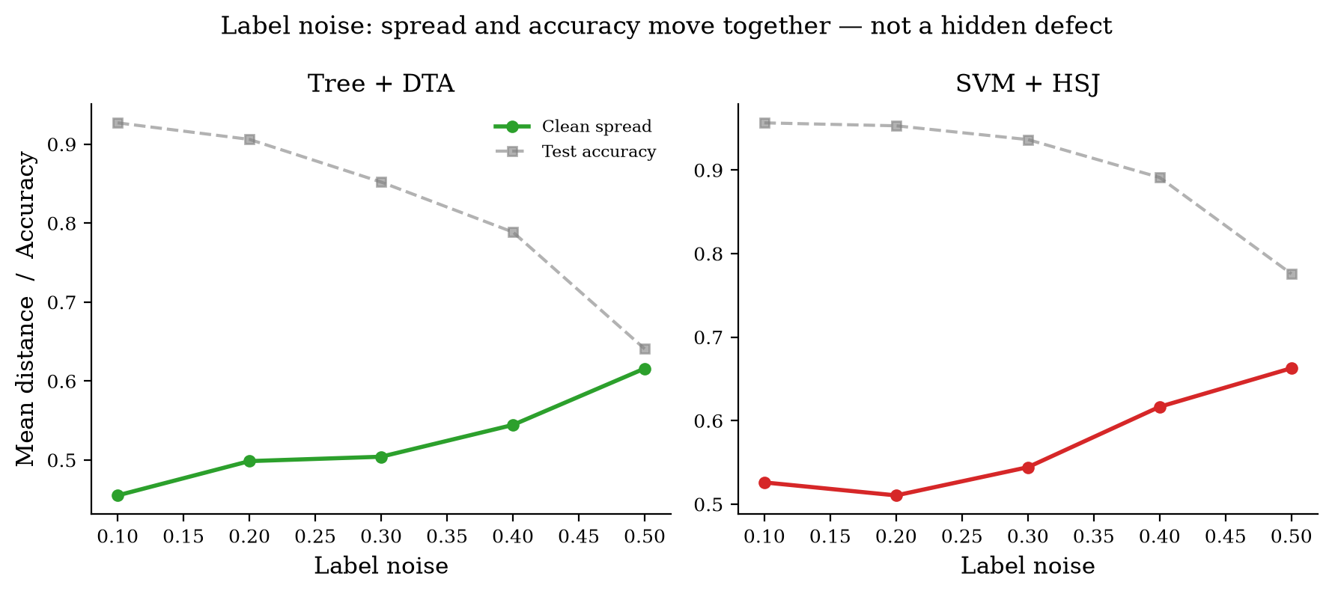
Figure 1. Label noise: geometric spread and test accuracy for Tree + DTA (left) and SVM + HSJ (right). Solid lines show mean pairwise distance; dashed lines show test accuracy. Both metrics move together, providing no independent diagnostic signal.
Under the black-box HopSkipJump attack (Figure 1), the decision tree showed density decreasing (Cohen's d = −0.80 between noise levels 0.1 and 0.5), but test accuracy collapsed from 0.93 to 0.64. The SVM showed no clear density trend (d = −0.09), while accuracy also declined from 0.96 to 0.78. In all cases, the geometric signal either tracks accuracy or is null. Label noise provides no diagnostic information beyond what test accuracy already conveys.

3.2 Coverage gap
Coverage gap produced a different result. Figure 2 shows the geometric spread (mean pairwise distance) of adversarial points plotted against bias level across three model-attack combinations.
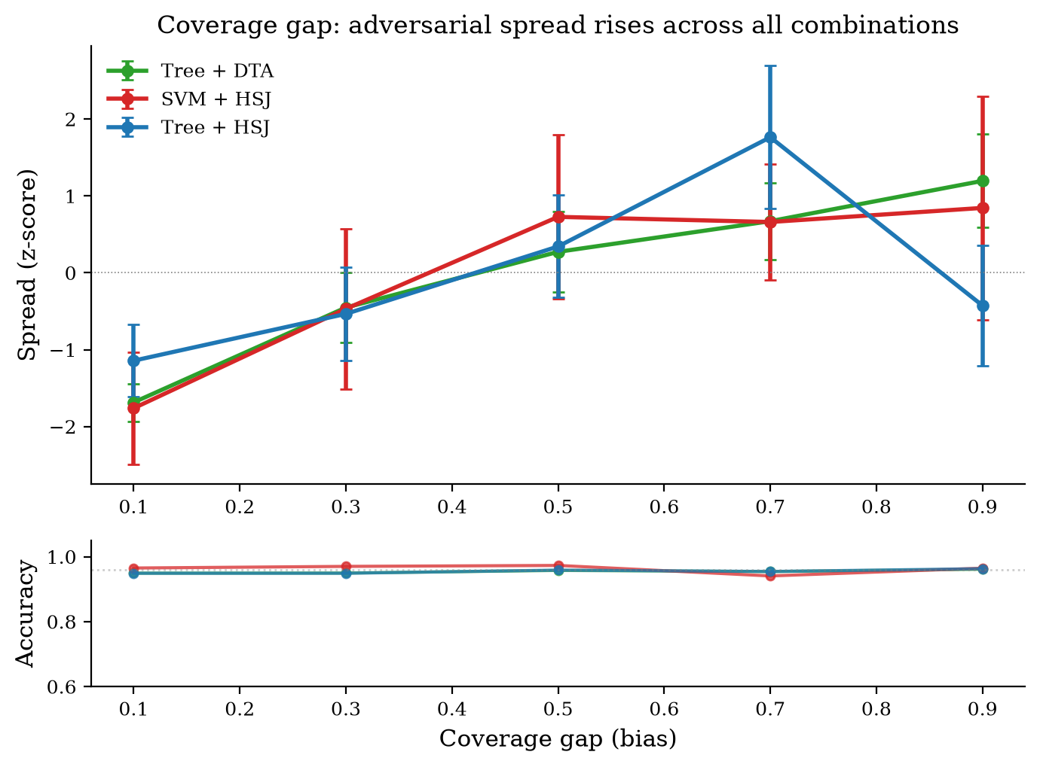
Figure 2. Coverage gap: geometric spread increases with bias. Top panel shows mean pairwise distance with 95% CI error bars. Bottom panel shows test accuracy, which remains flat at approximately 0.96 across all bias levels.
Geometric spread increased monotonically with bias on all three combinations: Tree + DecisionTreeAttack (Cohen's d = +2.06), SVM + HopSkipJump (d = +0.75), and Tree + HopSkipJump (d = +0.38). The Tree + HSJ combination produced the weakest signal because HopSkipJump estimates the direction to the boundary by sampling perturbations and observing which side of the boundary they fall on. A decision tree's boundary is a set of flat, axis-aligned facets; while the normal direction is well-defined on each facet, most perturbations remain inside the same leaf region without crossing the boundary, so the estimated direction is noisy and the attack frequently fails to converge (many such runs had to be terminated). Critically, test accuracy remained flat across all bias levels at approximately 0.96: the model classified test points correctly regardless of the coverage gap, yet the adversarial geometry exposed the defect.

3.3 Verification of the signal
A potential confound is that the coverage gap is injected before the cross-validation split, so the test-set composition changes with bias. An increase in geometric spread could simply reflect the changing test data rather than a genuine attack effect. To test this, two quantities were measured (Figure 3). First, the compression ratio: adversarial-point spread divided by the spread of the original correctly-classified test points from which they were generated. A ratio approaching 1.0 indicates the adversarial cloud merely mirrors the original test-point geometry. Second, the mean L2 perturbation magnitude: how far adversarial points moved from their starting positions.
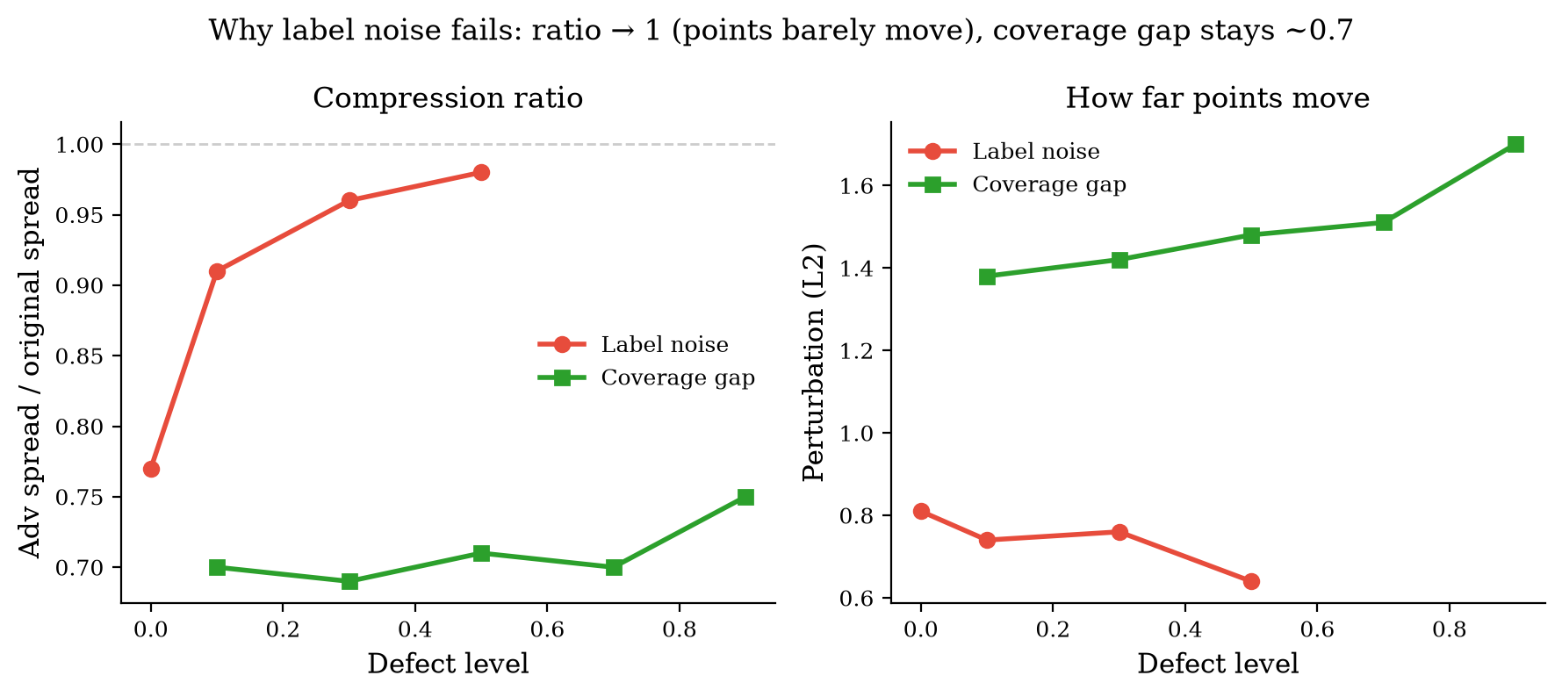
Figure 3. Left: compression ratio (adv_spread / orig_spread). Right: perturbation magnitude (L2). Red = label noise (Tree + DTA); green = coverage gap (SVM + HSJ). Label noise converges to 1.0 and perturbation decreases; coverage gap stays at ~0.70 and perturbation increases.
Under label noise, the compression ratio rose from 0.77 at noise level 0 to 0.98 at noise level 0.5: the adversarial cloud converged to the original test-point geometry, and the perturbation magnitude shrank from 0.81 to 0.64. The geometric signal under label noise was measuring the fixed test-data distribution, not the attack. Under coverage gap, the compression ratio remained at approximately 0.70 across all bias levels: the adversarial cloud was meaningfully compressed — about 30% tighter than the original test points. The perturbation magnitude increased from 1.38 to 1.70, meaning adversarial points had to travel farther to cross the boundary as the coverage gap widened. The coverage-gap geometric signal is a genuine consequence of the attack, not an artifact of the test-set distribution.

4. Discussion
The central finding is that coverage-gap bias in a training dataset is detectable from adversarial-example geometry in a setting where test accuracy reveals nothing. The geometric spread of adversarial points increased with bias on both a decision tree (d = +2.06 with DTA, +0.38 with HSJ) and an RBF-kernel SVM (d = +0.75 with HSJ), while test accuracy remained unchanged. The compression-ratio analysis confirms the signal is not an artifact of the test-set distribution changing with bias: the adversarial cloud is genuinely compressed to approximately 70% of the original test-point spread, and the perturbation magnitude grows with the gap.
The likely mechanism is that when a contiguous region of a class is deleted from training, the model places its decision boundary in an extrapolated, data-free zone. Adversarial perturbations that successfully cross this boundary scatter rather than concentrating at natural weak spots, since there is no training-data density in the gap region to constrain them. The surviving training data is still sufficient for accurate classification (test accuracy remains high), but the boundary placement is geometrically exposed by the attack.
Label noise does not provide a comparable diagnostic. First, when noise is severe enough to shift the adversarial geometry, test accuracy has already collapsed: the defect is visible without adversarial analysis. Second, the direction of the geometric change depends on class separability: well-separated data shows decreasing density (more boundaries cause points to scatter), while overlapping or categorical data shows increasing density (few new boundary regions are created). This data-dependence makes label-noise geometry unreliable as a general diagnostic. Third, the compression-ratio analysis shows the label-noise signal is not measuring attack behaviour but rather the fixed original test-point distribution.
Several limitations bound these findings. The experiments use iris, a low-dimensional dataset (4 features, 150 samples). OPTICS clustering is known to degrade in higher dimensions as reachability distances concentrate; whether the geometric signal survives in more realistic feature spaces requires validation. The Tree + HSJ signal was weak (d = +0.38) because the tree's flat, axis-aligned decision boundary yields a noisy sampling-based direction estimate, causing HSJ to frequently fail to converge. The coverage gap was injected before the CV split, so test-set composition varies with bias: although the compression-ratio analysis partially addresses this, a controlled experiment with bias injected into training folds only would be more rigorous. The multi-dataset label-noise comparison used an earlier formulation of the density metric and did not record geometric spread separately. Future work should validate the coverage-gap signal in higher-dimensional settings, extend to additional defect types (feature noise, class imbalance, outliers), and test with neural-network classifiers using gradient-based attacks.
These findings suggest a discrimination capability: adversarial geometry can distinguish between structured data defects that warp the training distribution without corrupting the model's accuracy (coverage gaps) and defects that corrupt the decision boundary directly (label noise). If this holds in higher dimensions and across more model families, adversarial geometry could serve as a component of data-quality auditing pipelines, flagging datasets that appear healthy to accuracy-based evaluation but carry hidden structural biases.

5. Conclusion
Adversarial-example geometry can detect coverage-gap bias in training data that test accuracy alone cannot see. The geometric spread of adversarial points increases with the severity of the coverage gap across two model families without any accompanying decline in test accuracy. Label noise produces no independent geometric signal: its effects are either visible through accuracy decline or depend on the separability of the original data distribution. The approach shows promise as a black-box diagnostic for structured data defects, pending validation in higher dimensions and across additional defect types.

