Project 3 report for phase 1

Team members:

Aolin Yang

Noah Miner

Julie Herrick

Evelyn Zhiyuan Tang

George Zhan Lan

In the google cloud editor, click “Run” and then click “Test as add on”. A google doc will pop up. On the top toolbar, click “315-fall2020-913-5-prj3” or the current google doc filename, and then click “Run”.

Then a sidebar will pop up on the right of the document. To view instructions or descriptions of the functions and the overview of the program, click the instruction button. Click “Template” to choose a template for your resume. Template 1,2,3 will have all the sections. Click “Section” to choose the section you want to include. If you decide only to choose a subset of sections, only a specific template will be used. You need to choose a template first before entering information.

Click on the “Header” button to enter personal header information and insert them. Click on the Education button to enter education information for your resume. Click on the “Skill” button to enter your skill. Click on the “Survey” button to evaluate yourself. Click the survey button to submit feedback.

Screenshots are available in the next few pages.

The Main Menu / Sidebar:

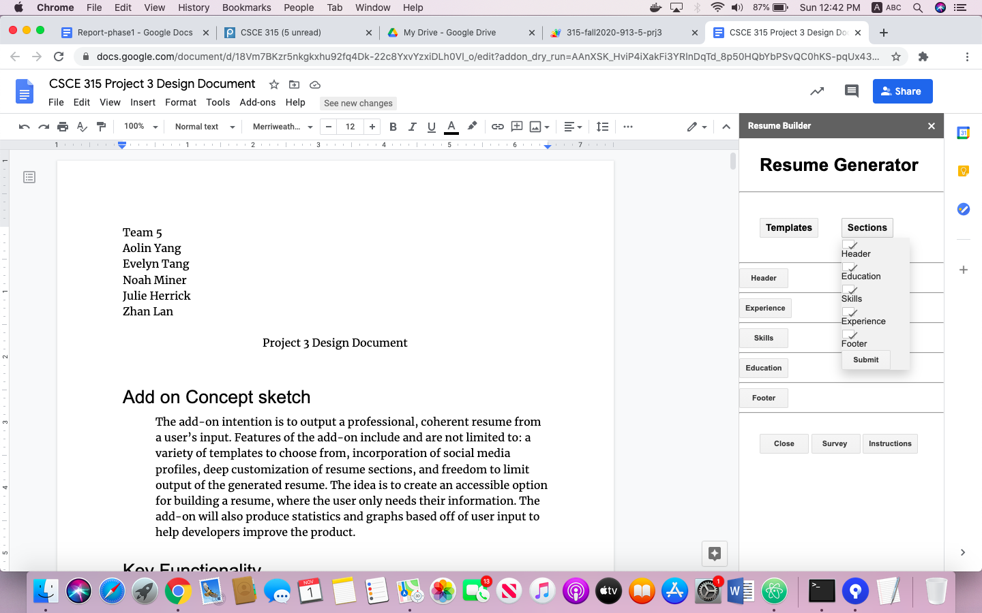

The Survey pop up windows:

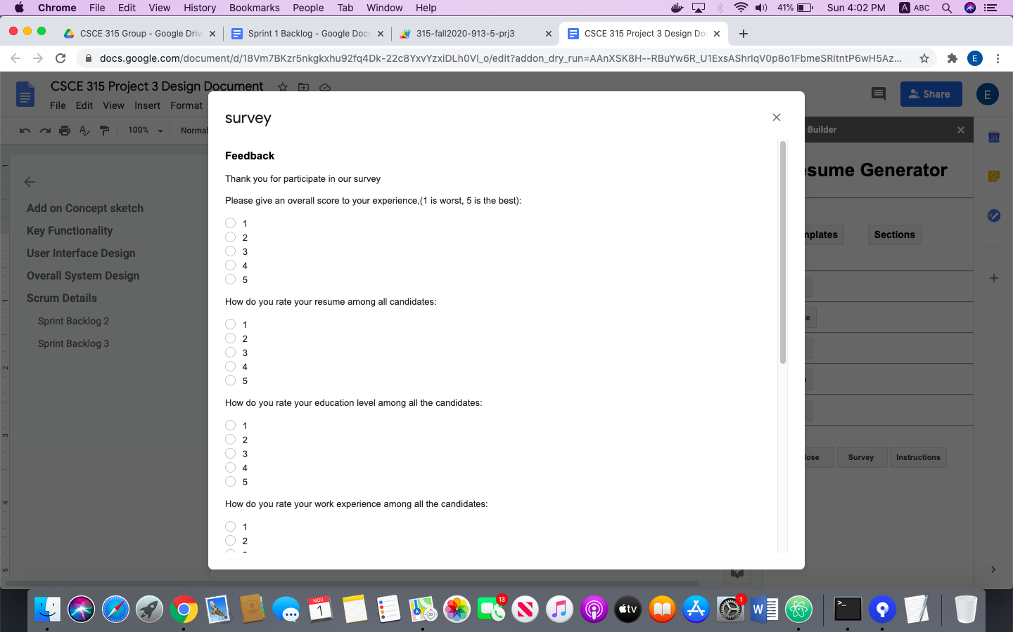

The Instruction pop up window:

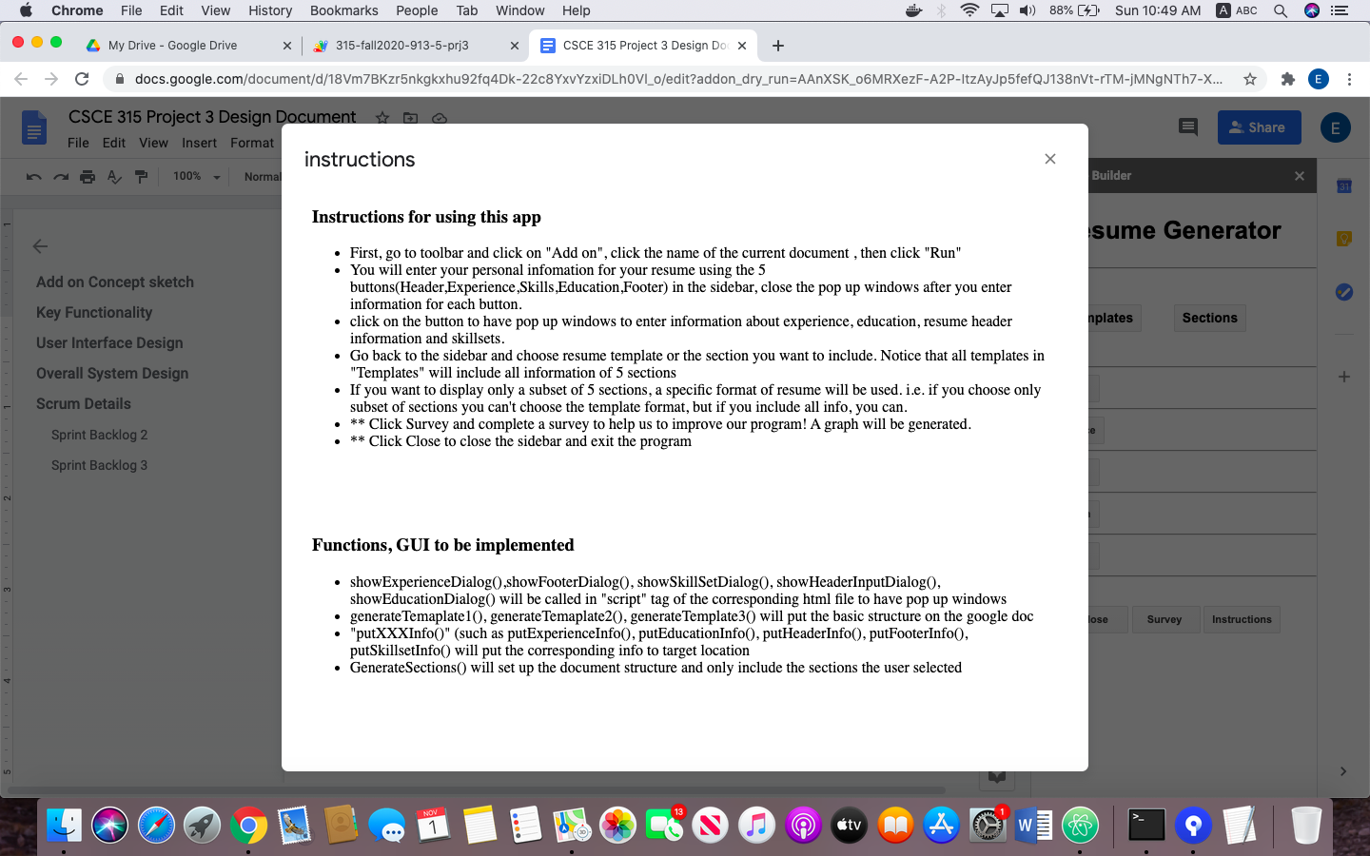

The experience pop up window:

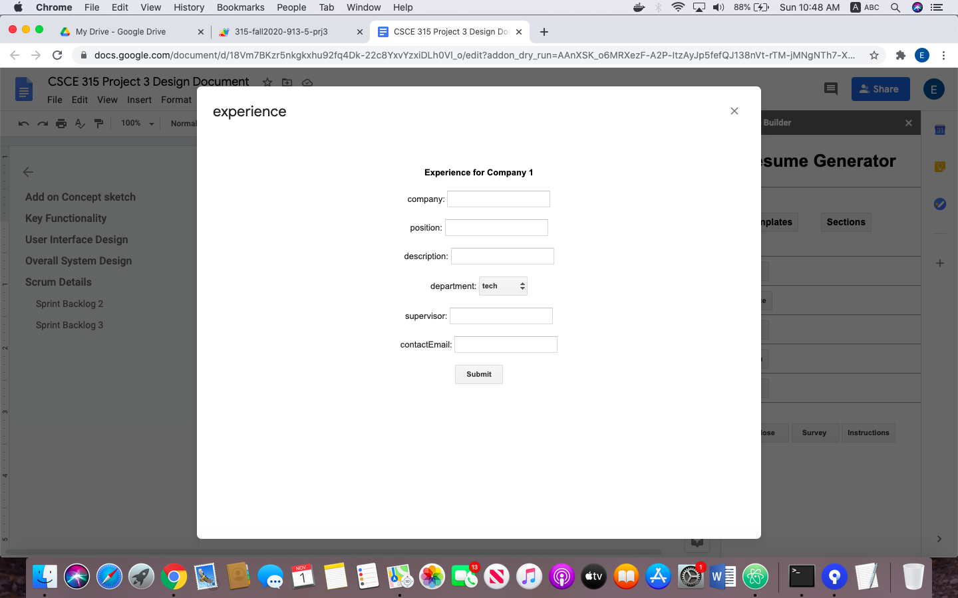

The Header pop up window:

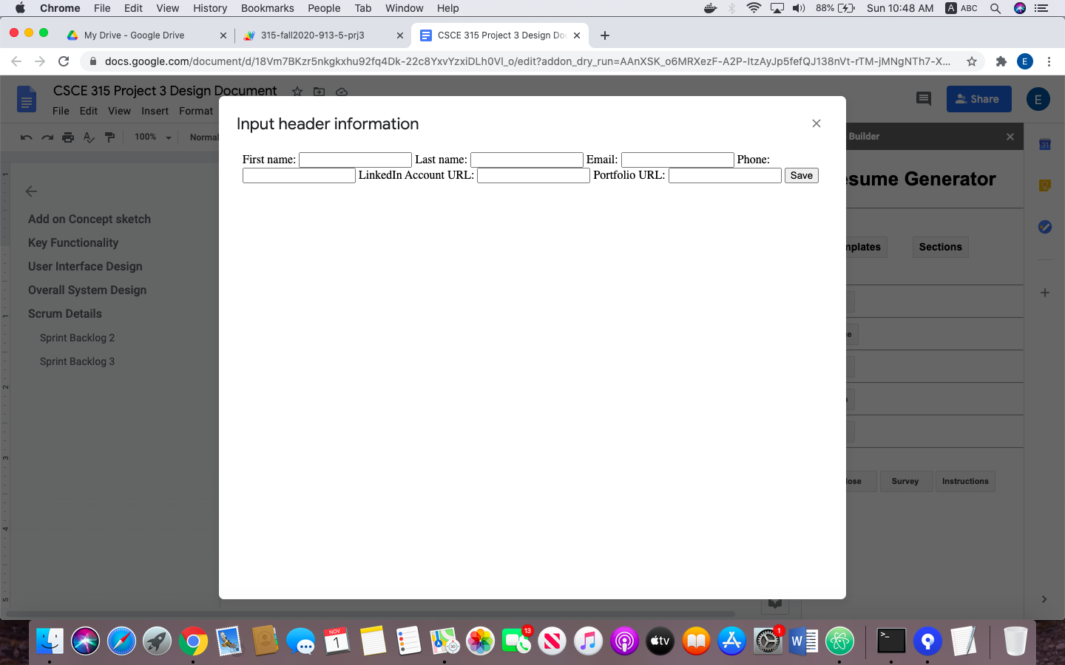

The skillset pop up window:

