All meeting logs

### Monday 10/26 12pm

Members present: Allen Yang, Julie Herrick, Evelyn Tang, Noah Miner

* <https://stackoverflow.com/questions/33174024/how-to-declare-a-custom-class-in-google-scripts>
* The app script can’t do any image manipulation, offers a plotting library to build charts
* May have to transfer data between docs and sheets
* Make buttons have “score 1-5” and then can build category charts around how the user answers
  + If we want to keep track of info we will need to keep track of it in a google sheet
* Change graph to be rating skills so that we don’t need to keep track of multiple users stats
  + Like this <https://i.stack.imgur.com/BAxRV.png>
* Will make separate files for everything we need to turn in then combine it for each submission
  + <https://www.agilealliance.org/glossary/backlog>
  + <https://www.agilealliance.org/glossary/sprint-backlog/>
* Scrum process <https://www.crystalloids.com/hs-fs/hubfs/Scrum%20Process.jpg?width=1800&name=Scrum%20Process.jpg>
* Product backlog will be the culmination of all of our sprint backlogs
  + First week will basically be doing the HTML file for the user interface
  + Would be good to have everyone do research into using google scripts so that we have the background knowledge once we get into more of the coding heavy phases
* <https://developers.google.com/apps-script/guides/dialogs#page.html>
* Finish HTML file before the weekend then we can style it
* Have information we input into whatever UI class we have
* <https://chrome.google.com/webstore/detail/google-apps-script-github/lfjcgcmkmjjlieihflfhjopckgpelofo/related> using GitHub with google script editor
* CSS style guide: <https://developers.google.com/gsuite/add-ons/guides/css>
* We should copy the code to our own project and not change directly in the shared drive file. Leave that to be the final working code.

### Tuesday 10/27 8am

Members present: Allen Yang, Julie Herrick, Evelyn Tang, George Lan, Noah Miner

* Clarification on goal 3
  + What will the functionality of the buttons be?
  + Doc wouldn’t update until the submit button was pressed, so we don’t have to worry about updating it until submit is pressed
* We like how easy pushing/pulling is in the doc
* For reading data from the document. If someone put in a written resume could we scan it and then adapt it to our formats
  + Could be difficult with different formats, if the user marks corresponding sections that could work
  + Have an unnamed abstract section to make it easier to adapt it
* Will need to make an html file for each popup
* Task 4:
  + Does this mean generate a section or entire resume?
  + Yes
* What are user stories in task 11
  + From the project description, basically different scenarios for how people will use the app
  + User design study is questions analyzing how people will interact with the project
* Task 9 is kind of what needs to be done with all other tasks in this phase to show what they would do
  + Could have a popup with instructions on how to use the program
  + Would also have the popups based on what should be happening after user interacts with certain elements of the UI

### Day 10/28 2pm

Members present: Allen Yang, Julie Herrick, Evelyn Tang, George Lan, Noah Miner

* Allen said he finished his tasks
* Everyone is added on the github repo now
  + George making a github with non TAMU email should fix the issue
* Noah: working on sidebar HTML and getting drop down forms working
* George: Going to start looking today
* Julie: Looking more into how to make user stories and user story design. Want to see our layout before I start too much
* Evelyn: Did HTML file for experience and unsure if that should be javascript since rn using HTML form tags
  + Not sure if it should be switched from HTML tags
* How to run the add on
  + From script choose run
  + Choose a document to test on
  + Open document then go to add ons
  + Select our add on and hover over to click run
  + Sidebar should pop up
* For this phase we just need to have the UI show up and pop ups to say what each one does
* <https://developers.google.com/gsuite/add-ons/editors/docs/quickstart/translate#translate.gs>
* Don’t merge from google drive because that seems to replace the code rather than merging
* Don’t push from google scripts, just pull. Push from a local branch
* In order to prevent overwriting code, only push to main branch when we’re on the call
  + Otherwise push into our own branch

### Day 10/29 8am

Members present: Allen Yang, Julie Herrick, Evelyn Tang, George Lan, Noah Miner

* Merging do it on the local branch so it doesn’t mess up the main branch
  + Only use shared script to test so we don’t want to mess it up
* Evelyn:
  + don’t think inserting text box is possible
  + Section for entire resume isn’t possible, can only insert into regular document
  + Use a table and insert info into different sections
  + Finished front end of task 7 (experience), looking more into the backend to prepare for the next phase
  + Still working on 9&13
* Julie:
  + Waiting until I see what the UI is looking more like in order to make sure the user stories are consistent with what we’re doing
* Allen:
  + Done with tasks, willing to help if anyone needs it
* Noah:
  + Sidebar has all elements, working on style
  + Make sure functions are calling the popups Allen made
* George:
  + Working on education
  + Making a popup text box

### Day 11/3 2pm

Members present: Allen Yang, Julie Herrick, Evelyn Tang, Noah Miner

* Reviewing feedback from our user study
  + Undo button
  + Delete button
  + Let users add a miscellaneous section to include whatever extra info they want that doesn’t fall into our sections
  + Edit button?
* Plan to have one resume generated by the end of this week to show the main functionality, next week will have the part where we switch templates
* Instead of adding info in real time add a “generate resume” button at the bottom of the sidebar
  + Will make it easier for us
  + Also easier to change templates
* <https://zety.com/blog/game-design-resume>
* Recap:
  + By Saturday have one resume template generated to satisfy that requirement
  + Add generate resume button in the side bar
  + Add an “extra” section for people to include whatever extra information
  + Flush out other sections – Add dates to sections and degree level to education
  + Clear all button
  + Satisfy graphics requirement: maybe generate a graph based on skill proficiency
    - Portfolio section could upload images

### Day 11/4 9am

Members present: Allen Yang, Julie Herrick, George Lan, Noah Miner

* Generate resume button so that it’s easy to update info
* Add graphics requirement, ideas:
  + Graph of skills
  + Portfolio
  + Picture from linked in
* Want to take out the footer
* Get one resume template completed, then it will be easier to set up the others
* Add something to keep track of what template is selected
* Different templates <https://careercenter.tamu.edu/Resources/Resume-Cover-Letters/Resume-Templates>
  + Set up template 1 first then we will add the other templates once the framework is set up
* Don’t need to implement all UI changes this week, but

### Day 11/9 3pm

Members present: Julie Herrick, Evelyn Tang, Noah Miner

* Evelyn: Edit section function is done
* Add what template we’re using as a global variable
* Add date section to input
  + Start date & end date
  + Put option for “present” as the end date
* Julie: Working on delete section and delete resume button
* Work on something for the user to add additional sections
* Store information in the global variables, define them too

### Day 11/10 8am

Members present: Allen Yang, Julie Herrick, Evelyn Tang, George Lan, Noah Miner

* Finish all tasks by Sunday with time for testing
* Add dates to each section
* Working on delete section
* Add one more section

### Day 11/17 8am

Members present: Allen Yang, Julie Herrick, Evelyn Tang, George Lan, Noah Miner

* Dividing tasks for final phase
* Not enough to just upload an image, need to do something with data so think generating a plot would be best
  + Maybe do it based on skill familiarity?
  + Something like this <http://puu.sh/GOpzc/328983ca6a.jpg>
* Project due Monday night

### Day 11/18 12pm

* More clarification on the tasks for phase 4.

### Day 11/19 8am

Members present: Allen Yang, Julie Herrick, Evelyn Tang, George Lan, Noah Miner

* Implement error handling
  + Check for valid email
  + Check for valid phone number
  + Check valid gps

Initial Sprint

|  |  |  |
| --- | --- | --- |
| User Story # | User Story details | Priority / importance |
| 1 | Connect buttons(dropdown+regular) with the functions built. Continue to work on the part that hasn't been done last week. Same person as last week. | 4 |
| 2 | Build code for creating templates for 3-5 resume sections. Get results that buttons deliver and put the content into specific formats and color. | 1 |
| 3 | Write to different google docs if inserting into current doc will mess up. Build a category chart with 3 columns to display mean, median, mode. Build a category chart for each of the score(1,2,3,4,5) | 2 |
| 4 | Documentation of details of every meeting. Taking meeting notes and update notes every day right after the meeting.   * user_study_design.docx or pdf: Include user stories and user study design, based on your implemented UI. See section 2, "Human Computer Interaction Requirement", above). * sprint.docx or pdf : sprint meeting logs , initial sprint backlog and final spring backlog, initial burndown chart, final burndown chart. Updated product backlog. * report.docx or pdf : include instructions to install and run, and include screenshots of the implemented user interface.   Overall system testing, have git working if we decide to use git. Help with Debugging. Don’t need to be familiar with javascript. | 3 |

Initial Burndown chart

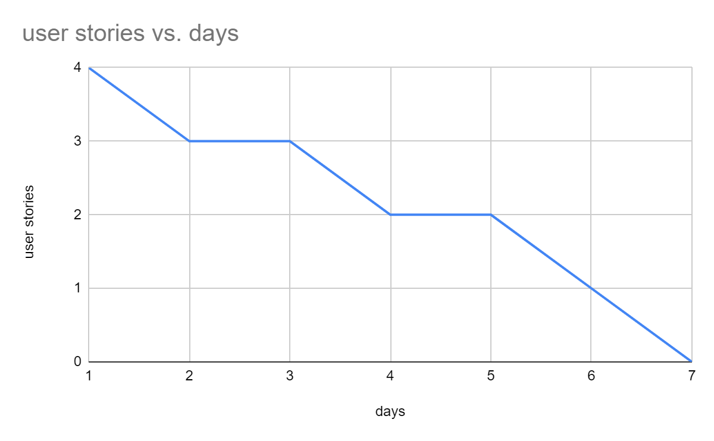

Final Sprint

|  |  |
| --- | --- |
| User Story # | User Story details |
| 1 | Documenting SCRUM meeting details, tracking burndown chart, etc. Sprint.docx |
| 2 | finishing template 2 and check & update template 3 |
| 3 | Add a new section (free text edit) |
| 4 | Uploading images |
| 5 | Generate plots (bar plot, etc.) |
| 6 | Add multiple experiences |
| 7 | Add multiple educations |
| 8 | Add multiple honors |
| 9 | Printing messages in pop up windows after submitting successfully |
| 10 | Within Edit pop up windows, add what values the variables currently have to let the user decide whether to edit or not |
| 11 | Delete whole section at once instead of individual elements |
| 12 | Add footer |
| 13 | Refine UI to make it more visually appealing |
| 14 | Add portfolio section |
| 15 | Fix InsertFrame() (small fix) |
| 16 | Report.docx |
| 17 | Backend code that only inserts selected sections into a default template |
| 18 | Removing sections from template based on user selection |
| 19 | Implement error handling (email, phone number, gpa, etc.) |

Final Burndown chart

