Conclusions: APA Analysis

## Acceleration of the shanks and force of the plateform

It’s clear that we can detect when the second step happens (when patient goes down from forceplate ) using the acceleration signal in the shanks (Z-axis) and the force signal. To do this, we can consider that this step starts when we detect activity in the acceleration signal (Alberto algorism to activity detection) and finish when it hasn’t signal of force:

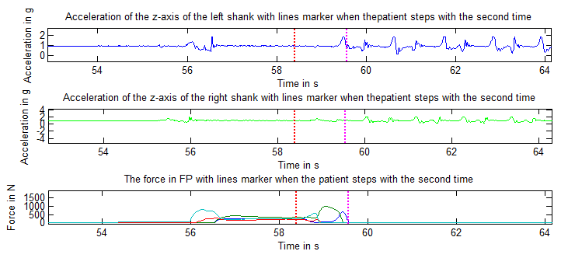

So far, we have an approximation of the interval where the second step happens, so we can obtain the parameters ( COP peak, Acc peak,…) to characterise the APAs .

## Acceleration of the trunk and COP of the plateform

We have to obtain the APA parameters from the trunk acceleration signals and COP signals because these signals are appropriate to be able to characterise properly the adjustments before gait.

So, at the beginning we observed the trunk signals when the patient starts with the right and left feet, and we saw the following signals:

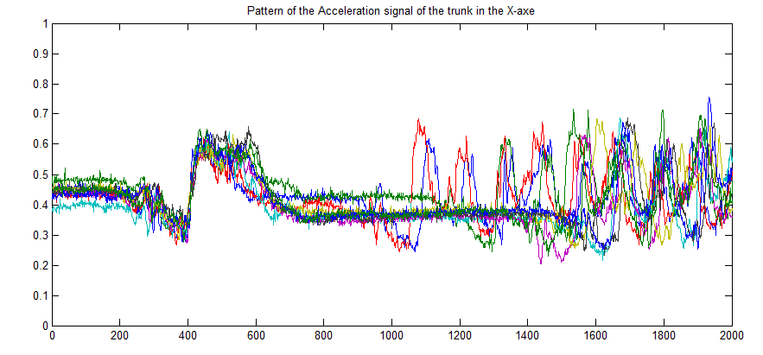

When the step happens

When the APA happens

*Figure 1*

The pattern of the acceleration in the X-axis (anterior-posterior movement), it’s always the same, also regardless of the leg which the patient starts to walk. The signal makes sense because there is a first ‘negative’ peak, it’s exactly when the APA happens, i.e when patient is shifted backwards, and after that, the patient steps (‘positive’ peak). *(Figure 1*)

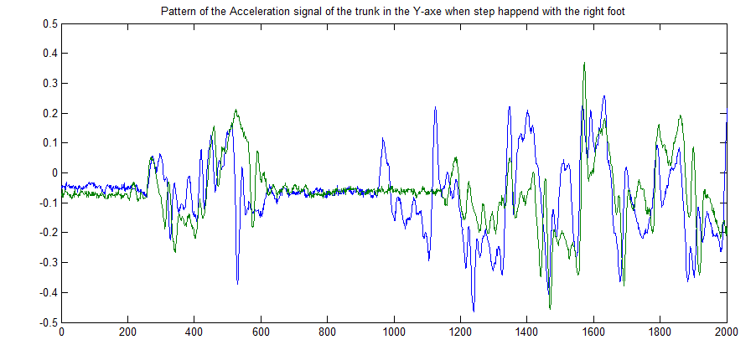

When the step happens

When the APA happens

*Figure 2*

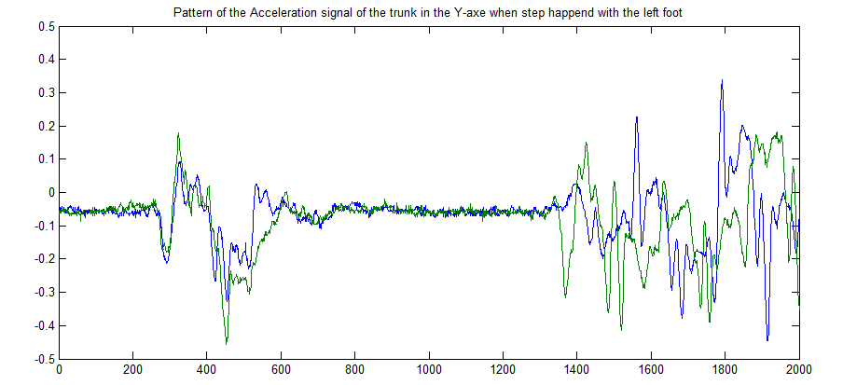

*Figure 3*

If the patient starts to step with the right foot, the center of pressure is shifted toward left. Seeing the signal, the positive direction is toward left. Therefore when patient starts with the right foot, there’ll be a positive peak and after that, other negative when the step is done. *(Figure 2)*

If the patient starts to step with the left foot, the center of pressure is shifted toward right, so in this case, there will be a first negative peak and after a positive peak when the step is done, in contrast to the above case*. (figure 3)*

To sum up, when the patient starts to step with the **right foot,** the center of pressure is **shifted backward and left** , so there are a positive peak in the trunk acceleration signal (Y axis), a ‘negative’ peak in the trunk acceleration signal (X axis), a positive peak in the ML COP and negative peak in AP COP. (*Right_trunk_COP.fig*)

When the patient starts to step with the **left foot**, the center of pressure is **shifted backward and right**, so there are a negative peak in the trunk acceleration signal (Y axis), a ‘negative’ peak in the trunk acceleration signal (X axis), a negative peak in the ML COP and negative peak in AP COP. *(Left_trunk_COP.fig*) ***🡪See the Figures ;)***

## Angular Velocity of the trunk (Gyroscope) and COP of the plateform

In this case, there isn’t difference when the patient starts with the right or left foot. In *trunk_Gyro_COP.fig* figure, we can see the behaviour of all signals (gyroscope and FP).

## Correlation

The correlation between all signals is negative and low. ES39 patient:

* *Correlation acc_trunk_X and AP COP:*

**Case I: Acc AP COP**

C=-0.0036

**Case II:**

C=0.0078

**Case III:**

C=-0.229

* *Correlation acc_trunk Y and ML COP*: the correlation is bigger (negative) than the above case.
* *Correlation gyro_trunk _X and AP COP*: the correlation is bigger (negative) than the above cases.
* *Correlation gyro_trunk_Y and ML COP*:

The negative correlation means that when a variable increases, the other decreases. Maybe is because when COP is bigger, the movement is longer and more constant, so the acceleration is minor.