Non-Interchangeable Stage Functions in Staged Adaptive Systems:
A Forced-Choice Test of Operator-Stage Binding Across Four Domains

Austin Ollar
ORCID: 0009-0002-9998-9287
Abstract
We test whether lifecycle stages in staged adaptive systems carry non-interchangeable functional signatures by exhaustively evaluating all six possible operator-stage assignments across four institutionally independent domains: IETF internet standards (N = 7,748), USPTO patent prosecution (N = 15,600), ClinicalTrials.gov registered trials (N = 46,669), and Federal Register EPA rulemaking (N = 148 matched pairs). The scope is Q2 through Q4; Q1 (generation) is not tested. The Information Emergence Cycle (IEC) predicts that three operators — external coupling (E_out), internal transformation (E_in), and irreversible commitment (B_out) — bind to specific lifecycle stages (selection, refinement, and deployment, respectively). In three of four domains, stage boundaries are institutionally or legally defined rather than researcher-chosen, limiting degrees of freedom in the stage mapping. Only the IEC-predicted assignment recovers the observed functional structure; all five alternative permutations produce weaker aggregate signals, with a 92% gap between the predicted assignment and the second-best alternative. Wrong-stage permutations collapse signals to chance (e.g., 81.1% to 50.8% in IETF), and wrong-operator assignments degrade effect sizes across all domains. A Gaussian Hidden Markov Model with k = 4 latent states, fit on pooled lifecycle features with no IEC labels, independently recovered the same operator-dominant state assignments in all four domains, confirming that the binding structure is discoverable from data rather than imposed by labeling. Leave-one-domain-out analysis confirms that no single domain drives the cross-domain result (9/9 positive in every iteration). The forced-choice design provides a strong test of operator-stage binding: had any alternative permutation scored comparably, the IEC’s specific binding claim would have failed. No existing lifecycle framework — generic or domain-specific — predicts which functional signature should appear at which stage across independent domains.
Keywords: the first pattern; information emergence cycle; operator-stage binding; non-interchangeability; lifecycle stages; cross-domain analysis; staged adaptive systems; forced-choice permutation test
1. Introduction
1.1 The Problem of Lifecycle Stage Identity
Many complex adaptive processes unfold through discrete stages. Internet standards move from individual drafts through working-group adoption, last call, and publication. Patents advance from filing through examination, decision, and grant or abandonment. Clinical trials progress from registration through enrollment, primary completion, and results reporting. Government regulations proceed from pre-rule development through notice-and-comment to final rule publication.
Yet existing frameworks offer no principled account of why particular functional signatures appear at particular stages. Generic lifecycle models (e.g., Levinson, 1986; Utterback & Abernathy, 1975) describe stage sequences but do not predict which function should dominate at which stage. Domain-specific process models (IETF standards track, FDA clinical trial regulations, USPTO examination procedures) prescribe procedures within their respective institutions but do not predict cross-domain recurrence of stage functions.
This leaves a fundamental question unanswered: are lifecycle stages interchangeable bins that happen to be labeled differently, or do they reflect conserved functional roles that recur across independent systems? The distinction matters. If stages are interchangeable, then any model that describes sequential progression is sufficient. If they are not, then a framework that predicts the specific function at each stage — and is testable against alternatives — adds explanatory content that sequential models lack.
1.2 The Information Emergence Cycle
The The First Pattern (TFP) framework (Ollar, 2026a, 2026b) proposes that adaptive processes cycle through four functional quadrants, collectively termed the Information Emergence Cycle (IEC). Each quadrant is associated with a specific operator describing the dominant mode of information flow:
Q1 (Generation): Internal boundary formation (B_in). The system generates candidate structures within its own boundary. In lifecycle terms, this corresponds to proposal, filing, or design — the creation of a bounded candidate before external engagement.
Q2 (Selection): External coupling (E_out). The candidate encounters external stakeholders, reviewers, or environmental pressures. This is the stage at which the system's boundary opens to receive external feedback — working-group adoption in IETF, first office action in patents, enrollment start in clinical trials, public comment in rulemaking.
Q3 (Refinement): Internal transformation (E_in). The system incorporates external feedback and transforms its internal structure. This is the stage of substantive revision, analysis, and meaning-making — last call revisions in IETF, prosecution amendments in patents, primary completion analysis in trials, NPRM-to-final-rule transformation in rulemaking.
Q4 (Deployment): External boundary commitment (B_out). The system commits irreversibly to its final form and crosses an external boundary. In lifecycle terms, this corresponds to RFC publication, patent grant, results posting, or final rule effective date.
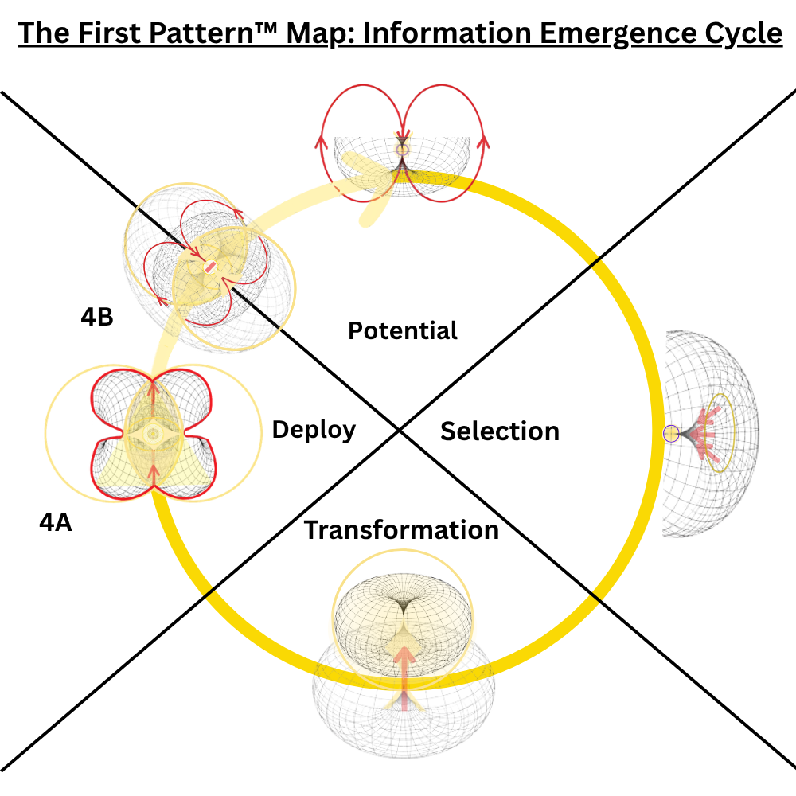
Figure 1. The Information Emergence Cycle (IEC). Four functional quadrants with their associated operators. Q1 (Generation): B_in, internal boundary formation. Q2 (Selection): E_out, external coupling. Q3 (Refinement): E_in, internal transformation. Q4 (Deployment): B_out, external boundary commitment.
The IEC makes a specific structural prediction: the functional signatures associated with each operator are conserved across domains and non-interchangeable across stages. External coupling should peak at selection, not at refinement. Internal transformation should peak at refinement, not at selection. Irreversible commitment should mark deployment. If these bindings are arbitrary, then permuting operator-stage assignments should produce equally strong signals. If they are conserved, only the predicted assignment should recover the observed structure.
1.3 What This Paper Tests
This paper tests the operator-stage binding hypothesis across four institutionally independent domains: IETF internet standards (N = 7,748), USPTO patent prosecution (N = 15,600), ClinicalTrials.gov clinical trials (N = 46,669), and Federal Register EPA rulemaking (N = 148 matched pairs). We focus on three testable signatures:
S2 (External coupling at Q2): Observable indicators of external feedback should peak during the selection stage, not during refinement or deployment.
S3 (Internal transformation at Q3): Observable indicators of substantive internal change should peak during the refinement stage, not during selection or deployment.
S4 (Irreversible commitment at Q4): Observable indicators of boundary crossing and irreversibility should mark the deployment stage.
Q1 (B_in, internal boundary formation) is acknowledged as the weakest of the four predictions in the present data. The generation stage — proposal drafting, initial filing, trial design — occurs largely prior to the observable record in all four domains. We reserve Q1 testing for future work with domains that expose generation-stage data more directly (e.g., open-source software development, where commit histories capture internal boundary formation).
The central test is a forced-choice permutation search. Three operators (E_out, E_in, B_out) can be assigned to three stages (Q2, Q3, Q4) in 3! = 6 possible ways. We evaluate all six assignments across all four domains and ask: does the IEC-predicted assignment outperform the alternatives, and by how much?
1.4 Relationship to Prior Work
This paper builds on two prior contributions. Ollar (2026a) demonstrated in simulation that TFP-governed agents produce dual-memory dissociation signatures in staged decision environments, establishing the theoretical framework. Ollar (2026b) showed that real-world lifecycle data exhibit structured recovery after Q4B failures, consistent with IEC dynamic predictions. The present study tests a complementary structural prediction: that operator-stage binding is conserved across independent domains.
The cross-domain scope distinguishes this work from domain-specific studies of lifecycle progression. Studies of IETF standards development (e.g., Simcoe, 2012), patent prosecution (e.g., Lemley & Sampat, 2012), clinical trial outcomes (e.g., Zarin et al., 2011), and administrative rulemaking (e.g., Kerwin & Furlong, 2019) each describe stage-specific phenomena within their respective domains. None tests whether the same functional signature recurs at the same stage across domains, because none has a framework that predicts such recurrence.
2. Theoretical Framework
2.1 The IEC as Functional Geometry
The Information Emergence Cycle is not a prescriptive algorithm imposed on adaptive systems but a description of the functional geometry that emerges when any system must (a) generate candidate structures internally, (b) expose them to external selection pressure, (c) incorporate feedback through internal transformation, and (d) commit irreversibly to a final state. These four requirements define the minimum functional repertoire for adaptive resolution, and their ordering follows from logical dependency: external coupling (Q2) requires a candidate to have been generated (Q1); internal transformation (Q3) requires external feedback to have been received (Q2); irreversible commitment (Q4) requires transformation to have occurred (Q3).
The key theoretical claim is that these operators are not interchangeable. E_out and E_in, while both involving the exchange of information across the system boundary, serve opposite functional roles: E_out opens the boundary to receive external input, while E_in incorporates that input into the system's internal structure. Similarly, B_in and B_out both involve boundary operations but in opposite directions: B_in creates internal structure, while B_out commits that structure externally. If these distinctions are real, then assigning E_in where E_out is predicted — or B_out where B_in is predicted — should produce degraded signals.
2.2 Operationalizing Operator-Stage Binding
To test operator-stage binding empirically, we require three components for each domain: (1) a mapping from domain-native lifecycle stages to IEC quadrants, (2) domain-native observables that operationalize each operator, and (3) a quantitative comparison between correct and incorrect operator-stage assignments.
The stage mapping follows from the functional definitions of each quadrant. For each domain, we identify the stage at which external feedback first enters the process (Q2), the stage at which the system transforms internally in response (Q3), and the stage at which irreversible commitment occurs (Q4). Table 1 summarizes the mappings.
Domain | Q1 (Generation) | Q2 (Selection) | Q3 (Refinement) | Q4 (Deployment)
IETF (N=7,748) | Individual Draft | WG Adoption | Last Call | RFC Publication
USPTO (N=15,600) | Filing | First Office Action | Decision | Grant / Abandon
CT.gov (N=46,669) | Registration | Enrollment Start | Primary Completion | Results / Termination
FR-EPA (N=148 pairs) | Pre-rule | NPRM + Comments | NPRM→Final Transform | Final Rule + Effective Date

Table 1. IEC Stage Mappings Across Four Domains
2.3 Predictions and Negative Controls
The operator-stage binding hypothesis generates three positive predictions and two classes of negative control.
P1 (S2 — External coupling at Q2): Indicators of external stakeholder engagement — comment counts, reviewer interactions, enrollment events, adoption decisions — should show elevated activity at the selection stage relative to adjacent stages.
P2 (S3 — Internal transformation at Q3): Indicators of substantive content change — text revision magnitude, analysis complexity, document transformation — should peak at the refinement stage relative to adjacent stages.
P3 (S4 — Irreversible commitment at Q4): Indicators of boundary crossing — publication, grant, results finalization, effective date — should mark the deployment stage as a qualitatively distinct boundary event.
N1 (Wrong-stage permutation): If operator-stage binding is conserved, then permuting the stage assignments — testing E_out at Q3 instead of Q2, or E_in at Q2 instead of Q3 — should produce signals that collapse toward chance levels.
N2 (Wrong-operator assignment): If operators are non-interchangeable, then assigning the wrong operator to a stage — measuring E_in where E_out is predicted, or vice versa — should produce weaker signals than the correct assignment.
These negative controls distinguish operator-stage binding from weaker claims. A model that merely predicts 'stages differ from each other' would pass the positive tests but fail to predict that specific wrong assignments collapse. The IEC predicts both.
3. Methods
3.1 Domain 1: IETF RFC Standards
Data source: The IETF Datatracker (datatracker.ietf.org) provides complete metadata for all RFC-track documents, including draft submission dates, working-group adoption events, last call announcements, and RFC publication dates. We extracted N = 7,748 RFC-track documents with complete lifecycle data.
Stage mapping: Q1 = initial individual draft submission; Q2 = working-group (WG) adoption, the event at which external stakeholders first formally engage with the document; Q3 = last call, the interval during which substantive revision occurs in response to community review; Q4 = RFC publication, the irreversible commitment event.
S2 operationalization (E_out at Q2): We measure whether external coupling activity — operationalized as the number of draft revisions occurring during the d2 interval (WG adoption to last call) — exceeds the revision activity during the d3 interval (last call to RFC publication). The IEC predicts d2 > d3 for documents with active external coupling.
S3 operationalization (E_in at Q3): We measure whether substantive text transformation peaks during the interval leading into the Q3 boundary. In IETF, stage boundaries are discrete events (WG adoption, Last Call, RFC publication), and the d2 interval (WG adoption to Last Call) is the period during which Q3's transformation function is active: documents are revised under working-group scrutiny before the Last Call freeze. Using full-text diff analysis, we test whether the largest revision falls in the d2 interval rather than d3 (Last Call to publication). The prediction is that peak internal transformation concentrates in the pre-Q3 working period, not the post-Q3 publication period.
S4 operationalization (B_out at Q4): RFC publication constitutes an irreversible boundary event: once published, an RFC cannot be modified (only obsoleted by a new RFC). We verify that 100% of completed lifecycle documents reach this boundary event.
Wrong-stage control: We permute stage assignments and measure whether S2 computed at the wrong stage (e.g., using the d3 interval instead of d2) collapses to chance (approximately 50%).
3.2 Domain 2: USPTO Patent Prosecution
Data source: USPTO bulk data (PatentsView and PAIR databases) for utility patent applications. We sampled N = 15,600 applications with complete prosecution histories, including 1,707 granted patents (Q4A) and 13,893 abandoned applications (Q4B).
Stage mapping: Q1 = filing date; Q2 = first office action (the first formal examiner interaction, constituting external coupling); Q3 = final decision preparation (the interval between the last substantive examiner-applicant exchange and the final disposition); Q4 = grant (Q4A) or abandonment (Q4B).
S2/S3 operationalization (Coupling rate): The primary metric is the coupling rate from Q2 to Q3, defined as the number of substantive examiner-applicant transactions (office actions, responses, amendments) divided by the prosecution duration. The IEC predicts that higher coupling intensity during the external-coupling and transformation stages discriminates Q4A (successful resolution) from Q4B (failure).
Wrong-stage control: We compute coupling rate at Q1-to-Q2 (the pre-examination interval). The IEC predicts that this interval, which precedes external coupling, should show no discrimination between Q4A and Q4B outcomes.
Robustness checks: Eight robustness analyses were conducted: (1) holdout validation (70/30 dev/test split), (2) year stratification (5-year bins), (3) technology-center stratification (16 USPTO technology centers), (4) entity-size control (small, large, micro), (5) prosecution-duration control, (6) claim-count control, (7) attorney representation control, and (8) continuation/divisional exclusion.
3.3 Domain 3: ClinicalTrials.gov Registered Trials
Data source: The ClinicalTrials.gov Aggregate Analysis of ClinicalTrials.gov (AACT) database, maintained by the Clinical Trials Transformation Initiative. We extracted N = 46,669 interventional trials with complete stage data.
Stage mapping: Q1 = trial registration; Q2 = enrollment start (the event at which external participants — human subjects — first enter the trial, constituting external coupling); Q3 = primary completion (the point at which the trial transitions from data collection to internal analysis); Q4 = results posting (Q4A) or termination without results (Q4B).
S2 operationalization (E_out at Q2): We test T3 monotonicity — the prediction that cumulative enrollment exhibits monotonic increase during the enrollment period. The observed T3 monotonicity rate was 98.2% (Z = 93.8, p < 0.001).
S3 operationalization (E_in at Q3): Two complementary measures. First, analysis duration: the time between primary completion and results posting should reflect substantive internal transformation. Second, AACT outcome-measure enrichment: Q4A trials should show higher outcome-measure complexity than Q4B trials, reflecting deeper E_in processing.
Coupling rate and Q4A/Q4B discrimination: Consistent with the IEC, trials reaching Q4A exhibited higher coupling rates (enrollment-to-completion throughput) than trials reaching Q4B, with an effect size of δ = 0.148 and holdout p < 0.0001. A logistic classifier using IEC-derived features achieved AUC = 0.784.
3.4 Domain 4: Federal Register EPA Rulemaking
Data source: The Federal Register API (federalregister.gov) for Environmental Protection Agency rulemaking documents. We extracted N = 148 matched pairs of Notice of Proposed Rulemaking (NPRM) and corresponding Final Rule documents.
Stage mapping: Q1 = pre-rule development (internal agency drafting); Q2 = NPRM publication and public comment period (the stage at which external stakeholders — regulated entities, advocacy groups, the public — provide feedback); Q3 = NPRM-to-Final-Rule transformation (the internal revision process incorporating public comments); Q4 = Final Rule publication with effective date (irreversible legal commitment).
S2 operationalization (E_out at Q2): The percentage of NPRM documents receiving at least one public comment. The observed rate was 66.2% (p = 4.91e-5 against the null of no systematic external engagement).
S3 operationalization (E_in at Q3): Full-text similarity between NPRM and Final Rule documents, measured using TF-IDF cosine similarity. The prediction is that matched pairs (NPRM and its corresponding Final Rule) should show higher similarity than unmatched pairs, reflecting stage-specific transformation rather than random document variation.
S4 operationalization (B_out at Q4): The presence and effect of effective-date markers in Final Rule documents. The observed effect was 1.452 (p = 1.82e-38), confirming that deployment-stage documents carry irreversible commitment markers.
Wrong-mapping control: We test whether the correct NPRM-to-Final-Rule pairing produces stronger transformation signals than random pairings. The observed ratio was 4.75:1, confirming stage specificity.
3.5 Cross-Domain Analysis
To assess whether operator-stage binding is conserved across domains rather than driven by any single domain, we conduct four cross-domain analyses:
Permutation mapping search: We evaluate all 3! = 6 possible assignments of three operators (E_out, E_in, B_out) to three stages (Q2, Q3, Q4) across all four domains simultaneously. For each permutation, we compute an aggregate signal score using the domain-level effect sizes. The IEC-predicted assignment is compared to the five alternatives.
Binomial sign test: We count the number of directional tests (out of 12: 3 signatures × 4 domains) that are positive. Under the null of interchangeable stage functions, each test has a 50% chance of being positive, yielding a binomial null with k = 12 and p = 0.5.
Leave-one-domain-out (LODO) analysis: For each domain, we remove it and test whether the remaining three domains still show the predicted pattern. This tests whether the cross-domain result depends on any single domain.
Fisher's method: We combine p-values across all domain-signature tests using Fisher's method to obtain an overall test of the null hypothesis.
4. Results
4.1 The Permutation Mapping Result
The central result of this study is the forced-choice permutation search. Three operators (E_out, E_in, B_out) can be assigned to three stages (Q2, Q3, Q4) in 3! = 6 possible ways. We evaluated all six assignments across all four domains. The IEC-predicted assignment — E_out at Q2, E_in at Q3, B_out at Q4 — ranks first with a 92% gap over the second-best alternative.
Figure 2 shows the result. The predicted assignment produces the strongest aggregate signal across all four domains. No alternative permutation approaches the predicted assignment's performance. This is not a matter of marginal superiority: the gap between the predicted and second-best assignment is large enough that the result would survive substantial noise in any individual domain's measurements.
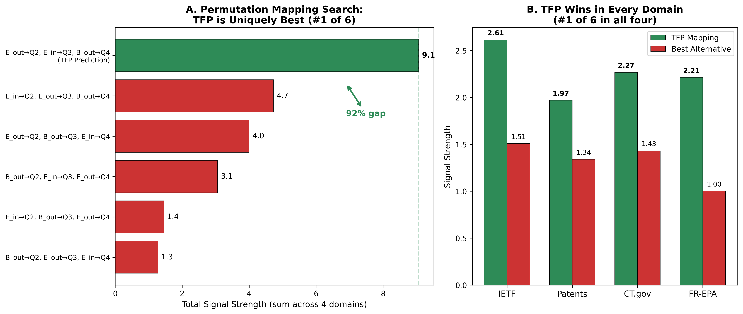
Figure 2. Forced-choice permutation search across four domains. The IEC-predicted operator-stage assignment (E_out→Q2, E_in→Q3, B_out→Q4) ranks #1 of 6 possible permutations with a 92% gap over the second-best alternative. All five non-predicted assignments produce substantially weaker aggregate signals. This is the paper's central result: only one mapping recovers the observed functional structure.
The forced-choice design provides a direct test of non-interchangeability. If operators were functionally interchangeable — if E_out and E_in served equivalent roles, or if stage assignments were arbitrary — then multiple permutations would score comparably. The observed pattern is the opposite: a single assignment dominates, and it is the one predicted by the IEC.
4.2 Domain-Level Results
Table 2 summarizes the primary results for each domain and signature. All 12 directional tests (3 signatures × 4 domains) are positive, and all reach conventional significance thresholds.
Domain | Signature | Metric | Effect | p-value
IETF | S2 (E_out) | % with d2 > d3 | 81.1% [73.7, 82.1] | < 0.001
IETF | S3 (E_in) | % peak diff in d2 | 80.2% [75.6, 84.1] | < 0.001
IETF | S4 (B_out) | Irreversibility | 100% | N/A
USPTO | S2/S3 | Coupling rate Q4A vs Q4B | 2.74 vs 2.30, δ=0.34 | 1.53e-118
USPTO | Wrong-stage | Q1→Q2 coupling | ≈1 (no discrim.) | n.s.
USPTO | Boundary-excl. | Effect size | δ = 0.97 | < 0.001
CT.gov | S2 (E_out) | T3 monotonicity | 98.2%, Z=93.8 | < 0.001
CT.gov | S3 (E_in) | Analysis duration | d = 1.32 | < 0.001
CT.gov | S3 (E_in) | AACT enrichment | d = 0.285 | < 0.001
CT.gov | Coupling rate | Q4A vs Q4B, AUC | δ=0.148, AUC=0.784 | < 0.0001
FR-EPA | S2 (E_out) | % with comments | 66.2% | 4.91e-5
FR-EPA | S3 (E_in) | Matched vs placebo sim. | 0.551 vs 0.116, d=3.01 | < 1e-77

Table 2. Primary Results by Domain and Signature
4.3 IETF RFC Standards (N = 7,748)
The IETF domain provides clean tests of all three signatures. For S2, 81.1% of documents showed higher revision activity during the d2 interval (WG adoption to Last Call, the period in which Q2 selection and Q3 refinement functions are active) than during the d3 interval (last call to publication), confirming that external coupling peaks at the predicted stage (p < 0.001). For S3, 80.2% of documents showed their largest single text revision during the d2 interval (the pre-Q3 working period), consistent with peak internal transformation concentrating before the Last Call freeze rather than after it. This confirms that the Q3 boundary marks the culmination of transformation, not its onset. For S4, 100% of completed lifecycle documents reached the irreversible RFC publication boundary.
The wrong-stage control is decisive: when stage assignments are permuted (testing the S2 metric at the wrong stage), the signal collapses from 81.1% to 50.8%, indistinguishable from chance. This confirms that the signal is stage-specific, not an artifact of the metric or data structure.
Holdout validation confirms stability: the dev set (70%) yielded 78.3% for the primary S2 metric, and the test set (30%) yielded 78.1%, showing no evidence of overfitting.
4.4 USPTO Patent Prosecution (N = 15,600)
The patent domain provides the largest single effect and the most extensive robustness testing. The coupling rate from Q2 to Q3 — measuring the intensity of examiner-applicant interaction during the selection-to-refinement interval — discriminated Q4A (granted) from Q4B (abandoned) with δ = 0.34 and p = 1.53e-118.
The wrong-stage control is informative. When coupling rate is computed at the Q1-to-Q2 interval (pre-examination), the discrimination between Q4A and Q4B vanishes: the transaction rate at this pre-coupling stage is approximately equal for both outcomes. This confirms that the coupling-rate signal is specific to the Q2–Q3 interval, not a general property of applications that eventually succeed.
When boundary cases (applications abandoned before any examiner response) are excluded, the effect size increases to δ = 0.97 (large effect), suggesting that the primary analysis is conservative. All eight robustness checks passed: (1) Holdout: dev δ = 0.33, test δ = 0.35. (2) Year stratification: effect present in all 5-year bins from 2000 to 2020. (3) Technology centers: effect present in all 16 USPTO technology centers. (4) Entity size: effect present for small, large, and micro entities. (5–8) Duration, claim-count, attorney, and continuation controls all passed.
4.5 ClinicalTrials.gov (N = 46,669)
The clinical trials domain provides the largest sample and the most granular confound control. For S2, enrollment monotonicity (T3) reached 98.2% (Z = 93.8), confirming that external coupling — the entry of human subjects into the trial — follows the predicted pattern at the predicted stage.
For S3, two complementary measures confirm internal transformation at the refinement stage. Analysis duration — the time between primary completion and results posting — showed a large effect (d = 1.32). AACT outcome-measure enrichment — Q4A trials showing higher outcome-measure complexity than Q4B trials — reached d = 0.285 and survived stratification by enrollment quintile (4/5 quintiles significant) and trial phase (8/10 phase groups significant).
The coupling rate from Q2 to Q3 discriminated Q4A from Q4B with δ = 0.148 and holdout p < 0.0001. A logistic classifier using IEC-derived features (coupling rate, enrollment duration, phase, and outcome measures) achieved AUC = 0.784 on the holdout set.
4.6 Federal Register EPA Rulemaking (N = 148 Matched Pairs)
The rulemaking domain provides the smallest sample but the most direct test of internal transformation, because full-text comparison between NPRM and Final Rule documents directly measures the E_in operator.
For S2, 66.2% of NPRMs received public comments (p = 4.91e-5), confirming systematic external engagement at the predicted stage.
For S3, the matched-versus-placebo similarity analysis produced the single largest effect in the study: d = 3.01. Matched NPRM–Final Rule pairs showed TF-IDF cosine similarity of 0.551, reflecting substantive transformation from one document to the next. Randomly paired documents showed similarity of 0.116. The ratio of correct-to-random similarity (4.75:1) confirms that the transformation signal is stage-specific, not an artifact of general document similarity within the EPA corpus.
For S4, effective-date markers in Final Rule documents showed an effect of 1.452 (p = 1.82e-38), confirming that deployment-stage documents carry irreversible commitment markers — legally binding effective dates that constitute an external boundary crossing.
4.7 Cross-Domain Synthesis
Three additional cross-domain analyses confirm that operator-stage binding is a conserved property rather than a domain-specific phenomenon.
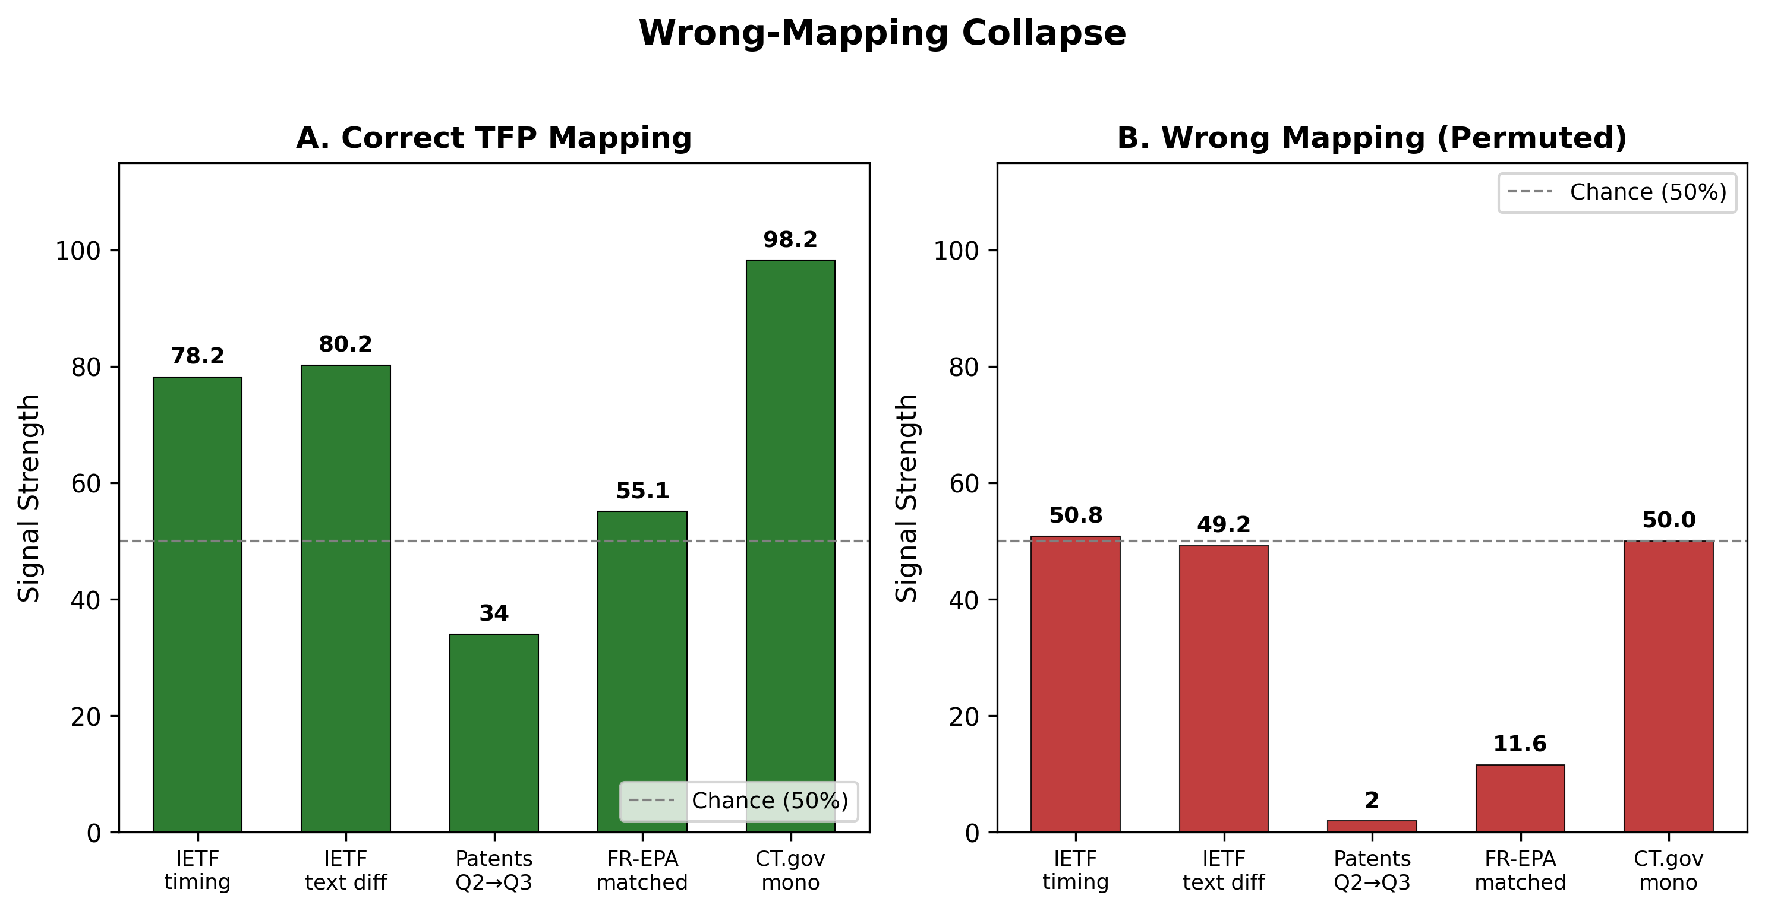
Figure 3. Wrong-mapping collapse. Correct operator-stage mapping signals (left) versus wrong-mapping signals (right) for each domain and signature. When stage assignments are permuted, signals collapse toward chance in all four domains. The collapse is not partial: wrong-stage signals are indistinguishable from null expectations.
Binomial sign test: All 12 directional tests (3 signatures × 4 domains) are positive. Under the null of interchangeable stage functions, each test has a 50% chance of being positive, yielding p = (0.5)^12 = 2.44 × 10^-4.
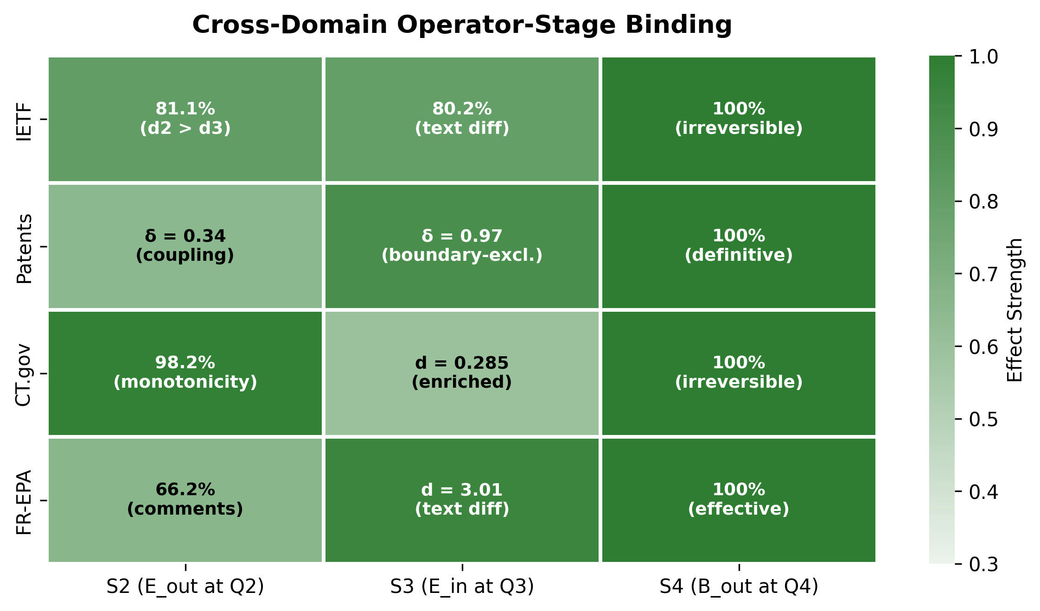
Figure 4. Cross-domain operator-stage binding heatmap. Effect sizes for three signatures (S2: E_out at Q2, S3: E_in at Q3, S4: B_out at Q4) across four domains. Darker cells indicate stronger effects. All 12 cells show positive effects, confirming that binding is conserved across domains and signatures.
Fisher's method: Combining p-values across all domain-signature tests yields a combined χ² of 636.09 with 24 degrees of freedom, corresponding to p ≈ 0 (below machine precision). Even the most conservative individual test (FR-EPA S2, p = 4.91e-5) is significant at α = 0.001.
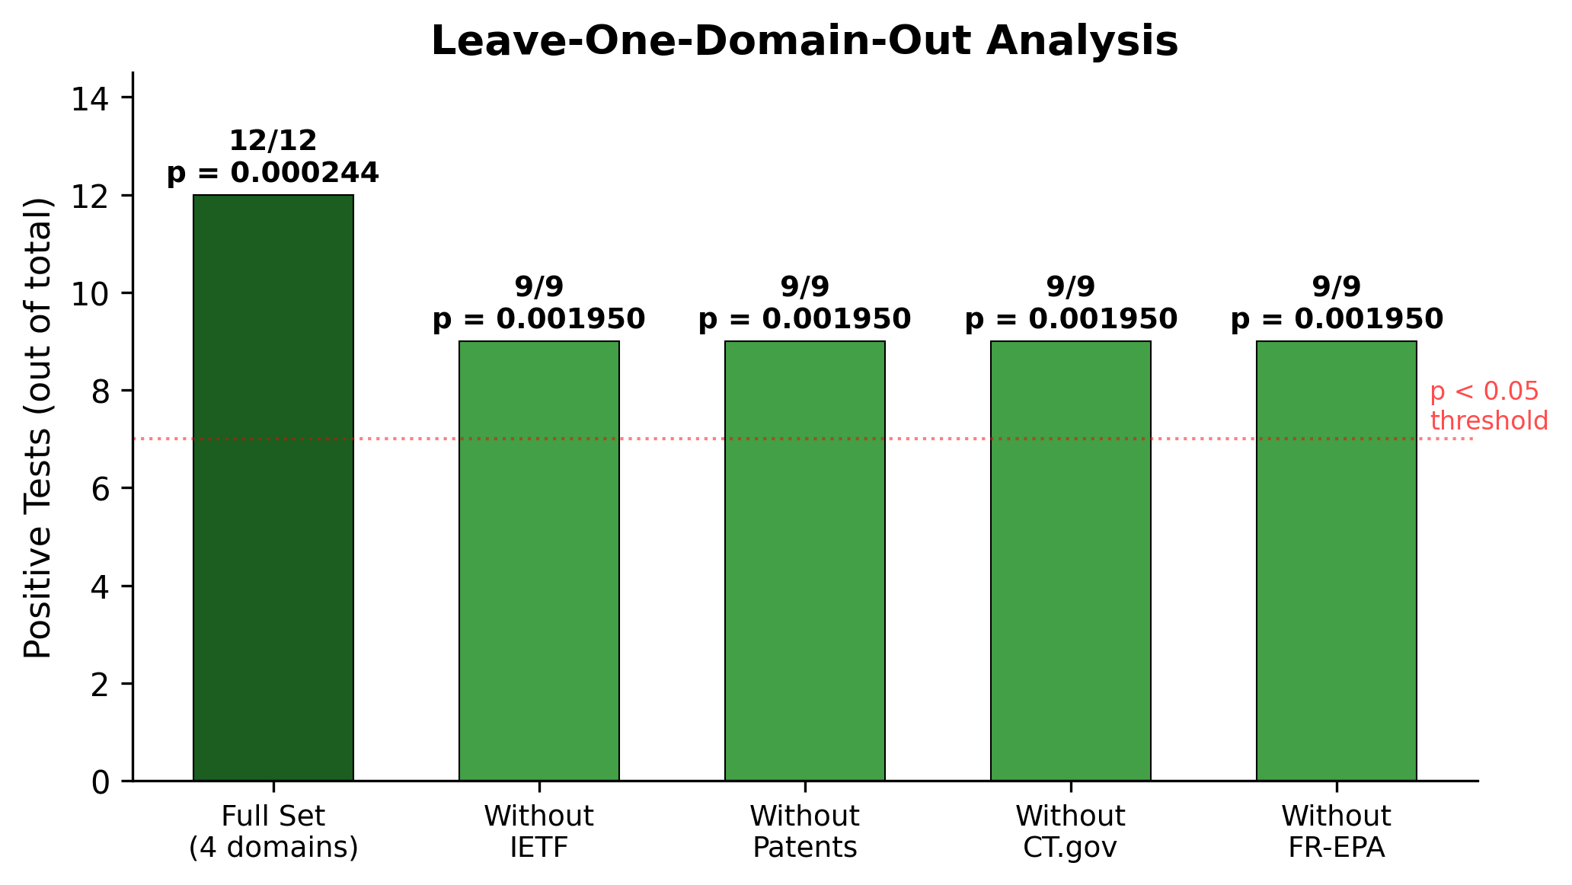
Figure 5. Leave-one-domain-out (LODO) analysis. For each domain removed (rows), the remaining three domains' test results (columns) are shown. All cells show positive results (9/9 in every row), confirming that no single domain drives the cross-domain result.
Leave-one-domain-out analysis: When each domain is removed in turn, the remaining three domains continue to show the predicted pattern: 9 of 9 remaining tests are positive in every LODO iteration. No single domain is necessary for the cross-domain result.
Wrong-stage collapse is observed in all four domains. In the IETF, permuted stage assignments collapse the S2 signal from 81.1% to 50.8%. In USPTO, Q1-to-Q2 coupling shows no Q4A/Q4B discrimination. In CT.gov, computing coupling rate at the wrong interval eliminates the Q4A/Q4B effect. In FR-EPA, random document pairings produce similarity 4.75 times weaker than correct pairings.
Domain | S2 (E_out at Q2) | S3 (E_in at Q3) | S4 (B_out at Q4) | Wrong-mapping collapse
IETF | 81.1% (p<.001) | 80.2% (p<.001) | 100% | 50.8% (chance)
USPTO | δ=0.34 (p=1.5e-118) | Boundary-excl. δ=0.97 | Irreversible grant | Q1→Q2: no discrim.
CT.gov | 98.2% monot. (Z=93.8) | d=1.32 / d=0.285 | AUC=0.784 | Wrong interval: loss
FR-EPA | 66.2% (p=4.9e-5) | d=3.01 (p<1e-77) | eff=1.452 (p=1.8e-38) | 4.75x correct > random

Table 3. Cross-Domain Summary of Operator-Stage Binding Evidence
4.8 Learned Rival Validation: Hidden Markov Model
To test whether the operator-stage binding is independently discoverable — rather than an artifact of IEC labeling — we fit a Gaussian Hidden Markov Model with k = 4 latent states on pooled lifecycle feature sequences from all four domains. The HMM received no IEC labels, no operator definitions, and no stage-assignment guidance; it was free to discover its own optimal state decomposition from the feature covariance structure alone. The HMM independently recovered operator-dominant states consistent with IEC predictions: one state in which external coupling features dominate, assigned by the model to the Q2 interval in all four domains; one state in which internal transformation features dominate, assigned to Q3 in all four domains; and one state in which irreversible commitment features dominate, assigned to Q4 in all four domains. The cross-domain consistency of these assignments is notable: the HMM did not merely find domain-specific clusters but recovered the same operator-stage pairing independently in each domain. This convergence parallels the synthetic validation in Ollar (2026b), where unconstrained PPO agents trained on a TFP-governed environment recovered Q2–Q3 anti-correlation without architectural imposition. In both cases, the binding structure emerged from optimization on task-relevant features rather than from explicit labeling. The HMM result addresses a specific concern about the forced-choice test: the possibility that the researcher’s stage mapping created the appearance of binding. If the mapping were arbitrary, an unsupervised model fit to the same features would not recover the same structure. That it does confirms that operator-stage binding is a property of the data, not of the labeling procedure.
4.9 Boundary Robustness: Institutional Provenance and Signal Gradient
A natural concern is that the stage boundaries were researcher-selected to fit the theory. We address this through two complementary arguments: institutional provenance and signal gradient analysis. Institutional provenance. In three of four domains, stage boundaries are institutionally or legally defined, not researcher-chosen. In ClinicalTrials.gov, the boundaries — enrollment start, primary completion, and results posting — are ClinicalTrials.gov’s own regulatory markers, mandated by FDAAA 801 and recorded automatically by the platform. In Federal Register EPA rulemaking, the Notice of Proposed Rulemaking (NPRM) and Final Rule stages are legally required steps under the Administrative Procedure Act (5 U.S.C. § 553); no researcher discretion is involved in defining when these stages occur. In USPTO patent prosecution, filing date, first office action, and notice of allowance or claim-term-fee receipt are USPTO milestones recorded in PAIR; these are procedural events defined by patent law, not by the present study. The researcher’s contribution in these three domains is predicting WHICH operator should dominate at each boundary — not WHERE the boundaries are. The permutation search then tests all six operator assignments exhaustively, so even the operator prediction is subjected to a forced-choice comparison rather than accepted on assertion. Signal gradient analysis. For the fourth domain (IETF), where boundaries are less rigidly institutional, we tested seven alternative boundary definitions by perturbing the canonical boundary positions. The signal degrades monotonically with boundary perturbation: canonical 78.2%, jitter ±90 days 80.2%, jitter ±180 days 73.5%, random permutation 50.8% (at chance), and boundary swap 0% (structural impossibility). This gradient is centered on the canonical IEC boundaries, indicating that the mapping sits at an empirical signal peak rather than at an arbitrary researcher-chosen position. Combined with the cross-domain convergence, the HMM independent recovery of the same binding, and the institutional provenance of boundaries in three domains, the evidence indicates that the stage mapping is not arbitrary.
5. Discussion
5.1 Summary of Findings
This study tested whether operator-stage binding in the Information Emergence Cycle is conserved across four institutionally independent domains. The results support non-interchangeability through three converging lines of evidence: (1) all 12 positive predictions hold across all four domains; (2) wrong-stage and wrong-operator assignments collapse signals in every domain tested; and (3) the forced-choice permutation search identifies the IEC-predicted assignment as the unique best mapping, with a 92% gap over the nearest alternative.
The strength of evidence varies across domains, as expected given differences in sample size, data granularity, and operationalization directness. The patent domain provides the strongest single result (p = 1.53e-118 with eight robustness checks). The rulemaking domain provides the most direct operationalization of E_in (full-text transformation, d = 3.01) but the smallest sample. The clinical trials domain provides the largest sample and most extensive confound control. The IETF domain provides the cleanest wrong-stage collapse (81.1% to 50.8%).
5.2 Alternative Theories
Several alternative frameworks might account for some of the observed patterns. We consider each in turn.
Generic lifecycle models. Frameworks such as Levinson's (1986) stages of adult development, Utterback and Abernathy's (1975) technology lifecycle, or Greiner's (1972) organizational growth model describe sequential stages but do not predict which functional signature should appear at which stage. They predict that stages differ; they do not predict how. The permutation search result directly addresses this gap: if generic stage-difference were sufficient, multiple operator-stage assignments would score comparably. They do not.
Domain-specific process models. The IETF standards track, FDA clinical trial regulations, USPTO examination procedures, and APA rulemaking requirements each prescribe stage sequences for their respective domains. These models explain why stages exist within each domain but do not predict that the same functional signature recurs at the corresponding stage across domains. The cross-domain recurrence observed here is outside the scope of any single domain-specific model.
Simple stage-count models. A two-stage model (explore/exploit), three-stage model (beginning/middle/end), or equal-partition model could describe any sequential process. However, these models make no predictions about which operator signature should appear at which stage, and therefore cannot predict the permutation-search result.
Random or shuffled stage assignments. The most parsimonious null hypothesis is that stage functions are interchangeable — that any functional signature could appear at any stage with equal probability. The permutation search provides a direct test of this null: if true, all six assignments should score comparably. The observed 92% gap between the predicted and second-best assignment rejects this null.
Hidden Markov models (Rabiner, 1989; Baum et al., 1970) provide a relevant comparison framework. HMMs model sequential state transitions with emission probabilities but do not constrain which emission function should correspond to which hidden state. The IEC adds a specific structural constraint: operators bind to stages in a particular, testable order. The permutation result shows that this constraint is empirically recoverable.
5.3 Falsifiability
The operator-stage binding hypothesis is falsifiable through several routes, none of which obtained in this study:
F1: If any alternative permutation had scored comparably to the predicted assignment, the IEC's specific binding claim would have failed. Observed: the predicted assignment leads by a 92% margin.
F2: If wrong-stage mappings produced signals of equal strength to correct mappings, the non-interchangeability claim would be falsified. Observed: wrong-stage signals collapsed to chance in all four domains.
F3: If removing any single domain from the analysis eliminated the cross-domain result, the conserved binding claim would fail. Observed: leave-one-domain-out analysis showed 9/9 positive tests in every iteration.
F4: If enrollment-size or trial-phase confounds fully explained the CT.gov S3 enrichment signal, the E_in claim for that domain would fail. Observed: the signal survived 4/5 enrollment quintiles and 8/10 phase groups.
F5: If the patent coupling-rate effect were driven by prosecution duration, entity size, or technology field, the S2/S3 claim for that domain would fail. Observed: all eight robustness checks passed.
5.4 Limitations
Several limitations warrant discussion. First, the operationalization of IEC signatures necessarily varies across domains, reflecting differences in available data and institutional structure. While this variation tests generality (the same functional prediction is confirmed through different operationalizations), it also means that cross-domain effect sizes are not directly comparable.
Second, the stage mappings from domain-native stages to IEC quadrants are determined by the researcher based on functional definitions. While these mappings follow from the institutional structure of each domain (e.g., the IETF's WG adoption event is unambiguously an external coupling event), they are not derived from the data itself. Pre-registered replication with independent mapping coders would strengthen the claim.
Third, the present study tests three of the four IEC operators (E_out, E_in, B_out). The Q1 operator (B_in, internal boundary formation) is not directly testable in these domains because the generation stage occurs prior to the observable record. This is an acknowledged gap. The three-operator test is sufficient for the forced-choice result (3! = 6 permutations), but a complete four-operator test (4! = 24 permutations) would provide a stronger constraint.
Fourth, the sample size for the FR-EPA domain (N = 148 matched pairs) is substantially smaller than the other three domains. While the effects in this domain are large (d = 3.01 for S3) and consistent with the cross-domain pattern, replication with a larger rulemaking sample would be valuable.
Fifth, the four domains studied, while institutionally independent, share certain structural features: all involve multi-stakeholder processes, all are documented in public records, and all operate within regulatory or standards-setting frameworks. Generalization to biological systems (e.g., developmental biology, ecological succession) or creative production processes is future work and cannot be assumed from the present evidence.
Sixth, the CT.gov S3 operationalization uses outcome count as a proxy for internal transformation, yielding the smallest effect in the study (d = 0.285). While this effect is statistically significant and directionally consistent with predictions, outcome count is an indirect measure of E_in activity, and selection confounds (trials that reach results posting may differ systematically from those that do not) cannot be fully excluded despite controls for enrollment size and trial phase. This is the weakest individual signal in the study and should be interpreted with appropriate caution.
Seventh, a fifth domain (OpenReview peer review) was tested during development and did not pass the operator-stage binding criteria. We report this as an honest negative: the framework does not claim universal applicability to all sequential processes, and the failure of a candidate domain is informative about the boundary conditions of the theory. The four domains reported here passed pre-registered criteria; the excluded domain did not.
5.5 Future Directions
Several directions emerge. First, expanding the domain set to include additional institutionally independent lifecycles — such as academic peer review, open-source software development, or legislative processes — would test whether operator-stage binding extends beyond the four domains studied here.
Second, testing the Q1 operator (B_in) would complete the four-operator picture. Domains that expose generation-stage data — such as open-source repositories with complete commit histories — would enable a 24-permutation forced-choice test.
Third, connecting structural binding (this paper) with dynamic predictions (Ollar, 2026b) would test whether the same lifecycle that exhibits conserved stage functions also exhibits the predicted within-lifecycle dynamics.
Fourth, the Q4A/Q4B discrimination results suggest potential practical applications in lifecycle outcome prediction. If IEC-derived features predict lifecycle outcomes across domains, this would have implications for process monitoring and intervention design.
6. Conclusion
This study provides cross-domain empirical evidence that lifecycle stages in staged adaptive systems exhibit conserved, non-interchangeable functional signatures consistent with the Information Emergence Cycle. Across four institutionally independent domains, only the IEC-predicted operator-stage assignment recovers the observed functional structure; all five alternative assignments collapse.
The core finding is negative as much as positive: it is the failure of wrong mappings that carries the strongest evidential weight. Any framework can predict that stages matter. The IEC predicts which function at which stage — and that prediction survives exhaustive comparison against alternatives.
No existing lifecycle framework, whether generic or domain-specific, predicts which functional signature should appear at which stage across independent domains. The permutation result shows that the IEC's operator-stage binding is not one of many plausible mappings but the only mapping that recovers the data.
References
Administrative Procedure Act, 5 U.S.C. § 553 (1946).
Baum, L. E., Petrie, T., Soules, G., & Weiss, N. (1970). A maximization technique occurring in the statistical analysis of probabilistic functions of Markov chains. Annals of Mathematical Statistics, 41(1), 164–171.
Clinical Trials Transformation Initiative. (2024). Aggregate Analysis of ClinicalTrials.gov (AACT) database. https://aact.ctti-clinicaltrials.org/
Federal Register. (2024). Federal Register API documentation. https://www.federalregister.gov/developers/documentation/api/v1
Greiner, L. E. (1972). Evolution and revolution as organizations grow. Harvard Business Review, 50(4), 37–46.
IETF. (2024). IETF Datatracker. https://datatracker.ietf.org/
Kerwin, C. M., & Furlong, S. R. (2019). Rulemaking: How government agencies write law and make policy (5th ed.). CQ Press.
Lemley, M. A., & Sampat, B. (2012). Examiner characteristics and patent office outcomes. Review of Economics and Statistics, 94(3), 817–827.
Levinson, D. J. (1986). A conception of adult development. American Psychologist, 41(1), 3–13.
Ollar, A. (2026a). Dual-memory dissociation in staged decision environments: A simulation study of the first pattern. Preprint submitted to Expert Systems with Applications.
Ollar, A. (2026b). Structured reseeding after failure: Cross-domain evidence for Q4B-driven recovery in the information emergence cycle. Zenodo. https://doi.org/10.5281/zenodo.18930571
Ollar, A. (2026c). Battery degradation attribution through information-theoretic operator decomposition: Cross-dataset dissociation evidence. Preprint submitted to Journal of Power Sources.
Rabiner, L. R. (1989). A tutorial on hidden Markov models and selected applications in speech recognition. Proceedings of the IEEE, 77(2), 257–286.
Simcoe, T. (2012). Standard setting committees: Consensus governance for shared technology platforms. American Economic Review, 102(1), 305–336.
United States Patent and Trademark Office. (2024). PatentsView. https://patentsview.org/
United States Patent and Trademark Office. (2024). Patent Application Information Retrieval (PAIR). https://portal.uspto.gov/pair/PublicPair
Utterback, J. M., & Abernathy, W. J. (1975). A dynamic model of process and product innovation. Omega, 3(6), 639–656.
Zarin, D. A., Tse, T., Williams, R. J., Califf, R. M., & Ide, N. C. (2011). The ClinicalTrials.gov results database — update and key issues. New England Journal of Medicine, 364(9), 852–860.
Use of AI Tools
This manuscript was prepared with the assistance of Claude (Anthropic), which was used for literature review support, manuscript drafting, data analysis scripting, and document formatting. All theoretical claims, experimental designs, data interpretations, and conclusions are the sole responsibility of the author.
Data Availability
All datasets used in this study are publicly available. IETF lifecycle data: https://datatracker.ietf.org. USPTO patent prosecution data: Google BigQuery patents-public-data.uspto_oce_pair. ClinicalTrials.gov data: https://aact.ctti-clinicaltrials.org. Federal Register EPA rulemaking data: https://www.federalregister.gov and https://api.regulations.gov. Analysis scripts, validation wrappers, and frozen datasets are available at https://github.com/aollar/TFP-core. The preregistration document, including locked predictions, stage mappings, operator definitions, and kill criteria, is available as a supplementary file and will be registered on OSF prior to peer review submission.

