The First Pattern: Theory Reference

Austin Ollar — ORCID: 0009-0002-9998-9287
1. What TFP Is
TFP (The First Pattern) proposes that successful adaptive systems exhibit a conserved four-phase lifecycle structure — an emergent organizational geometry that systems fall into when learning, growing, or developing. TFP describes this natural structure, not an algorithm to impose on systems.
The claim is not that all systems follow TFP, but that systems exhibiting staged lifecycle progression show conserved, non-interchangeable stage functions consistent with TFP's predictions.
2. The Four Information Operators
TFP identifies two primitive operator types — Bind and Explore — each with two orientations (internal and external), yielding four fundamental information operators.
Operator | Symbol | Description
Bind_in | B_in | Internal binding and stabilization. The system forms a stable local reference point — compressing and consolidating what it has in immediate space.
Explore_out | E_out | External exploration and coupling. The system opens its boundary to receive from outside — scanning, gathering, and engaging with external sources.
Explore_in | E_in | Internal exploration and transformation. The system refines, narrows, and integrates internally — observing and reorganizing its own contents.
Bind_out | B_out | External binding and commitment. The system commits irreversibly to a larger structural alignment — expanding its pattern outward across an external boundary.

Key distinction — Bind_in vs Bind_out. Bind_in is local consolidation (stabilize what you have). Bind_out is larger-scale structural commitment (expand pattern into the world). The natural progression: after local stability, the system attempts alignment at a larger scale.
3. The Four Quadrants
Each quadrant is defined by an entry operator and an exit operator. The order matters — the entry operator activates first, followed by the exit operator.
Quadrant | Entry | Exit | Function
Q1 (Potential) | Bind_in | Explore_in | Concentrated potential, centering, stabilization before action
Q2 (Selection) | Explore_out | Bind_in | Selection by environment, recognition, alignment, filtering
Q3 (Transformation) | Explore_in | Bind_out | Transformation where separate elements become one new thing
Q4 (Deployment) | Bind_out | Explore_out | Outward propagation, spread, replication of pattern

Q4 splits into two sub-modes:
- Q4A (Continuation): Successful pattern repeats; local propagation loop.
- Q4B (Reorientation): Pattern exhaustion triggers reset to a new Q1.
3.1 Stability Gates
Each quadrant functions as a stability gate. The system requires minimum viable stability at each stage to progress. Each quadrant has its own kind of stability, not a universal threshold. Each quadrant's output becomes the input for the next:
- Q1's stable base is what Q2 works with.
- Q2's consolidated findings feed Q3.
- Q3's actualized potential feeds Q4.
- Q4's deployment either continues (Q4A) or reseeds Q1 (Q4B).
3.2 Process vs Contextual Quadrants
- Process quadrants (Q2, Q3): Their behavioral processes are externally visible and directly measurable. Empirically, these are the easiest stages to detect.
- Contextual quadrants (Q1, Q4): Their processes are internal and contextual — they establish conditions for the process quadrants but produce weaker, more diffuse behavioral signatures. Q1 and Q4 are harder to measure directly.
3.3 Subject/Object Dynamics
- Q1 is the subject's domain (the initiating entity has direction and intentionality).
- Q2 flips to the object's domain (the environment or receiving entity does the selecting).
- From Q2 onward, a dominant/recessive dynamic emerges — one pole leads while the other follows.
3.4 Q3 as Fusion
Q3 does not merely recombine. It takes the two stabilized elements from Q1 and Q2 (subject and object, both now bound), creates a space of potential where they co-exist, and then Bind_out fills that potential with manifested structure. This is why Q3 represents fusion, transformation, and creation.
3.5 Q4A and Q4B Energy
- Q4A energy is concentrated — like a magnifying glass at its focal point. Precise, powerful, local. This concentration is what enables Q4A to propagate and replicate the pattern.
- Q4B energy is dispersed — like a magnifying glass pulled back from focus. Diffuse, spread out. This naturally occurs when Q4A concentration cannot be sustained. Energy disperses and the system opens up to reorient.
4. The Information Emergence Cycle (IEC)
The IEC is TFP's primary validated structure. It describes the lifecycle as a fixed, invariant pattern of moves: Q1 → Q2 → Q3 → Q4, with Q4 either continuing (Q4A) or reseeding (Q4B → Q1).
Key properties:
- The IEC is a fixed structure — it repeats the same way every time. It is the shell, not the contents.
- Analogy: The cardiovascular system (heart → arteries → capillaries → veins → heart) does not change over a lifetime. The structure stays the same. What changes is the blood flowing through it.
- The IEC is information-based, observer-perspective, outside-in.
- Q4B is the beginning and end of the IEC cycle.
- This is the structure validated by Papers 4 and 5.
Empirical detectability ranking (weakest to strongest): Q4B → Q1 → Q3 → Q4A → Q2.
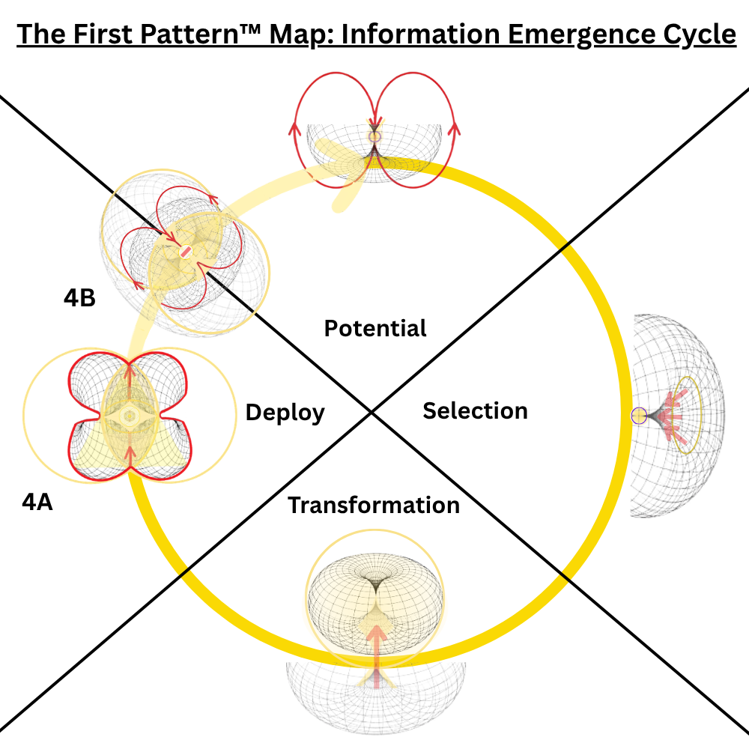
Figure 1. The Information Emergence Cycle (IEC). The invariant four-phase lifecycle proceeds Q1 → Q2 → Q3 → Q4, with Q4 branching into continuation (Q4A) or reorientation (Q4B → Q1).
5. The Energy Integration Loop (EIL)
Status: Not yet validated. The following is theoretical.
The EIL is TFP's second proposed loop structure, complementary to the IEC. Where the IEC is information-based and observer-perspective (outside-in), the EIL is energy-based and decider-perspective (inside-out). Q4A is the beginning and end of the EIL cycle.
Key properties:
- EIL is rare and conditional. It requires sufficient energy and alignment to activate. Most systems run IEC most of the time. EIL activates when things are working — during successful deployment and propagation.
- EIL has a flipping/merging dynamic: subject and object merge, flip, separate, and merge again. This continues as long as energy is sufficient. When energy drops, the system falls back to Q4B and IEC.
5.1 IEC vs EIL Comparison
Property | IEC | EIL
Perspective | Observer (3rd person) | Decider (1st person)
Direction | Outside → in | Inside → out
Substance | Information-based | Energy-based
Anchor quadrant | Q4B (reorient) | Q4A (propagate)
Frequency | Common (default mode) | Rare (requires prior IEC success)
External signature | High variability, visible transitions | Low variability, stable repetition

Co-existence. IEC and EIL are not sequential. They are co-existing structures — always both present. IEC is the circulatory structure (invariant pattern). EIL is the blood flowing through it (variable energy). One cannot exist without the other.
Speed inversion. IEC is externally fast (visible transitions) but internally slow (each stage builds stability sequentially). EIL is externally slow (stable repetition) but internally fast (uses compressed memory of prior IEC processes).
6. Structural Properties
6.1 Space/Time Ratio
The ratio of structured/committed behavior to open/exploratory behavior shifts across the lifecycle:
Quadrant | Space | Time | Character
Q1 | 1% | 99% | All potential, no structure. Tiny seed with infinite possibilities.
Q2 | Shifting | Shifting | Selecting, filtering potential into structure.
Q3 | Shifting | Shifting | Fusing, transforming into committed form.
Q4 | 99% | 1% | All structure, no potential. Fully committed, fully deployed.

At Q4B → Q1, the ratio resets.
6.2 Q2 and Q4B Polarity
- Q2 is the most fundamental energy expression of the IEC.
- Q4B is the most fundamental information expression of the IEC.
They are two sides of the same coin — the beginning and end of the information emergence cycle.
7. Domain Examples
TFP's IEC structure appears across multiple domains with consistent operator mappings. The following are proposed mappings — some are well-supported empirically, others are theoretical analogies.
7.1 Fertilization (Strongest Biological Example)
- Q1: Readiness (sperm capacitation, stabilization).
- Q2: Selection/Binding (egg selects via zona pellucida).
- Q3: Genetic Fusion (pronuclei merge into new entity).
- Q4A: Cell Division (pattern replicates).
- Q4B: Differentiation (cells specialize, new cycle begins).
7.2 Evolution
- Q1: Genetic variation.
- Q2: Natural selection.
- Q3: Recombination.
- Q4A: Reproduction.
- Q4B: Adaptation.
7.3 DNA Replication
- Q1: Stable blueprint.
- Q2: Enzyme binding at origin.
- Q3: Nucleotide fusion.
- Q4A: Strand elongation.
- Q4B: Proofreading/reset.
7.4 Four Fundamental Forces
- Q1 (Potential): Gravity.
- Q2 (Selection): Strong Nuclear Force.
- Q3 (Transformation): Weak Nuclear Force.
- Q4 (Deployment): Electromagnetic Force.
7.5 Business and Innovation
- Q1: Insight gathering.
- Q2: Team alignment.
- Q3: Product building.
- Q4A: Scaling.
- Q4B: Pivot.
7.6 Compute Cycle
- Q1: Load/prepare.
- Q2: Memory fetch.
- Q3: Execute/transform.
- Q4A: Store/distribute.
- Q4B: Recompile.
7.7 Self-Development
- Q1: Inner potential.
- Q2: Path selection.
- Q3: Identity crystallization.
- Q4A: Skill scaling.
- Q4B: Reassessment.
7.8 Objective Personality (Animals)
- Q1: Sleep.
- Q2: Consume.
- Q3: Blast.
- Q4: Play.
Based on the work of Dave Powers and Shan Renee on Objective Personality, which informed aspects of TFP.
8. What Has Been Validated
Claim | Status | Evidence
4-phase lifecycle structure | Validated | Consistently beats 2/3-state alternatives
Q2→Q3 unidirectional flow | Validated (Paper 4) | AI = -0.92, 4 domains
Q2-Q3 structural opposition | Validated (Paper 4) | rho = -0.75, 100% of 84 individuals
Q4B viability-gated reseeding | Validated (Paper 4) | p = 3.9e-83, 20/20 universal
Q2-Q4 non-interchangeable stage functions | Validated (Paper 5) | #1 of 6 permutations, 92% gap, 4 domains
HMM independent convergence | Validated (Paper 5) | Same binding recovered unsupervised
Dual-memory dissociation | Validated in simulation (Paper A) | Existence proof
Cross-dataset attribution | Validated empirically (Paper B) | Battery data
Depletion-gated reorientation | Validated, scoped (Paper C) | Foraging mechanism
Q1 internal orientation | Not yet validated | Requires process-tracing
Q4A deployment continuation | Not yet validated | Requires multi-stage tracking
EIL dynamics | Not yet validated | Theoretical, hard to measure
B_in independent validation | Partial (3/4 operators tested) | B_in not independently tested
Non-institutional generalization | Not yet tested | Biological/ecological future work
Four-operator irreducibility | Not tested | Is 4 the minimum?
Operator order within quadrants | Not tested | Entry→exit sequence untested

9. Confidence Hierarchy
Ranked from most to least confident:
- The Information Emergence Cycle exists as a conserved structure.
- Four operators produce four distinct quadrants based on operator order.
- Each quadrant involves an entry and exit operator.
- (Lower confidence) The two fundamental loops (IEC and EIL) as co-existing structures.
10. Epistemological Ordering
The correct order for TFP research, established through systematic experimental iteration:
- Invariant: Lock a testable behavioral claim (architecture-independent).
- Mechanism: Identify the abstract behavioral pattern that satisfies the invariant.
- Architecture: Implement the mechanism in specific code.
- Interpretation: Map results back to TFP theory.
Key principle: Test TFP as emergent geometry (look for it in data), not as a prescriptive algorithm (impose it on agents). Observational studies have consistently succeeded where prescriptive experiments have not.
11. Open Questions
- Is 4 really the minimum number of phases, or could 3 work?
- Does operator order within quadrants (entry → exit) matter, or just composition?
- Can EIL be measured empirically?
- Is the Q4A/Q4B bifurcation truly binary, or is there a continuum?
- What are the domain boundary conditions — which systems do not show TFP structure?
- How does TFP relate to existing frameworks (explore-exploit, optimal foraging, phase transitions)?
- What is the minimal internal generator that could reproduce TFP's surface invariants?
- What quantitative predictions can TFP make (phase durations, transition probabilities)?
12. Acknowledgments
The author acknowledges the work of Dave Powers and Shan Renee on Objective Personality, which informed aspects of The First Pattern framework.
Author
Austin Ollar — ORCID: 0009-0002-9998-9287

