Design Document

- Description of the Project/App
The Play Gym app is an application which tracks a member’s progress. The user can log their measurements as often as they like. The app will calculate the user’s BMI based on their latest assessment and indicate their BMI Category. The application indicates if the user’s weight is in the ideal weight category according to the Devine formula. The user can also see how their assessment compares to the previous assessment using red/blue/green trend indicators. The trainers can log in and view the list of members in the Play Gym. The trainer can view the members assessments and can leave a comment.
- Goals
  - What is the purpose of the App
    - Allow trainers to easily view a member’s progress in a user friendly dashboard.
    - Store a member’s assessment information and clearly display the member’s weight metrics including BMI and Ideal Weight.
  - What is the scope of the App
    - The app will accept numbers only for the assessments.
    - Previous assessments cannot be edited.
    - Assessment dates are set to the date of entry by default. User cannot upload assessment information for a previous date.
    - Trainers are unable to add assessment information for the members.
- User Experience
  - Personas
    - Members: Members will use this application to track their fitness progress. Members will store their assessment information on the application. They are able to register and enter their information. Once they enter an assessment the assessment is dated and the members BMI is calculated. There is an Ideal Weight indicator which tells the member if their weight is within 2kg of the ideal weight. On the dash board they are also able to see the Trainers comments. Their progress is colour coded using the trend label.
    - Trainers: This application will make it simple for trainers to track their clients’ progress. Trainers can log in and view all the members’ assessment information. On log in they are presented with a list of members’ names and number of assessments. From here they can select a member and view their assessments. They can view the information the same as the member, however they have an option to comment on the members’ assessments.
  - Scenarios
    - Member adding their assessment: A member has begun a new fitness plan. They have just finished their week. Before beginning they input their measurements into the Play Gym app. The log in, and input their assessments after week 1. They Play Gym app displays all previous measurements. The member can see their trend – red if they are further from their ideal weight, green if they are closer and blue if their weight is unchanged. They can see their BMI value change once a new assessment has been entered. They are also able to see their BMI Category.
    - Trainers checking the progress of their clients: A trainer has been unable to meet all their clients this week. They want to check if the members have been making progress this week. They log in and select the members they didn’t get to meet. They can see their most recent assessments. Some members have done very well, the trainer will comment to say “Well done!”. Some members didn’t reach their goals for this week. The trainer can comment to motivate the member to keep working towards their ideal weight.
    - Member checking feedback on their progress: One member has not been happy with their progress for the week. They have not met their goals and are feeling down. They logged an assessment yesterday and haven’t been motivated to work out. They log in and see the trainer has left a comment motivating them to keep going.

- Content Structure & Navigation
  - Content Inventory:
  - Content Grouping and Labelling [Table of Contents]
- Start
  - Login
  - Member
      - Dashboard
      - Account Settings
      - About
  - Trainer
      - Trainer Dashboard
      - Member
      - Account Settings
      - About
  - Signup
  - Context Diagram 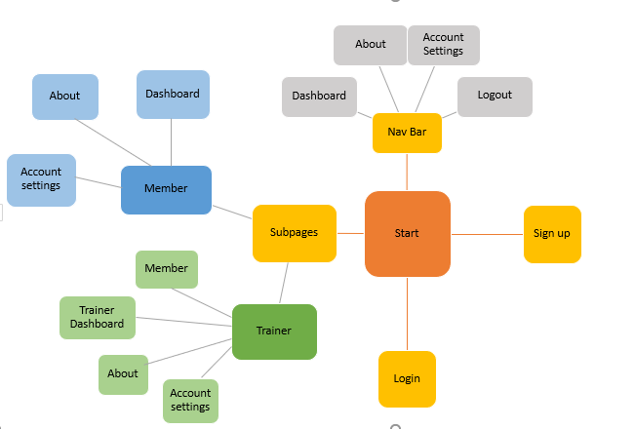
  - Flow Diagram [*1 as appropriate using same software as above]
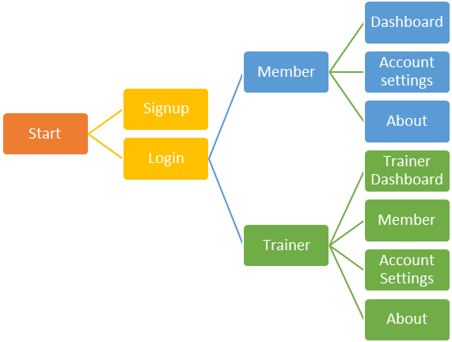

- Visual Design
  - Mock-Ups
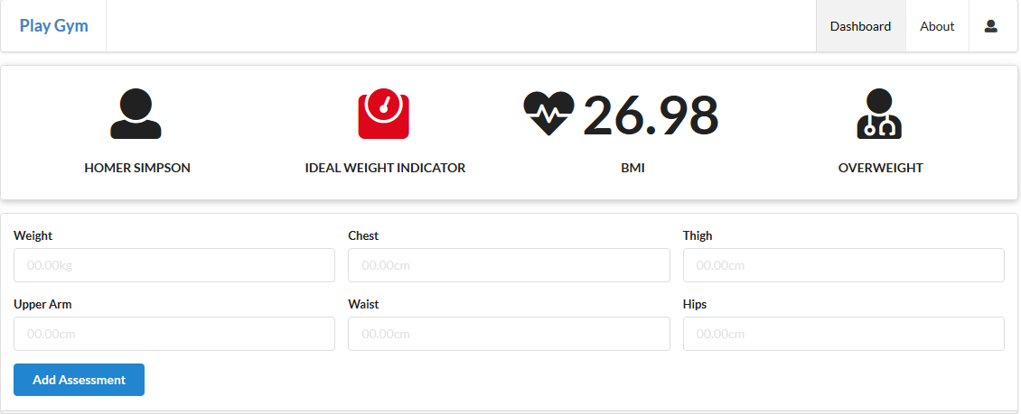

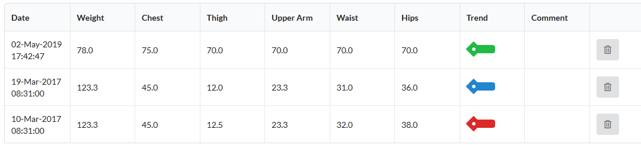
Content Inventory
Home
Start | About | http://playgym-aol.herokuapp.com/ | Provides a brief description of the application
Signup | Signup | http://playgym-aol.herokuapp.com/signup | Allows members to enter their details and register for the website
Login | Login | http://playgym-aol.herokuapp.com/login | Members can login using their email and password
Member
Dashboard | Dashboard | http://playgym-aol.herokuapp.com/dashboard | The Member can view a summary of their metrics.  They can add new assessments easily.  They can view their assessments in order from newest to oldest including a trend which indicated if their assessment is better or worse than the previous one.  They can view the comments left by their trainer.  They can delete any assessment
Account Settings | Account Settings | http://playgym-aol.herokuapp.com/accountsettings | The member can view and update their account setting by entering the new value and hitting the Edit button.
About | About | http://playgym-aol.herokuapp.com/about | Provides a brief description of the Play Gym App
Trainer
Trainer Dashboard | Trainer Dashboard | http://playgym-aol.herokuapp.com/trainerdashboard | Trainers can view a list of members and the number of assessments they have.  Trainers can select a member to see more information.  Trainers can delete members from the application.
Trainer About | About | http://playgym-aol.herokuapp.com/trainerabout | Provides a brief description of the Play Gym App
Trainer Account Settings | Account Settings | http://playgym-aol.herokuapp.com/traineraccountsettings | Trainer can view and update their account setting by entering the new value and hitting the Edit button.
Member | Member | http://playgym-aol.herokuapp.com/members/3 | Trainers can view a summary of the member's metrics.  They can easily comment on the assessment  They can view the assessments in order from newest to oldest including a trend which indicated if the assessment is better or worse than the previous one.

