11/30/2024

**Breadboard Bakery**

Handling Taxes and HST for The Breadboard Bakery Business

**Amany Omar**

**ID#126 127 166**

**Table of Contents**

**Introduction 2**

**Class Diagram…………………..…………………………………………………………………………………………………………………2**

**Sequence Diagram……………………………………………………………………………………………………………………………..3**

**Controller Classes……………………………………………………………………………………………………………………………….5**

**Wireframe Prototype………………………………………………………………………………………………………………………….6**

**Additional Functionality**

# **Handling Taxes and HST**

**INTRODUCTION**

Requirements

According to the provided Case Study, The Breadboard Bakery owner, Victoria, requested a system that meets specific acceptance requirements that coincide with her growing business needs. One of these requirements is:

* Tracking annual sales earned amount to be able to file HST tax with the Canada Revenue Agency when her sales exceed $30,000 per year.

**UML**

1. Class Diagram

Created class diagram including essential classes, attributes, and operations needed to handle HST calculations and Tax Report generation.

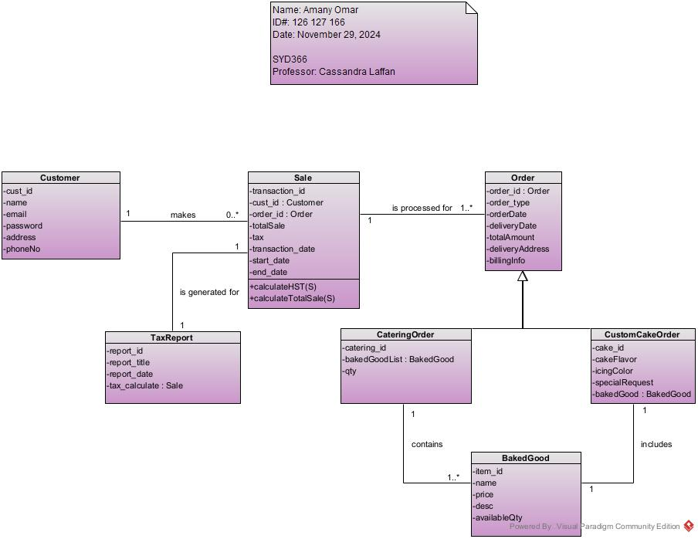

1. Sequence Diagram

Generate Tax Report and Calculate HST(by date range)

Implemented sequence diagram visualizing the process of retrieving sales information within a date range, calculating HST if sales have exceeded $ 30,000 and returning proper messages if there is no need to file tax for a specific year. The sequence diagram use case is as follows:

* 1. Actor: Owner
  2. Preconditions: The owner has opened the Main Menu and logged in to their managing account.
  3. Post Conditions: Sales list retrieved within a required date range, HST calculated, and Tax report is generated to keep track of tax records and documentation.
  4. Alternative Combination: Implemented If condition to proceed to calculate HST if total Sales amount per requested year exceeds $30,000 and return a proper message if sales are below $30, 000.

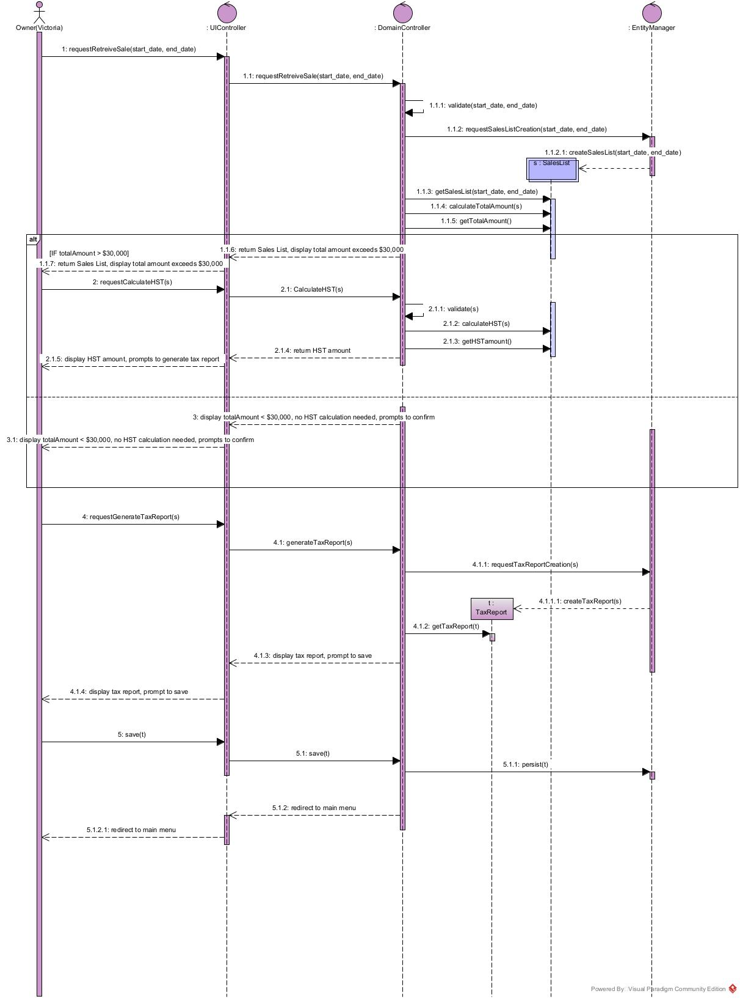

1. Controller Classes

Created Controller Classes including UI Controller, Domain Controller, and Entity Manager listing implemented operations under each controller class.

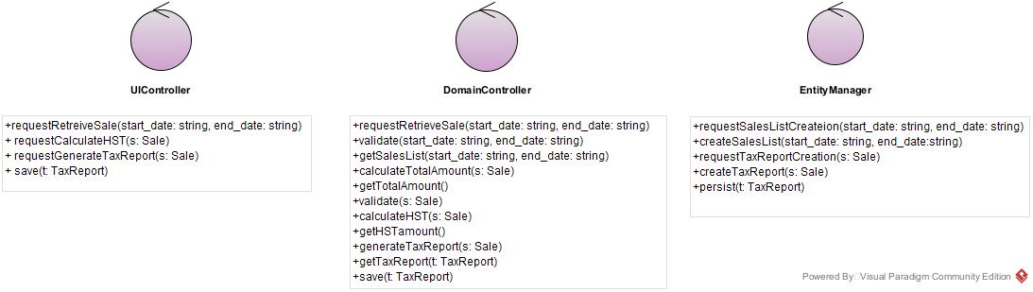

**WIREFRAME MOCKUP**The prototype displays the Sales Dashboard providing a user-friendly functionality to fill in the required date range, allowing options of calculating the total sale amount within the date range, calculating HST, or generating a report and downloading it to file the tax.

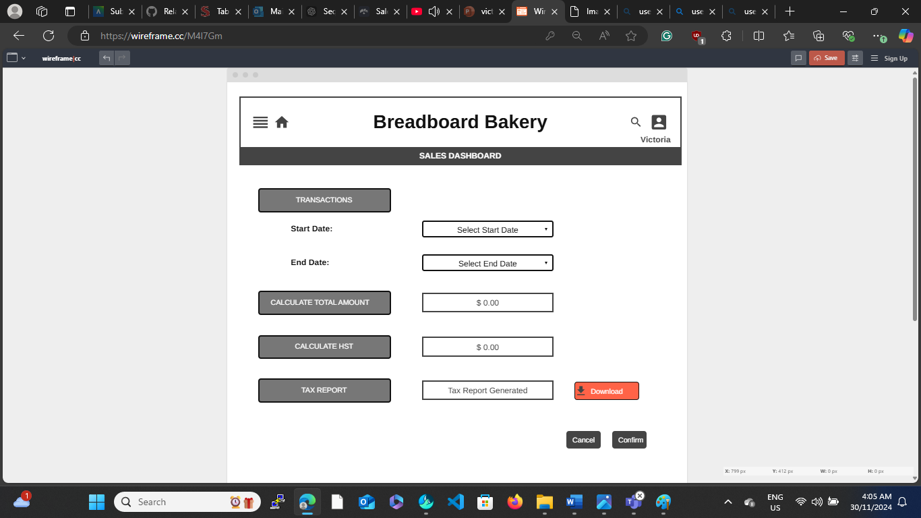

**SUMMARY**  
In response to the Breadboard Bakery business owner to create a system that handles taxes and calculating HST, the proposed design and implementation meets the acceptance requirement of the business owner as it helps to calculate HST on all sales of the chosen year and generate reports needed to file the income tax. It also tracks annual sales records.