UniVision
Application Screenshots & Page Descriptions
University Student Portal System
Generated: June 9, 2026

Table of Contents

Public Pages
1. Landing Page
2. Login Page
Student Pages
3. Student Home / Dashboard
4. Grades Page
5. Attendance Page
6. Performance Comparison
7. Academic Reports
8. Class Schedule
9. GPA Simulator
10. Course Materials
11. CV / Work Section
12. Student Profile
Doctor Pages
13. Doctor Dashboard - Students List
14. Doctor Dashboard - Student Grades Tab
15. Doctor Dashboard - Student Attendance Tab
16. Doctor Dashboard - Student Feedback Tab
17. Doctor Dashboard - Schedule Management
18. Doctor Dashboard - Course Materials Management
Admin Pages
19. Admin Dashboard - Notifications Management
20. Admin Dashboard - Add Student

Landing Page
URL: http://localhost:3001/
Purpose: The public landing page of UniVision. It provides an overview of the platform's features and serves as the entry point for all users. It showcases the system capabilities and provides navigation to the login page.
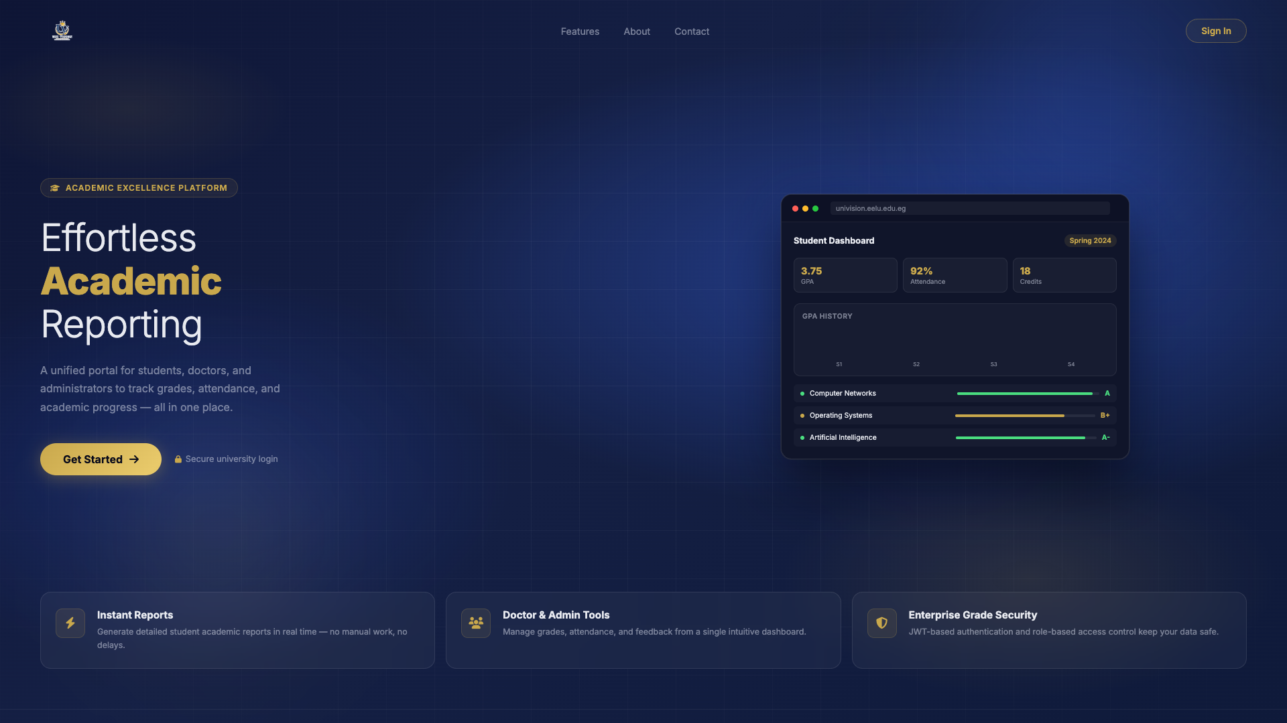

Login Page
URL: http://localhost:3001/login
Purpose: The login page where students, doctors, and administrators authenticate using their National ID and password. It provides secure access to the system with role-based redirection after successful authentication.
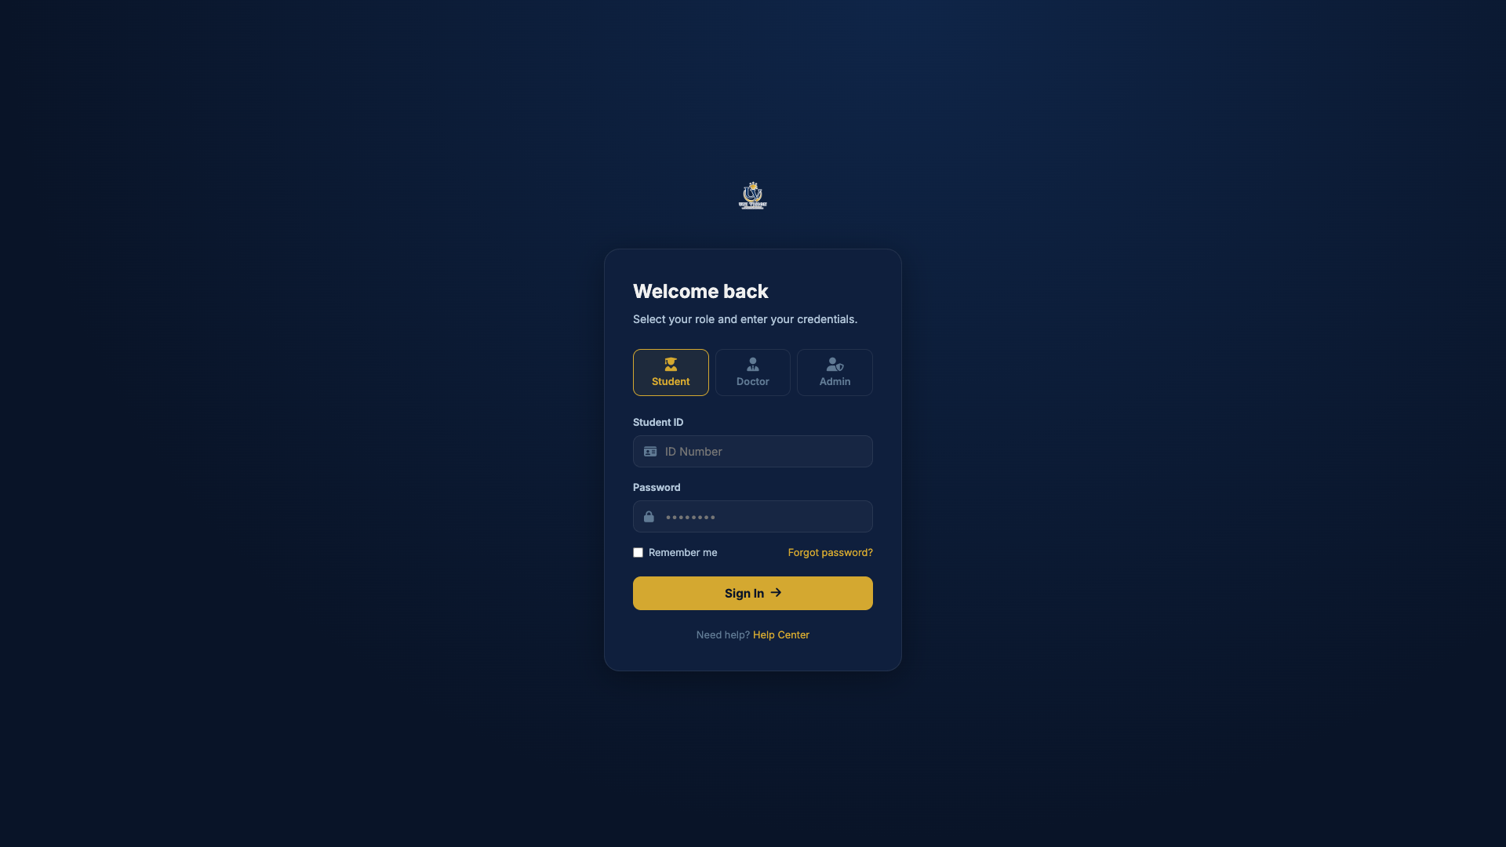

Student Home / Dashboard
URL: http://localhost:3001/home.html
Purpose: The student dashboard displays an overview of the student's academic status including cumulative GPA, current semester performance, today's schedule, recent notifications, and activity summary. It serves as the central hub for student navigation.
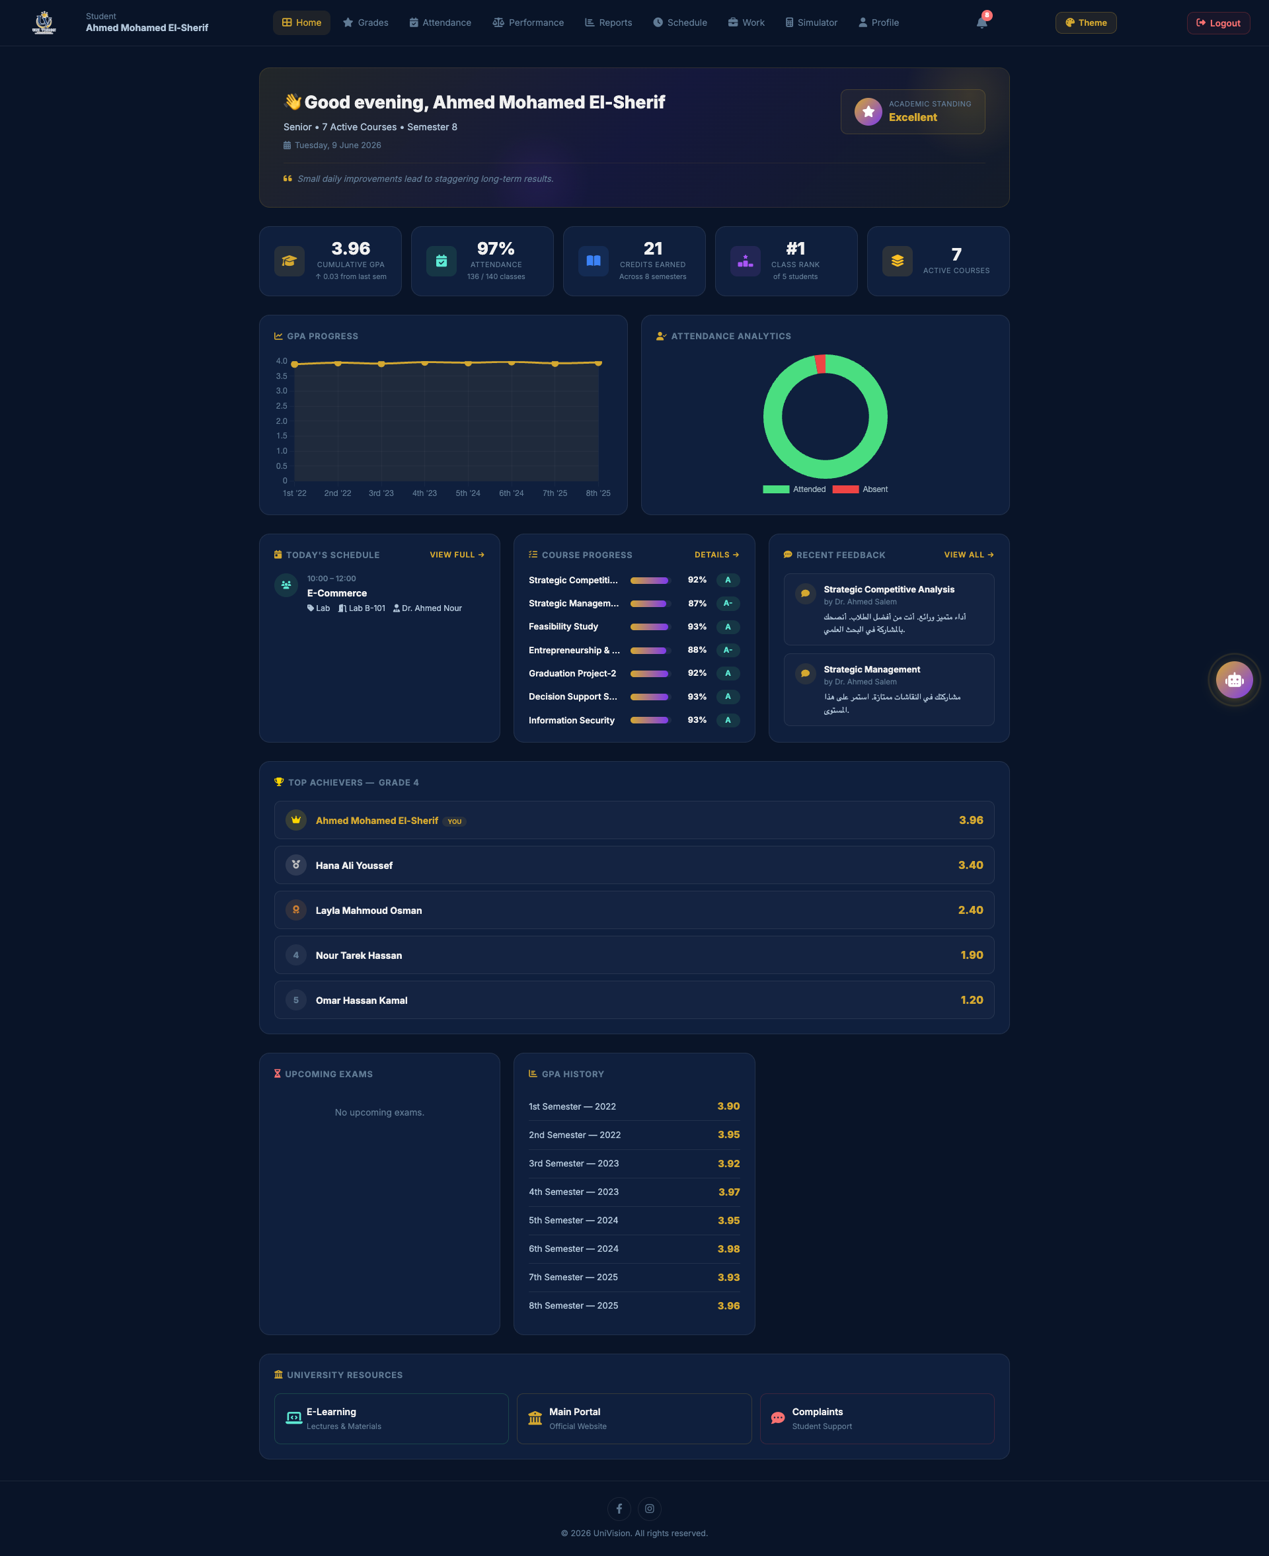

Grades Page
URL: http://localhost:3001/grades.html
Purpose: The grades page shows detailed grade breakdowns for each course the student is enrolled in. It displays midterm, assignments, practical, and final exam scores along with the course instructor information and overall course grade.
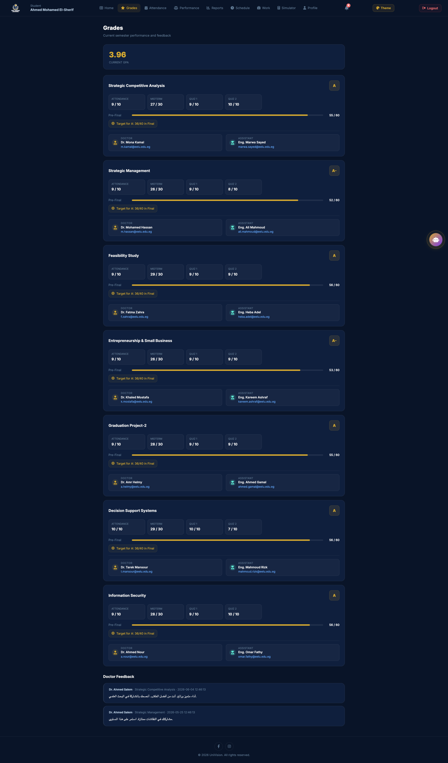

Attendance Page
URL: http://localhost:3001/attendance.html
Purpose: The attendance tracking page displays the student's attendance record for each course. It shows attendance percentage, number of absences, and warnings when attendance drops below acceptable thresholds.
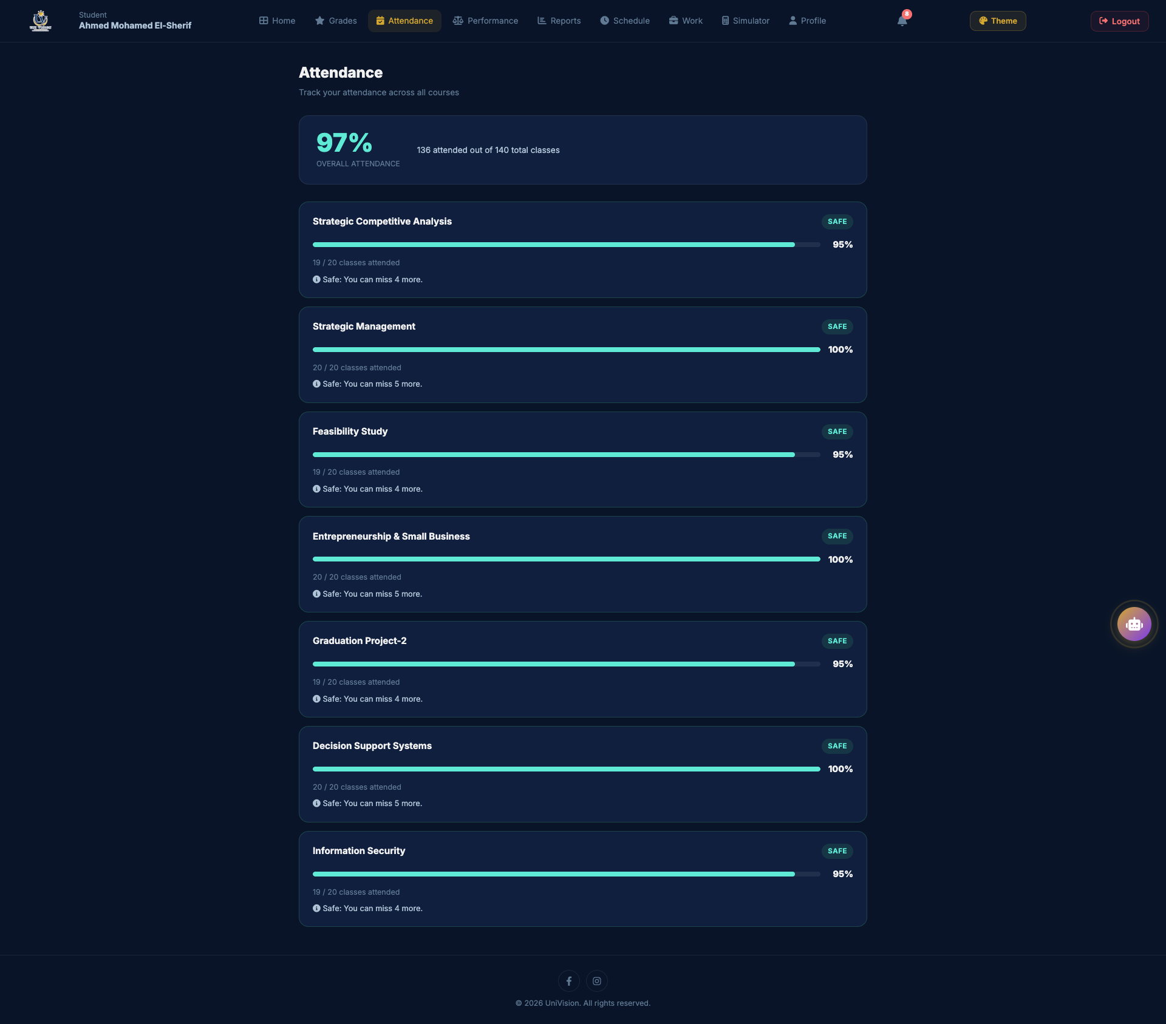

Performance Comparison
URL: http://localhost:3001/comparison.html
Purpose: The performance comparison page allows students to compare their academic performance (GPA, attendance, grades) against class averages and peer rankings. It provides visual charts and statistics to help students understand their relative standing.
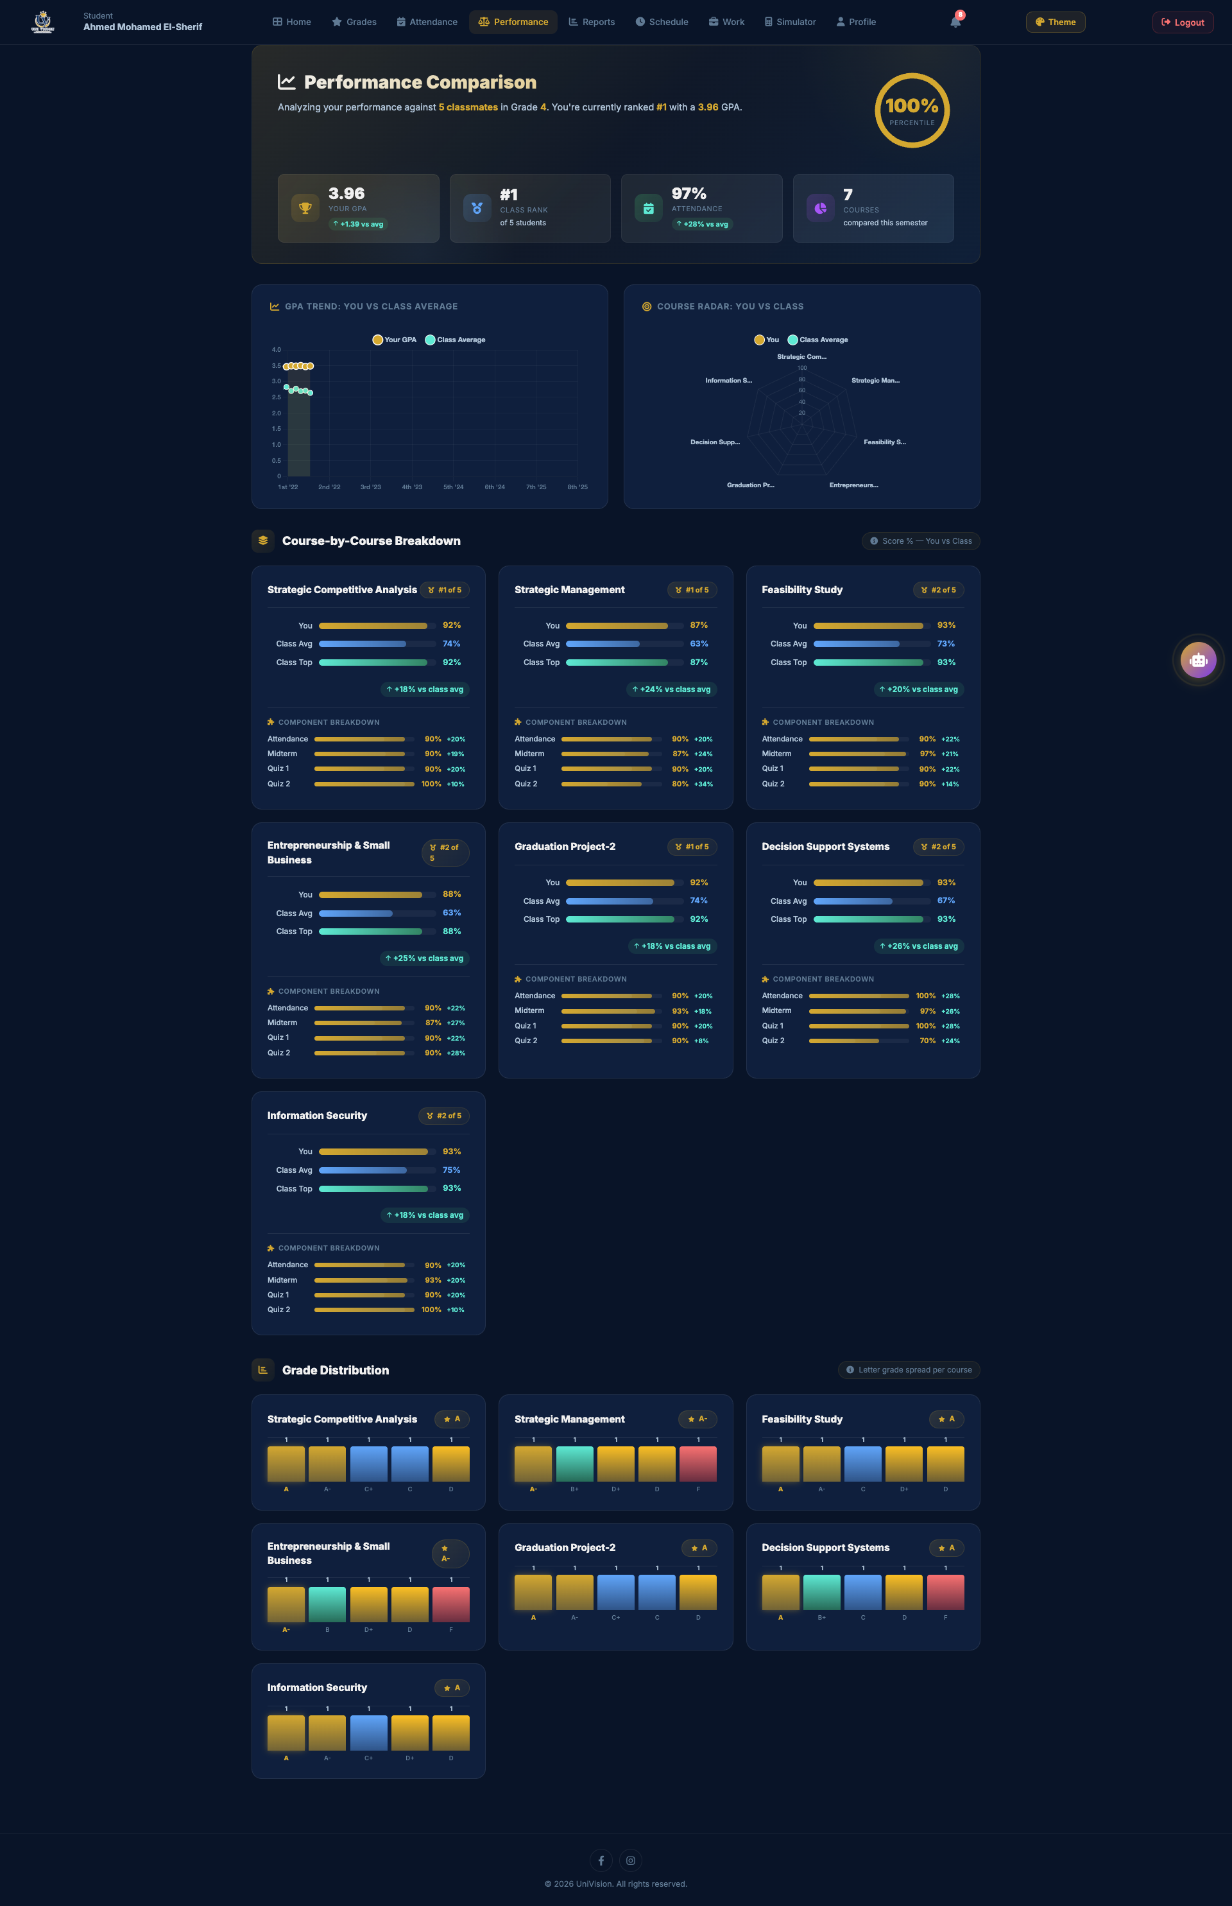

Academic Reports
URL: http://localhost:3001/reports.html
Purpose: The reports page provides access to detailed academic reports for each semester. Students can view comprehensive semester summaries including GPA, course results, and can download/export these reports for their records.
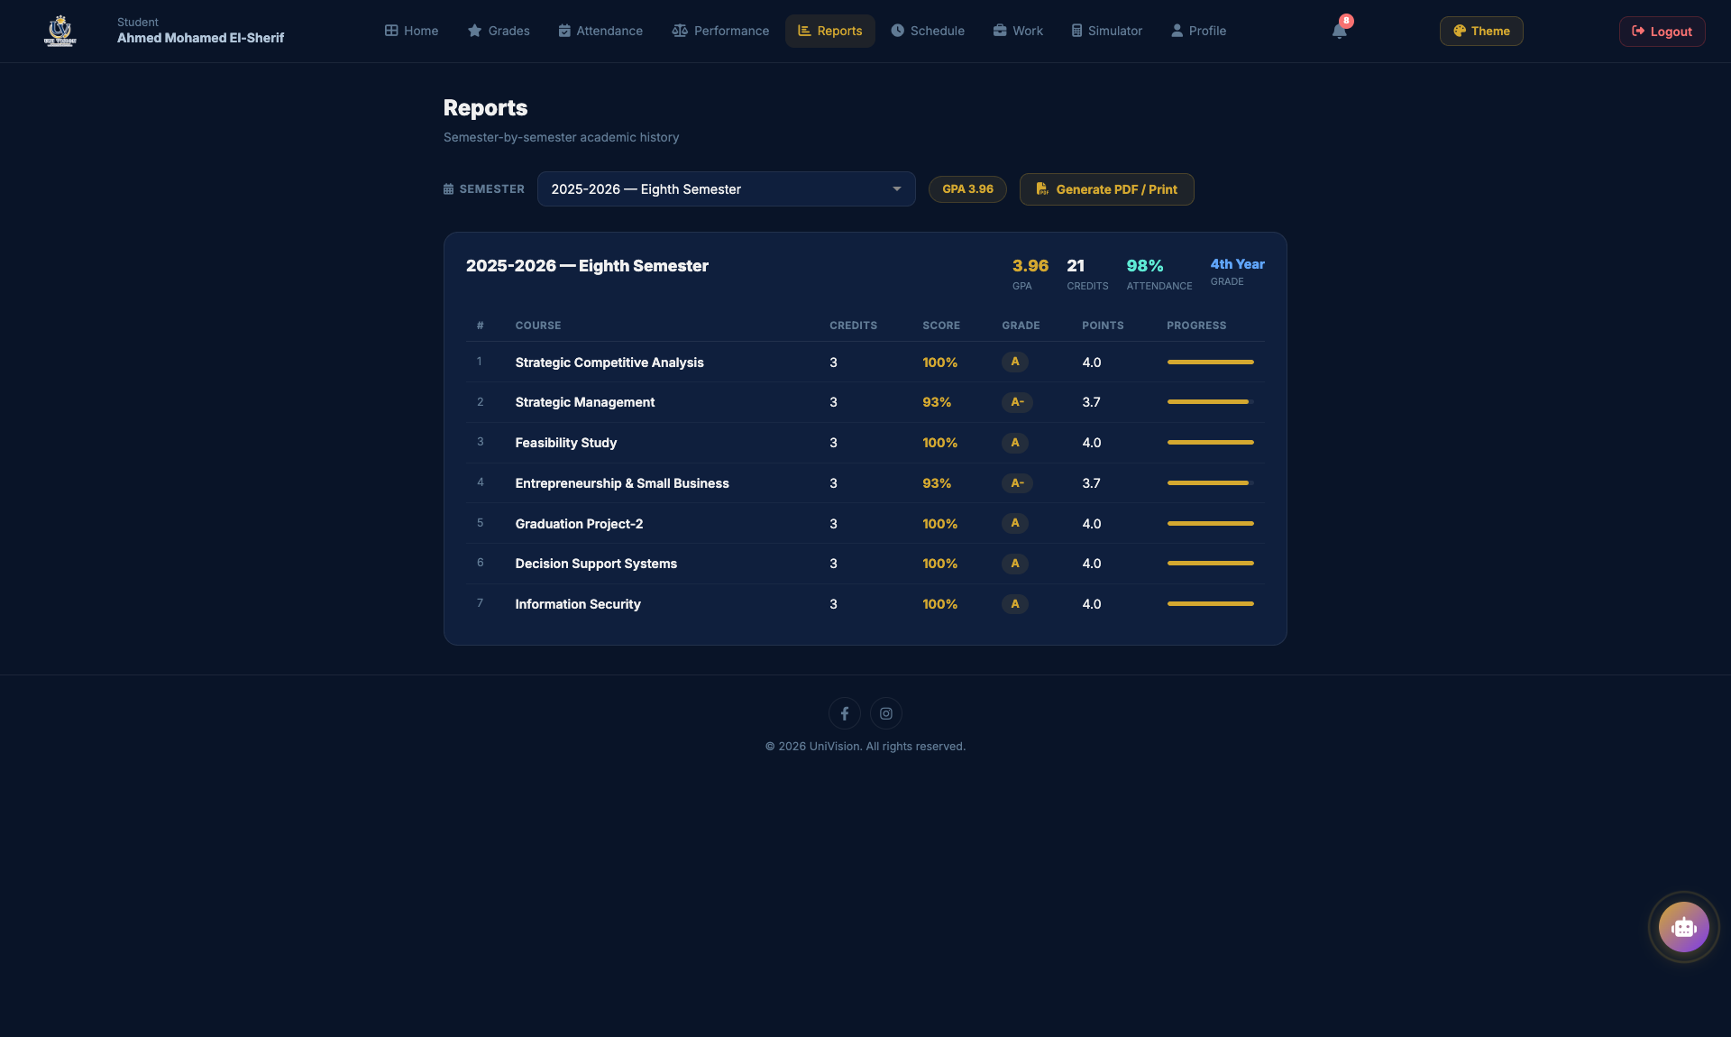

Class Schedule
URL: http://localhost:3001/schedule.html
Purpose: The schedule page displays the student's weekly class timetable. It shows course names, times, locations, and days for all enrolled courses in the current semester in a clear, organized format.
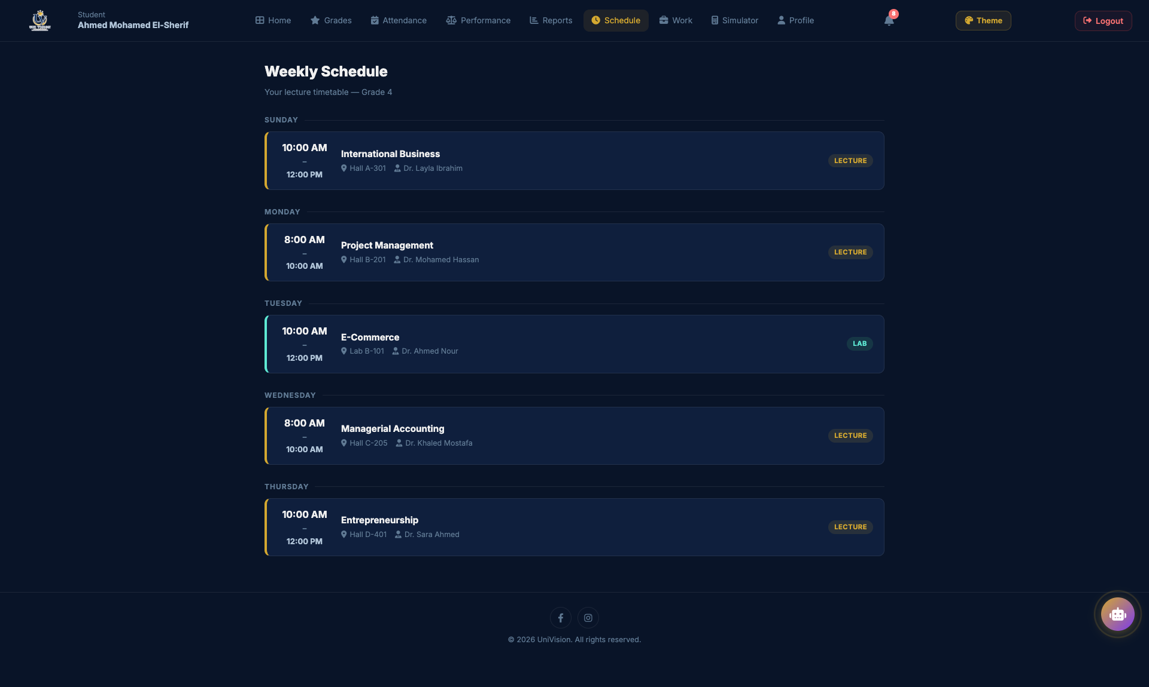

GPA Simulator
URL: http://localhost:3001/simulator.html
Purpose: The GPA simulator allows students to plan their academic goals by simulating different grade scenarios. Students can input expected grades for current courses to predict their semester and cumulative GPA outcomes.
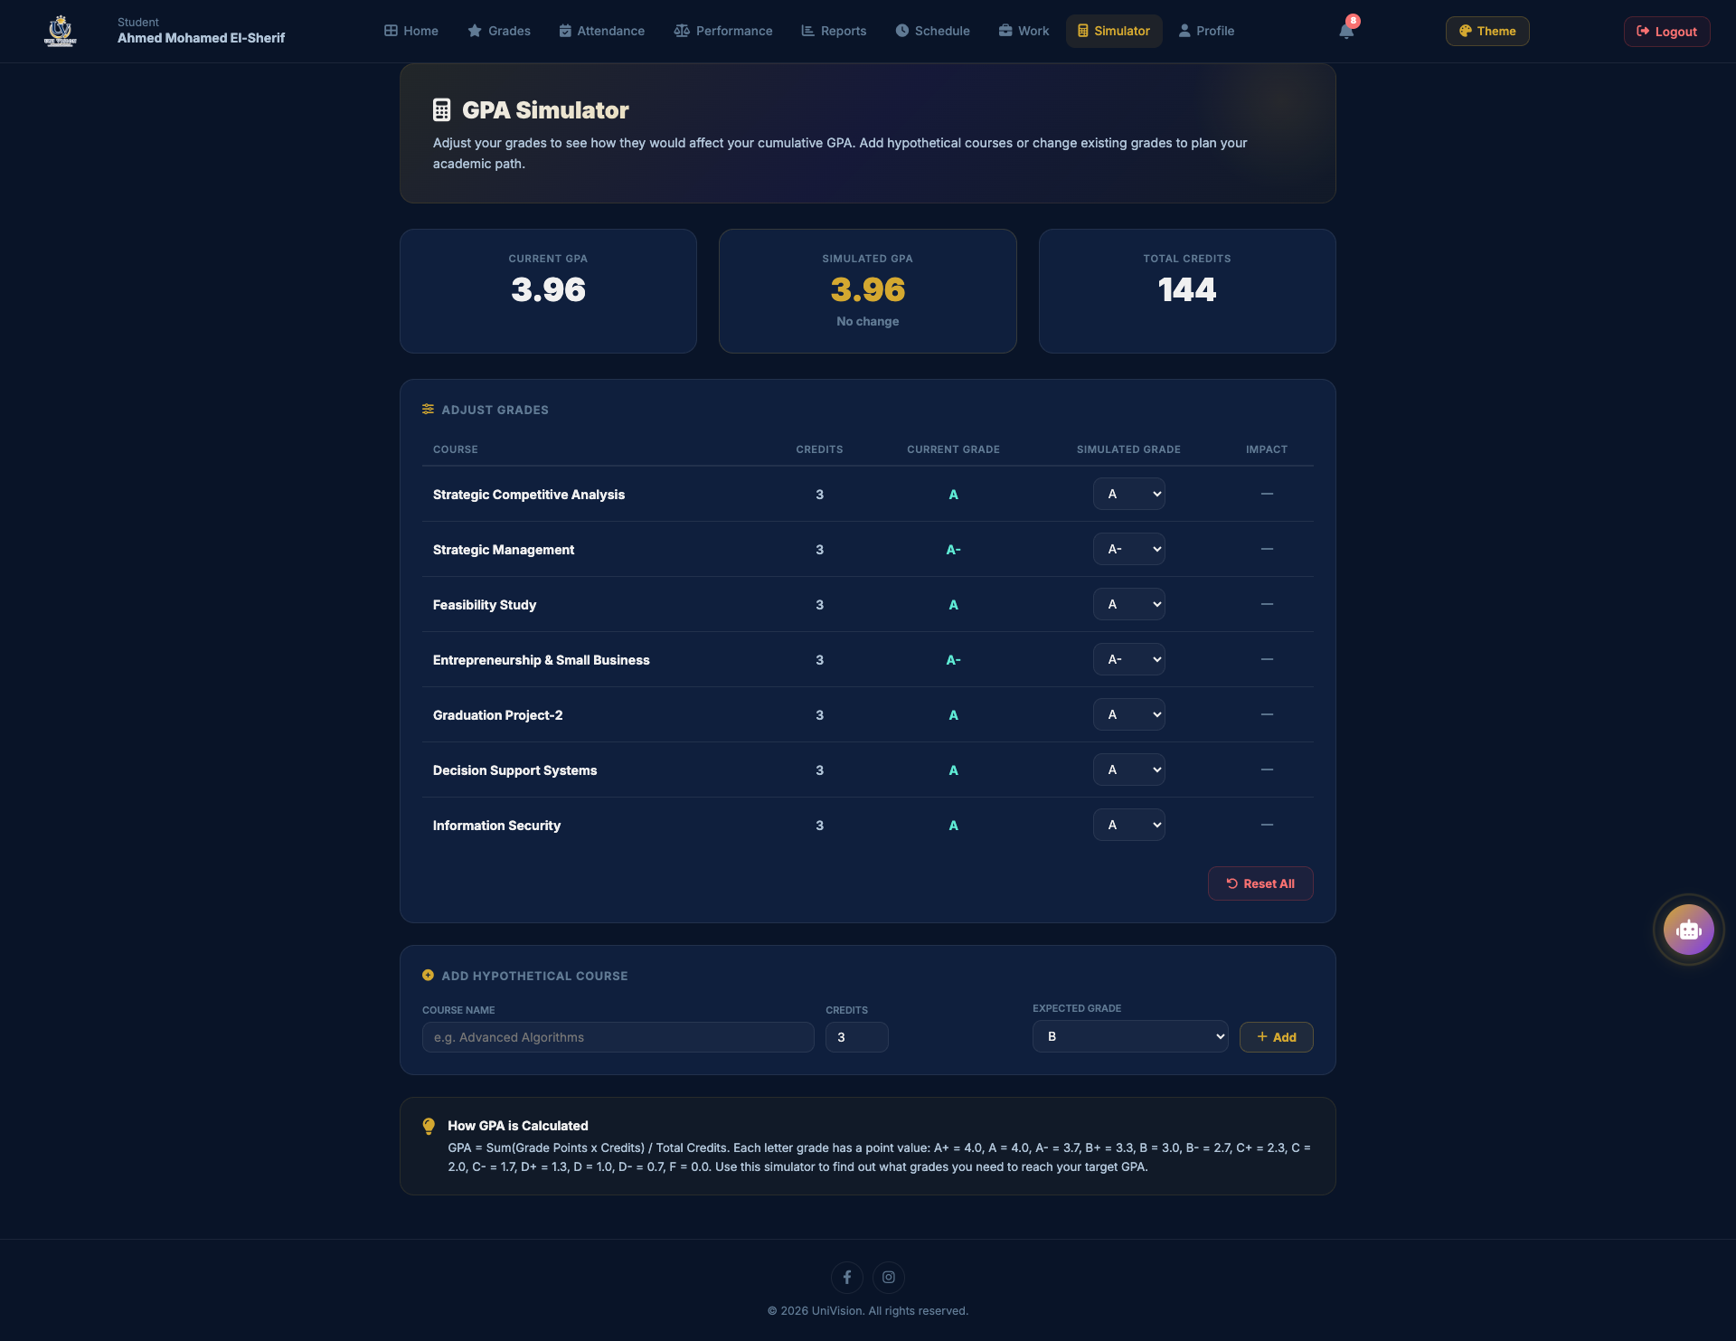

Course Materials
URL: http://localhost:3001/materials.html
Purpose: The course materials page provides access to learning resources uploaded by instructors. It includes lecture notes, PDFs, video links, and other educational materials organized by course for easy access.
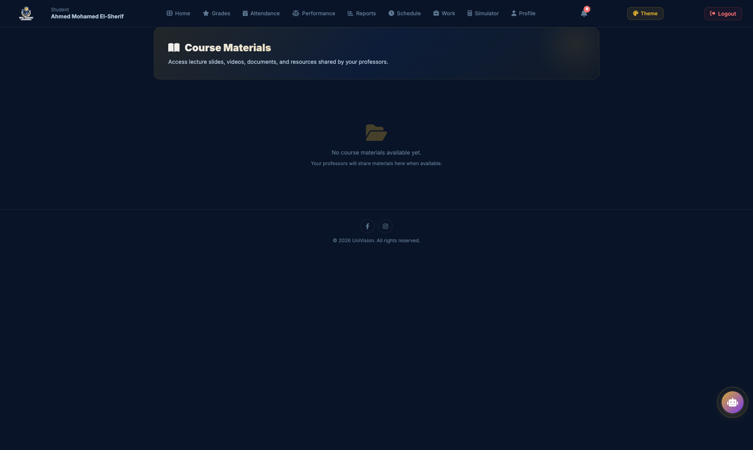

CV / Work Section
URL: http://localhost:3001/work.html
Purpose: The CV/Work section allows students to build and maintain their professional profile. Students can add their skills, experience, projects, and achievements to create a comprehensive curriculum vitae within the platform.
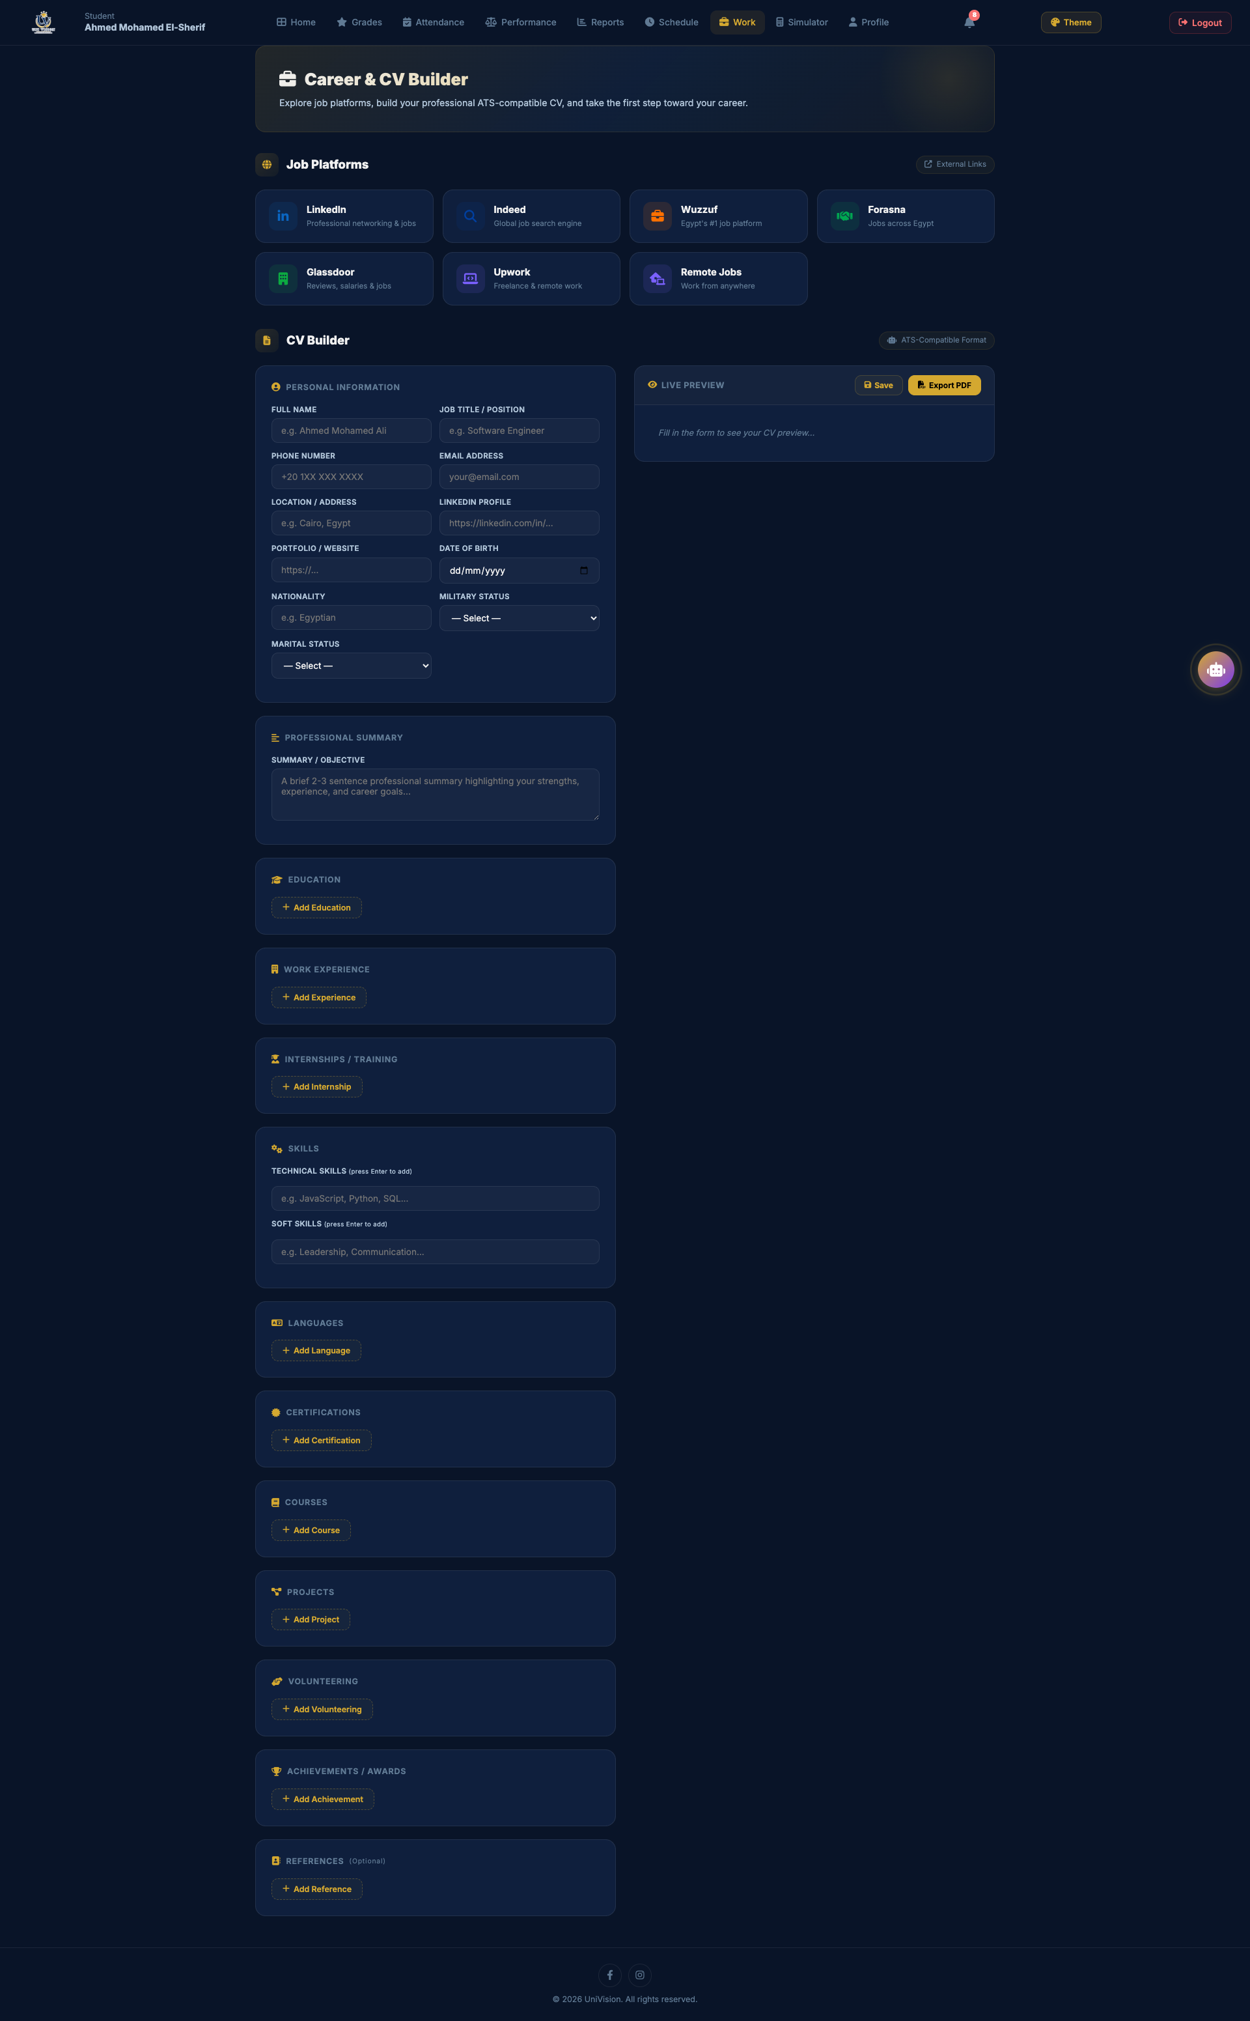

Student Profile
URL: http://localhost:3001/profile.html
Purpose: The profile page displays the student's personal and academic information including name, national ID, department, enrollment year, contact details, and allows students to manage their account settings.
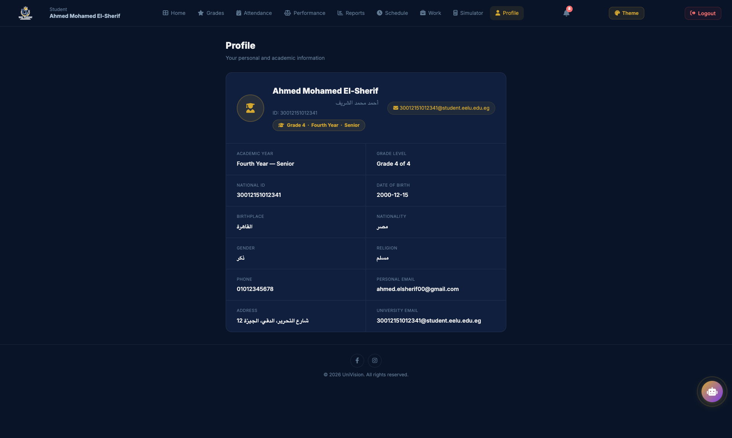

Doctor Dashboard - Students List
URL: Single-page view within the dashboard
Purpose: The doctor's main dashboard view showing a list of all students. Doctors can search, filter by grade level, and select any student to view their detailed academic records, manage grades, attendance, and provide feedback.
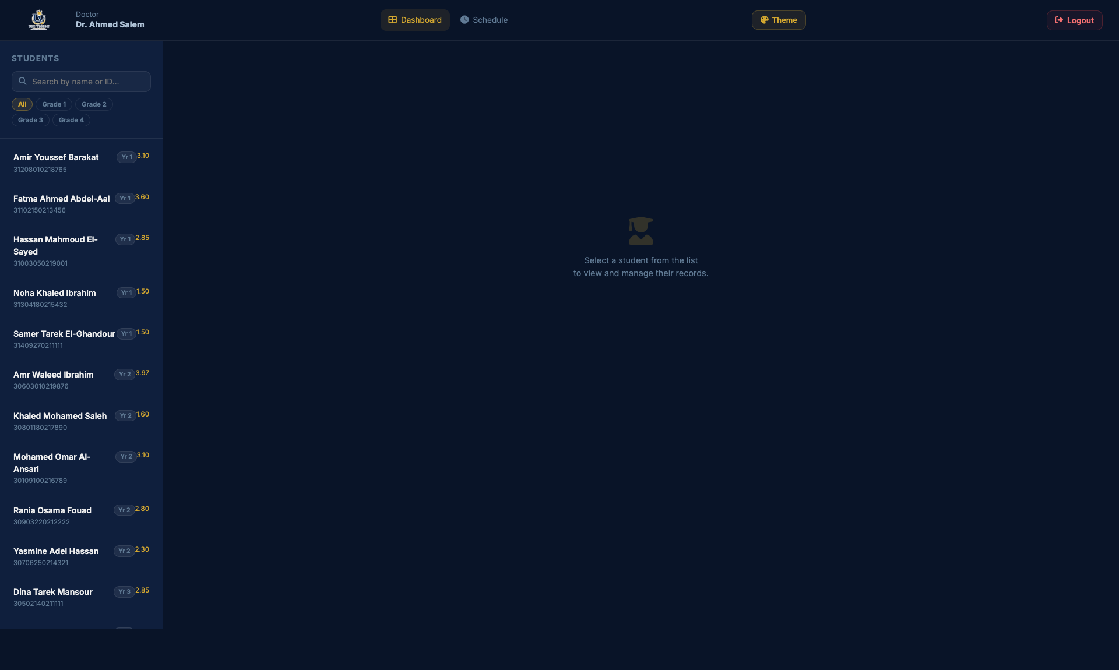

Doctor Dashboard - Student Grades Tab
URL: Single-page view within the dashboard
Purpose: The grades management tab within the doctor dashboard. After selecting a student, doctors can view all their grades across semesters, add new grades, edit existing grades, and see detailed breakdowns of midterm, practical, assignments, and final exam scores.
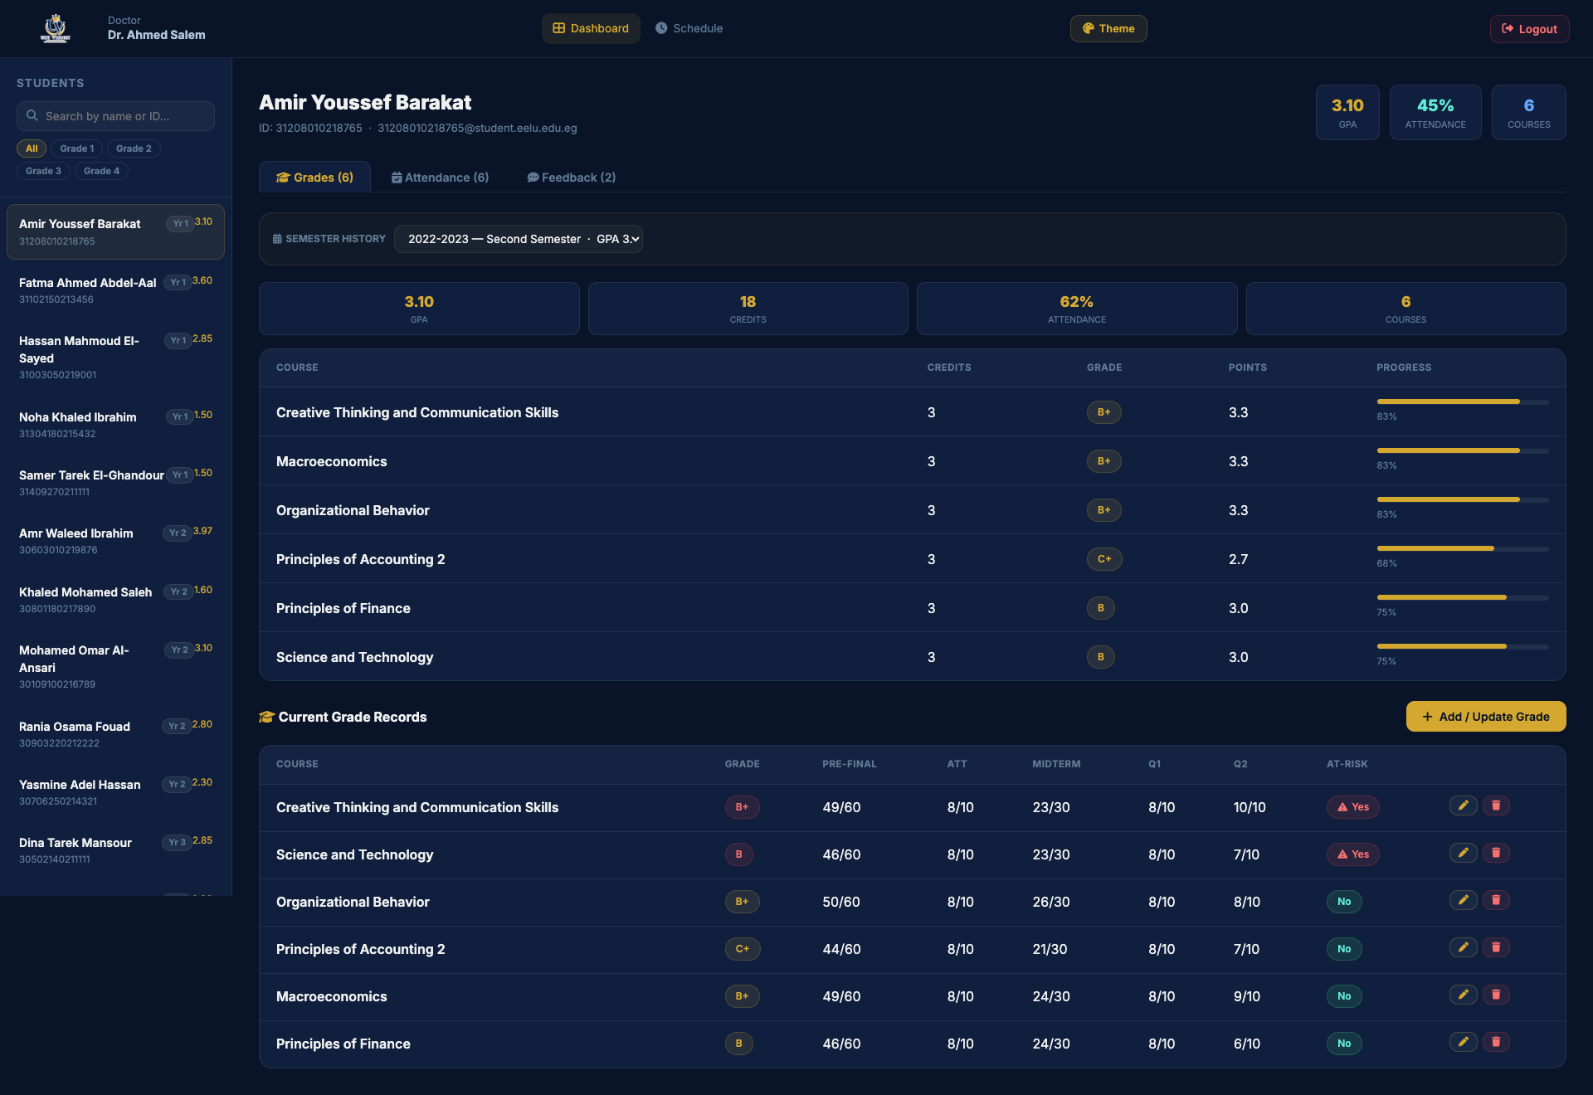

Doctor Dashboard - Student Attendance Tab
URL: Single-page view within the dashboard
Purpose: The attendance management tab within the doctor dashboard. Doctors can view a student's attendance records per course, mark attendance, update records, and monitor absence patterns to identify students at risk.
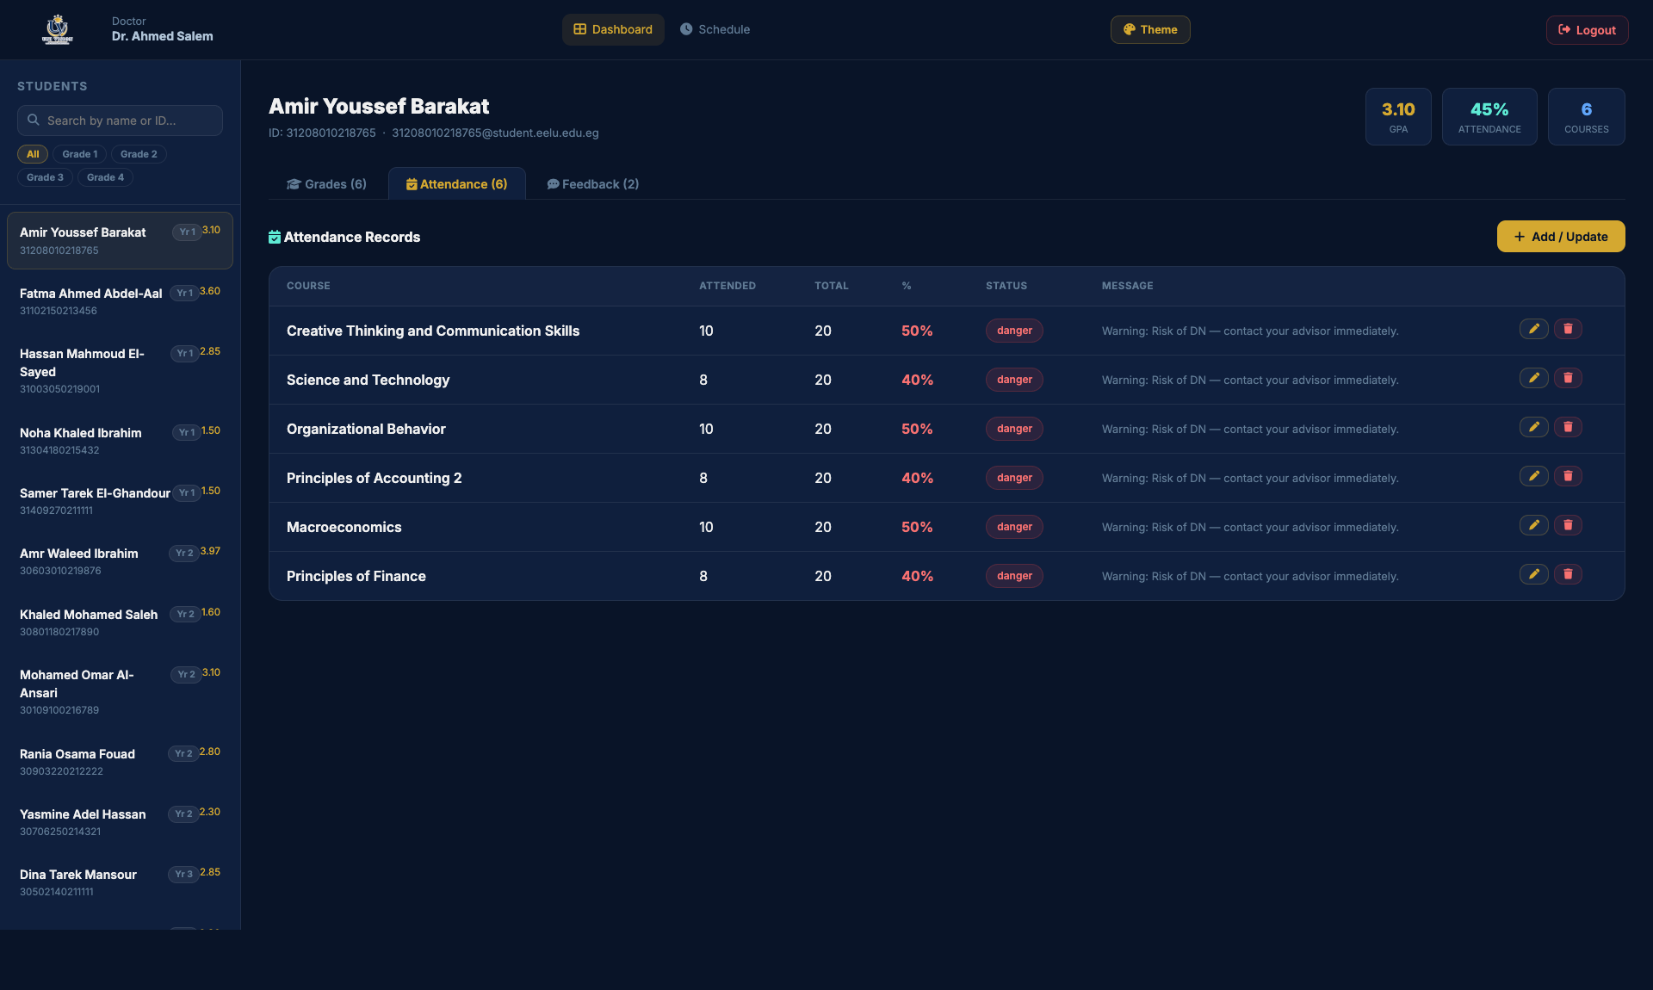

Doctor Dashboard - Student Feedback Tab
URL: Single-page view within the dashboard
Purpose: The feedback tab within the doctor dashboard. Doctors can send personalized feedback to students about their academic performance, provide encouragement, suggestions, or warnings. Previous feedback messages are displayed in a conversation-style format.
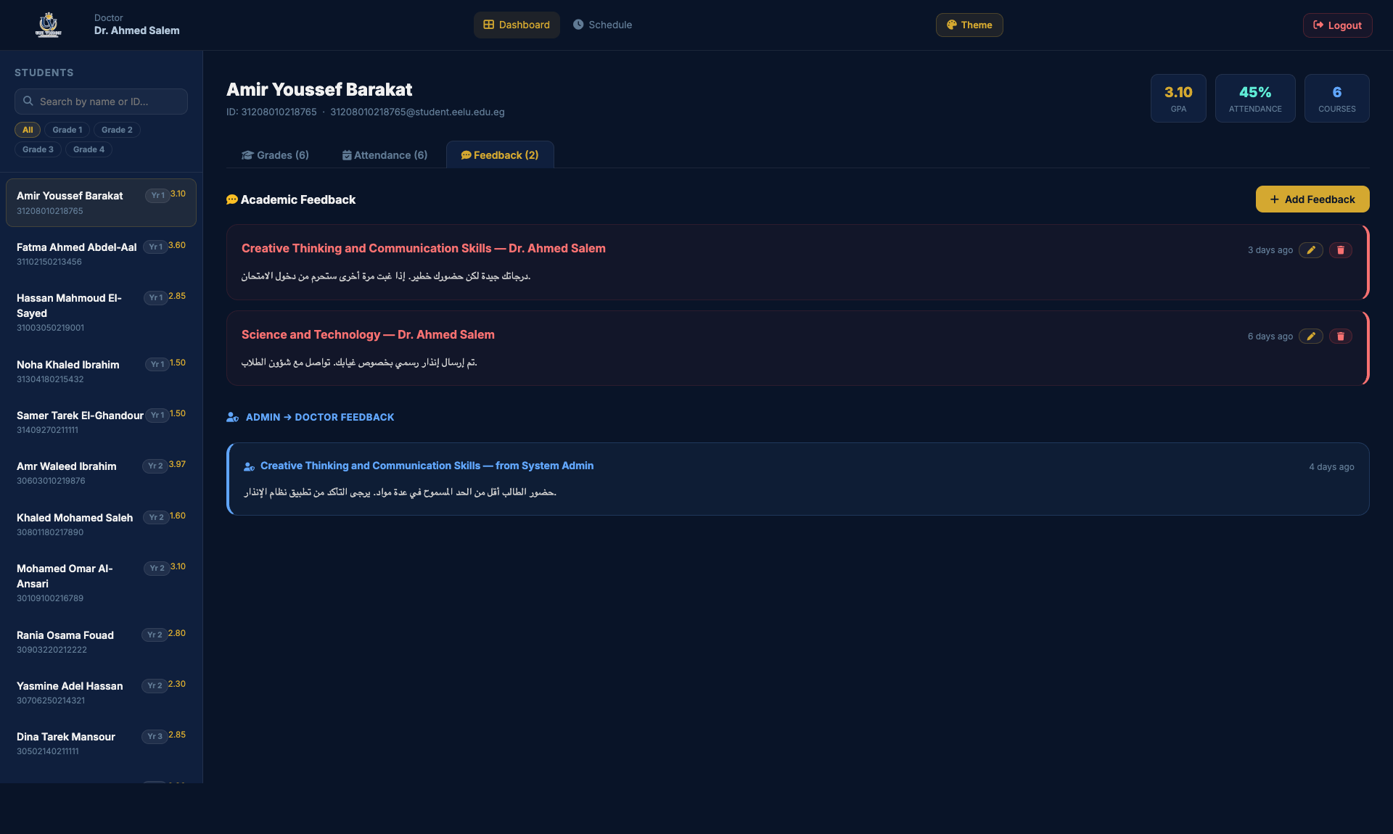

Doctor Dashboard - Schedule Management
URL: Single-page view within the dashboard
Purpose: The schedule management section where doctors can view and manage the class schedule for each semester. They can add new lecture entries, edit times/locations, and organize the weekly timetable for their courses.
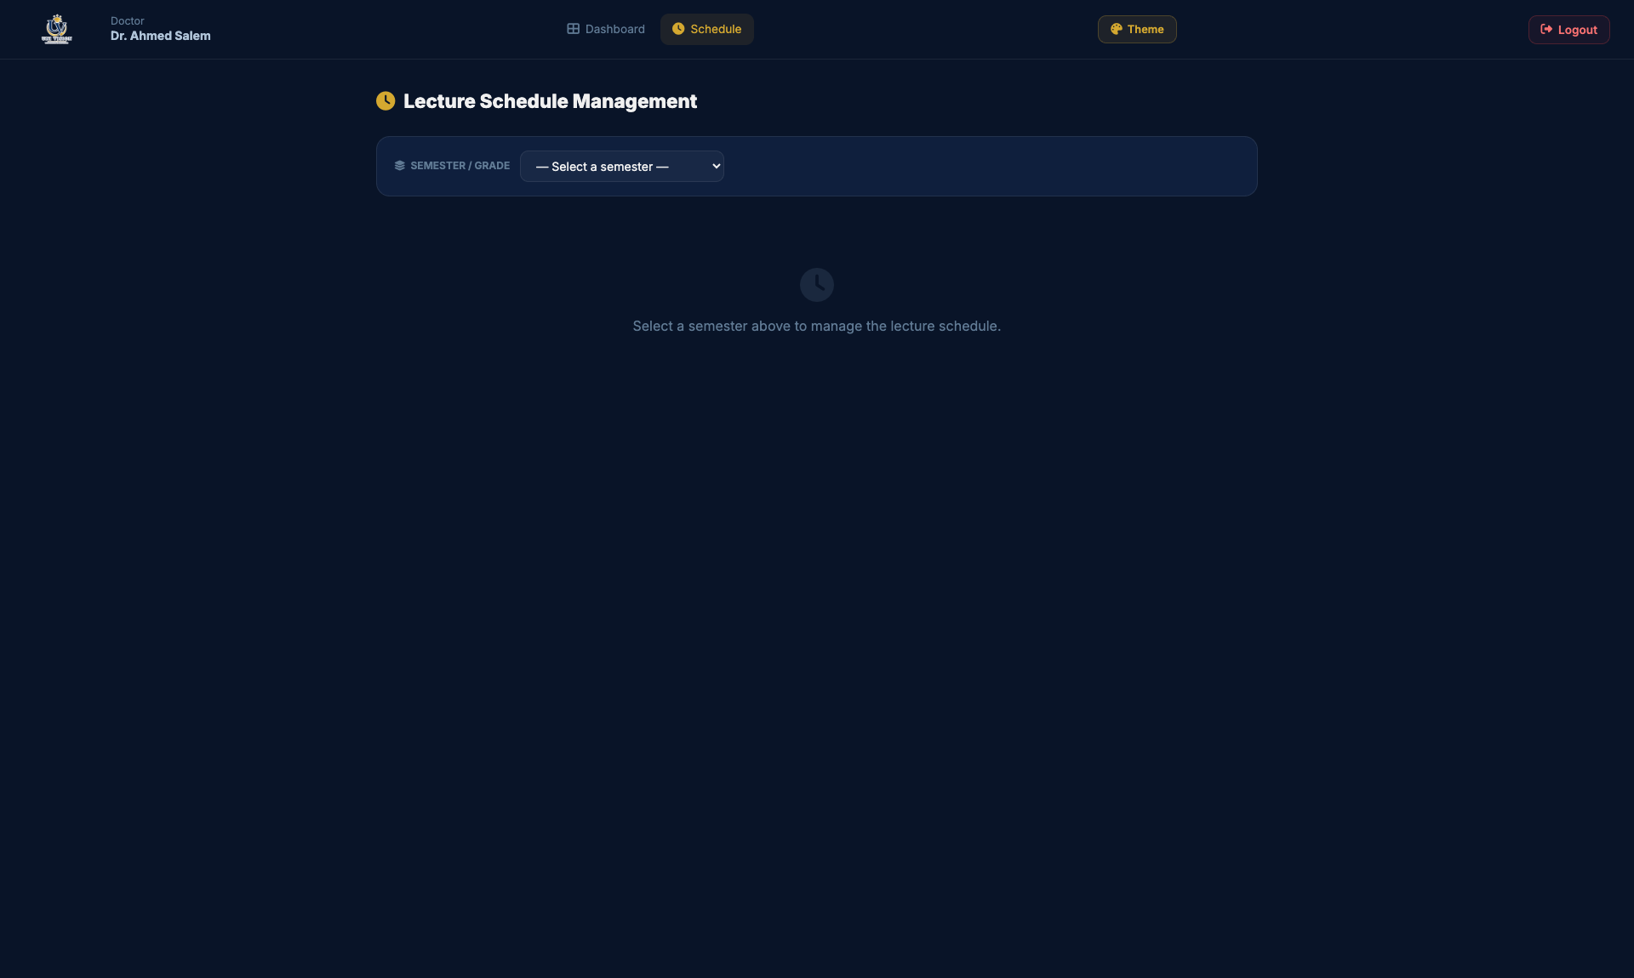

Doctor Dashboard - Course Materials Management
URL: Single-page view within the dashboard
Purpose: The course materials management section where doctors can upload and manage learning resources. They can add links to lecture notes, PDFs, videos, and other educational materials organized by course for students to access.
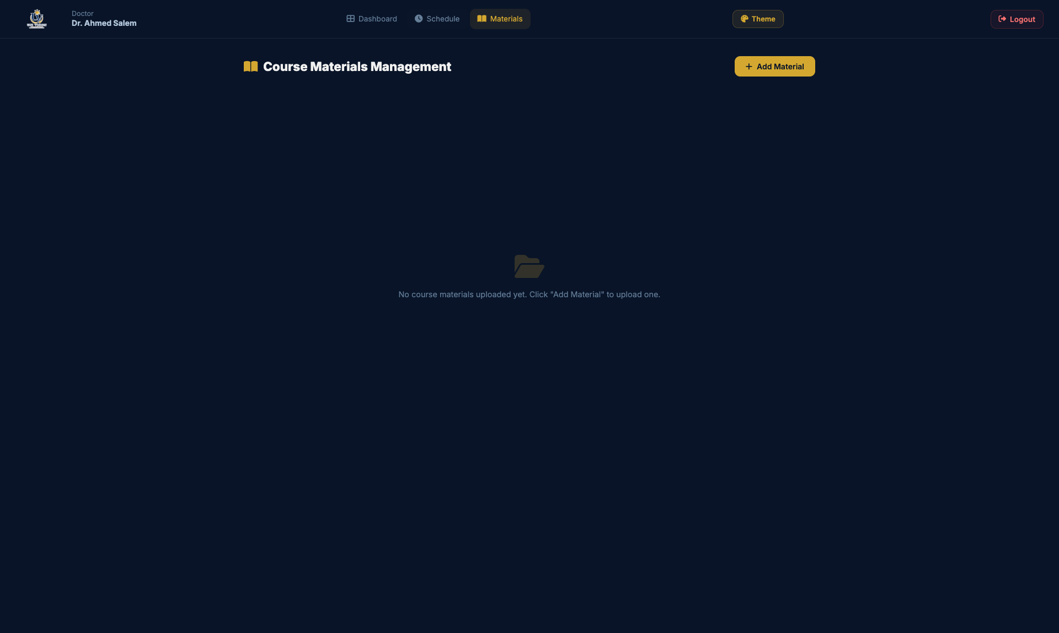

Admin Dashboard - Notifications Management
URL: Single-page view within the dashboard
Purpose: The notifications management section available only to administrators. Admins can create system-wide announcements, send targeted notifications to specific grade levels or all students, and manage existing notifications.
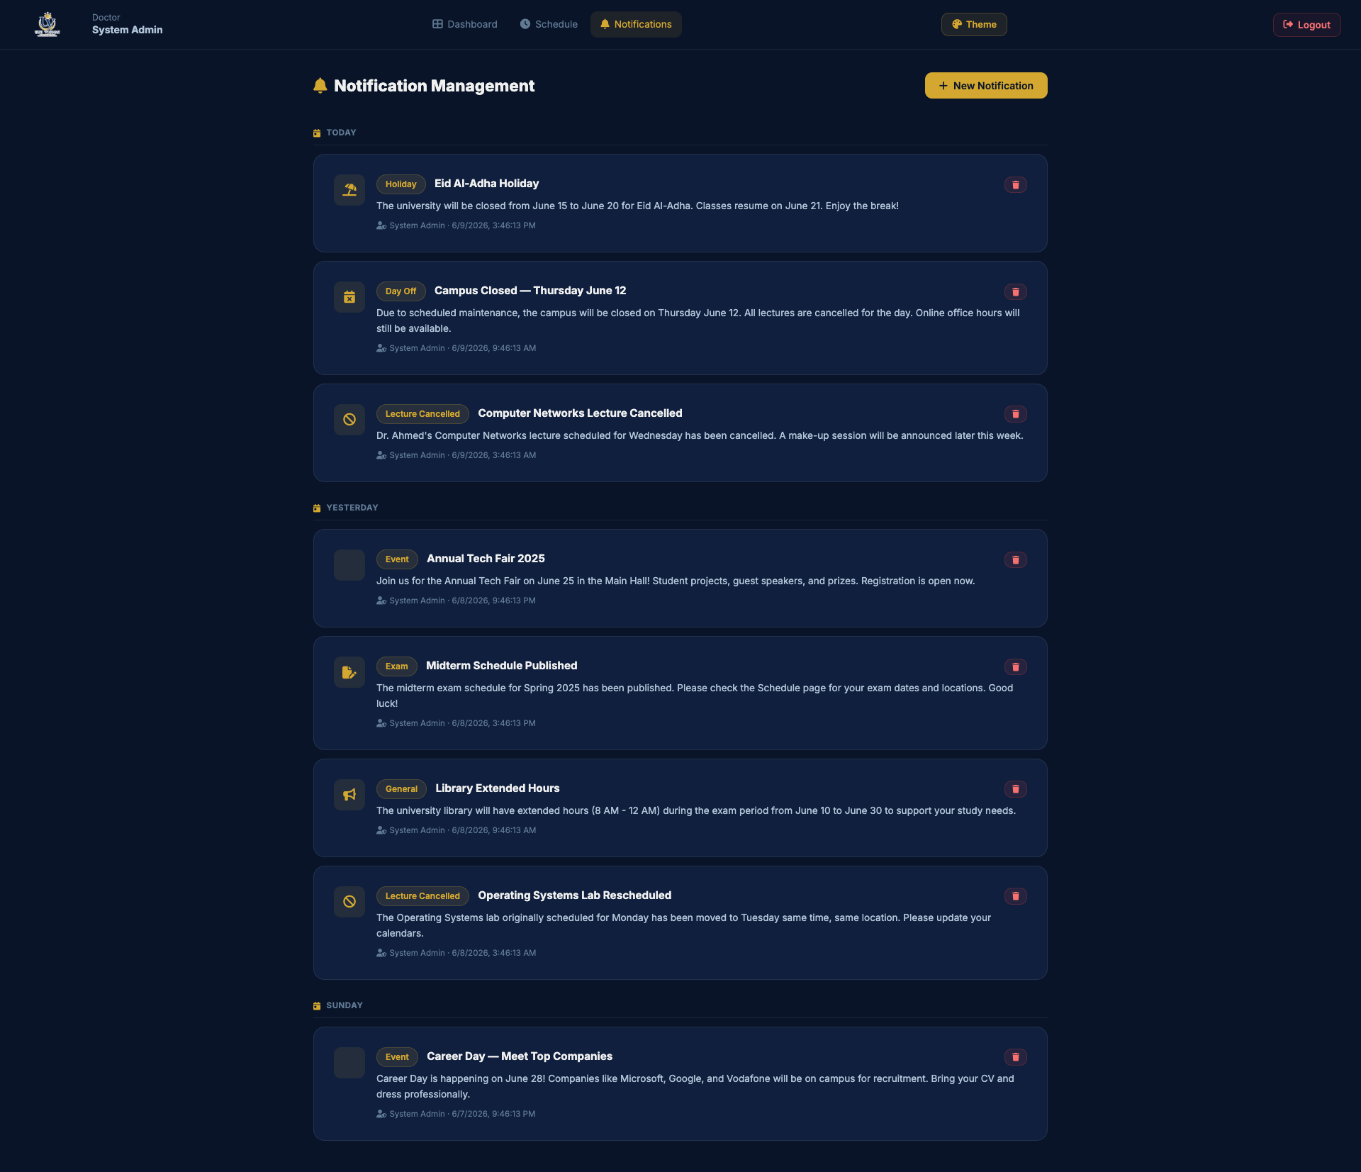

Admin Dashboard - Add Student
URL: Single-page view within the dashboard
Purpose: The add student modal available only to administrators. Admins can register new students into the system by providing their national ID, name, department, grade level, and initial credentials.
