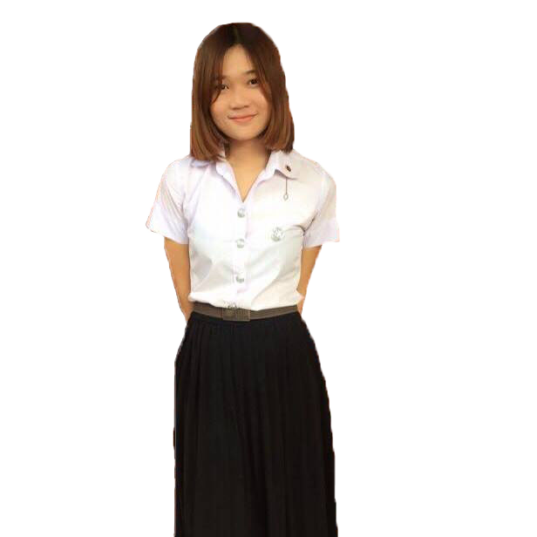

**Github: url(**[**https://github.com/aommy05349**](https://github.com/aommy05349)**)**

**Miss. Kanjanaporn Ngamwong**

Graduated from Bachelor of Software Engineering Program

Faculty of Science Payap University (First Class Honors, Gold medal)

**2015 - Participate in programming contest C, C# Java Programing Honorable**

**mention 1 sequence In Payap University**

**2016 - Join the Training to make the robot Lolibot**

**- Participate in programming contest ACM CONTEST in Chiang Mai University**

**- Join the Training Oracle Academy Excellence Student Workshop 2016 Chiang Mai Rajabhat University**

**- Join the Training to use AXURE RP Program in Chiang Mai University**

**- Join the Training C# Programing in Payap University**

**- Join the Training Strengthen Object Oriented Programming with Database in Payap University**

**- Join Community Project Competition 2016 SCB Challenge, Innovation media for Disseminating Knowledge Regarding of Midwifery with Thai Traditional Medicine Web Application The final 20 teams (**[**http://www.pregnancycarethailand.com/**](http://www.pregnancycarethailand.com/)**)**

**2017 - Create and Write Programs, Basic Devices Command Internet of Things**

**(IOTs)**

**2018 - Join the Training Strengthen IT for Work Website Development too Yii**

**Framework MVC in Payap University**

**- Join the Training Strengthen for Use GIT HUB in Payap University**

**- Co-Operative Education in Software Engineering at Mana Software**

**Company Position Full Stack Developer (1 term)**

**- Development Responsive Web Application HR Leave Management System**

**to Mana Software Company**

**- Join the Training BOOT CAMP 2018 Thai Text Analytics & Social Analytics**

**in Chiangmai University**

**2019 - Development Responsive Web Application for Sandee Housing Development**

**(**[**http://3.1.153.167/**](http://3.1.153.167/)**)**

**- Create and Write Programs Python about AI and Machin Learning**

**Achievement**

**Talent**

**Sport:** football, futsal, volleyball

**Crafts:** Weaver, Carve, Drawing

**Education History**

**Junior High School:** LoengnokthaSchool Yasothon

**Senior High School:** Rajaprajanugroh 54 School, Amnat-Charoen

**Bachelor of Arts:** Software Engineering Payap University

**Qualification**

**Have responsibility**

**Able to work under pressure**

**Have Patience**

**Can work hard**

**Ready to learn new things and improve myself all the time**

**Having good human relations with other people easily**

**Personal Information**

**Age : 22 years old**

**Gender : Female**

**Marital Status: Single**

**Date of Birth: 18 July 1996**

**Address: 82 M.3 Loengnoktha District Yasothon 35120**

**Contact**

**Level**

**EXPERT**

**Type of Skills**

**Skills**

Machine Learning

Yii Framework

**AVERAGE**

Laravel Framework

IOTs, Python

C# ,C

JAVA

JavaScript

PHP, MySQL

Bootstrap, HTML, CSS

**ROOKIE**

**: aommy05349**

**L**

**: Aommy Kjp’n**

**F**

**: aommy05349@gmail.com**

**: 098-2525734**

**About me**

**Seeking a position in Software development field where I can improve my programming skill and gain work experience**