## Mindtree SQL Interview Questions

### 11. Briefly describe the super key, foreign key, and candidate key.

* **Super Key:** We use an attribute or group of keys to identify table rows. Typically, super keys are the supersets of candidate keys.
* **Foreign Key:** It denotes a single or set of columns of a table stored in a database. The columns are usually associated with the primary key of another table.
* **Candidate Key:**like super key, it is an attribute or group of attributes that we use to identify tuples of a table. Note that candidate keys have the same strength as primary keys.

### 12. Define data integrity.

It is the ability of data to keep up its consistency and accuracy throughout its lifecycle. It is one of the crucial aspects considered in software design in addition to implementation.

### 13. Mention the clauses used with SELECT statements in SQL.

WHERE, GROUP BY, ORDER BY, and HAVING are the clauses used with SELECT statements.

We use the WHERE clause to filter records based on certain conditions.

GROUP BY clause can be used to group records based on identical data. It is typically used with aggregate functions and generates summarized results.

We will use the ORDER BY clause to sort field records in ascending or descending order.

We use the HAVING clause and the GROUP BY clause to filter records in a table. It is essential to note that the WHERE clause is entirely different from the HAVING clause because we use the HAVING clause to filter aggregated records.

**[Related Article:**[**SQL Interview Questions**](https://mindmajix.com/sql-interview-questions)**]**

### 14. Briefly describe the relationships used in SQL.

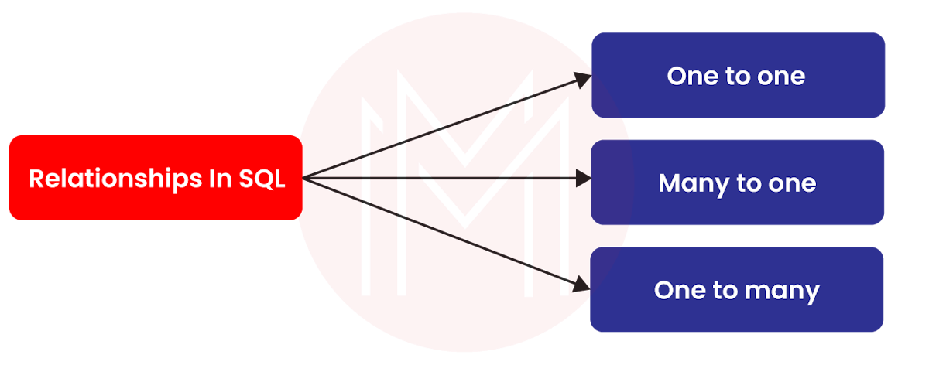

**One-to-one:** It is a relationship made between two tables. It means that a record in a table is associated with a record in another table.

**Many-to-one:** It is similar to the previous one. Many records in tables are associated with a single record in a table.

**One-to-many:** It is a relationship made between a record in a table and multiple records in other tables.

### 15. List out the uses of SQL.

SQL is a query language that performs various operations in a database. Jotted down are the uses of [SQL](https://mindmajix.com/sql).

* It executes queries in a database
* It inserts, deletes, and updates data in a database
* It fetches data from a database
* It creates a new table or view in a database
* It creates a new database

### 16. Explain pattern matching in SQL.

In pattern matching, wildcards are used instead of writing the exact word. We can use the LIKE operator with wildcards to retrieve the required data.

There are four ways by which we can fetch the required data.

* By using the % wildcard for a simple search
* By using % wildcard twice
* By using the NOT keyword
* By using the _wildcard to match the pattern based on position

[](https://bit.ly/3if9dmk)

### 17. Describe User-Defined Functions.

UDF or User-Defined Function helps to create functions using SQL expressions. User-defined functions accept parameters, perform operations, and return a value. We can define UDF in two ways: persistent and temporary. We can reuse a persistent UDF in multiple queries and use a temporary UDF in a single query.

Furthermore, [UDF](https://cloud.google.com/bigquery/docs/reference/standard-sql/user-defined-functions)s provide many benefits, such as quick execution, modular programming, and reduced network traffic.

Two types of user-defined functions are denoted below:

* **Table-valued functions** – They return a table. A single SELECT statement is used to return the table.
* **Scalar functions**– they return a scalar value. The value is usually defined in the RETURNS clause.

### 18. Is a zero equivalent to a NULL value?

No. A NULL value is not equivalent to a zero or blank space. This is because NULL is the unavailable value for performing arithmetic operations. We can consider a NULL value as a missing value or unknown value.

### 19. Differentiate the Truncate and Delete SQL statements.

|  |  |
| --- | --- |
| **Truncate** | **Delete** |
| We use this statement to remove all table rows. | We use this command to remove specific rows of a table. |
| It is a DDL statement | It is a DML statement |
| The WHERE clause is not used. | The WHERE clause is used. |
| It doesn’t support indexed views. | It supports indexed views. |

### 20. Compare NO SQL with SQL.

|  |  |
| --- | --- |
| **NoSQL** | **SQL** |
| It uses a dynamic schema. | It uses a predefined schema. |
| It takes work to process complex queries. | Complex queries can be quickly processed. |
| Scaling is done horizontally. So, we must add more servers to balance loads. | Scaling is done vertically. So we need to add SSDs and RAMs to balance loads. |
| It supports CAP Theorem. CAP stands for Consistency, Availability, along with Partition tolerance. | It supports ACID properties. |

## Mindtree Java Interview Questions

### 21. What exactly is ClassLoader in Java?

ClassLoader is nothing but a subsystem of [JVM](https://en.wikipedia.org/wiki/Java_virtual_machine#:~). It loads the required interfaces and classes to the JVM when needed.

There are totally three built-in classloaders in Java as follows:

* Bootstrap classloader
* System classloader
* Extension classloader

### 22. What is precisely JVM?

JVM stands for Java Virtual Machine. It is a runtime engine that enables a computer to run Java programs. It is achieved by converting Java codes into byte codes. In other words, the JVM loads, examines, and executes codes. Also, JVM calls the main method in a Java program.

### 23. What do you mean by Java thread lifecycle?

A thread in [Java](https://mindmajix.com/core-java) goes through various stages throughout its lifecycle. Below are the multiple stages of a Java thread lifecycle.



### 24. What do you understand by static variables in Java?

It is the variable declared only in the class itself. No other instance cannot use the variable. Simply put, only one copy of the variable is available in memory, no matter how many class instances are created. The main thing about using a static variable is that it simplifies memory management. Simply put, it makes a Java program memory-efficient.

### 25. State the various access specifiers used in JVM.

Access specifiers are nothing but keywords. They help to define the access scope of a method, class, or variable.

Java comes with four access specifiers, as mentioned below:

* Public
* Default
* Protected
* Private

### 26. Compare static and instance methods.

|  |  |
| --- | --- |
| **Instance method** | **Static method** |
| It is a method that is not declared static. | It is a method declared static. |
| We do need objects to call static methods. | Objects are not required to call static methods |
| Both static as well as non-static variables can access instance methods | Non-static variables cannot access static methods |

### 27. Is it possible to declare a constructor as final?

No. It is not possible to declare a constructor as final. This is because constructors never inherit. If we declare a constructor, the compiler will throw an error definitely.

### 28. State the differences between checked and unchecked exceptions in Java.

|  |  |
| --- | --- |
| **Checked exceptions** | **Unchecked exceptions** |
| They are checked during the time of compilation. | They are checked during the time of execution. |
| They support using ‘throws’ keywords. | They don’t support using these keywords. |
| They are the subclass of the exception classes. | They are not part of the exception classes since they are runtime exceptions |
| The JVM needs the exception to handle these exceptions. | The JVM doesn’t need the exception for the same. |
| FileNotFoundException and IOException are checked exceptions. | ArithmeticException and NullPointerException are unchecked exceptions. |

### 29. Write a Java code to perform a recursive binary search.

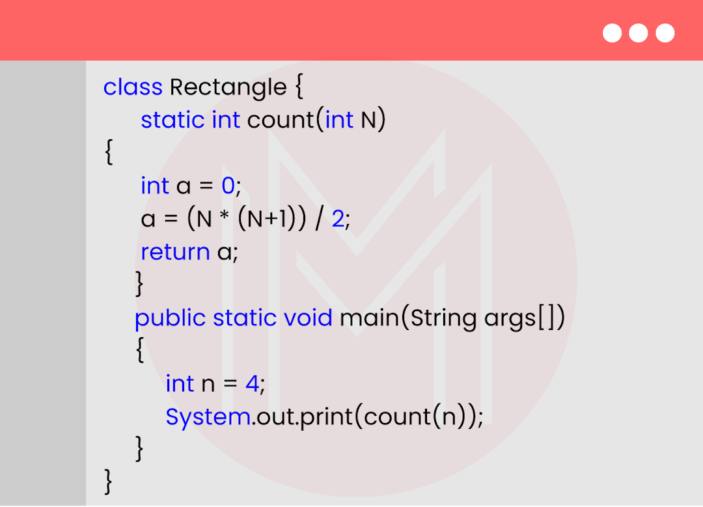

Output:

2

### 30. Create a Java program to find the average of given numbers.

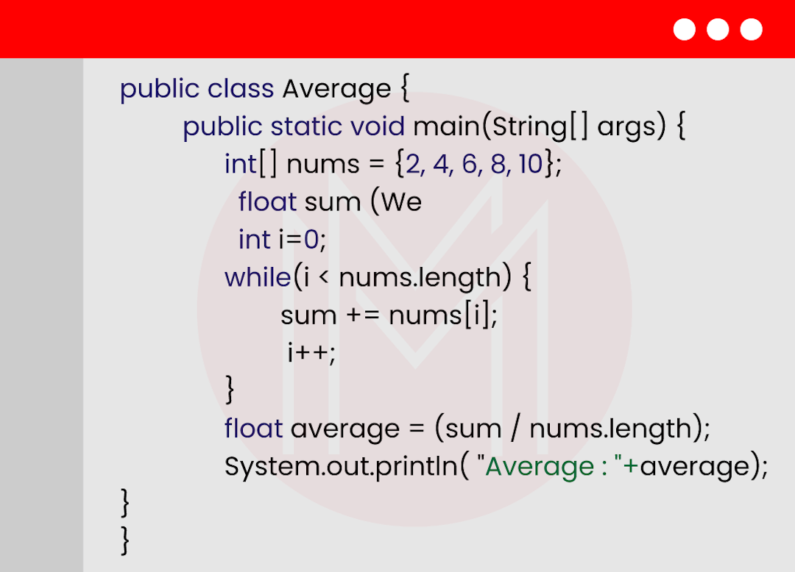

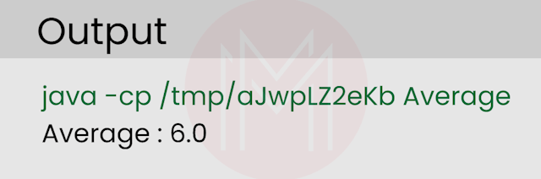

## Mindtree React JS Interview Questions

### 31. List the advantages of ReactJS.

* Scripting is simple
* It comes with a component-based architecture
* It is easy to learn and use
* Mobile app development is simplified
* It ensures a stable code structure

### 32. What is precisely useState( ) in ReactJS?

The useState ( ) is nothing but a built-in React hook. It allows having state variables in functional components. In other words, it will enable tracking state in a function component. Here, the state denotes the data that needs tracking in applications.

This hook typically returns an array with two values. One value is the current state, and another is the function needed to update the state. Besides, we can use this hook when the DOM is manipulating something dynamically.

### 33. What do you mean by JSX?

JSX stands for JavaScript XML. With JSX, we can write [HTML](https://en.wikipedia.org/wiki/HTML)codes inside JavaScript. We can also place them in DOM without using any function. Note that DOM represents Document Object Model.

### 34. Define state object in ReactJS.

Every component in ReactJS contains the built-in state object. This object has all the property values of the component.

In a way, state objects control the behavior of [ReactJS](https://mindmajix.com/introduction-to-react-js) components. If there is any change in any property value of a state object, then it leads to the re-rendering of the component.

### 35. What is the role of prop drilling in ReactJS?

We use props to pass data from the higher hierarchy to a component in a deeper order. The props can go deep until it reaches the required hierarchy level.

**[Related Article:**[**ReactJS Interview Questions**](https://mindmajix.com/reactjs-interview-questions)**]**

### 36. Briefly Describe React hooks.

They are essentially built-in functions. It allows using state along with lifecycle methods in react components. As a result, we can improve the reuse of codes and navigate the component tree flexibly.

The main thing about react hooks is that we can use all the features of hooks without writing class components. In other words, we cannot use hooks in class components.

### 37. Why do we use Custom Hooks?

It is a function of JavaScript. With custom hooks, we can replace render props as well as Higher Order Components(HoCs). It also reduces the amount of nesting required. Custom hooks will help to avoid multiple layers of abstraction.

### 38. How can you prevent re-renders in ReactJS?

Re-rendering of a component occurs when props are changed. Not only components, but re-rendering may also happen in child components. If we don't update the re-rendering components, it will significantly affect the applications' performance.

We can prevent re-rendering using the ‘shouldComponentUpdate ( )’ method.

### 39. How React Hooks is different from Classes.

|  |  |
| --- | --- |
| **React Hooks** | **Classes** |
| We use react hooks in functional components. | We use classes in class-based react components. |
| It won’t require the declaration of constructors. | It is necessary to declare constructors inside class components |
| It doesn’t use the ‘this’ keyword in state declaration. | It uses the ‘this’ keyword for state declaration. |
| The ‘usestate’ feature makes react hooks ‘easy to use’. | No single function is used for ease of use. |
| It supports implementing context and Redux API. | Classes are not preferred for context and redux API. |

### 40. Differentiate Controlled and Uncontrolled Components.

|  |  |
| --- | --- |
| **Controlled Components** | **Uncontrolled Components** |
| They are managed by React state. It means that their internal states don’t play any role | They are managed by their own internal states. |
| Data usually flows from the parent component to other components. | It flows within components. |
| The parent component controls data. | DOM controls data. |
| We can easily debug these components. | We cannot easily debug these components. |
| It has good control over the data. | It needs better control over data. |
| The complexity is less. | The complexity is high. |
| It does validation control. | It doesn’t do validation control. |
| It is faster. | It is slower. |