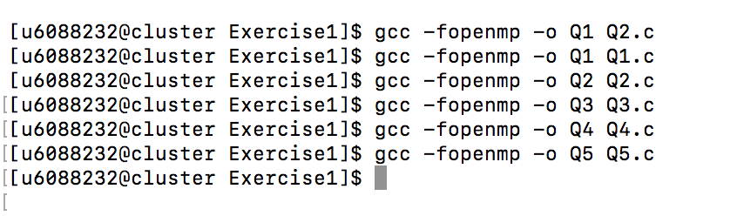Output of Exercise 1

Sirichoke Yooyen 6088232 Section 3

