Lab 1: OpenMP

Name: Sirichoke Yooyen ID: 6088232 Sec: 3

Rename your file to “lab1_u5xxxxxxx.docx” and upload it to Mycourses website

**Lab: 3.5.** helloomp.c

Result

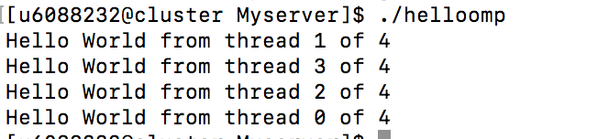

**Lab: 4.** ompsum.c

(with -fopenmp)

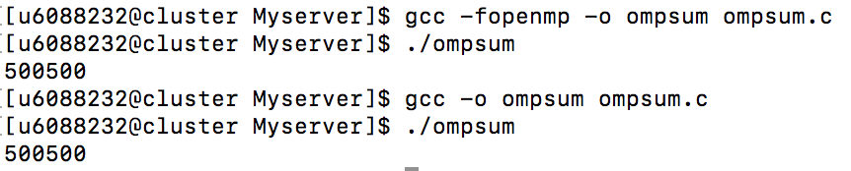Result

(without -fopenmp)

Result:



**Lab: 5.** omprace.c

(with #pragma omp critical)

Result

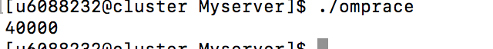

(without #pragma omp critical)

Result



**Lab: 6.**

Source Code

Result

