**Exercise 2: MPI Basics**

1) Draw a task graph of the following instructions and determine which tasks can be executed in parallel.

1. T1:  a = cos(1.0);
2. T2:  b = sin(2.0);
3. T3:  c=a+b;
4. T4:  d=a-b;
5. T5:  e = c*d;

T5

T4

T3

T2

T1

2) Write an MPI program with two processes working as follows:

* Process 0 sends an integer number to process 1
* Process 1 calculates the square of the number, and sends the result to process 0
* Process 0 prints out the result.

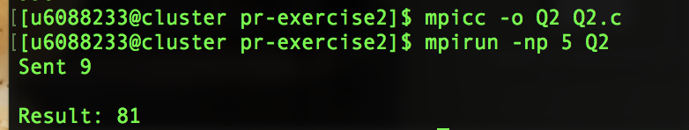

3) Write an MPI program with two processes working as follows:

* + Process 0 sends **an array** of 10 integers to process 1
  + Process 1 multiplies 10 to each element in the array, and sends the **result array**

back to process 0

* + Process 0 prints out the result

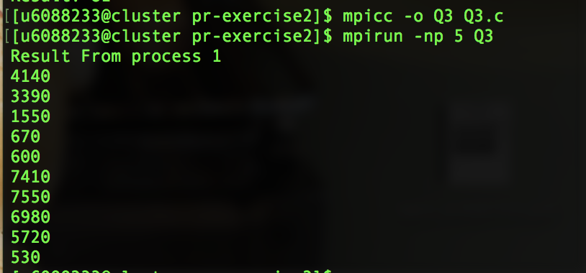

4) Create an MPI program with 1 master and 8 slave processes. The master process initializes an 8x8 matrix A, which each element Ai,j = i + j as shown below. Then, the master sends a distinct row of matrix A to each slave. Each slave calculates the summation of all elements in the row it has received from the master. Finally, all slaves send back the results to the master for aggregation into the total summation.

