Analysis of the effect of different irrigation and fertilization strategies in Kentucky bluegrass

Justin Shattuck, Hayley Mangelson

INTRODUCTION

Rapid population growth, economic development, and climate change are all contributing to increased demands on global water resources. Water stress is already apparent in arid and densely populated regions world-wide, and projections show that water scarcity shows a pattern of pandemic increase in the years to come. The areas at most risk are urban areas, which are projected to be the location of much of the world’s population increase1,2. Because agriculture is reportedly responsible for nearly 90% of groundwater consumption globally3, it stands to reason that water conservation has been emphasized in agricultural systems. However, locally available water in urban areas is also at risk. There is significant potential for water conservation within urban landscapes, particularly in arid and semi-arid environments4.

Urban water protection efforts have identified residential and commercial landscapes as one of the largest sources of conservation potential. These landscapes are estimated to consume 40-70% of all municipal water.5 Covering approximately 50 million acres in the US, turfgrass is the most common landscape feature in most urban landscapes and consumes the majority of landscape water. Endter-Wada, et al., performed research on urban landscape water consumption in Utah, where they determined that lawns were typically overwatered. The most common reason for overwatering is automatic, timer-run sprinkler systems. These systems water lawns at designated times regardless of actual water needs. Due to this and other factors, 31.3% of residential and 64.8% of corporate sites were practicing wasteful landscape watering6. Although community resource management strategies have been shown to be effective in reducing urban water consumption2,6, more can be done as landscape managers have a better understanding of optimizing water application.

The importance of nutrient management and its relationship to turf water use and drought tolerance is often overlooked. For example, application of excessive nitrogen fertilizer is common in landscape turf settings. Excess nitrogen increases rates of growth and simultaneously reduces root development7, both of which make turf more vulnerable to drought. However, nutrient deficiencies can also be problematic when drought occurs because plants are already experiencing abiotic stress and are less able to tolerate drought conditions. It is important for turf managers to find optimal nitrogen application in order to optimize water use. This can be done by carefully regulating plant health. One approach being evaluated is to employ soil or remote sensors to fertilization and watering decisions.

Remote sensing technologies have been available for decades, but have not been applied to turfgrass on a large scale. They have proven to be incredibly valuable in other cropping systems. Measuring the temperature of the canopy with an infrared thermometer is one remote sensing approach of interest. The first infrared thermometer devices were developed in the 1960s and were discovered to work well for assessing water stress, because canopy temperature increases as plant available water declines. This is because transpiration has a cooling affect, so a decline in transpiration leads to an increase in temperature. A method developed in the 1980s compares measured canopy temperatures with well-watered and non-transpiring baselines to produce a measurement called the Crop Water Stress Index (CWSI)8. One problem with use of CWSI alone to optimize water application is that some nutrient deficiencies may have a confounding affect. This was demonstrated by Carroll, et al., in maize8. However, some of these can be accounted for by including spectral reflectance sensors. These measure the Normalized Difference Vegetation Index (NDVI) of plant canopies and can be used to assess green biomass or nitrogen content9.

In one of the first studies using remote sensing in turfgrass, Taghvaeian et al.10 used hand-held, multi-spectral radiometers to determine which species of grass were most tolerant to water stress. Data from radiometers were sent to a data-logger controller, which stored information for analyses. One downside to this system is that measurements must be taken within two hours of solar noon on cloud-free days, and measurements took an average of 37 minutes on each study day.

The Brigham Young University Turfgrass research program is seeking to optimize water and nitrogen supply to turfgrass. As part of this goal, they would like to evaluate the potential application of soil water sensors and remote canopy sensors to improve irrigation and fertilization decisions. Construction of a turf irrigation research facility was initiated outside of the BYU research greenhouse in the fall of 2016 and Kentucky bluegrass (*Poa pratensis)* was established in the summer of 2017. The facility consists of 27 individual research plots (3.4 m x 3.4 m), divided in a randomized, complete block design among three irrigation zone treatments. Irrigation treatments are low, full, and high. Within each irrigation treatment, there are three nitrogen levels, each replicated three times. Nitrogen fertilizer treatments are deficient, optimum, and excessive. In collaboration with Decagon Devices, water content sensors, water potential sensors, spectral reflectance sensors, and infrared radiometers monitor the plots and report to data-loggers in the field. These sensors take automatic measurements hourly and require much less user interaction than those used in previous studies. If they prove effective, they are in a price range that would make them accessible to businesses and parks, resulting in more efficient watering in urban landscapes. During a three-week period from September 23, 2017 to October 16, 2017, the nitrogen and fertilizer treatments were implemented and sensor activity logged. Our objectives are to create a data analysis pipeline that will allow the user to combine all sensor data, visualize soil and plant conditions over time, identify periods where stress occurred, generate descriptive statistics to compare experimental treatments, and provide a Docker container11 that will make it possible to recreate our analysis on future data-logger datasets from the same experimental site.

METHODS

*Data Generation*

The Brigham Young University Turfgrass research program provided data from 13 Decagon data-loggers. Figure 1 is a simple graphical representation of the plots with alphanumeric labels corresponding to the plot location and irrigation treatment, and color-coded to indicate nitrogen treatment. Each data-logger supports input from up to five sensors, but not all ports were utilized on all loggers. Rows 4, 5, and 6 had two loggers—each with full port utilization, but the rear bank of sensors reported data only for the plot in the third column. Data from the rear bank had to be combined with third-column plot data from the forward bank on these rows.

Both the GS3 and MPS6 sensors report soil temperature. With the additional sensors in the third-column plot (one each at 64mm, 150mm, and 300mm), there is both a GS3 and MPS6 sensor at 150mm and 300mm and just an MPS6 at 64mm on the rear bank, and a GS3 at 64mm on the forward bank. We calculated the average of the two soil temperature measurements at each sensor depth.

*Data Tidying and Preparation*

The .xls data files output by the Decagon server were not properly initialized—the file header was missing data, and it was necessary to manually open and save each file in Excel in order to reinitialize the metadata. Simply saving the file with no changes is sufficient to fix the header.

To reinitialize the files, we used Microsoft Excel for Mac (v15.27). After reinitializing the file metadata, data retrieval and processing was done in a Jupyter Notebook running jupyter_core 4.3.0 (on Python v3.6.2). The numpy (v1.13.0) and pandas (v0.20.2) libraries were also used. We exported the Jupyter Notebook to a single python script that can be run from the command line (such as bash or zsh).

After initialization, starting with the file generated by the data-logger on the front of the first row, each file was read in as a pandas dataframe. For each row, sensor data for individual plots was sliced into separate frames. For rows 4, 5, and 6, rear-bank plot data (for the third column) was sliced and merged with third-column plot data from the forward sensor bank. For all rows, data from each plot was stacked into a single frame. Finally, each frame corresponding to each row was stacked and output to a tab-delimited file (allrows.tsv) with nulls as “N/A” for further processing by R. One of the data-logger files logged irrigation flow for all of the plots (first row rear sensor bank), so it was not included in the main dataframe; data from this file was read into a separate frame so it can be merged with the final frame later.

*Adjusting for Missing Data*

To account for two missing observations, we simply checked during the initial processing steps and inserted zero data. This re-aligns the errant logs so that observations can be compared chronologically. Future work would include modifying the code to handle missing observations (wherever they might occur) by alerting the user and/or automatically inserting zero data.

*Docker Setup*

To facilitate reproducibility of data tidying and preparation, we created a Docker container based on the Python3 image using Docker version 17.12.0-ce. To use the Docker container, download the most-recent recent version of Docker. Make sure the daemon is running. We recommend going through at least the first two steps of the Get Started guide. Then, clone the repository (nitro) and switch to the root folder. Make two directories: “data” and “results,” then copy the (re-initialized) data files into the first folder (/data). Now run the run_docker.sh script. This will build the container, run an image based on the container, then copy the output file to the results directory.

By default, the script will only create the final file, but the boolean outputIntermediateFiles in process_input.py (line 22) can be set to “True” and intermediate files will be created in the /data folder. These files will need to be copied from the image manually.

*Figure Design*

R and RStudio were used to analyze trends in the data from the three-week period of interest. The readr and dplyr packages will be used to read the tidied data into dataframes, then select only rows associated with the study period. The ggplot2, gridExtra, ggfortify, and grid packages were used to design figures demonstrating relationships between treatments and plant stress. Figure 3 was designed using geom_area, figures 4 and 5 were created with geom_line, and figures 6 and 7 were made with geom_boxplot. The aov function was used to perform one-way ANOVA tests identifying relationships between nitrogen treatment and NDVI, irrigation treatment and NDVI, nitrogen treatment and canopy temperature, and irrigation treatment and canopy temperature. All code is detailed in an rmarkdown file and can be easily adjusted to accommodate new data-logger data.

RESULTS

*Data-logger and Sensor Efficiency*

There were some problems with data-logger or sensor consistency. The loggers on two rows have no data for one observation—one in row 1 (5/10/2017 17:00:00) and one in row 7 (5/24/2017 11:00:00). Both of these are well outside of the observation period and can be safely ignored for data purposes. The total number of observations was 169k, resulting in an error rate of <0.0001%. There were 73 missing readings from the 64mm GS3 sensor in plot 11, again outside of the observation period, with an error rate of 0.0004%. There were 775 missing readings from the 64mm GS3 sensor in plot 63. This is reflected in the broken blue line in the top middle plot of Figure 5. This was likely a sensor issue, as the other sensors linked to the same logger did not have any issues. This is an error rate of 0.0046%.

*Soil Water Content*

Weather data was collected by an on-site weather station during the three-week study period. Precipitation monitors indicted cumulative precipitation totaling 27.88mm (Figure 3) and all precipitation events occurred between September 23 and October 3. These events significantly affected volumetric water content (VWC) and available water content (AWC) (Figures 4 – 5) and prevented significant dry down. Average VWC measurements show greater water retention in plots treated with high irrigation, followed by plots treated with full irrigation. These irrigation treatments are consistent across all three nitrogen treatments. Interestingly, more water is retained in the excessive nitrogen plots at low water than in any other low water plots (Figure 4).

Figure 5 give a comparison of three water treatments at optimum nitrogen and measures VWC and AWC at three depths. While VWC measurements fluctuate most noticeably from irrigation treatments at the 64mm depth, the 300mm depth shows the largest peak due to precipitation. As expected, more water is contained deeper in the soil and some drying is evident near the surface, particularly with low irrigation. AWC plots show soil saturation for the duration of the experiment across all irrigation treatments, with the exception of the 64mm sensor in the low irrigation treatment. From October 9 to October 16, there is a dramatic drop in water potential to nearly -200 kPa. This is still not quite at the level expected to cause significant stress in turfgrass.

*Canopy Measurements*

To further investigate the one-week dry period indicated by Figure 5, noon NDVI measurements were selected from all nine measured plots from October 9 through October 16 and were compared by treatment (Figure 6). NDVI decreases significantly in two of the low irrigation plots (deficient and optimum nitrogen) and slightly in the deficient nitrogen and full irrigation plot. Both irrigation and nitrogen appear to be significantly correlated to NDVI, with irrigation and nitrogen treatments resulting in the same p-value of 2 * 10-16 (α = .001).

The same time period was examined for variation in canopy temperature. All plots were normalized based on data from a non-stressed standard (optimum nitrogen and high irrigation) and noon measurements were selected. Plot 7 shows significant (p = 2.29 * 10-9, α = .001) canopy temperature variation between nitrogen treatments. Irrigation treatment did not appear to be significantly correlated with canopy temperature (p = .049, α =.001).

DISCUSSION

*2017 Dry-down Experiment*

Unfortunately, the results of the examined study period were skewed by precipitation in the first week. (Figure 3). Despite soil saturation for the duration of the first two weeks of the three-week study, patterns began to develop by week three. The sudden and significant drop in AWC at the 64mm sensor was evidence of some water stress (Figure 5). This is corroborated by differences between treatments in NDVI and canopy temperature (Figures 6-7). As expected, most of the variation in NDVI is a lower index value for low irrigation treatments. Interestingly, low irrigation in combination with excessive nitrogen compensates for lack of water. Likewise, the full irrigation treatment in combination with deficient nitrogen shows some symptoms of stress. Clearly, NDVI measurements on their own would not provide sufficient information for turf managers to make educated irrigation and fertilizer decisions8.

When combined with canopy temperature measurements, it may still be challenging to identify the source of stress. When compared to a non-stressed standard, both nitrogen deficient and excessive nitrogen plots show an increase in temperature. This signifies a decrease in transpiration, and less healthy internal processes for the plant10. The canopy temperature comparison also agrees with a previous finding of Bilgili, et al, that nitrogen may increase water demands of turfgrass. In this case, the low water and excessive nitrogen plot showed the greatest increase in canopy temperature over the one week dry period and all excess nitrogen plots showed some canopy warming (Figure 7).

Although the results of this study period were not as clear as desired, the same study design could be repeated with interesting results. The data from the final week showed trends supporting the hypothesis that nitrogen has a strong effect on plant stress and water consumption. The study also supports the efficacy of combining soil sensing data with remote sensing technologies. The data analysis pipeline we created will provide the BYU Turfgrass research program with a powerful tool for fast and effective data analysis in the future.

*Analysis of Decagon sensors and data-loggers*

In addition to a data analysis pipeline, our research also identified specific areas in which the Decagon sensor and data-loggers can be improved. Because the BYU Turfgrass lab is working in collaboration with Decagon, our feedback may impact further development of these technologies.

The sensors appear to have provided data that is consistent with expected trends, such as daily irrigation events. They also show expected differences in VWC between depths and irrigation treatments. The NDVI and canopy temperature readings were also very consistent across groups. However, despite the data consistency and low error rate, there were some missing data points that would have thrown off all data analysis if not corrected. It would be valuable for Decagon to develop a way to account for missing data points if they cannot be avoided.

The data-loggers seemed to work effectively, with the exception of strange output files. Data is uploaded as .xls files from the Decagon server, but Microsoft excel does not recognize the files due to improper initialization of the meta data. We would recommend that Decagon bypass this issue by outputting data as a tab-delaminated file. The data would also be more manageable if output was also output in a tidy format, ready for data analysis.

FIGURES

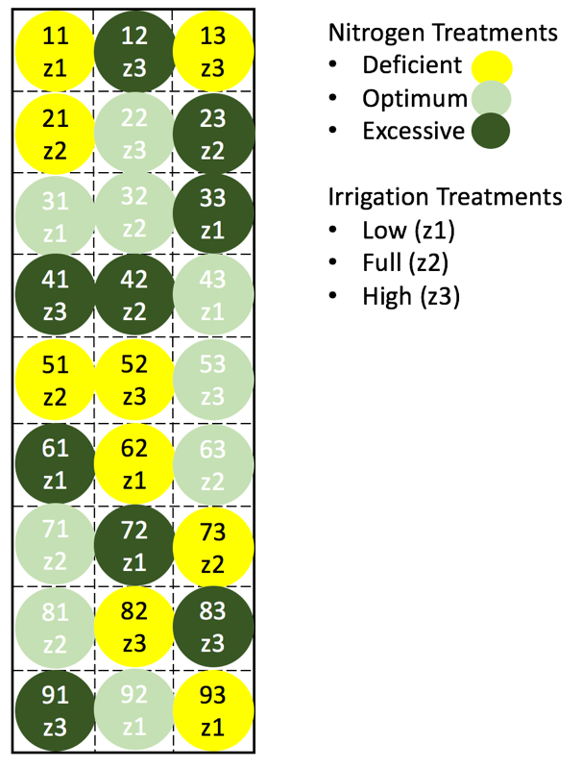

**Fig. 1** **Plot treatments**

The 27 plots of Kentucky bluegrass measure 3.4m square. They were split into three groups and randomly assigned a nitrogen treatment level and irrigation treatment level.

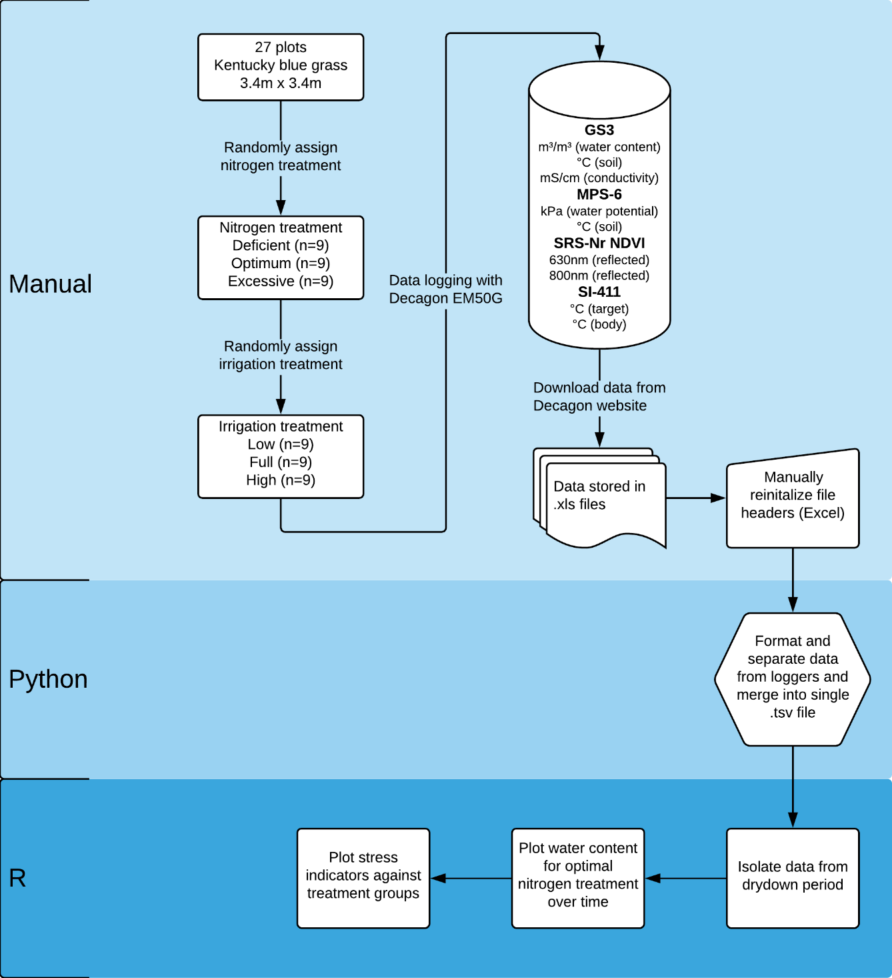

**Fig. 2** **Flowchart of data collection, processing, and analysis**

In the summer of 2017, 27 Kentucky bluegrass plots were established. Subterranean data was measured with GS3 and MPS-6 sensors, and grass canopy data with SRS-Nr NDVI and SI-421 sensors. The first two sensors measure volumetric water content in cubic meter per cubic meter, temperature of soil in degrees Celsius, and electrical conductivity in millisiemens per centimeter. The other two measure reflected light at 630 and 800 nanometers, and temperature of the canopy in degrees Celsius. The SRS-Nr NDVI calculates a NDVI (Normalized Difference Vegetation Index) during daylight hours using the reflected light.

**Fig. 3** **Cumulative sum of precipitation at study site during study period**

From September 23, 2017 through October 16, 2017, a cumulative 27.88mm of rain was recorded by the on-site weather station. Almost all of the precipitation events occurred between September 23 and October 2, with none in the last week of the study period (October 9 through October 16).

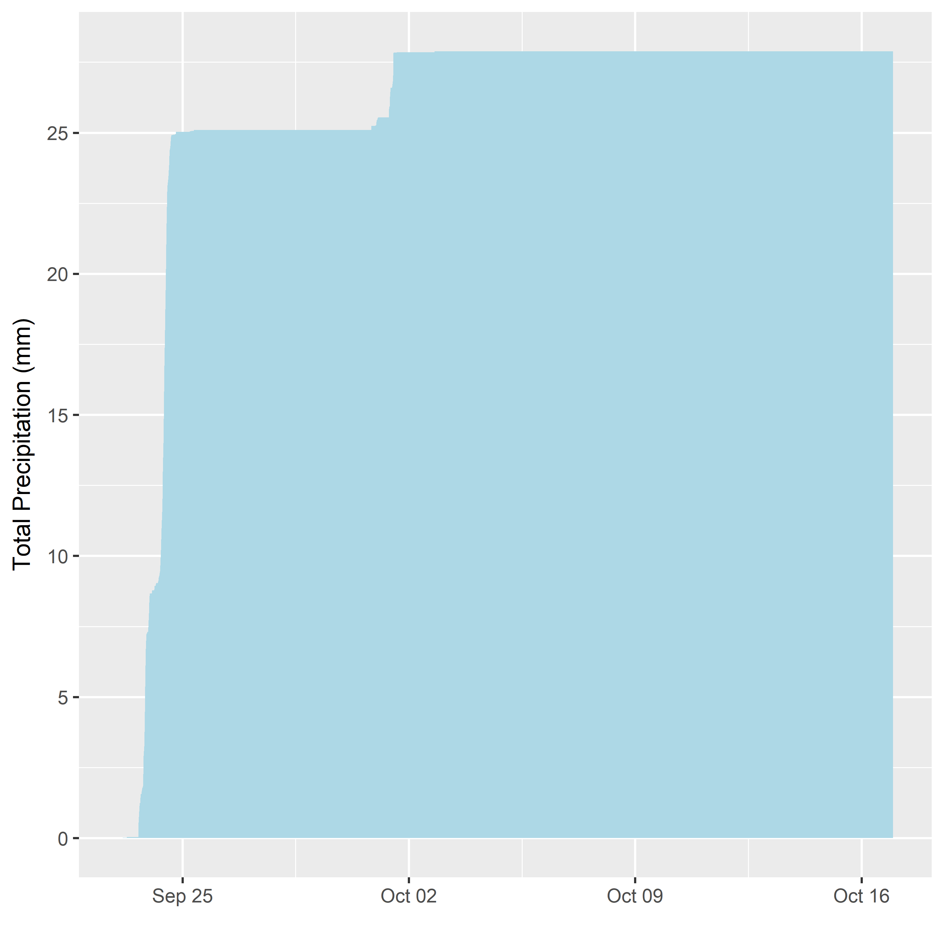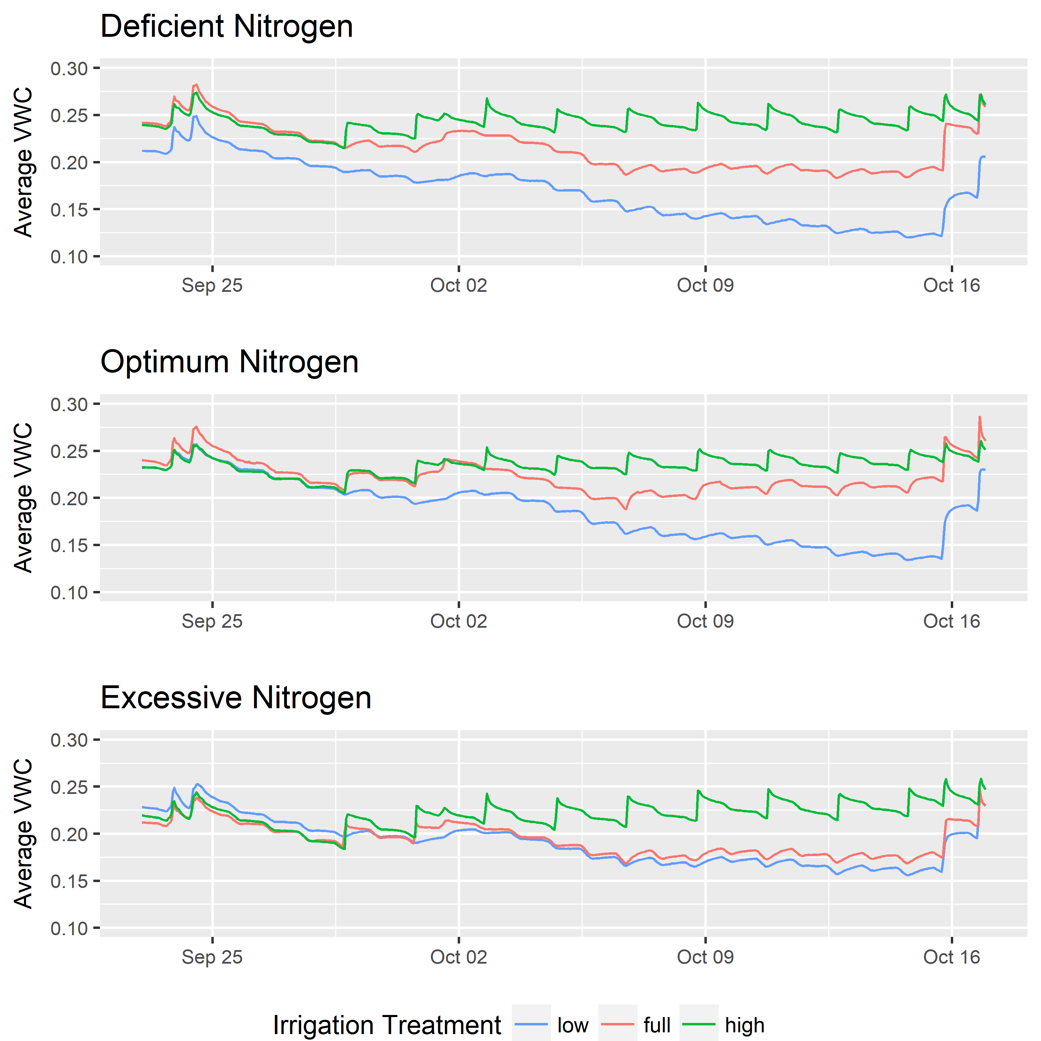

**Fig. 4 Average volumetric water content**

Volumetric water content (VWC) was measured in all plots at a depth of 64mm. Each treatment group was replicated three times (excessive nitrogen and high water, excessive nitrogen and full water, excessive nitrogen and low water, etc.). These figures show the mean VWC across all three replications. As expected, high, full, and low water treatments almost always fall in order. Interestingly, the low and full treatments at excessive nitrogen have very similar values.

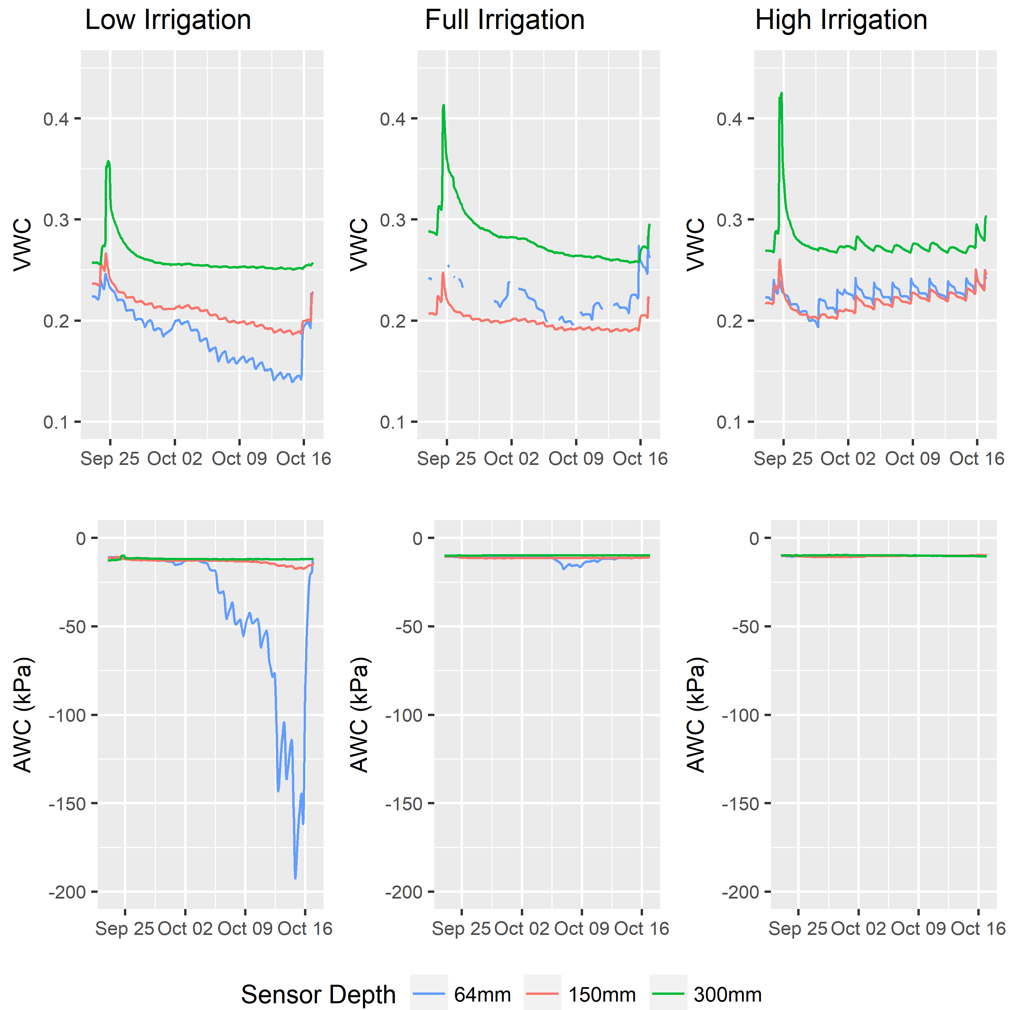

**Fig. 5** **Soil water data from three depths**

Plots 43, 53, and 63 were instrumented with soil sensors at depths of 64mm, 150mm, and 300mm. All three plots were assigned to the optimum nitrogen treatment, but each had a unique water treatment. This allows for comparison of volumetric water content (VWC, measured from 0 – 1 with one being saturated) and available water content (AWC, a measure of water potential relative to plant uptake with numbers closer to zero being more available) between water treatments and at varying depths. Daily fluctuations are clearly visible in VWC charts, showing the irrigation schedule during the study period. It is also clear that lower depths fluctuate less and retain more water than soils near the surface. The AWC plots show that soils stayed near saturation in all treatments for the duration of the period, with the exception of the low water treatment. At 64mm of depth, water availability plummeted in the last week of the dry down period.

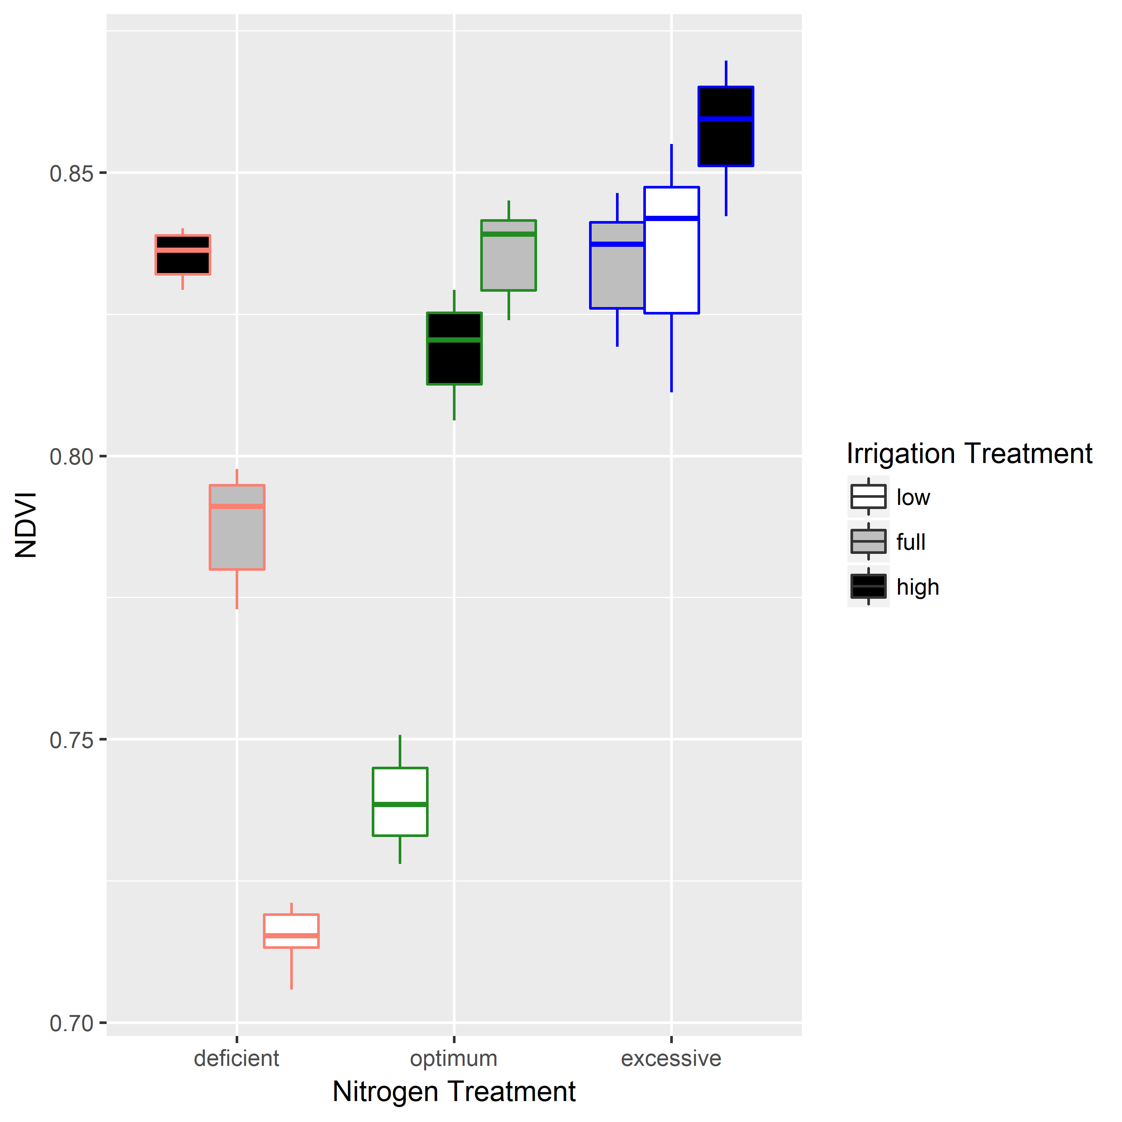

**Fig. 6** **NDVI at noon from October 9 to October 16**

Normalized difference vegetation index (NDVI) was measured hourly during daylight hours in plots 13, 23, 33, 43, 53, 63, 73, 83, and 93. To understand differences between treatments, only the noon measurement during the last week of the study period was used. This figure shows the distribution of noon measurements during that week for each plot. Plots are grouped and outlined according to nitrogen treatment and filled according to irrigation treatment. Higher NDVIs indicate a higher level of canopy greenness, typically positively indicative of plant health and turf attractiveness.

**Fig. 7** **Degrees above a non-stressed reference at noon from October 9 to October 16**

Canopy temperature (oC) was normalized to the high irrigation and optimum nitrogen reference. Nitrogen treatment is shown by group and outline color and irrigation is shown by fill. Both deficient and excessive nitrogen groups have warmer canopies than those receiving optimum nitrogen. However, high irrigation seems to compensate for deficient nitrogen.

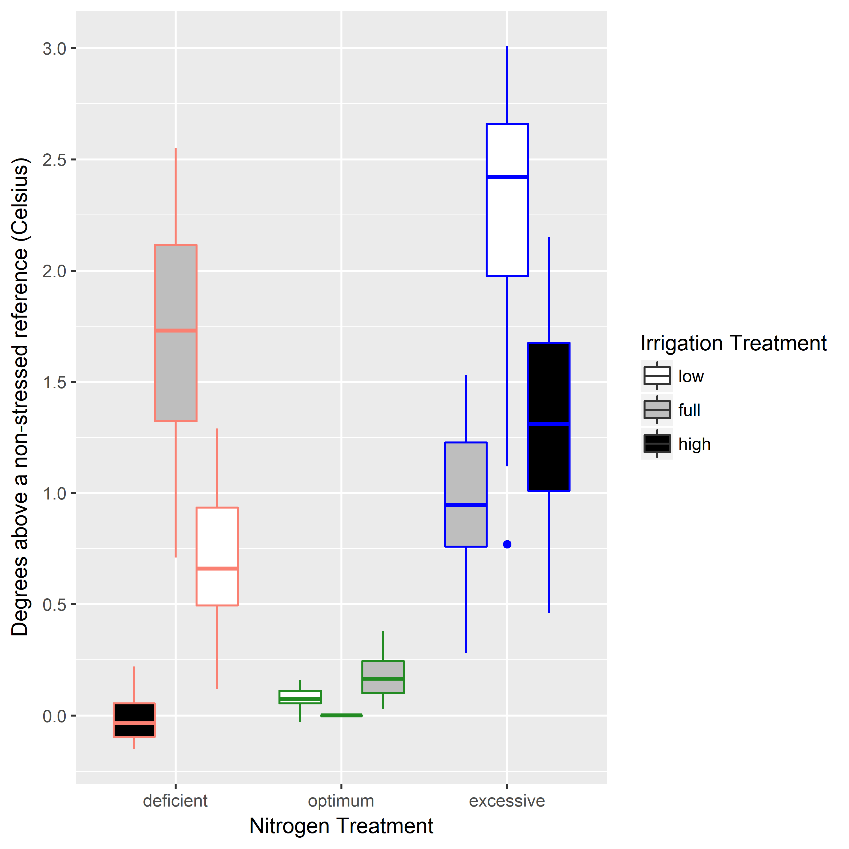

REFERENCES

1. Vörösmarty, C. J., Green, P., Salisbury, J. & Lammers, R. B. Global water resources: vulnerability from climate change and population growth. *Science* **289,** 284–8 (2000).

2. Haque, M. M., Egodawatta, P., Rahman, A. & Goonetilleke, A. Assessing the significance of climate and community factors on urban water demand. *Int. J. Sustain. Built Environ.* **4,** 222–230 (2015).

3. Rost, S. *et al.* Agricultural green and blue water consumption and its influence on the global water system. *Water Resour. Res.* **44,** (2008).

4. Heberger, M., Cooley H., Gleick, P. Urban Water Conservation and Efficiency Potential in California. (2014).

5. St., R. *et al.* Efficient Water Use in Residential Urban Landscapes. *HortScience* **43,** (The Society, 2008).

6. Endter-Wada, J., Kurtzman, J., Keenan, S. P., Kjelgren, R. K. & Neale, C. M. U. Situational Waste in Landscape Watering: Residential and Business Water Use in an Urban Utah Community 1. *JAWRA J. Am. Water Resour. Assoc.* **44,** 902–920 (2008).

7. Bilgili, U. & Acikgoz, E. Year-Round Nitrogen Fertilization Effects on Growth and Quality of Sports Turf Mixtures. *J. Plant Nutr.* **28,** 299–307 (2005).

8. Carroll, D. A., Hansen, N. C., Hopkins, B. G. & DeJonge, K. C. Leaf temperature of maize and Crop Water Stress Index with variable irrigation and nitrogen supply. *Irrig. Sci.* **35,** 549–560 (2017).

9. Cabrera-Bosquet, L. *et al.* NDVI as a potential tool for predicting biomass, plant nitrogen content and growth in wheat genotypes subjected to different water and nitrogen conditions. *Cereal Res. Commun.* **39,** 147–159 (2011).

10. Taghvaeian, S., Chávez, J., Hattendorf, M. & Crookston, M. Optical and Thermal Remote Sensing of Turfgrass Quality, Water Stress, and Water Use under Different Soil and Irrigation Treatments. *Remote Sens.* **5,** 2327–2347 (2013).

11. Piccolo, S. R. & Frampton, M. B. Tools and techniques for computational reproducibility. *Gigascience* **5,** 30 (2016).