Setting Home Logo

Go to Appearance > Menu

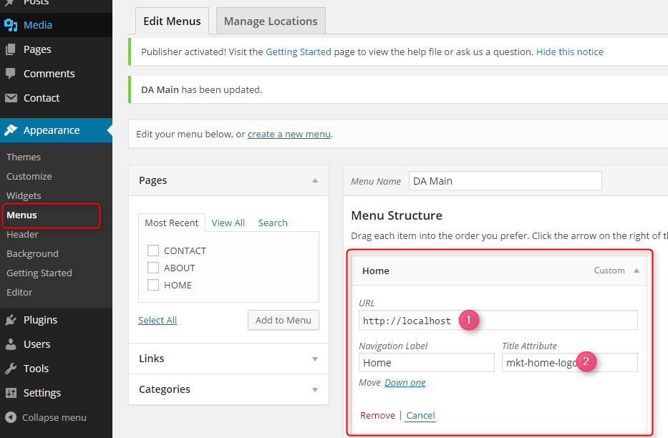

Create a link with

1. Your target URL
2. Enter “**mkt-home-logo**” on Title Attribute.

Provide Image source

1. Go to Publisher theme
2. Put logo on “wp-content\themes\publisher\tym-library\img”

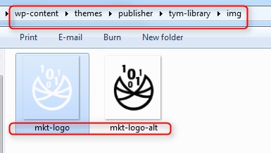

The name must be

* 1. Main image called “mkt-logo”
  2. Alternate image called “mkt-logo-alt”

Recommended Image size: 50x54px or same as this ratio

Upper Menu



You can modify the two menu links above by going to appearance > menus and create the latest two menu links (link order is important) as shown below.

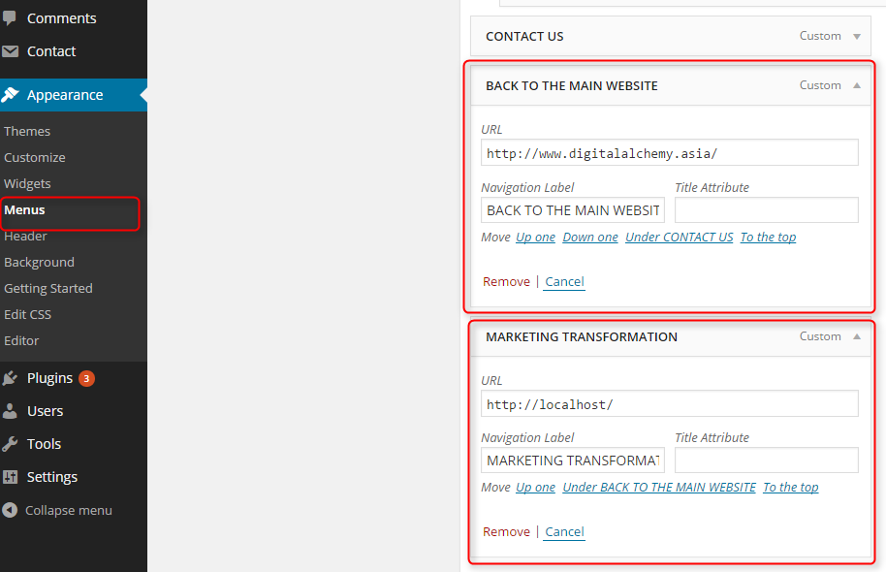

Disable Comment

Set the options as below

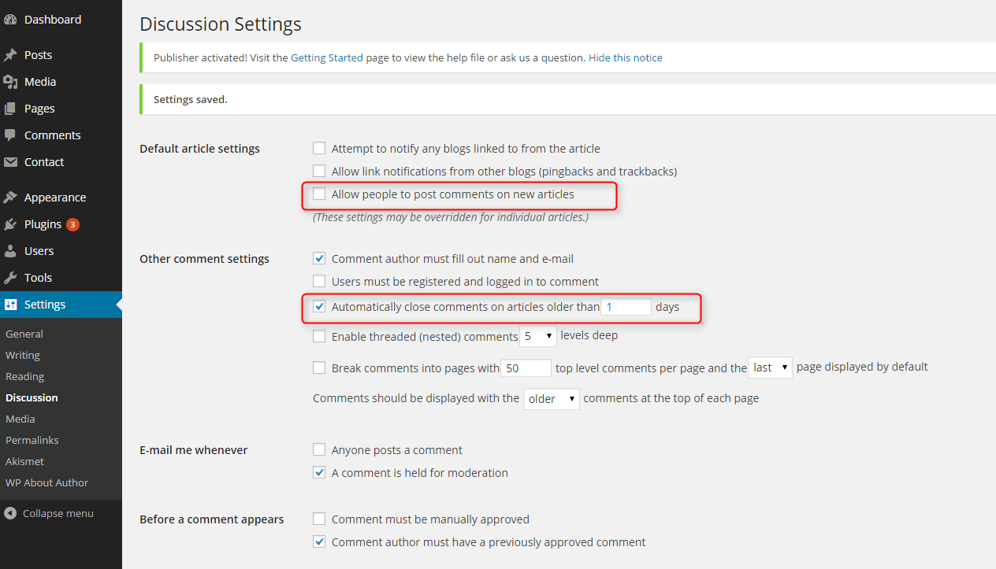

Author Management

Create authors

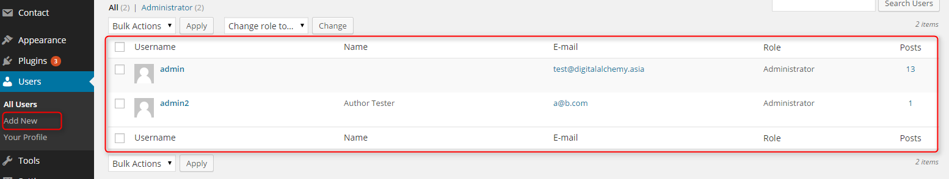

Assigning a post to an author

* Go to edit a post
* Expand “Screen Options” and check “Author”

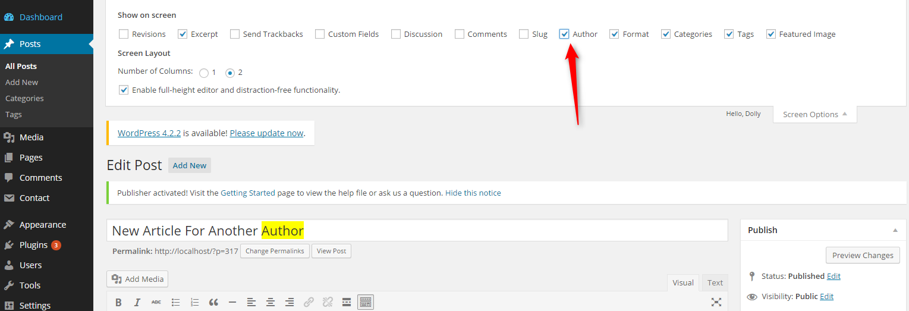

* Author option will show up for you to select one

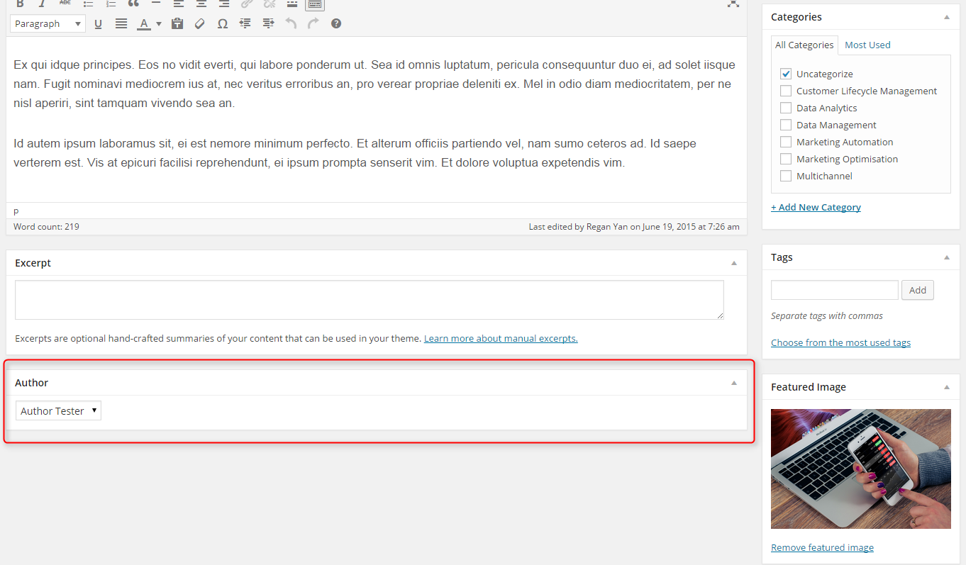

Social Media Sharing

Read this documentation for reference.

See “Adding Your Own Service” to add a new social sharing service you need.

<https://en.support.wordpress.com/sharing/#adding-your-own-service>

Author Image

You must register an account (per author) at <https://en.gravatar.com/> by using author email to register. Then, upload image to gravatar profile.

About Author Section

* Configure WP Author Plugin

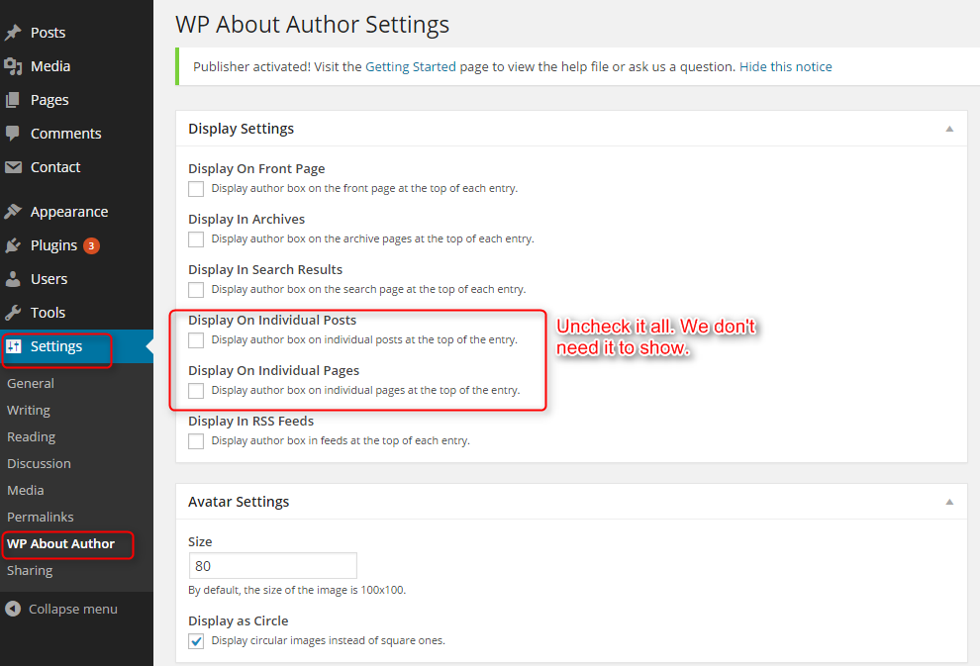

* Go to a user and specify LinkedIn url for that user

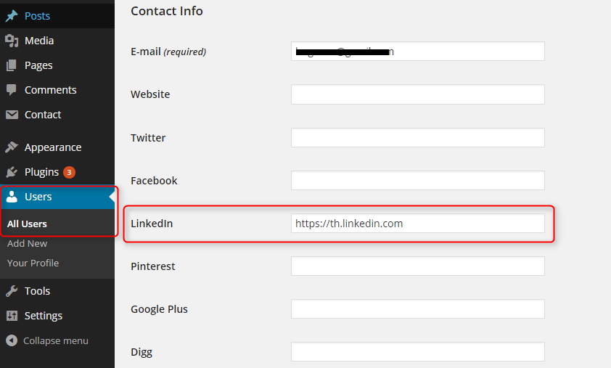

Create Youtube/Vimeo Posts

Make sure “Shortcode Embeds” module of Jetpack plugin is activated.

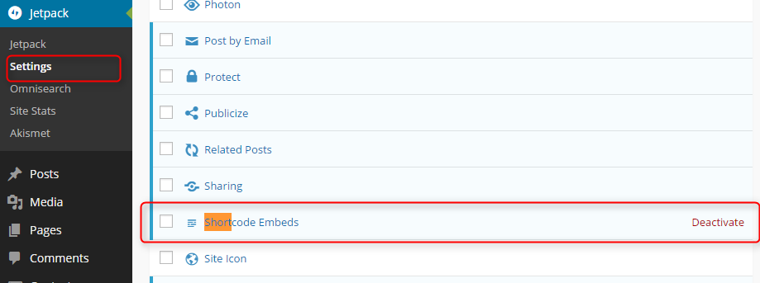

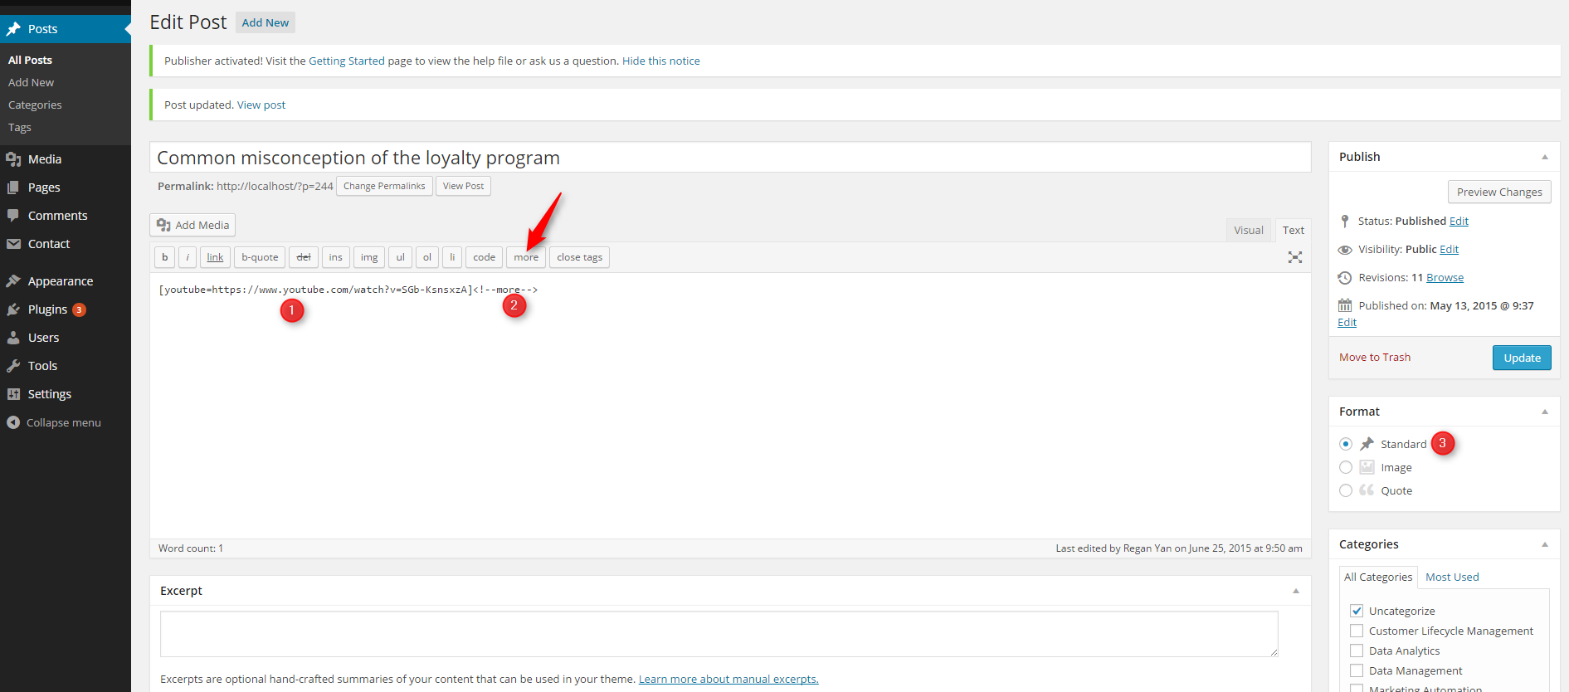

1. Enter shortcode [youtube=URL] or [vimeo=URL] shortcode.

Check tutorial here

For Youtube: <https://en.support.wordpress.com/videos/youtube/>

For Vimeo: <https://en.support.wordpress.com/videos/vimeo/>

1. Click more button to add <!--more--> tag at the end of the post content
2. Select “Standard” post format