2010-2011 A
- Questions(40)
  - What are the five layers in the Internet protocol stack? What are the principal responsibilities of each of these layers? (5)
答案：从上向下各层：
- 应用层：提供与用户应用有关功能，包括网络浏览、电子邮件、不同类文件系统的文件传输、虚拟终端软件、过程作业输入、目录查询和其他各种通用的和专用的功能等。（1分）
- 传输层：完成端到端的可靠数据传输。（1分）
- 网络层：关系到子网的运行控制，其中一个关键问题是确定分组从源端到目的端的路由选择，以分组为单位进行传输。（1分）
- 链路层：主要任务是加强物理传输原始比特的功能，以帧为单位进行传输。完成相邻结点间的可靠数据传输。（1分）
- 物理层：负责提供和维护物理线路，并检测处理争用冲突，提供端到端错误恢复和流控制以比特为单位进行传输。（1分）
  - Why is it said that FTP sends control information "out-of-band" but HTTP sends control information “in-band”? (6)
答：HTTP和FTP都是文件传送协议，它们有许多共同的特征（如都运行在TCP之上）。不过这两个应用层协议最重要的差别是FTP使用两个并行的TCP连接来传送文节件，一个是控制连接，一个是数据连接。（2分）控制连接用于在客户主机和服务器主机之间发送控制信息，例如用户名和口令、改变远程目录的命令、取来或放回文件的命令。数据连接用于真正发送文件。既然TCP使用一个独立的控制连接，我们说FTP在带外(out-of-band)发送控制信息的。（2分）HTTP中，同一个TCP连接既用于承载请求和响应头部，也用于承裁所传送的文件，因此我们说HTTP在带内(in-band)发送控制信息。（2分）
  - What is the difference between network architecture and application architecture? (6)
答：网络体系结构是指以分层的方式来描述通信过程的组织体系。（例如五层网络结构）另一方面，应用体系结构是由应用程序的研发者设计，并规定应用程序的主要结构（例如客户机/服务器或P2P）从应用程序研发者的角度看，网络体系结构是固定的，并为应用程序提供了特定的服务集合。
（评分标准：网络体系结构和应用体系结构各占3分）
  - Suppose Host A sends two TCP segments back to back to Host B over a TCP connection. The first segment has sequence number 92; the second has sequence number 111. (6)
a. How much data is in the first segment?
b. Suppose that the first segment is lost but the second segment arrives at B. In the acknowledgment that Host B sends to Host A, what will be the acknowledgment number?
答：a) 19 bytes b) ack number = 92
（评分标准：a，b各占3分）

  - What are the two most important network-layer functions in a datagram network? What is the difference between them? (6)
答：数据报网络中网络层两个最重要的功能是转发和选路。（2分）转发（Forwarding）特指在一个路由器内将数据从输入端口移动到合适的输出端口（2分），而选路（Routing）特指确定从数据源端到目的端的整条传输路径（2分）。
  - If all the links in the Internet were to provide reliable delivery service, would the TCP reliable delivery service be redundant? Why or why not? (5)
答：不多余（1分）。虽然每条链路都能保证数据包在端到端的传输中不发生差错，但它不能保证IP 数据包是按照正确的顺序到达最终的目的地。IP 数据包可以使用不同的路由通过网络，到达接收端的顺序会不一致，因此，TCP 需要用来使字节流按正确的序号到达接收端（2分）。路由器也可能由于缓存溢出而丢弃IP数据包（2分）。
  - In Cyclic Redundancy Check (CRC), consider the 4-bit generator G is 1001, and suppose that D has the value 1011101. What is the value R? Show your calculation steps. (6)
答：本题中G=1001，D=1011101，需要求R，先将D补全3个0（G的位数-1），为1011101000（2分）.再对其用G进行二进制除法，得到的余数即为R=111。（2分）其具体计算过程如下：
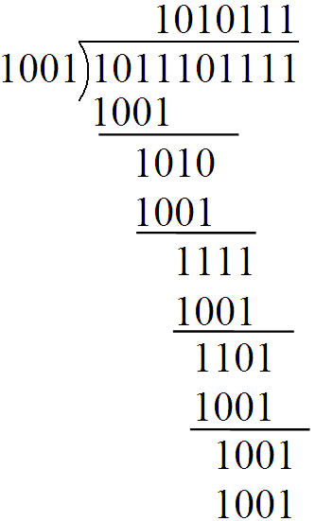
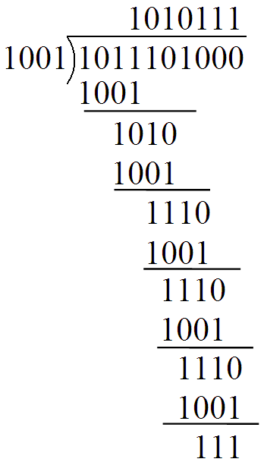
计算过程（2分） 验算过程（不算分）

三. Consider transferring an enormous file of L bytes from Host A to Host B. Assume an MSS of 1,460 bytes. (10’)
  - What is the maximum value of L such that TCP sequence numbers are not exhausted? Recall that the TCP sequence number fields has 4 bytes.
  - For the L you obtain in (a), find how long it takes to transmit the file. Assume that a total of 66 bytes of transport, network, and data-link header are added to each segment before the resulting packet is sent our over a 100 Mbps link. Ignore flow control and congestion control so A can pump out the segments back to back and continuously.
一共有 2³² = 4,294,967,296个可能的序列号。（2分）
a) 由于序列号不随着TCP报文段个数增长而增长。而是根据发送数据的字节数而增长。因此，MSS的大小与可以从A发送到B的文件的大小无关。文件大小可以简单估算为： 2³²≈ 4.19 Gbytes 。（3分）
b) TCP报文段的个数为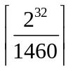= 2,941,758。66字节的首部加到每个报文段将带来194,156,028字节的首部。要传输的字节总数为：(2³²+ 194,156,028) ×8 = 3,591×10⁷ bits。（3分）
因此将花费 359 seconds = 6 minutes 来传输文件在一个 100Mbps 链路上。（2分）
（思路正确，计算错误给1半分）

四. Consider a router that interconnects four subnets: N1, N2, N3 and N4. Suppose all of the interfaces in each of these four subnets are required to have the prefix 101.101.101.64/26. Also suppose the N1 is required to support up to 24 interfaces, N2 is required to support up to 12 interfaces, and N3 and N4 are each required to support up to 6 interfaces. Provide four network addresses of the form a.b.c.d/x that satisfy these constraints. (10’)
答：N1: 101.101.101.64/27 （3分）
N2: 101.101.101.96/28 （3分）
N3: 101.101.101.112/29 （2分）
N4: 101.101.101.120/29 （2分）

五. (10’) Suppose CSMA/CD protocol is used in a LAN. The distance between hosts A and B is 2 km, propagation speed is 200000 km/s, transmission rate of the link is 10 Mbps. Please answer the following questions:
(1) Suppose collision occurred when the two hosts send data. How long is the time from the beginning of data transmission to collision is detected?
(2) What is the smallest frame from A to B?
（1）2/200000=10⁻⁵(s)
(2)2*10⁻⁵*10*10⁶=200(bit)

六. Suppose within your Web browser you click on a link to obtain a Web page. The IP address for the associated URL is cached in your local host. Further suppose that the Web page associated with the link contains a small amount of HTML text, and the HTML file references five very small objects on the same server. Let RTT2 denote the RTT between the local host and the server containing the object. Neglecting transmission times, how much time elapses with: (10’)
a. Non-persistent HTTP with no parallel TCP connections?
b. Non-persistent HTTP with parallel TCP connections?
c. Persistent HTTP with pipelining?
d. Persistent HTTP without pipelining?
答：
a. 无并行TCP连接的非持久HTTP：12RTT2 （3分）
b. 有并行TCP连接的非持久HTTP：4RTT2 （3分）
c. 有流水线的持久HTTP：3RTT2 （2分）
d. 无流水线的持久HTTP：7RTT2 （2分）

