**1) Please compare the characteristics of the connection-oriented service and the connectionless service**

面向连接的可靠数据传输在传输数据之前建立连接，数据有序到达，提供可靠性，流量控制，拥塞控制无连接的不可靠数据传输传输之前不需要建立连接，不提供可靠性数据库传输，流量以及拥塞控制

**2) Please describe how a link-layer switch operates its function of self-learning filtering and forwarding**

交换机通过自学习建立转发表，将接受帧的源MAC地址和到达端口号写入转发表。当交换机接收到一帧，首先根据帧的目的MAC地址查找转发表如果帧的目的MAC地址在转发表中且不是去往此帧到达的端口，则转发到相应的目的端口，如果目的端口和此帧的入口为同一接口，则将此帧过滤丢弃，如果此帧的目的MAC地址不存在于转发表中，则向所有的端口广播该帧

**3) List at least six access technologices you often use in your daily life**

dial-up(拨号)、HFC、ADSL、LAN、Wireless LAN、Wide area wireless access network

**4)If both source and destination nodes are in the same LAN, please explain how ARP protocol works**

每一个节点中的ARP模块在它的RAM中有ARP表，此表中存有IP地址到MAC地址的映射，发送方发送一帧数据给接收方时，若发送节点ARP表中有目的节点的映射，则直接使用此地址，若没有，则发送节点向局域网中所有的节点发送ARP查询报文，此查询分组通过广播的形式被局域网中所有的节点接受，所有的节点检查本身的IP地址是否和ARP包中的目的IP地址吻合，符合的节点发送ARP响应报文给查询节点，包括其MAC地址和IP地址的映射关系，发送节点更新本身的ARP路由表，利用查询的结果，发送数据报。

**5)Are flow control and congestion control same? Why?**

（没标准答案，网上找的）

Flow control means preventing the source from sending data that the sink will end up dropping because it runs out of buffer space. This is fairly easy with a sliding window protocol--just make sure the source's window is no larger than the free space in the sink's buffer. TCP does this by letting the sink advertise its free buffer space in the window field of the acks.

Congestion control means preventing (or trying to prevent) the source from sending data that will end up getting dropped by a router because its queue is full. This is more complicated, because packets from different sources travelling different paths can converge on the same queue.

**2 Suppose some users share a 1Mbps link Also suppose each user require 100 kbps when transmitting but each user transmits only 10 percent of the time.**

**1) When circuit switching is used how many users can be supposed?**

因为每个用户需要10%的带宽，因此可以有10个用户

**2) For the remainder of this problem suppose packet switch is used Find the probability that a given user is transmitting.**

**3) Suppose there are 40 users Find the probability that at any given time. exactly n users are transmitting simultaneously.**

**4) Find the probability that there are 11 or more users transmittinh simultaneously.**

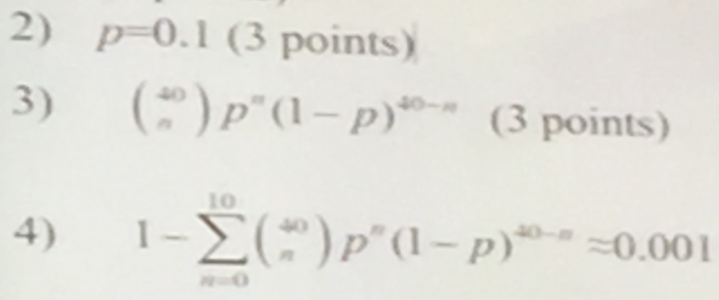

**3 Consider Fig1 a message that is 8*106 bits long that is to be sent from source to distination via two packet switches Suppose each link in the figure is 10 Mbps Ignore propagation queuing and processing delays**

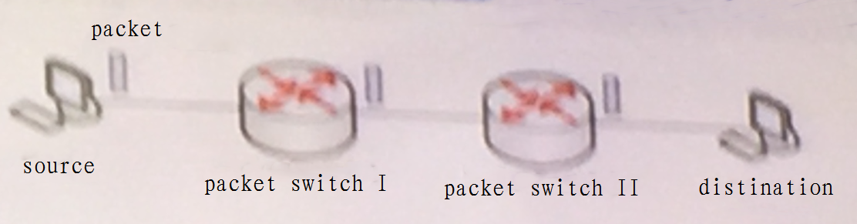

**1) Consider sending the message from source to destination without message segmentation How long does it take to move the message from the soruce to the first packet switch? Keep in mind that each switch uses store-and-forward packet switching. what is the total time to move the message from source host to destination host?**

L/R = 0.8s 3*L/R = 2.4s

**2) Now suppose that the message is segmented into 4000 packets each packet being 2000 bits long How long does it take to move the first packet from source host to the first switch? When the first packet is being sent from the first seitch to the second switch the second packet is being sent from the source host to the first switch. At what time the second packet be fully received at the first switch?**

L/R = 0.2ms t = 3L/R + (n-1)L/R = 3L/R + (4000-1)L/R = 0.8004s

**4 In Fig2 two HTTP clients visit one HTTP server via three TCP connection IP address and some source port number. Please fill the blanks of each packet fields**

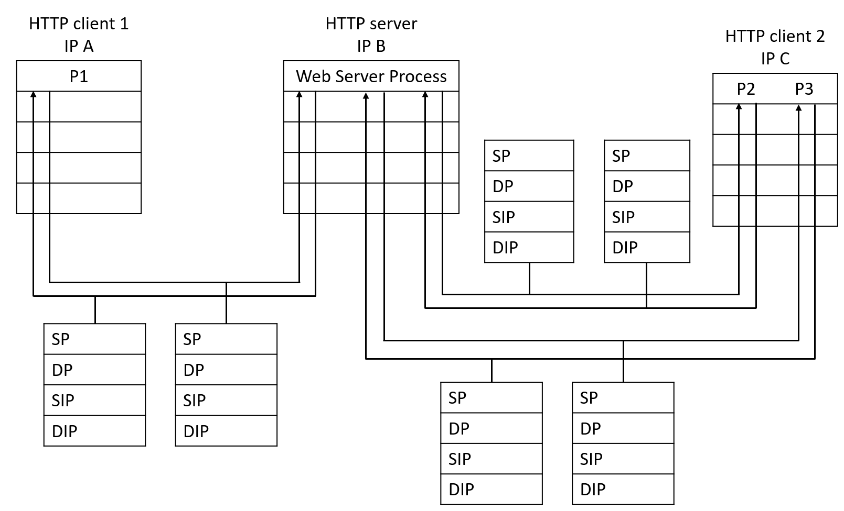

**5 Consider the network shown in Fig3 and assume that each node initally knows the cost to each of its neighbors Conder the distance-vector algorithm and show the running steps of the distance vector table entries at node z**

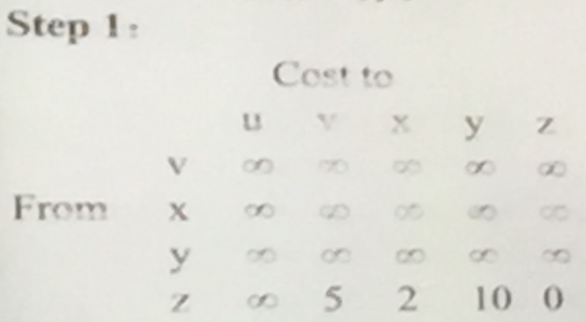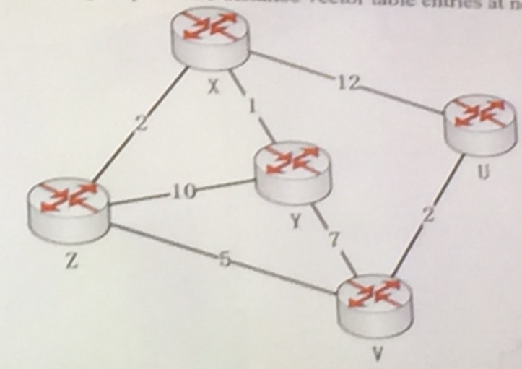

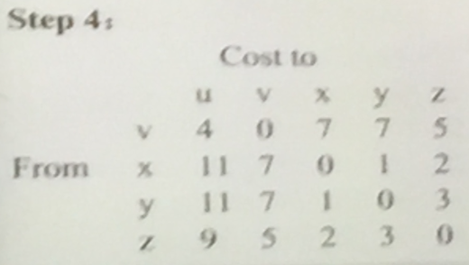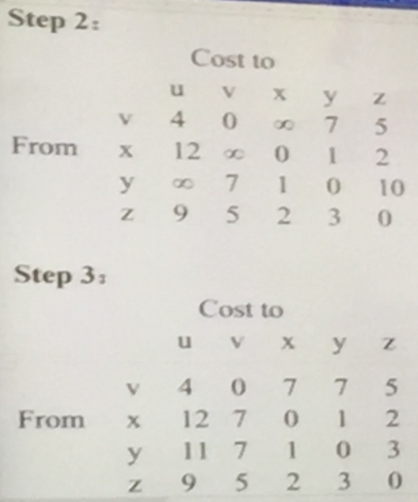

**6 To make CSMA/CD work it must be impossible to transmit an entire frame in the Round-Trip Time Consider building a CSMA/CD network running a 100Mbps over a 400m cable with no repeaters(中继器) The signal speed in the cable is 200,000 km/sec What is the minimum frame-size?**

For a 400m cable the onrway propagtion time is 2usec so RTT = 4usec

To To make CSMA/CD work it must be impossible to transmit an entire frame in the Round-Trip Time At 100Mbps all frame shorter than 400bits can be completely transmitted in under 4usec ao the minimum frane is 400bits