**Appendix**

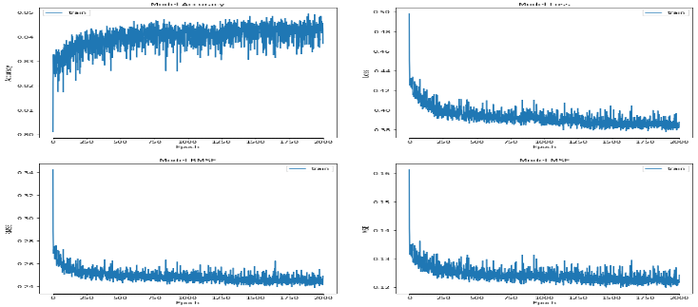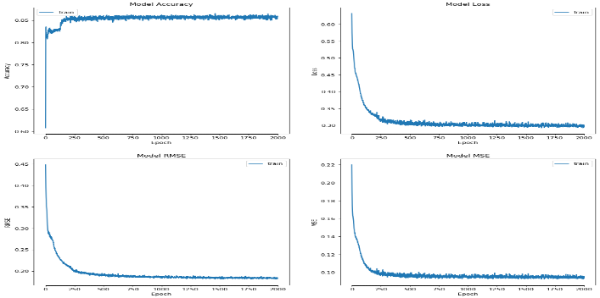

Figure 1: Neural Network running over 2000 epochs

Table 2: Results of the training data using NN model

Table 3:Results of the testing data using NN model